Homework 3

Zichen Pan(zp2197)

**Problem 1**

**(a)**

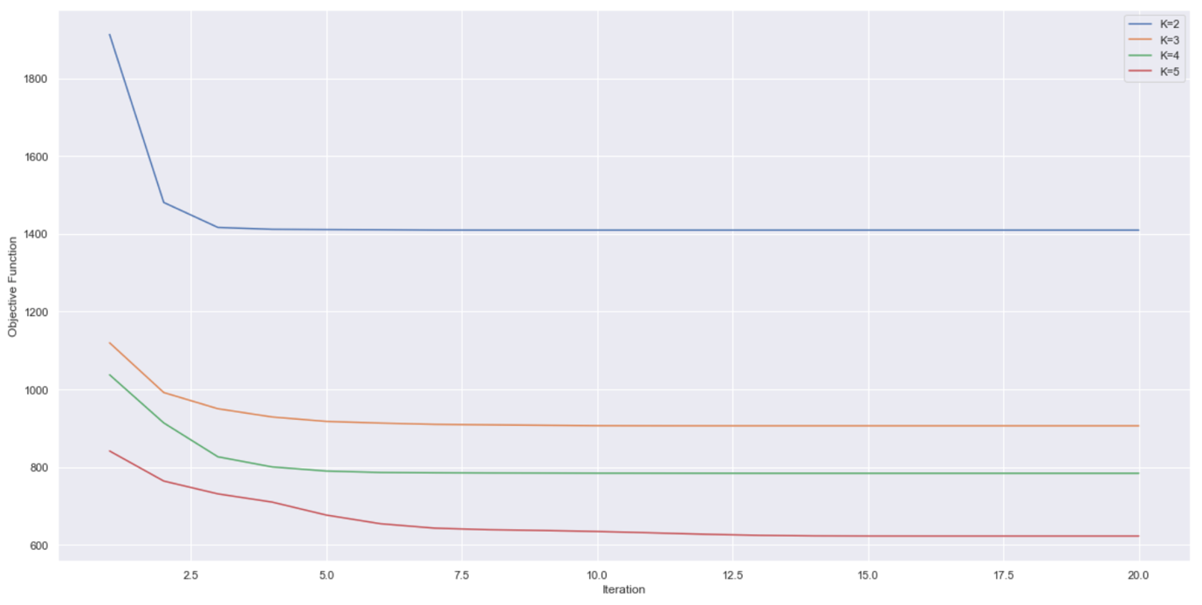

**(b)**

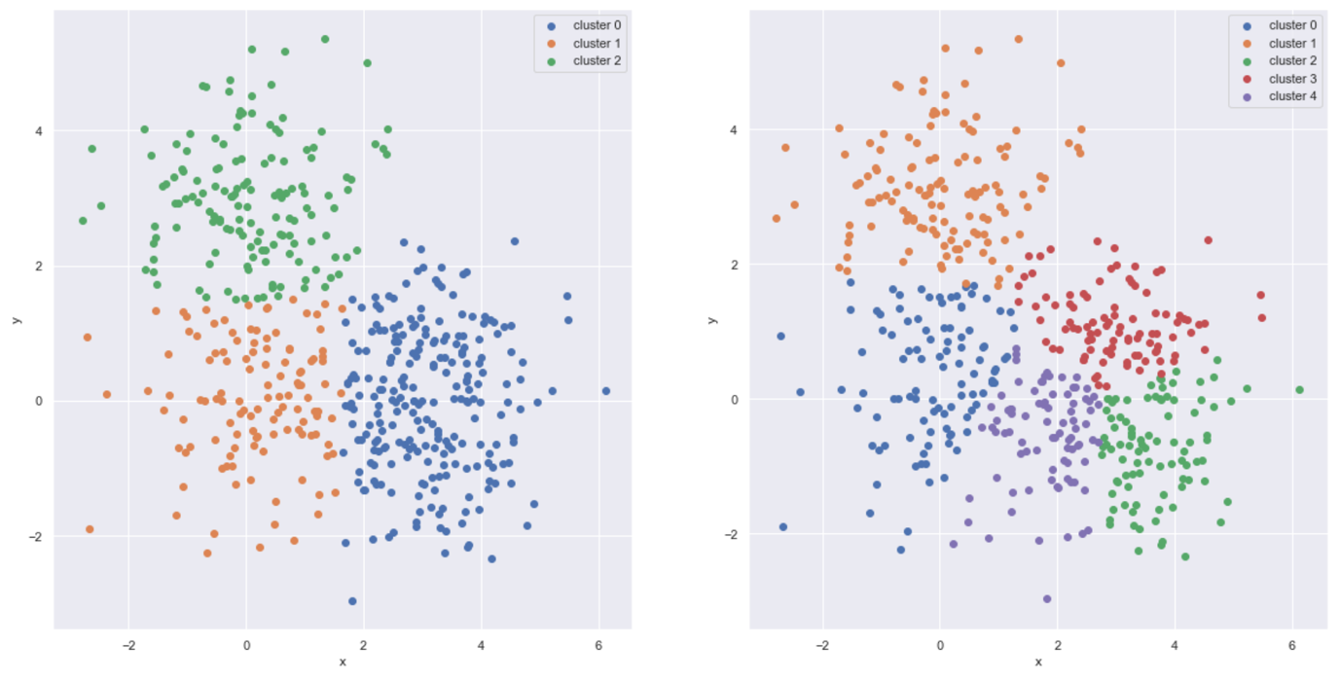

**Problem 2**

**(a)**

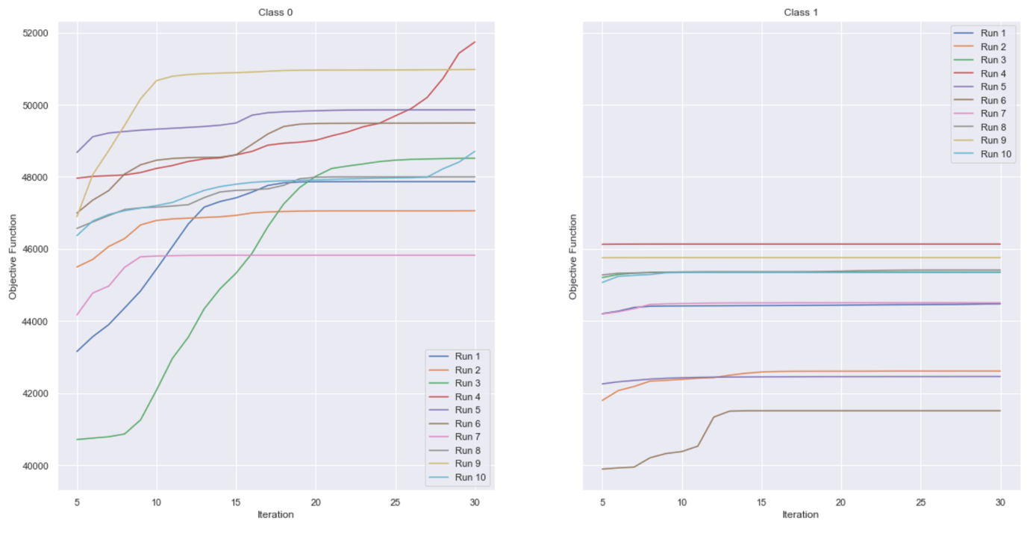

**(b)**

**1-Gaussian GMM:**

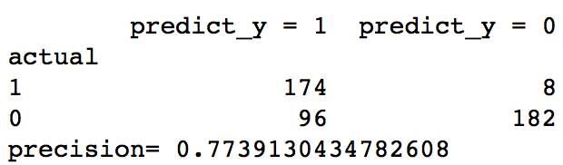

**2-Gaussian GMM:**

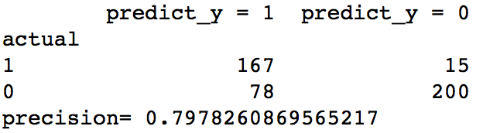

**3-Gaussian GMM:**

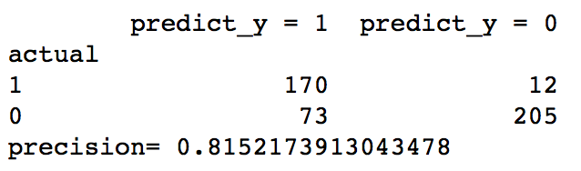

**4-Gaussian GMM:**

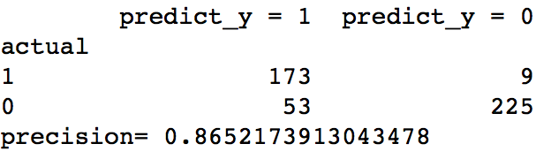

**Problem 3**

**(a)**

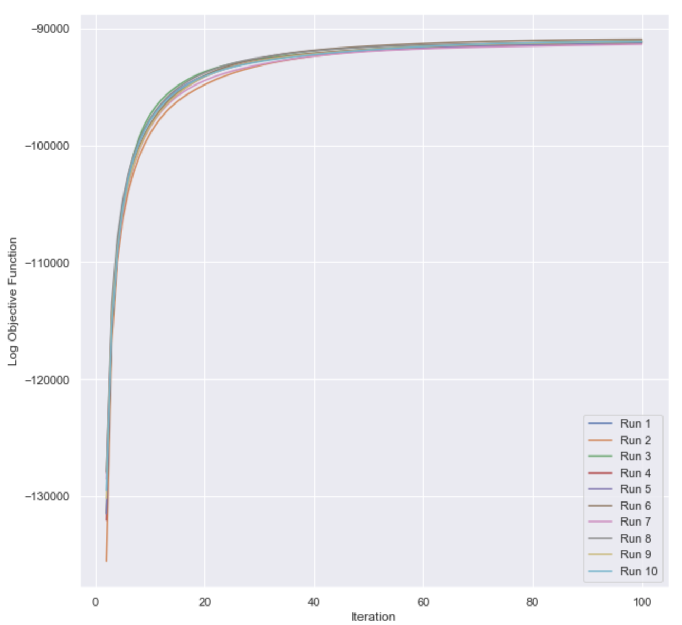

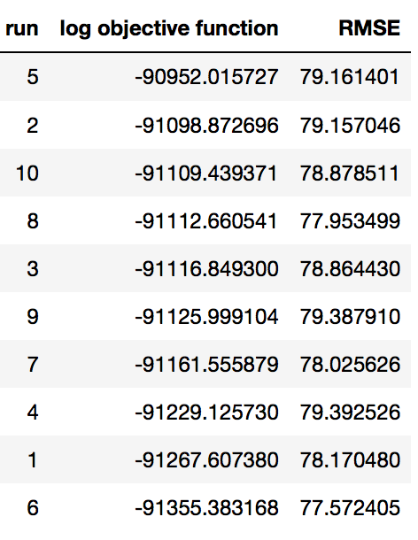

**(b)**

