

**Name : Peter Sameh Tadros**

**B.N: 262**

**Email: Beter195288@feng.bu.edu.eg**

**Date:**

**Course code : ECE001**

**Topic : Artificial Intelligence**

**Application Breif:**

Artificial Intelligence or (AI) for short is one of the most important elements of technology, Every company is trying to make the perfect AI that can mimic the human or even surpass it in intelligece and creativity ,AI is a very complicated topic and it needs great ammount of resources to preform the tasks it can do because it fouceses on machine learning with millions of iterations to reach reasonable results of but all this is called Weak AI because its only fouces on a specific set of tasks that it can do , the ultimate goal of scientsts is reach the Strong AI that it can be creative and even preform better than human in all tasks .

**Link:**

<https://peter-sameh.github.io/ece001/>

**Screenshots :**

Home Page

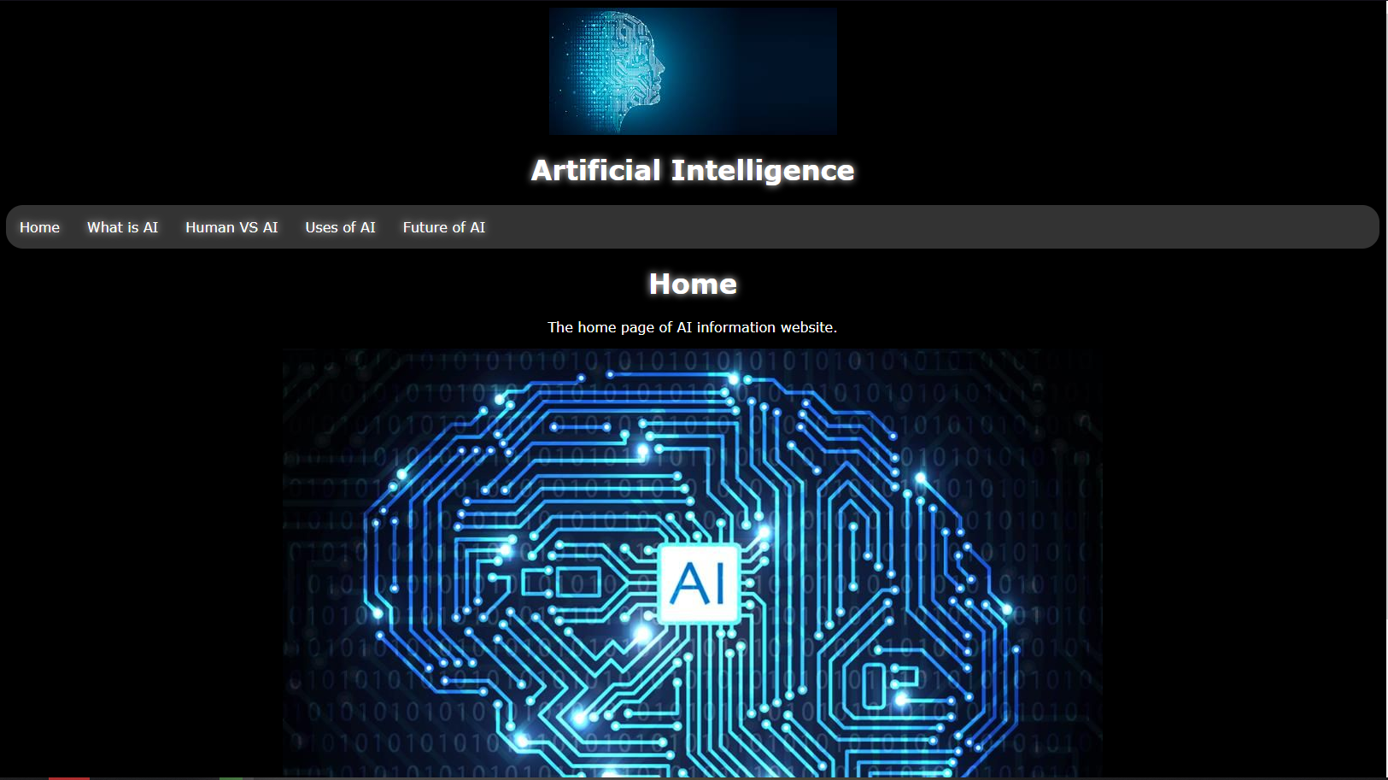

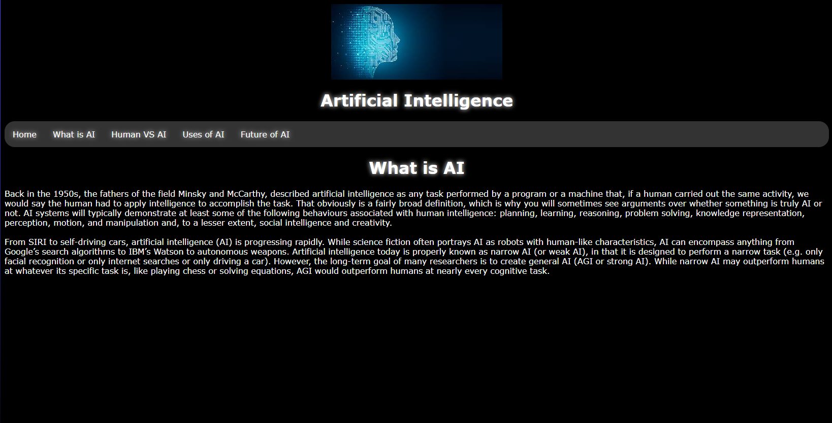Page 1 (What is AI)

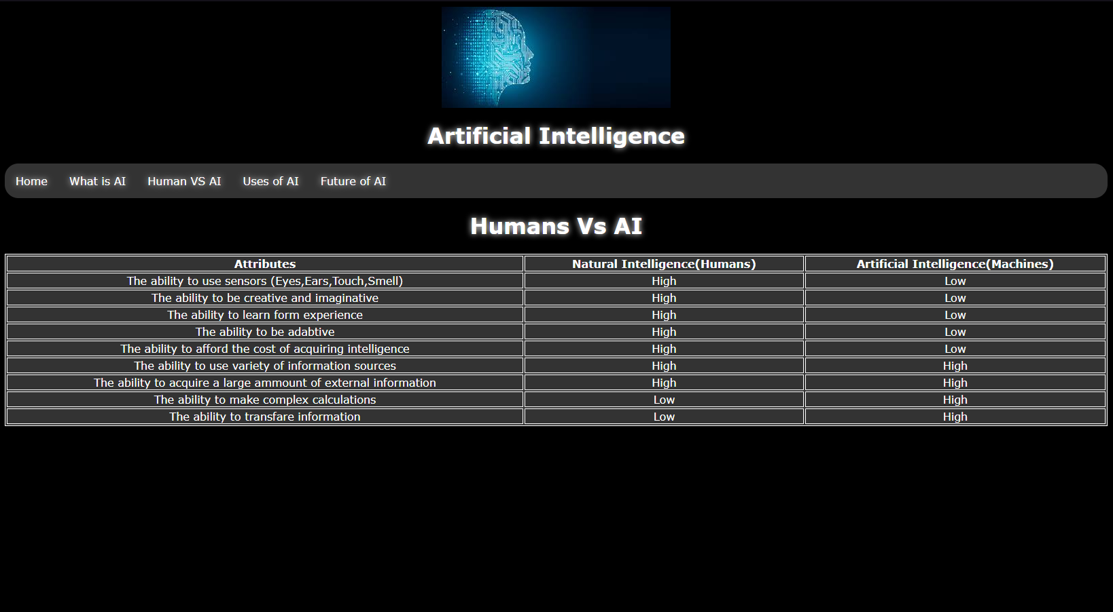Page 2 (Human VS AI table)

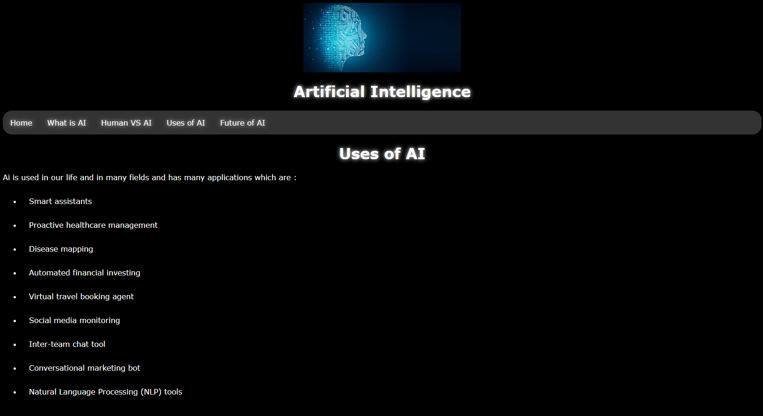Page 3 (Uses of AI List)

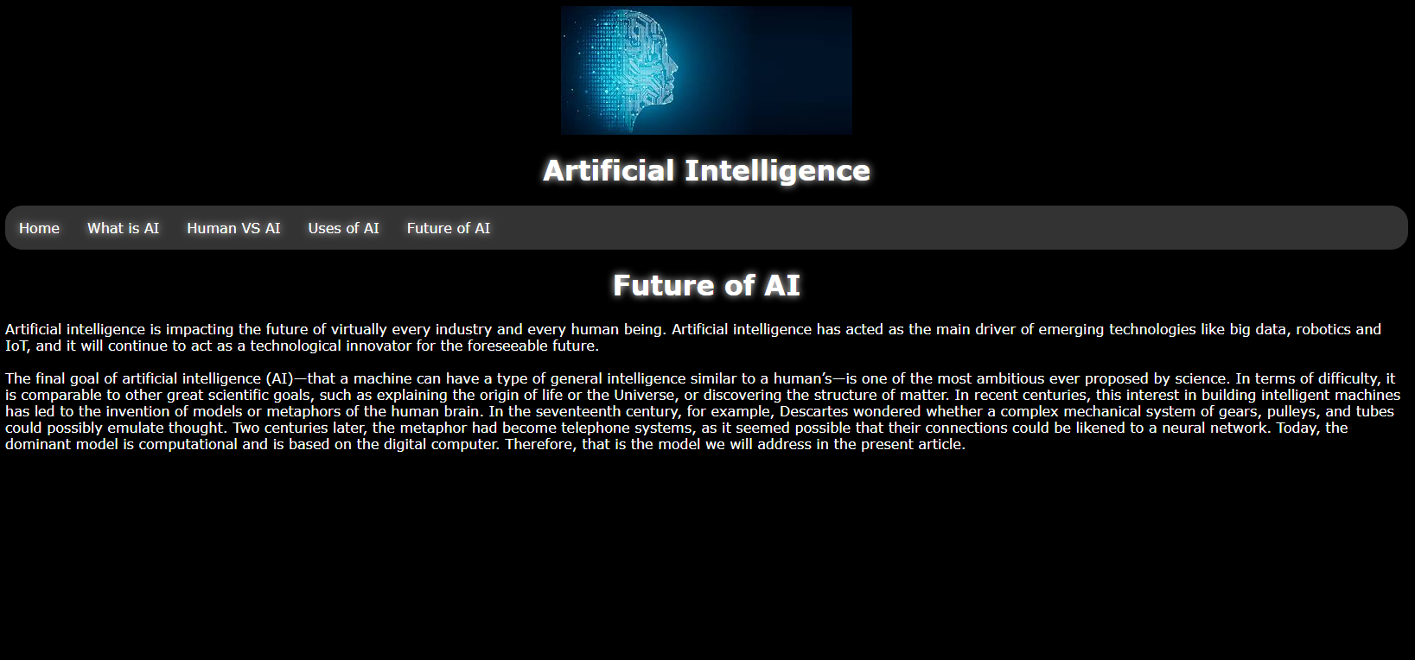Page 4 (Future of AI)

**Source Code :**

Home:

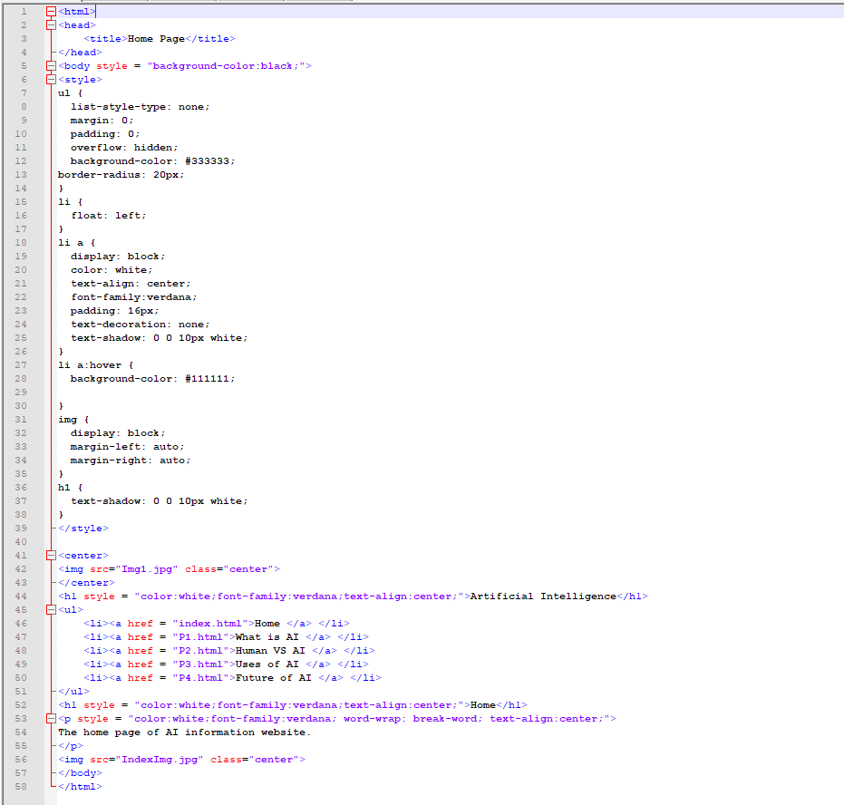

Page 1 (What is AI)

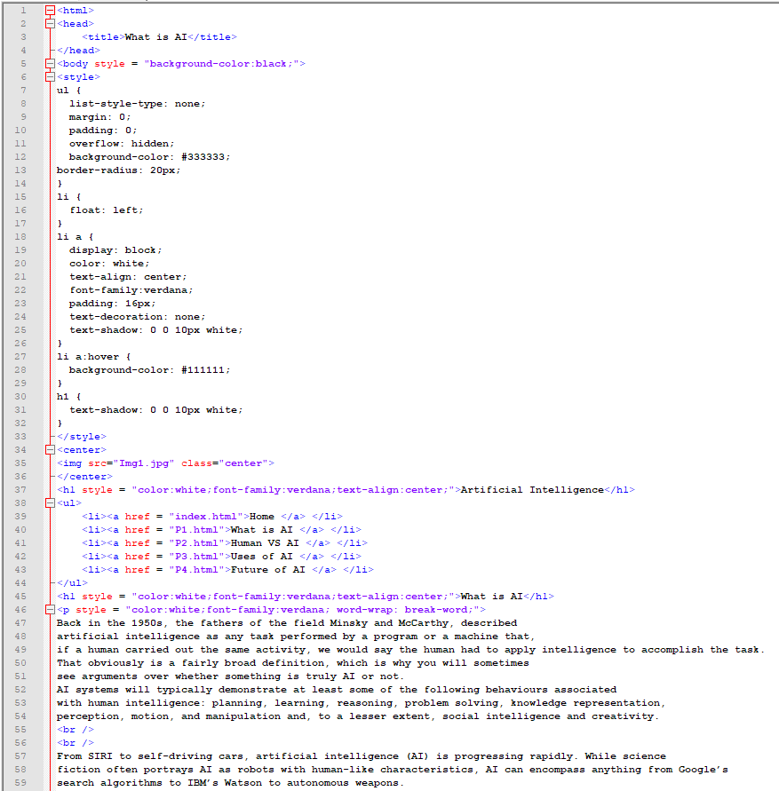

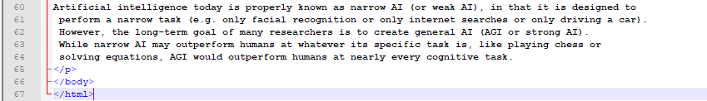

Page 2 (Human VS AI table)

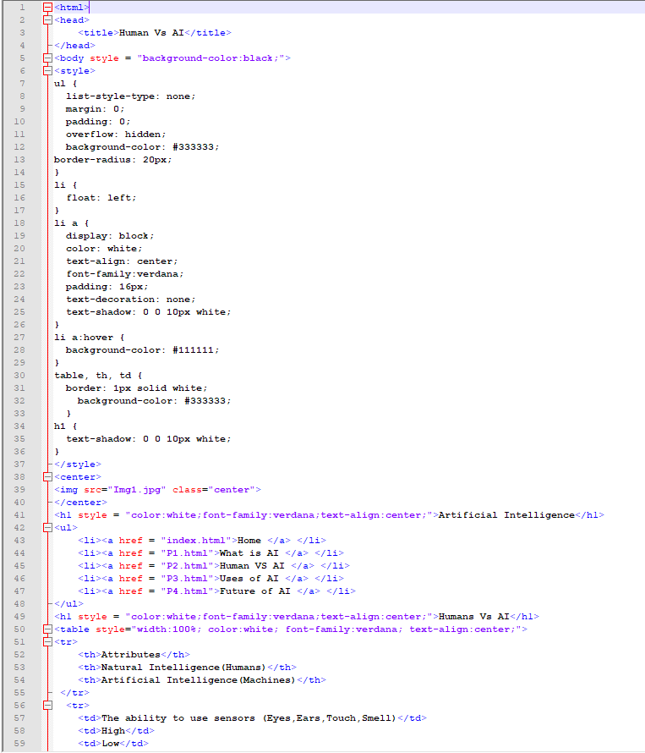

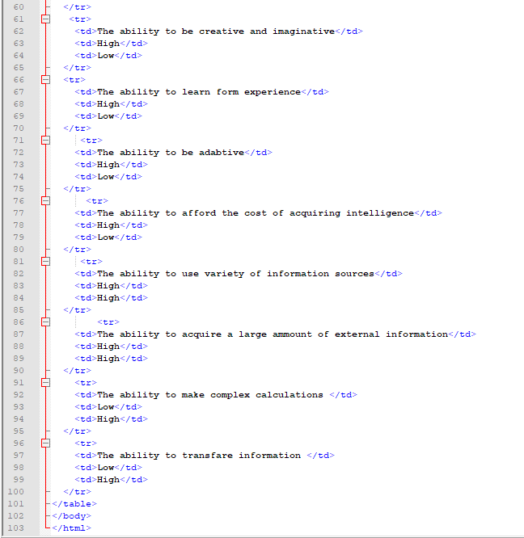

Page 3 (Uses of AI List )

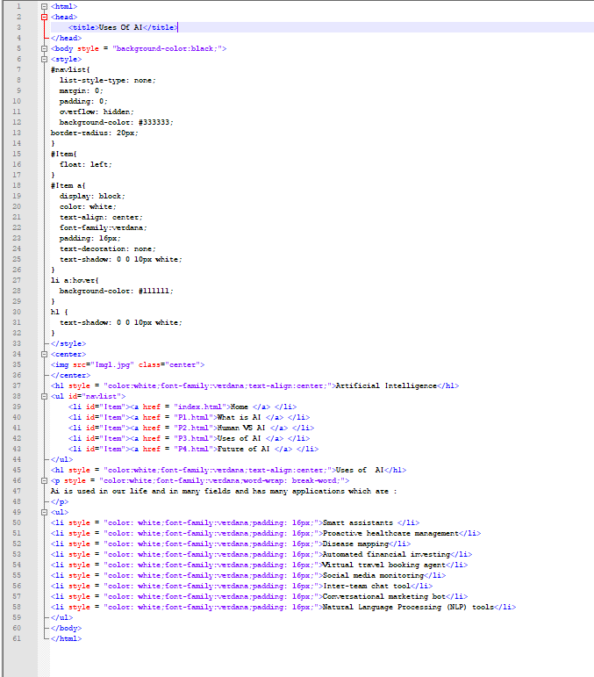

Page 4 (Future of AI)

