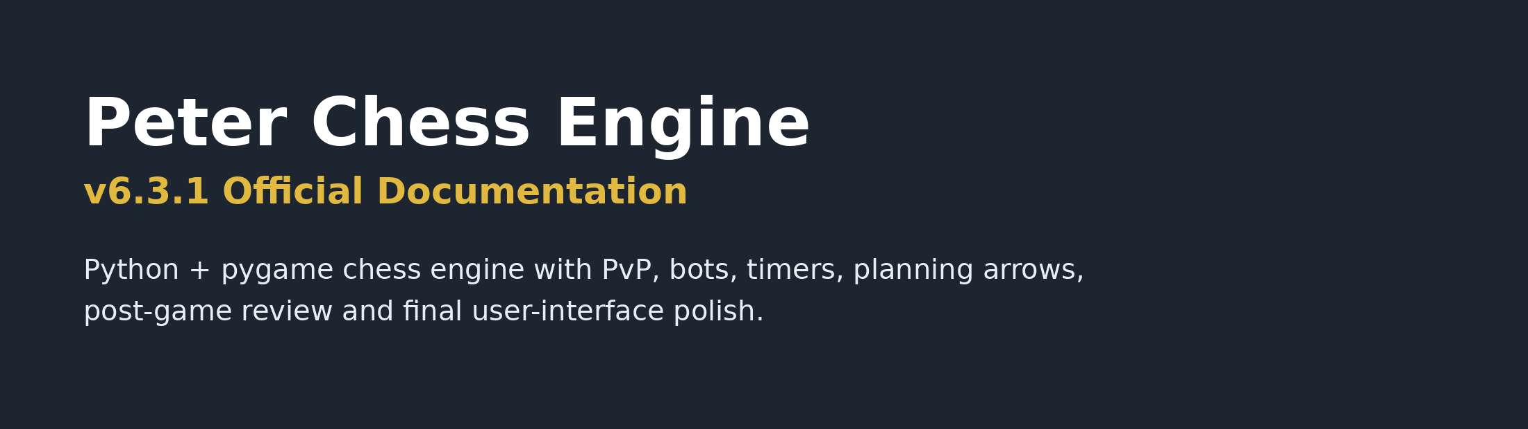
HSC Software Engineering Major Project Documentation
Field | Details
Project title | Peter Chess Engine v6.3.1
Student name | Peter Trinh
Course | HSC Software Engineering
Teacher | Andrew Zhukov
GitHub repository | https://github.com/Peter-Trinh55/Chess-Engine
Submission date | Wednesday, 1 July 2026
Version number | v6.3.1 official release

Academic integrity note: This documentation reflects the final chess engine version v6.3.1. Screenshots, source acknowledgements, testing evidence and GitHub links should be checked by the student before final submission.

Table of Contents
1. Introduction
2. Project Planning
3. Technologies and Justification
4. Design Documentation
5. Directory Structure
6. Secure Programming
7. Testing
8. GitHub Management
9. Logbook and Version History
10. Reflection
11. AI and Source Acknowledgement
12. Appendices

Section 1 - Introduction

1.1 Problem Statement
Many chess engines and online chess tools are designed for competitive players who already understand ratings, notation and analysis tools. This can make them difficult for students, beginners and school chess club players to use. Peter Chess Engine v6.3.1 addresses this problem by providing a clearer, more accessible chess program with a home menu, simple controls, timed modes, bot difficulty settings and post-game review.

1.2 Purpose
The purpose of this project is to develop an advanced desktop app that allows users to play chess in either Player vs Player or Player vs Bot mode. The project focuses on usability, fair gameplay, clear feedback and iterative improvement. The final app supports legal move checking, turn management, timers, result pop-ups, visual planning arrows and a post-game review system.

1.3 Intended Users
User group | Need | Benefit
Students | Practise chess in a simple interface. | Improves confidence, strategy and understanding of legal moves.
Chess club members | Play timed games and practise against bots. | Supports training and school tournament preparation.
Teachers | Use the project as a software engineering example. | Demonstrates UI design, algorithms, testing and version control.
Beginner players | Learn chess without a complicated engine interface. | Simple controls, visual feedback and post-game review support learning.

1.4 Success Criteria
Criterion | Measure of success
Playable chessboard | Users can start a match, choose game mode and move pieces clearly.
Legal move validation | Illegal moves are rejected and a notification is displayed.
Bot mode | Easy, Medium and Hard bots generate moves at different difficulty levels.
Time controls | Rapid, Blitz, Bullet and Endless modes work correctly.
User-friendly interface | Menus, player tags, clocks and settings are easy to read.
Post-game review | Move history and replay controls appear after the game ends.
Testing evidence | Unit tests and manual tests support the final software quality.

Section 2 - Project Planning

2.1 Software Methodology
Methodology | Suitability for this project | Decision
Agile | Allows the chess engine to be improved in small working versions such as menus, bot logic, timers and UI updates. | Selected
Waterfall | Useful when requirements are fixed, but less flexible for repeated testing and UI changes. | Not selected
WAgile | Supports planning first, then iterative development during implementation. | Supporting approach
DevOps | Useful for GitHub management, repeated commits and testing evidence. | Supporting practice

Agile was selected because the project required repeated improvements after testing. For example, bot behaviour, timer logic, menu controls and user interface layout were refined across multiple versions. This allowed feedback from testing to be converted into new features and bug fixes.

2.2 Sprint Plan
Sprint | Main task | Deliverable
Sprint 1 | Set up original pygame chess engine. | Running board, pieces and basic movement.
Sprint 2 | Add menus and game modes. | Home menu, PvP, Player vs Bot and colour selection.
Sprint 3 | Add timers and game result handling. | Rapid, Blitz, Bullet, Endless and result pop-up.
Sprint 4 | Improve user controls and feedback. | Click-to-move, illegal move notice and check indicator.
Sprint 5 | Improve bot difficulty and performance. | Easy, Medium and Hard bot behaviour with thinking delays.
Sprint 6 | Final UI refinement and documentation. | Final v6.3.1 interface, README and documentation evidence.

2.3 Requirements Analysis
Functional requirements describe what the chess engine must do. Non-functional requirements describe how well the system should perform and how usable, reliable and maintainable it should be.
ID | Functional requirement | Priority | Final status
FR1 | Display a chessboard and pieces. | High | Completed
FR2 | Allow click-to-select and click-to-move controls. | High | Completed
FR3 | Validate legal moves and reject illegal moves. | High | Completed
FR4 | Show check indication on the king. | High | Completed
FR5 | Provide Player vs Player and Player vs Bot modes. | High | Completed
FR6 | Provide Easy, Medium and Hard bot difficulties. | High | Completed
FR7 | Provide Rapid, Blitz, Bullet and Endless time controls. | High | Completed
FR8 | Show post-game review and move history after the game. | Medium | Completed
FR9 | Allow planning arrows for visual move planning. | Medium | Completed
FR10 | Provide settings menu and theme changing. | Medium | Completed

Area | Non-functional requirement | Final approach
Performance | The app should not freeze during bot moves. | Bot logic was moved away from blocking gameplay and image loading was optimised.
Usability | Controls should be clear for beginners. | Click-to-move controls, buttons and clear menus were implemented.
Reliability | Unexpected moves or inputs should not crash the program. | Illegal moves are rejected and game states are checked.
Maintainability | Code should be modular and easier to edit. | Files are separated into board, game, pieces, move, config and UI logic.
Accessibility | Text and controls should be readable. | Large sidebar text, clear buttons and consistent UI colours were used.

2.4 Stakeholder Analysis
Stakeholder | Interest | Consultation/evidence
Student developer | Builds, tests and documents the software solution. | Development notes, version history and final reflection.
Teacher/client | Checks the project meets HSC Software Engineering outcomes. | Assessment notification, feedback and final presentation.
Peer testers | Use the software and identify bugs or usability issues. | Testing feedback about bot timing, UI layout and controls.
End users | Play the game and use the interface. | Simple menu, clear timers, readable controls and post-game review.

2.5 Gantt Chart
Phase | Weeks | Milestone
Planning | Week 1 | Project idea, problem statement and requirements.
Base engine setup | Weeks 2-3 | Original pygame chess engine running locally.
Feature development | Weeks 4-6 | Home menu, game modes, AI, timers and result screen.
Testing and refinement | Weeks 7-8 | Bot timing, UI changes, check indicator, arrows and performance fixes.
Final UI polish | Week 9 | Settings menu, final cogwheel icon and README instructions.
Documentation and presentation | Week 10 | Final report, screenshots, testing evidence and slides.

2.6 Risk Management
Risk | Probability | Impact | Mitigation
Bot logic plays too weakly or too strongly. | Medium | High | Use separate Easy, Medium and Hard behaviours and adjust after testing.
Game freezes during bot moves. | Medium | High | Optimise AI processing and avoid blocking the main pygame loop.
User interface becomes cluttered. | High | Medium | Move actions into settings menu and separate timers from side panel.
Legal move bugs. | Medium | High | Use manual testing and unit tests for board logic.
Timer starts too quickly. | Medium | Medium | Add five-second countdown before the game begins.
Files cannot be run on another device. | Medium | Medium | Provide Windows and macOS README instructions.

Section 3 - Technologies and Justification

3.1 IDE Selection
Tool | Advantages | Limitations | Decision
VS Code | Lightweight, supports Python, integrated terminal and GitHub tools. | Requires correct folder to be opened for assets to load. | Selected
PyCharm | Strong Python debugging and project tools. | Heavier and less simple for different school devices. | Alternative

3.2 Programming Language
Language | Suitability | Decision
Python | Readable syntax, suitable for pygame, game loops and AI-style decision logic. | Selected
Java | Strong object-oriented structure but slower to prototype for this task. | Not selected
Node.js/JavaScript | Useful for web apps, but the project is a desktop pygame application. | Not selected

3.3 Libraries and Tools
Tool/resource | Purpose | Justification
pygame | Graphics, input handling, sounds and game window. | Best suited to the desktop chess interface.
Python standard library | Threading, random timing, file paths and system logic. | Used to support bot timing and reliable cross-platform behaviour.
VS Code | Coding and running the project. | Accessible for Windows and macOS devices.
GitHub | Version control and project evidence. | Stores the final project and shows development progress.
Word | Formal documentation. | Required for project documentation submission.
PowerPoint | Final simulated client handover. | Required for presentation evidence.

Section 4 - Design Documentation

4.1 High-Level Architecture
The chess engine is designed as a modular desktop application. Separating board state, user interface, bot logic, timer logic and review tools improves maintainability and makes it easier to test changes independently.
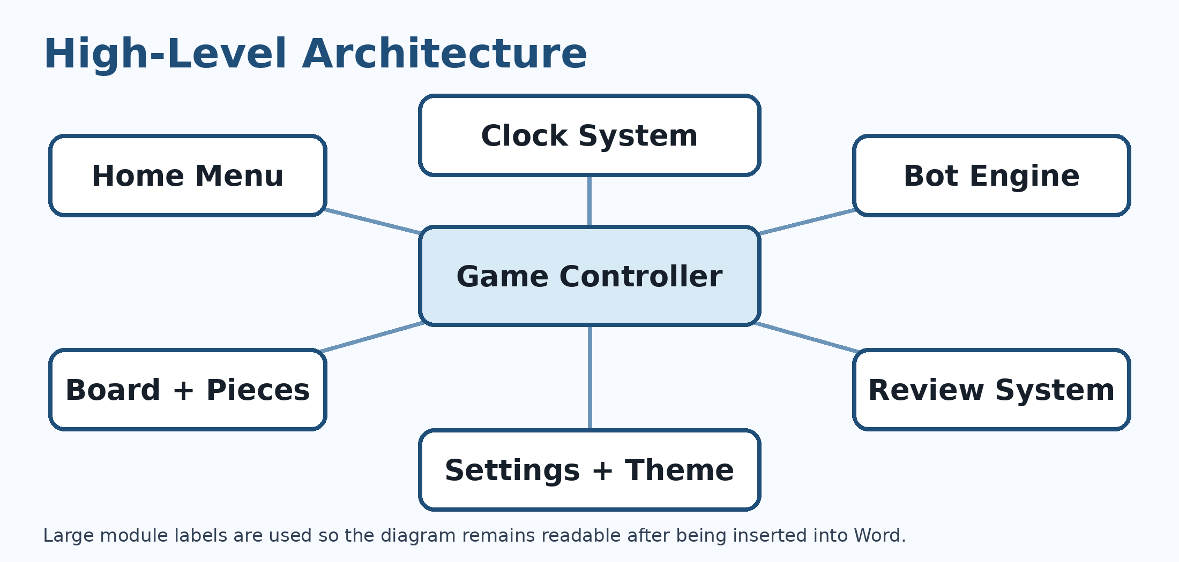
Figure 1: High-level architecture for Peter Chess Engine v6.3.1
Module | Responsibility
Home Menu | Collects match settings such as mode, side, time control and bot difficulty.
Game Controller | Coordinates turns, status messages, game state and screen changes.
Board + Pieces | Stores and displays piece positions, legal moves and board highlights.
Bot Engine | Chooses moves for Easy, Medium and Hard bot difficulties.
Clock System | Controls countdown, timers, timeouts and Endless mode.
Review System | Displays move history and lets users replay positions after the game.
Settings + Theme | Controls restart, resign, return home and colour theme changes.

4.2 Low-Level Design: Key Classes and Files
File/class | Responsibility
main.py | Starts pygame, creates the main window and runs the main event loop.
game.py | Controls screen drawing, menus, buttons, timers, arrows, review mode and user interaction.
board.py | Stores board state, piece positions, legal moves and special move handling.
piece.py | Defines chess piece classes including Pawn, Knight, Bishop, Rook, Queen and King.
move.py | Represents moves between squares and supports move history.
square.py | Stores row, column and piece information for each board square.
config.py | Loads themes, fonts, piece images and sounds.
sound.py | Manages pygame sound effects.

4.3 UML Class Diagram
The UML class diagram shows how the main classes and files interact in the final project. It demonstrates modular design by separating the board, pieces, game controller, bot logic, theme system, sounds and movement objects.
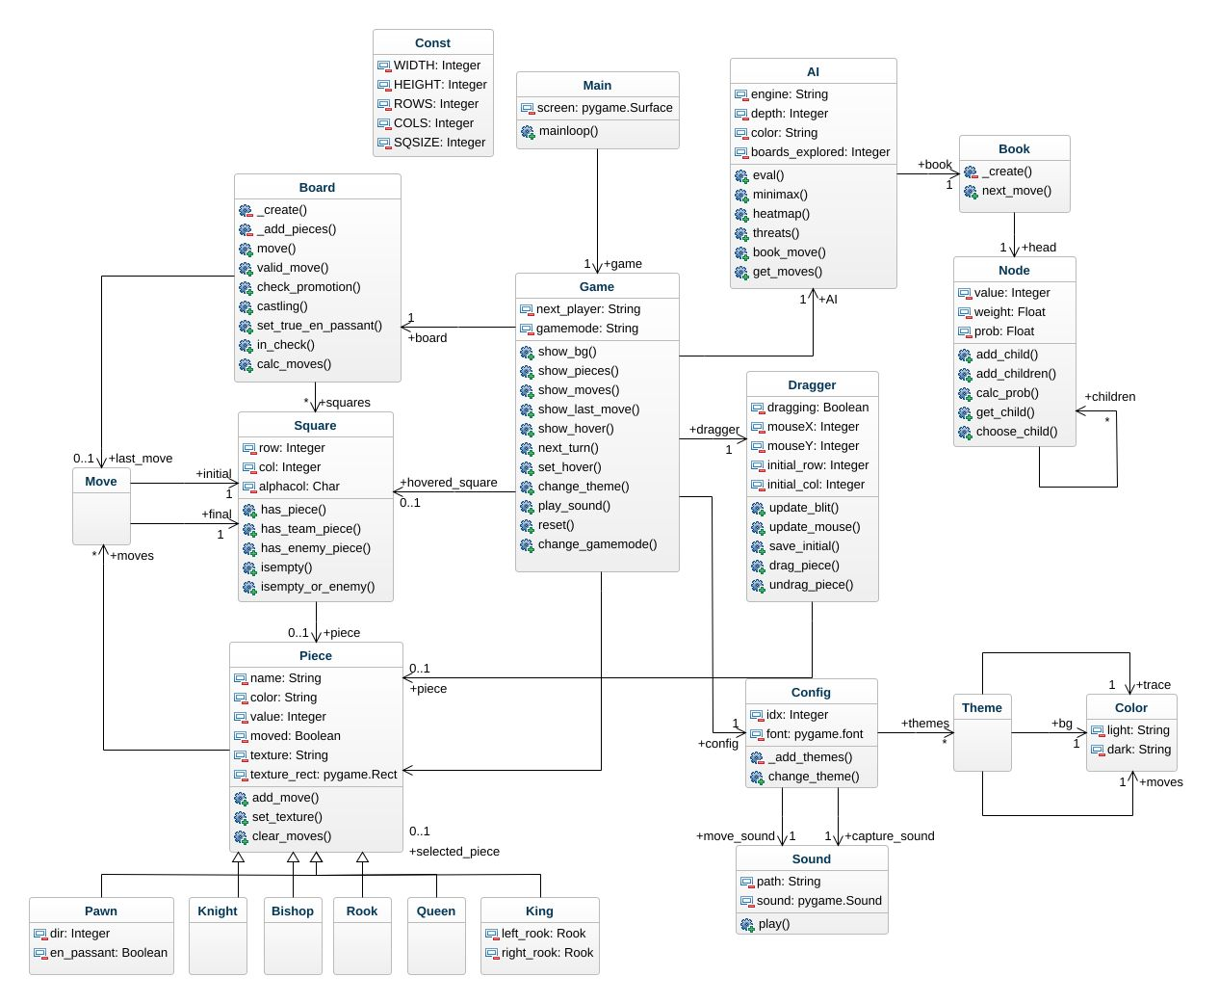
Figure 2: UML class diagram for Peter Chess Engine v6.3.1

4.4 Flowchart
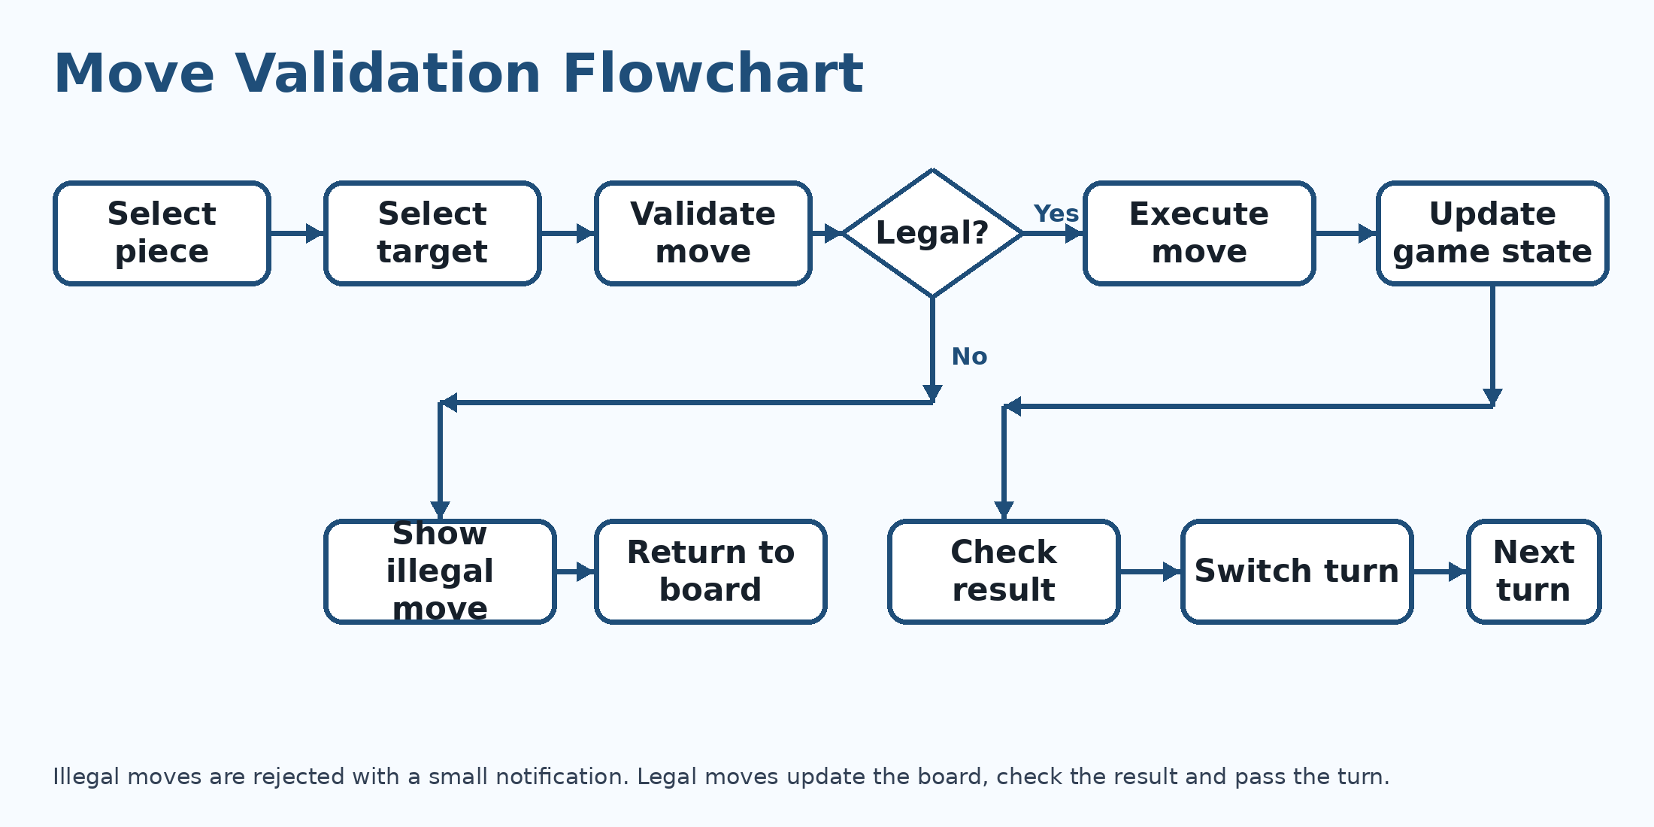
Figure 3: Move validation flowchart

4.5 Pseudocode
Move validation pseudocode:
IF the user selects a piece belonging to the current player THEN
highlight the legal moves for that piece
IF the user selects a legal destination square THEN
execute the move
clear planning arrows
update the clock and move history
check whether the king is in check
check whether the game ended by checkmate, stalemate, draw or timeout
switch turns
ELSE
display an illegal move notification
ENDIF
ENDIF

4.6 Wireframes and Interface Planning
Screen | Purpose | Final feature
Home screen | Allows the user to configure the match before it begins. | Mode, colour, time control and bot difficulty buttons.
Game board screen | Main live gameplay screen. | Board, player bars, timers, sidebar and settings cogwheel.
Settings menu | Contains match actions without cluttering the live screen. | Resign, restart match and return to home menu.
Game result pop-up | Clearly explains why a game ended. | Checkmate, timeout, resignation, stalemate or draw reason.
Review screen | Allows users to review the game after it ends. | Move history and replay controls.

The final interface screenshots below show the completed home menu, countdown screen and live gameplay layout with player tags, timers and side panel information.
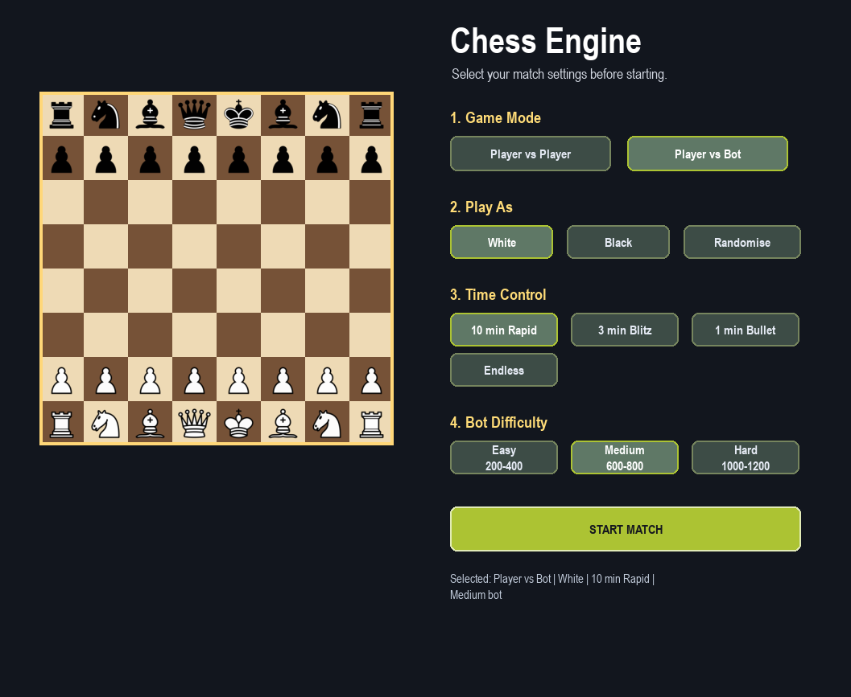
Figure 4: Home menu with mode, colour, time control and bot difficulty selection
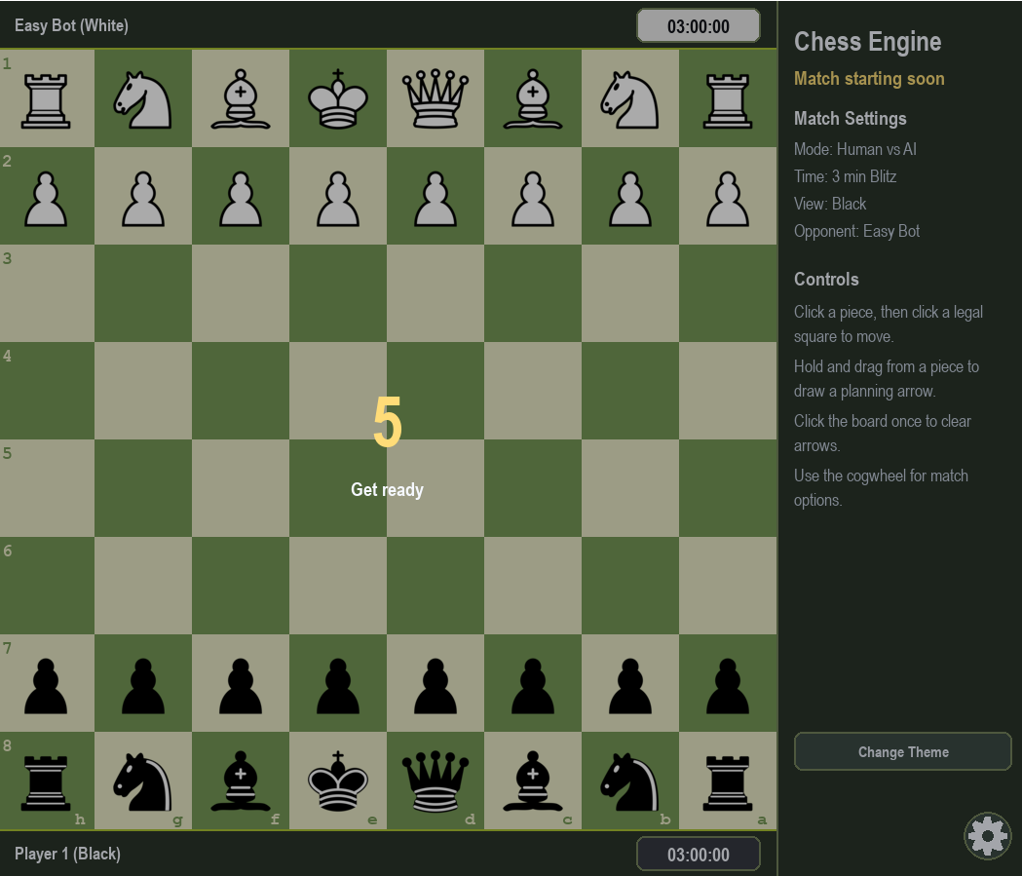
Figure 5: Five-second countdown before the timer starts
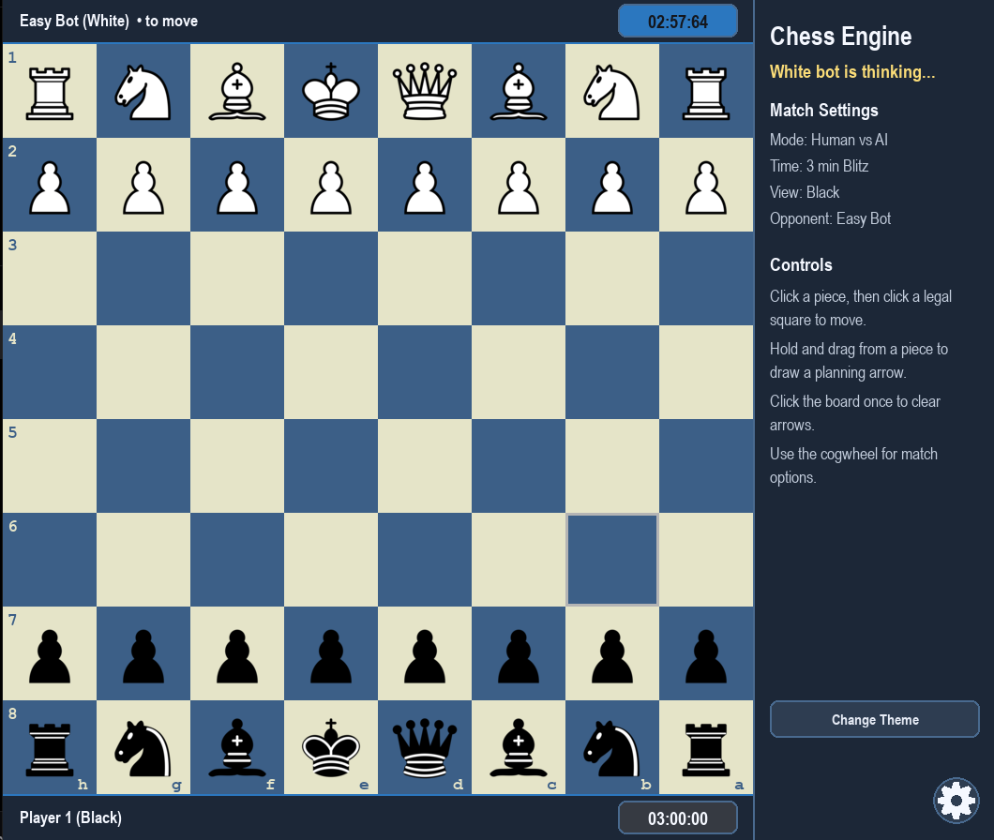
Figure 6: Live game interface with player bars, timers, side panel and theme colours

Section 5 - Directory Structure
The final folder structure separates source code, assets, tests, snapshots and documentation. This supports maintainability and makes the project easier to run on different devices.
Peter Chess Engine v6.3.1/
|-- assets/
| |-- images/
| |-- sounds/
|-- docs/
|-- snapshots/
|-- src/
| |-- main.py
| |-- game.py
| |-- board.py
| |-- piece.py
| |-- move.py
| |-- square.py
| |-- config.py
| |-- sound.py
|-- tests/
| |-- test_board_logic.py
|-- README.md
|-- requirements.txt
|-- .gitignore

Section 6 - Secure Programming
Although this is a desktop game rather than a web application, secure and defensive programming are still important. The final chess engine uses input validation, controlled game states and graceful feedback to prevent unexpected user actions from breaking the program.
Secure/defensive feature | How it is applied in the chess engine
Input validation | The program only accepts valid board selections and legal moves. Illegal moves trigger a small notification.
Exception awareness | Assets and sounds are stored in a clear folder structure to prevent missing-file crashes.
Race condition awareness | Bot move timing and clock timing were refined to avoid the interface freezing during bot turns.
Graceful failure | Invalid user actions do not end the program; they are handled through visual feedback.
No unnecessary authentication | The final app does not collect accounts or passwords, reducing privacy and security risk.
Clear user controls | Buttons and settings menu reduce misuse compared to hidden keyboard-only shortcuts.

Web-specific features such as CSRF protection, XSS prevention, SQL injection protection and password hashing are not required because the final version is a local desktop pygame application, not an online database-driven system.

Section 7 - Testing

7.1 Unit Testing Plan
Test area | Example test | Expected result
Board setup | Start a new game. | All pieces appear in correct starting positions.
Legal move | Move a pawn one or two squares from starting position. | Move is accepted if legal.
Illegal move | Attempt to move a piece to an invalid square. | Move is rejected and notification appears.
Check indication | Place a king in check. | King square is highlighted.
Timer | Start Rapid, Blitz or Bullet mode. | Timer counts down and ends game on timeout.
Endless mode | Start Endless mode. | No clock limit is applied.
Bot move | Play in Player vs Bot mode. | Bot responds after the correct delay range.
Post-game review | Finish a game. | Review mode appears with move history and replay controls.

7.2 Manual Testing Evidence
Feature tested | Tester feedback or issue | Improvement made
Home menu | Game previously started immediately. | Home menu added so users select settings first.
Controls | Dragging pieces was less friendly for beginners. | Click-to-select and click-to-move were added.
Bot timing | Bot moved too quickly and timer barely changed. | Thinking delays were added for each difficulty.
Bot freeze | Game froze while bot calculated moves. | Bot calculation/performance was refined.
Game result | Timeout or win condition was unclear. | Result pop-up now explains the reason.
Sidebar UI | Right panel was crowded. | Player tags and timers moved above/below board.
Settings button | Original icon looked like a sun. | Final app-style cogwheel icon was added.

7.3 Edge Cases
Edge case | Expected behaviour
Illegal move | Move is rejected and the game continues.
King in check | The king is visually highlighted.
Checkmate | Game ends and win condition is shown.
Stalemate | Game ends as a draw with reason shown.
Timeout | Player with remaining time wins and reason is shown.
Resignation | Opponent wins and reason is shown.
Bot no legal moves | System identifies checkmate or stalemate rather than crashing.

Section 8 - GitHub Management
GitHub is used to store the final project, support version control and provide evidence of file management. The final repository should include the project folder, README, requirements file, source code, assets and testing files. Repository link: https://github.com/Peter-Trinh55/Chess-Engine
Evidence | Target
Repository link | Add to cover page and PowerPoint title slide.
Commits | Use meaningful commit messages for major feature changes and documentation updates.
README.md | Explain how to download and run the project on Windows and macOS.
requirements.txt | List pygame as the required library.
.gitignore | Exclude unnecessary system files such as .DS_Store and cache folders.
Testing file | Include test_board_logic.py or other relevant tests.

If some development was completed locally before GitHub upload, this should be explained in the logbook and reflection. The repository still provides evidence of the final organised project and file structure.

Section 9 - Logbook and Version History

9.1 Version History Summary
Version group | Title summary
Modified Chess Engine | Core AI + Review Update
v2 Menu Timer | Home Menu + Timer Update
v3 | File Rename Update
v4 | Game-End Screen Update
v5 | Planning Arrows Update
v5.2 - v5.4 | Controls, Check Indicator, Bot Lag + Timer Performance Update
v6 - v6.3 | Difficulty Rebalance, Endless Mode, UI + Settings Menu Update
v6.3.1 | Final Cogwheel Icon Update

9.2 Logbook Draft
Date | Task completed | Hours | Challenge | Reflection
[Add date] | Set up original pygame chess engine. | [ ] | Getting the project running on local device. | Confirmed base engine could be modified.
[Add date] | Added home menu and match settings. | [ ] | Preventing game from starting immediately. | Improved user control before gameplay.
[Add date] | Added bot difficulties and timers. | [ ] | Balancing timing and difficulty. | Bot play became more realistic.
[Add date] | Added click-to-move, check indicator and illegal move notices. | [ ] | Making controls beginner friendly. | Improved usability and feedback.
[Add date] | Improved UI layout and added countdown. | [ ] | Right panel was too crowded. | Moved timers and player tags to board edges.
[Add date] | Finalised settings menu and cogwheel icon. | [ ] | Icon needed to be recognisable. | Final UI became cleaner.
[Add date] | Prepared documentation and presentation evidence. | [ ] | Making evidence match final version. | Final documentation should reflect v6.3.1 only.

Section 10 - Reflection

10.1 Challenges
Challenge | How it was addressed
Bot difficulty was hard to balance. | Easy, Medium and Hard behaviours were adjusted through testing and feedback.
Bot movement caused lag or freezing. | Performance was improved so the interface and timers remained responsive.
Users needed clearer controls. | Keyboard-heavy controls were replaced with buttons and click-to-move.
Game-ending reasons were unclear. | A result pop-up was added to explain timeout, checkmate, resignation or draw.
The interface was crowded. | Timers and player tags were moved above/below the board and actions moved into settings.

10.2 Final Reflection Draft
This project demonstrates software engineering because it required planning, modular code changes, testing, feedback, version control and documentation. The final chess engine evolved from a basic pygame chess project into a more complete application with menus, timers, bot difficulties, post-game review, planning arrows and a cleaner interface. The most important lesson was that software quality is improved through iteration. Each test run revealed usability or performance issues that could be fixed in the next version.

10.3 Future Improvements
Improvement | Purpose
Stronger engine logic | Further improve bot strength and reduce unrealistic blunders.
Opening book | Make bot openings more realistic.
PGN export | Allow users to save and analyse games outside the app.
Executable build | Let users run the game without opening VS Code.
Online multiplayer | Allow users to play across different devices.
Advanced review scoring | Add accuracy, mistakes and blunder labels after the game.

Section 11 - AI and Source Acknowledgement
This section should be checked before final submission. Any external code, tutorials, AI assistance, generated images, libraries or teacher feedback should be acknowledged clearly.
Source/tool | Use | Modification/verification
Original pygame chess engine/tutorial project | Used as the base project to modify. | Final project was extended with menus, bots, timers, UI changes and review features.
AI assistant | Helped draft documentation wording and plan feature changes. | Student reviewed and tested the final project before submission.
pygame | Used to create the desktop window, graphics, sounds and input handling. | Installed through pip and tested on Windows/macOS.
Teacher/client feedback | Informed required documentation and assessment criteria. | Used to organise sections and evidence.
Peer testing | Identified UI, bot timing and usability issues. | Feedback was used to create later versions.

11.1 Copyright Acknowledgement
The following table acknowledges the main third-party tools, libraries and assets used in the final chess engine. Copyright remains with the original creators and organisations.
Source/tool | Copyright acknowledgement and use
Python | Owned and maintained by the Python Software Foundation and contributors. Used as the programming language and runtime.
pygame | Created and maintained by the pygame community and contributors. Used for graphics, input handling, sounds and the desktop window.
Original pygame chess engine/tutorial project | Original creator(s) retain copyright over the base project. It was modified with menus, timers, bot difficulties, review features, planning arrows and UI changes.
Chess piece images and sound assets | External assets remain the property of their original creators unless created by the student. Used for piece graphics and move/capture sounds.
VS Code, Git and GitHub | External development and version-control tools. Used for coding, testing, repository storage and project evidence.
AI assistant support | Acknowledged as a support tool for planning, documentation and debugging guidance. Final testing, editing and submission responsibility remains with the student.
Note: Any extra third-party images, sounds or copied code should be checked and acknowledged before final submission.

Section 12 - Appendices

Appendix A - Evidence Checklist
Requirement | Status
Final version is clearly named v6.3.1 | Completed
README explains Windows and macOS running instructions | Completed
Project includes source folder and assets | Completed
Project includes testing folder | Completed
GitHub link added to cover page | Completed
Screenshots of final interface added | Completed
Presentation slides align with final project | To complete
Teacher/client consultation evidence added | To add

Appendix B - Final Interface Screenshots

Screenshot 1: Home menu showing final match settings options

Screenshot 2: Countdown screen before the clock starts

Screenshot 3: Live gameplay interface with timers and side panel
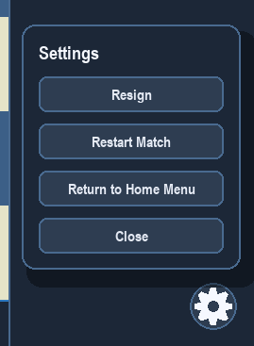
Screenshot 4: Settings menu opened from the final cogwheel button
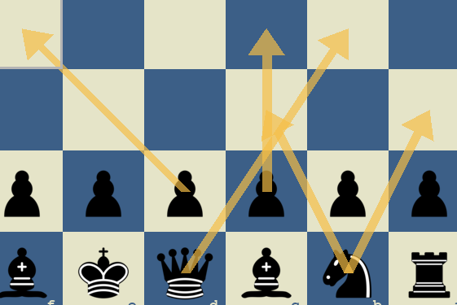
Screenshot 5: Planning arrows used for visual move planning
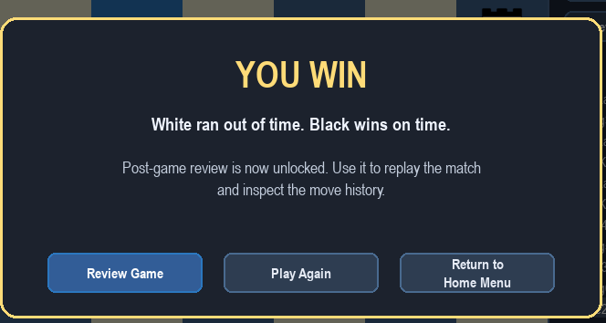
Screenshot 6: Game result pop-up explaining the win condition
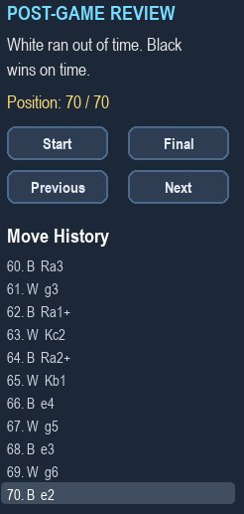
Screenshot 7: Post-game review with move history and replay controls

