Meetjestad! station repair checklist

By: Peter-dM
Contributions by: Teus Hagen

Introduction

Purpose
When you have a broken Meetjestad! station, this document lists possible actions for repair.

PCB version
At https://github.com/meetjestad/mjs_pcb/releases you can see which version of the PCB you have.

Tools
The tools that, depending on your IT and electronic skills, you can use for troubleshooting, are listed in chapter 5.

Contact
Meetjestad repair contact:
Diana Wildschut, meedoen@meetjestad.nl

Operation history

Check the meetjestad website
Check URL e.g.: https://meetjestad.nl/data/sensors_recent.php?sensor=2000&limit=50 if your station ID is 2000.
Column “Time” shows when a measurement was received from the station the last time.
Column “Voltage” shows the most recent (battery and) supply voltage.
Nodes 1-1999 should have a battery voltage of around 4.0 V and a (supply) voltage of 3.3 V.
Nodes 2000++ should have a battery voltage of around 4.0 V and a (supply) voltage of 3.0 V.
Note:
Most v4 and v5 stations (station ID 2000++) also have a web page showing graphs of the voltages over time, e.g. https://meetjestad.nl/static/graphs/batt/index_batt_2002.html, if your station ID is 2002.
If the station has a solar panel these graphs also show the solar panel voltage (dark orange).
They also show the solar activity (light orange).

Supply testing

Unbox
Remove the top from the holder (weerhut) (if you have a solar panel, note the wire connecting it),
gently shift the circuit board up (you need to rotate it a bit), and take the circuit board out.

Unloaded (onbelast) battery testing
Measure the unloaded battery voltage with a multi-meter.

For discharge-only batteries, this voltage should be between 4.5 and 3.6 V.
If the voltage is lower then 4.0 V, replace the batteries (with discharge-only batteries).

For rechargeable batteries, this voltage should be between 4.2 and 3.6 V.
If the voltage is lower then 4.0 V, check the solar panel.
In daylight or when you shine a bright light on it, it should charge the batteries with at least some mA.
Rechargeable batteries can be revived by discharging and charging them several times.
Some battery chargers support discharge-charge cycles.
All batteries for a station should be of the same type, brand and capacity (mAh).

Battery testing under load
Take out the batteries from the container and measure their resp. voltages with a battery tester that applies a current load to a battery.
Each voltage should be at least 1.20 V or 80% of full scale.
Also the voltages of all 3 batteries should be approximately equal.
Replace all 3 batteries if necessary.

Test voltages under load
Shortly load the batteries with a 33 Ohm 1W resistor.
Note: when applied longer, the resistor may become hot.
For a v1 station, under load, their voltage should be at least 3.3 V.
For a v2 station, their voltage should be at least 3.0 V.
If the voltage is too low:
- Check the battery holder’s contacts for corrosion. They might be not shiny enough.
- Check the battery’s contacts.
  - If they are covered with white powder, remove the white powder carefully and replace the batteries and the battery container.
  - If they are corroded, polish or replace the corroded parts.
- Check that the the batteries make good electrical contact.
You can bind a binder or wire around the container so that the battery contacts are firmly attached to the holder contacts.

Operational voltages - explanation
Every 15 minutes the station awakes from sleep.
It gathers measurement data and uploads the data to the Meetjestad! website.
The station’s components use the following amounts of current:
- GPS: ca 50 mA for a few to maximally 120 secs, once per 24 hours
- PM-sensor: 80 mA for ~ 10 secs at every upload
- LoRa: 120 mA, for ~ .3 secs with every upload .
This is a substantial amount of current to be delivered by 3 small batteries.
Due to the current, the battery voltage can drop to such a low voltage that the station may stop to function.
Note:
A simple multimeter might be unable to show the battery voltage during short times.

Connection testing

Connectors
Check the following connectors:
- Si7021 temperature sensor
Check that the Si7021 was placed correctly. The contacts might have gotten corroded.
- SPS30 PM-sensor
The connector cable for the SPS30 PM sensor is very fragile.
Check with a bright light and a magnifying glass if all wires are firmly connected.
Spare connector cables are available, to re-solder one or more contacts is quite a challenge.
- 6-pin and USB-C programming connector
The 6-pin programming connector can also get corroded.
This can make re-programming error-prone or even impossible.

Antenna:
- Check the length of the antenna; it should be a bit shorter then 8.7 cm.

Notes:
- Make sure you have a proper antenna when you power up or reboot the station !
- I suggest that, when you take the station out again, you cover any unused connectors, including the USB-C connector, with a dummy, to prevent corrosion.

Soldering
If you are familiar with electronics, you can check the solder points, including those for the RFM95 LoRa transceiver, for corrosion.
If there is, you can remove solder with a tin sucker (tinzuiger) and apply new heat and/or new solder.

Electronic circuit diagrams can be found at https://github.com/meetjestad/mjs_pcb/releases

Tools

Hand tools
Recommended tools for beginners (in order of priority):

- Web browser
URL e.g.: https://meetjestad.net/data/sensors_recent.php?sensor=2000&limit=50 if your station ID is 2000.

- 2.54 mm female pin jumper
To bridge the reset pins when you need to enforce a reset

- Multimeter (universeelmeter)
To measure power supply and other voltages (no load)
To measure solar panel charge current

- Battery tester
To measure a battery’s voltage under load
Also some multimeters have this option.

- Connection wires with hooks
E.g. to connect the load resistor with the battery case connections.

- Resistor 33 Ohm 1 W (orange, orange, black)
To load (belasten) the batteries

- Bright light
To inspect possibly moisted and corroded contacts and soldering

- Magnifying spectacles (bril) or glass (loupe)
To inspect possible moisted or corroded contacts.
Magnifying glasses are sold @NL in e.g. the Hema department store .

- Binding wire or straps/tie-wraps
To contain batteries firmly in their holder

Status indicator light
The v1 station has a small red light that blinks shortly at reboot.

The v2 station has a light indicating what the station is doing at the moment.
Colors are in order of occurrence:
- red, while waiting for USB/Serial (max 10s)
- orange, while doing initial sensor readings
- yellow, while waiting for TTN activation
- cyan, while waiting for a GPS fix
- purple, while reading the SPS030 sensor
- blue, when doing LoRaWAN transmission
In all other situations (including when sleeping, which will be most of the time), the LED is off to save power.

IT tools
Recommended tools for people with an IT background:

Cables needed for v1 stations:
- USB-A to USB-A extension cable
- USB-A-to-serial (TTL) dongle, e.g. CP2102, use 5V setting
- 6-pin female-to-female adapter (preferred) or 6-wire Dupont cable
check that the serial connection is swapped;
dongle-RX connects to PCB-TX and dongle-TX to PCB-RX.
- Use colored cables! E.g. red for +5V, black for ground.
Cable needed for for v4-v5 stations:
- USB-A to USB-C extension cable

Install on your laptop:
- Since library setups for v1-v3 and v4-v5 slightly differ, I recommend creating separate login users for
  - v1 (stations 1-1999), e.g. ard_mjs3
  - v2 (stations 2000++) , e.g. ard_mjs4.
- the Arduino IDE, most recent version 1.8.16 is working OK for this
- the Meetjestad firmware zipfile, for each user, it contains the libraries.
- DON’T upgrade any libraries after that !
- Get familiar how to use the Arduino IDE, how to get it into programming mode, and how to reset the controller and replace the firmware code.
Note:
- Usually first time things go wrong, so be patient.
- Once an environment is running OK, DON’T make any unnecessary changes to it anymore !

Programming tools
The v1 Meetjestad! stations follow the Arduino IDE conventions closely.
@Linux, the serial dongle port = e.g. /dev/ttyUSB0, and your ard_mjs3 and ard_mjs4 users must be a member of the dialout group.
@Linux, lsusb lists the serial dongle e.g. as “CP210x UART bridge“

The v2 stations can be programmed as follows:
- press “Boot”; the USB (@Linux e.g. /dev/ttyACM0) should reactivate
- connect the programming jumper (near the “Boot” button)
- press “Boot” again
- @Linux, lsusb should now show: “STMicro electronics STMdevice in DFU mode”
- start the Arduino IDE compiler, followed by upload
- when that is uploading, gently remove the jumper
- you might need to press “Boot” again

Program debugging
The v1 stations have the Arduino Serial via the 6-pin connector and USB for debugging.
Set DEBUG to true.
Some ATMEL328Ps give issues when being programmed serially.
This might be caused by a deviation of the internal clock oscillator frequency.
In that case, the ATMEL328P can be programmed via SPI using e.g. an USBasp.
In case the station doesn’t respond to a reset, the reset can be applied to ATMEGA328P pin 1 directly, the connectors might be corroded and need replacement, or the soldering needs to be refreshed.
In case the station seems to hang e.g. after listing EEPROM contents, check the sensors.
A broken sensor might hang the station.

The v2 stations can use the USC-C port or Serial1, a separate 6-p pin connector.
Using either USB-C or Serial1 can be set in the Arduino IDE.

Library debugging
If you would wish to write debug code to the libraries, be aware that they can be located in the libraries directory, in directory ~/.arduino15 or at your laptop’s generic Arduino install directory.
Also libraries might (multiple) include other libraries in an order of that might not be straightforward.
Note:
When you restore original libraries, make sure you touch their files or they might not be re-compiled and re-linked again !

Electronic tools
The following electronic tools can be used for troubleshooting:
- Arduino Uno SPS30 test unit
- Arduino Mini Pro Si7021 test unit
- USB UART dongle with matching connector to the v1 GPS
and the following optionally:
- Arduino Mini Pro 3.3V + Meetjestad ATmega328p programmer
for setting the ATmega328p fuses and EEPROM
- Arduino UNO + DIYMORE AVR ISP shield
for setting ATmega328p fuses
- USBasp + DIYMORE AVR shield for writing the program code into flash via SPI, in case programming via serial has failed.
You will need the compiled binary code for this, not the source code.

TODO:
- Build new test equipment: battery loader with minimum voltage output.
- If things go wrong…. Where to give comments/improvements

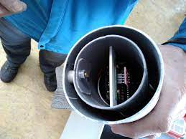Figure 1: Holder bottom view, circuit board rotated  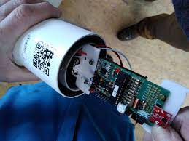Figure 2: Removing the circuit board from the holder | 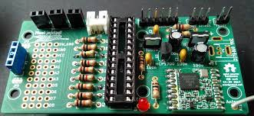  Figure 3: v1 circuit board without the ATmega328p controller  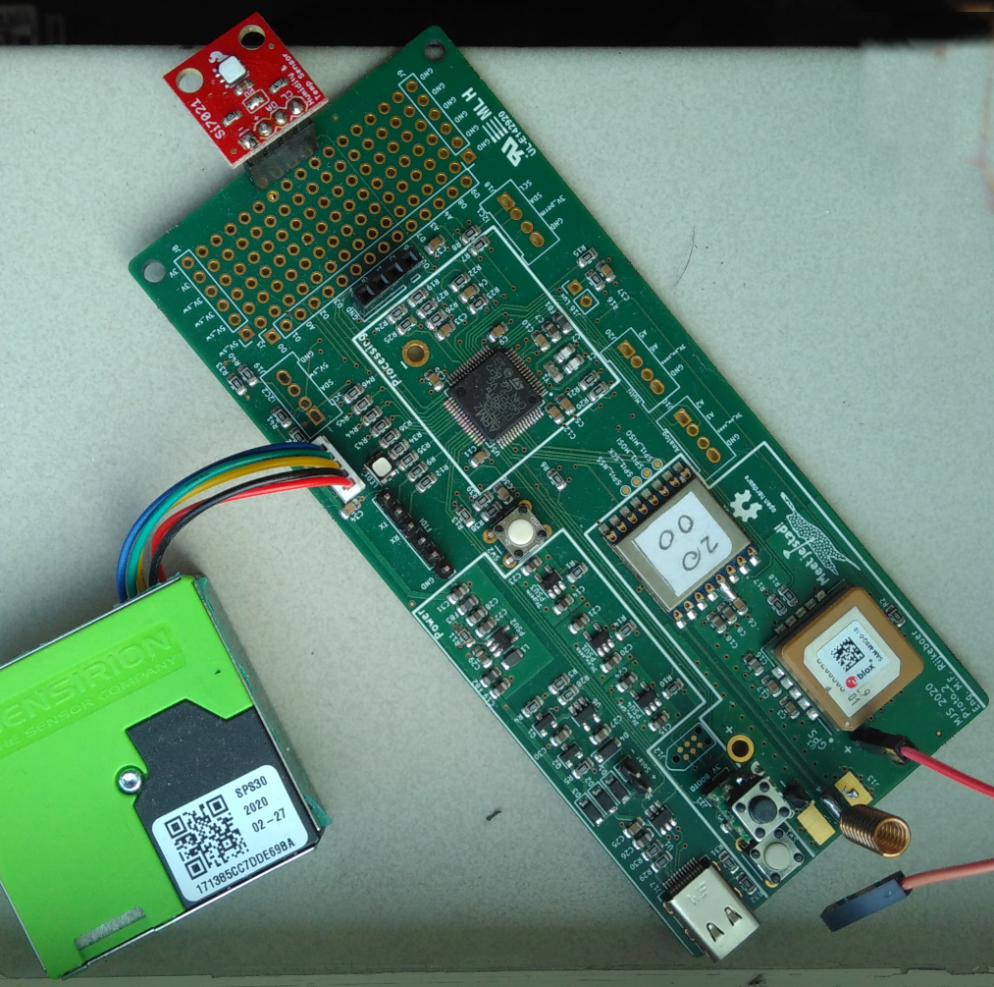  Figure 4: v4 circuit board with SPS30 PM-sensor
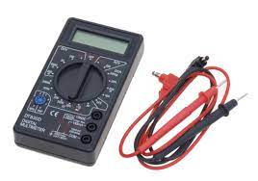
Figure 5: Multimeter
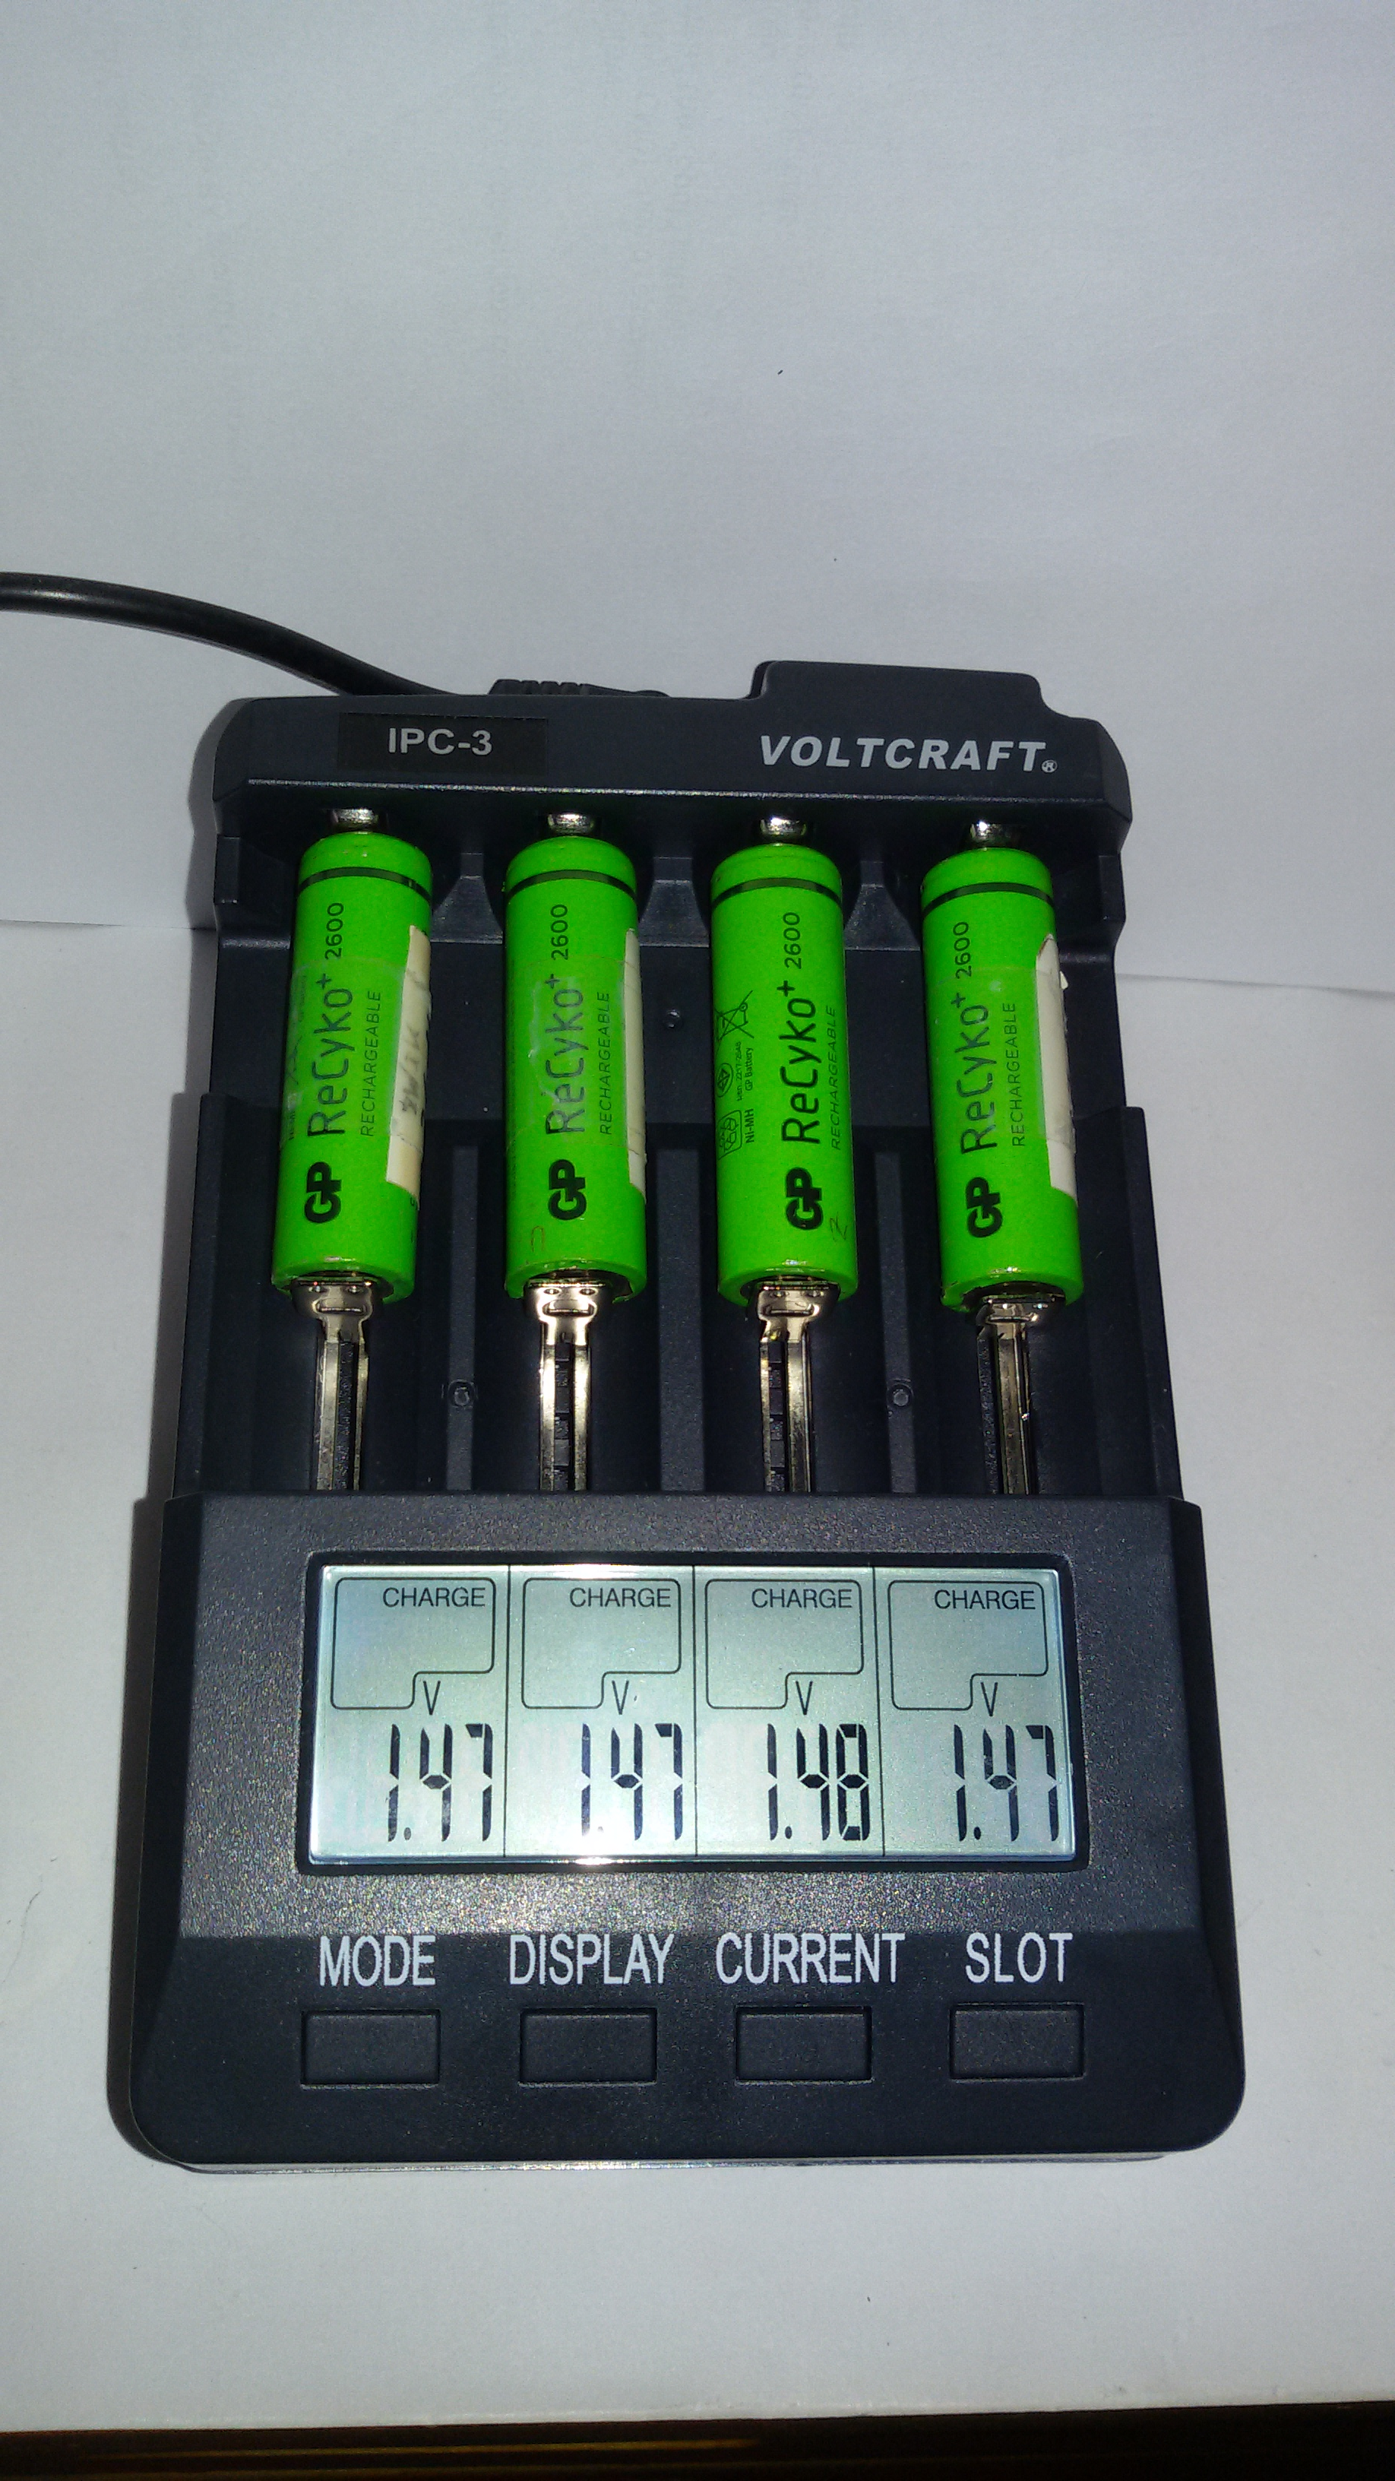  Figure 6: Battery charger and -tester | 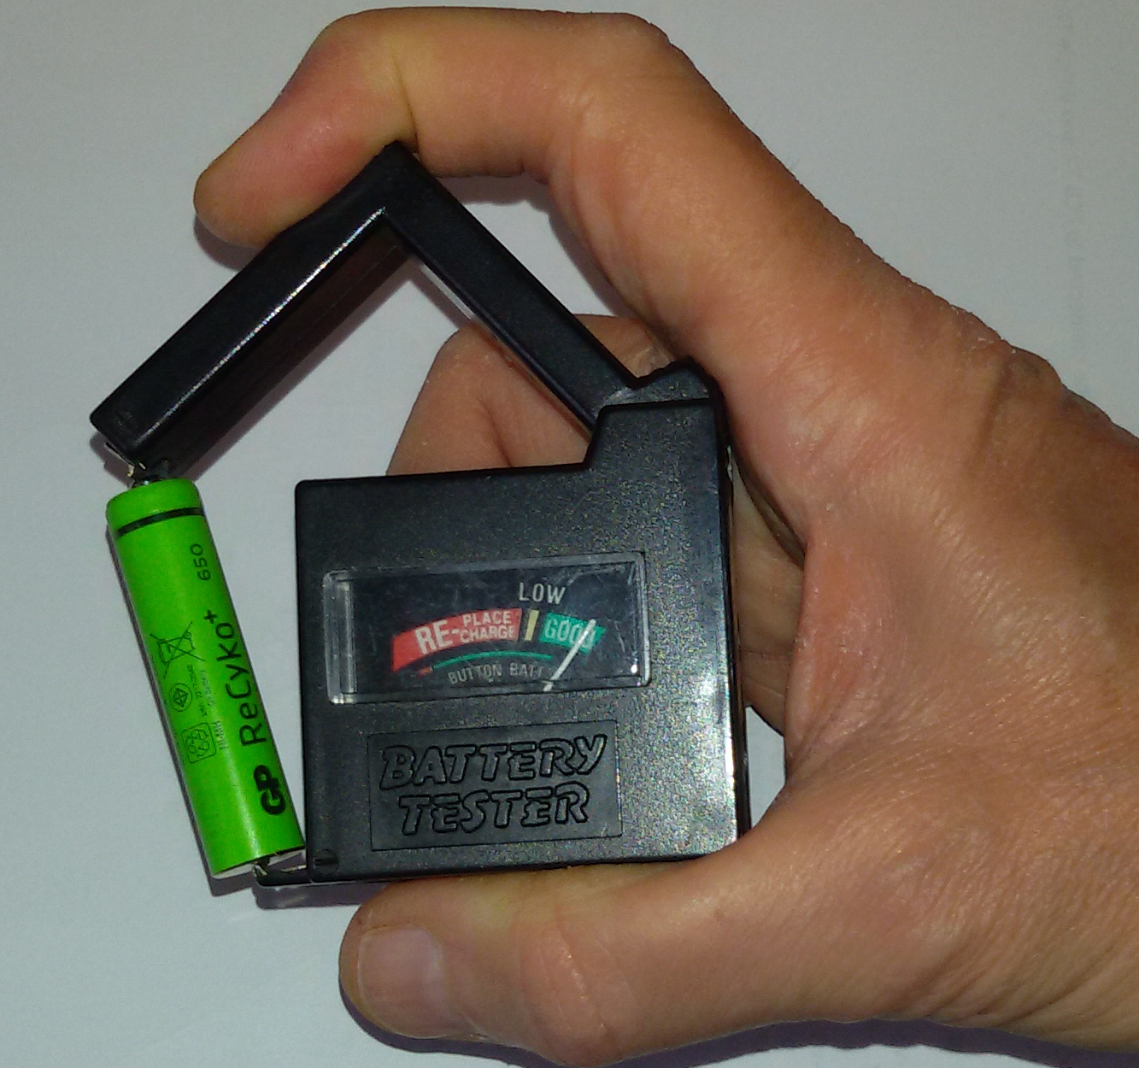Figure 7: Battery tester with built-in load
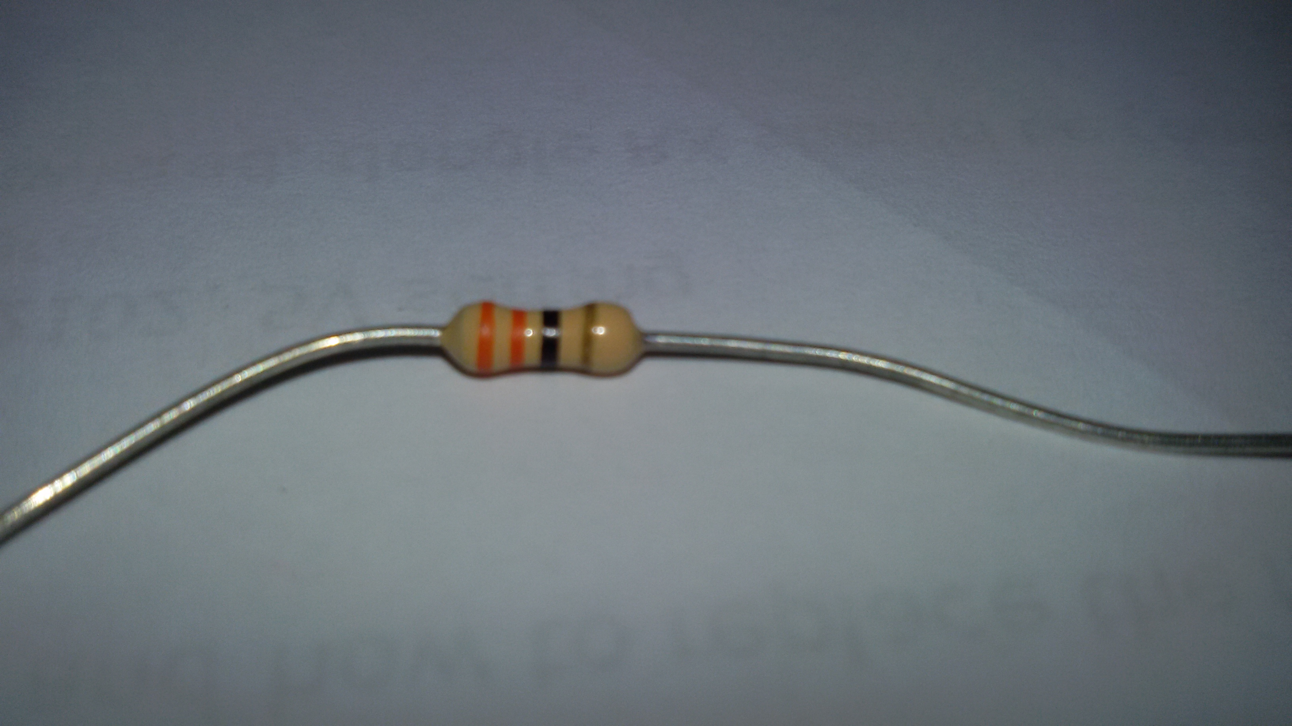Figure 8: 33 Ohm resistor | 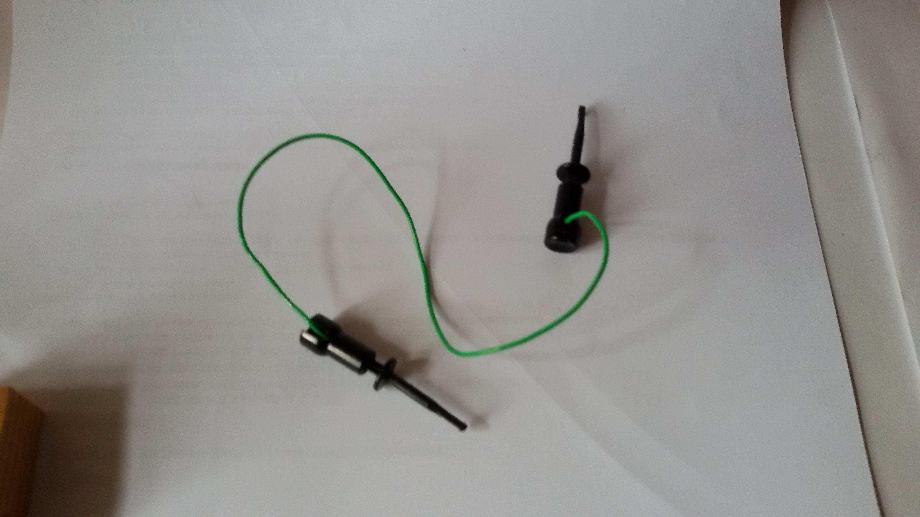  Figure 9: Wire with hooks to make ad-hoc connections
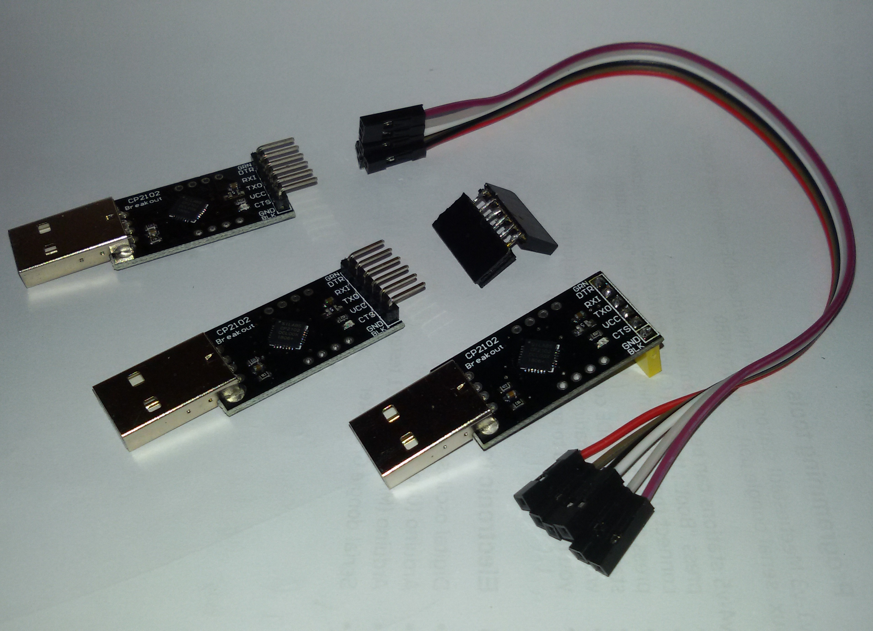  Figure 10: 3 ways to make a serial connection via USB  - CP2102 with 6-wire Dupont cable (not recommended)  - CP2102 with hand-made 6-pin female-to-female connector  - CP2102 with male pin connector replaced with female connector (yellow) (recommended) | 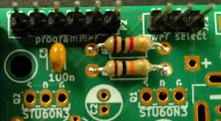 v1 circuit board under construction (detail):  Figure 11: top: the serial and power select pins
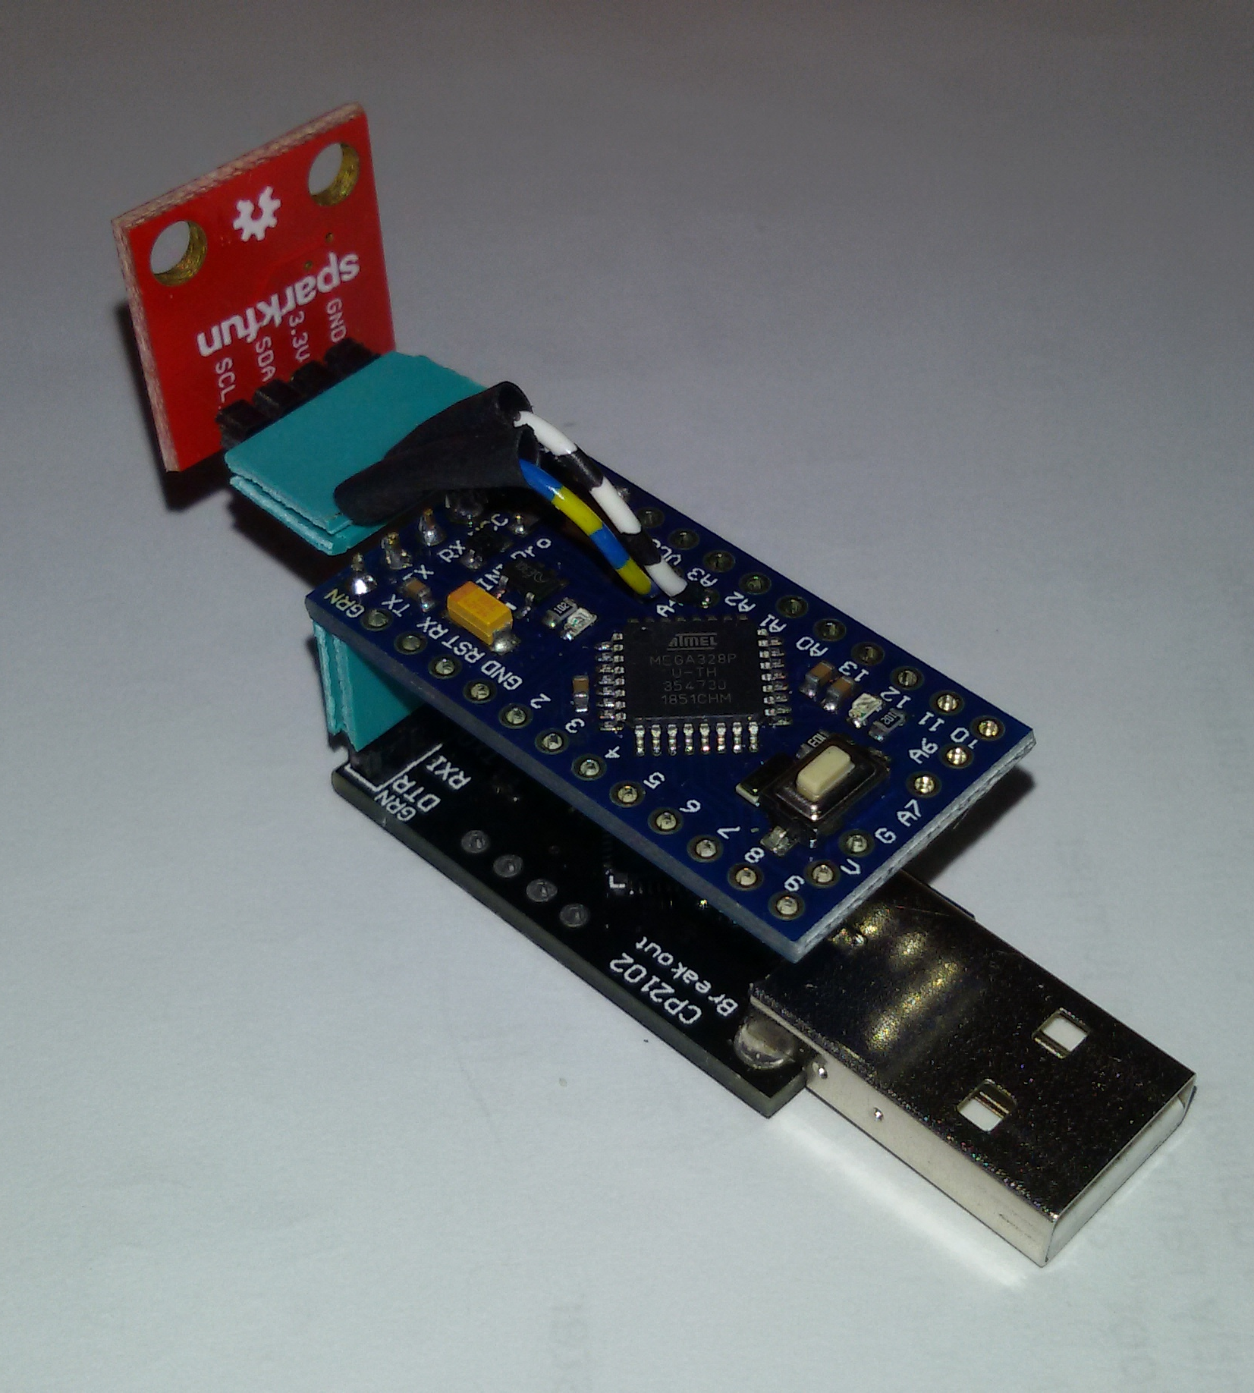  Figure 12: Hand-made Si7021 temperature sensor tester  using CP2102 (below) and Arduino Mini Pro on 3.3 V | 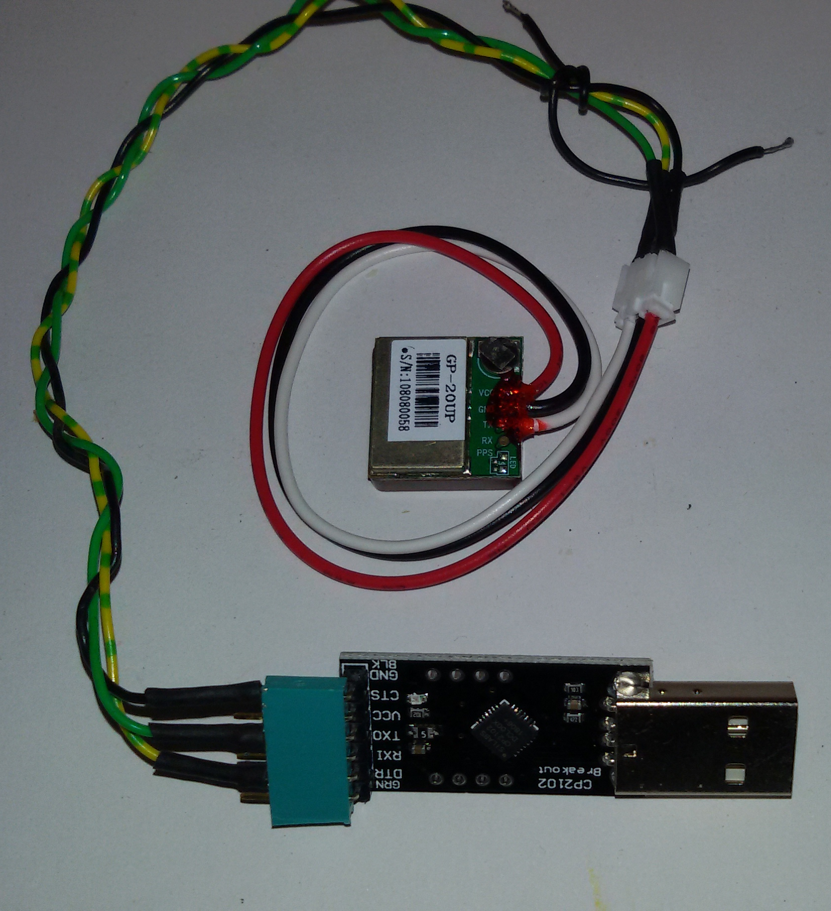  Figure 13: v1-v3 GPS sensor tester  using CP2102 USB-to-serial and matching connector.  Note: On the v4-v5 boards, the GPS sensor is attached to the board
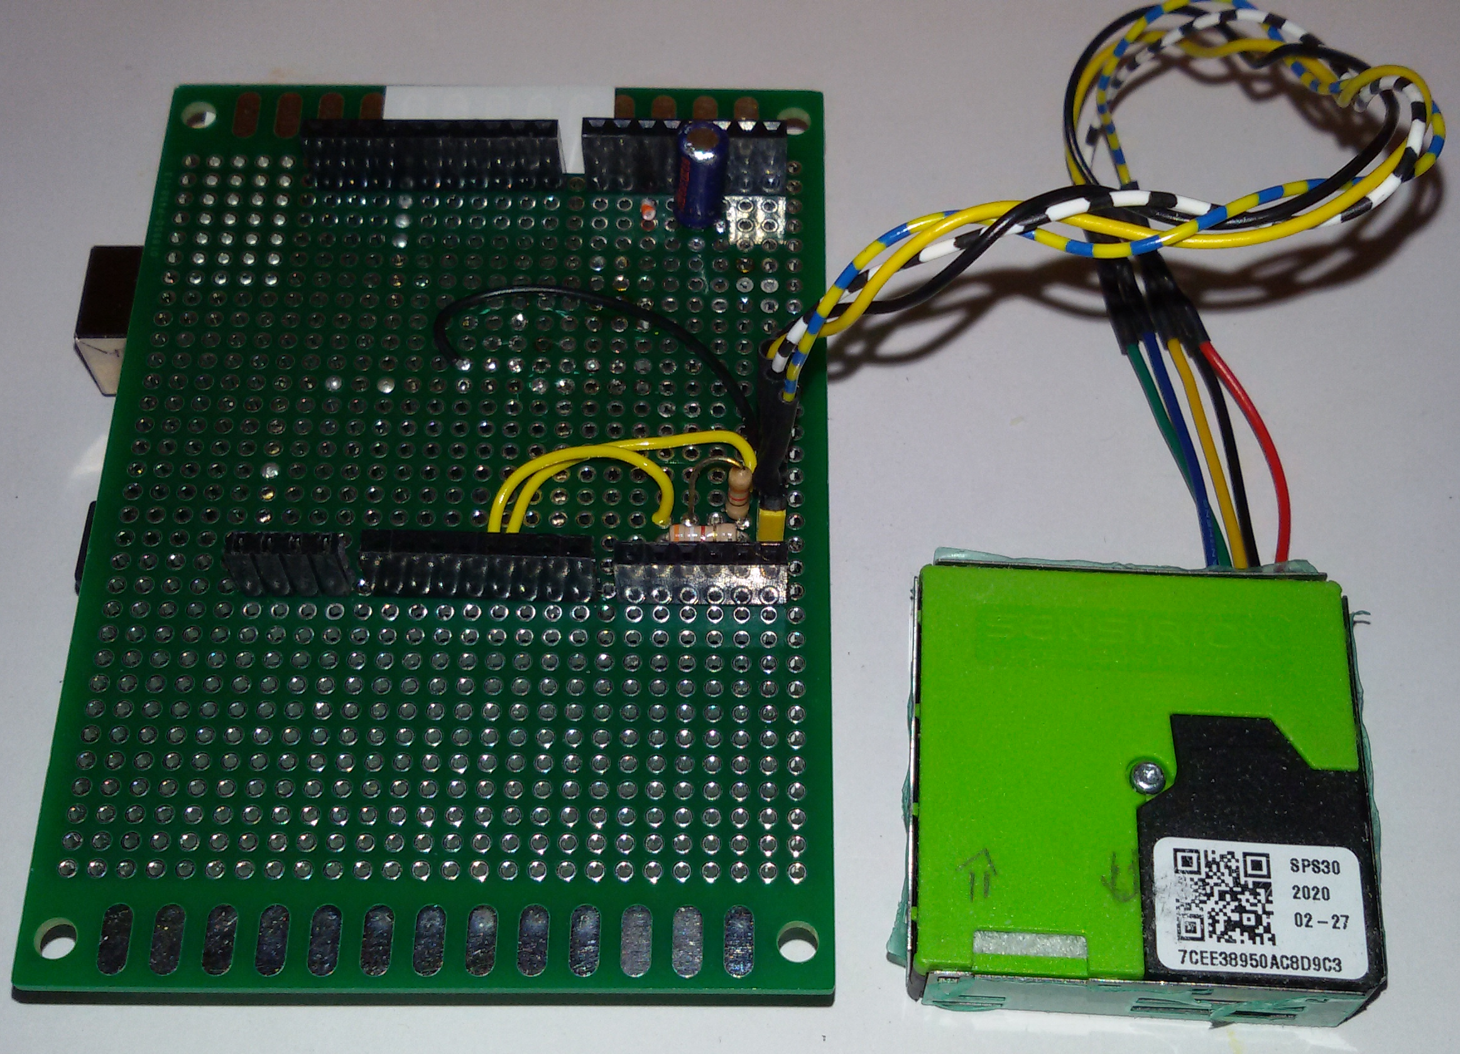
Figure 14: Hand-made SPS30 PM(fijnstof)-sensor tester
using Arduino Uno (hidden) and shield using 3.3V I2C
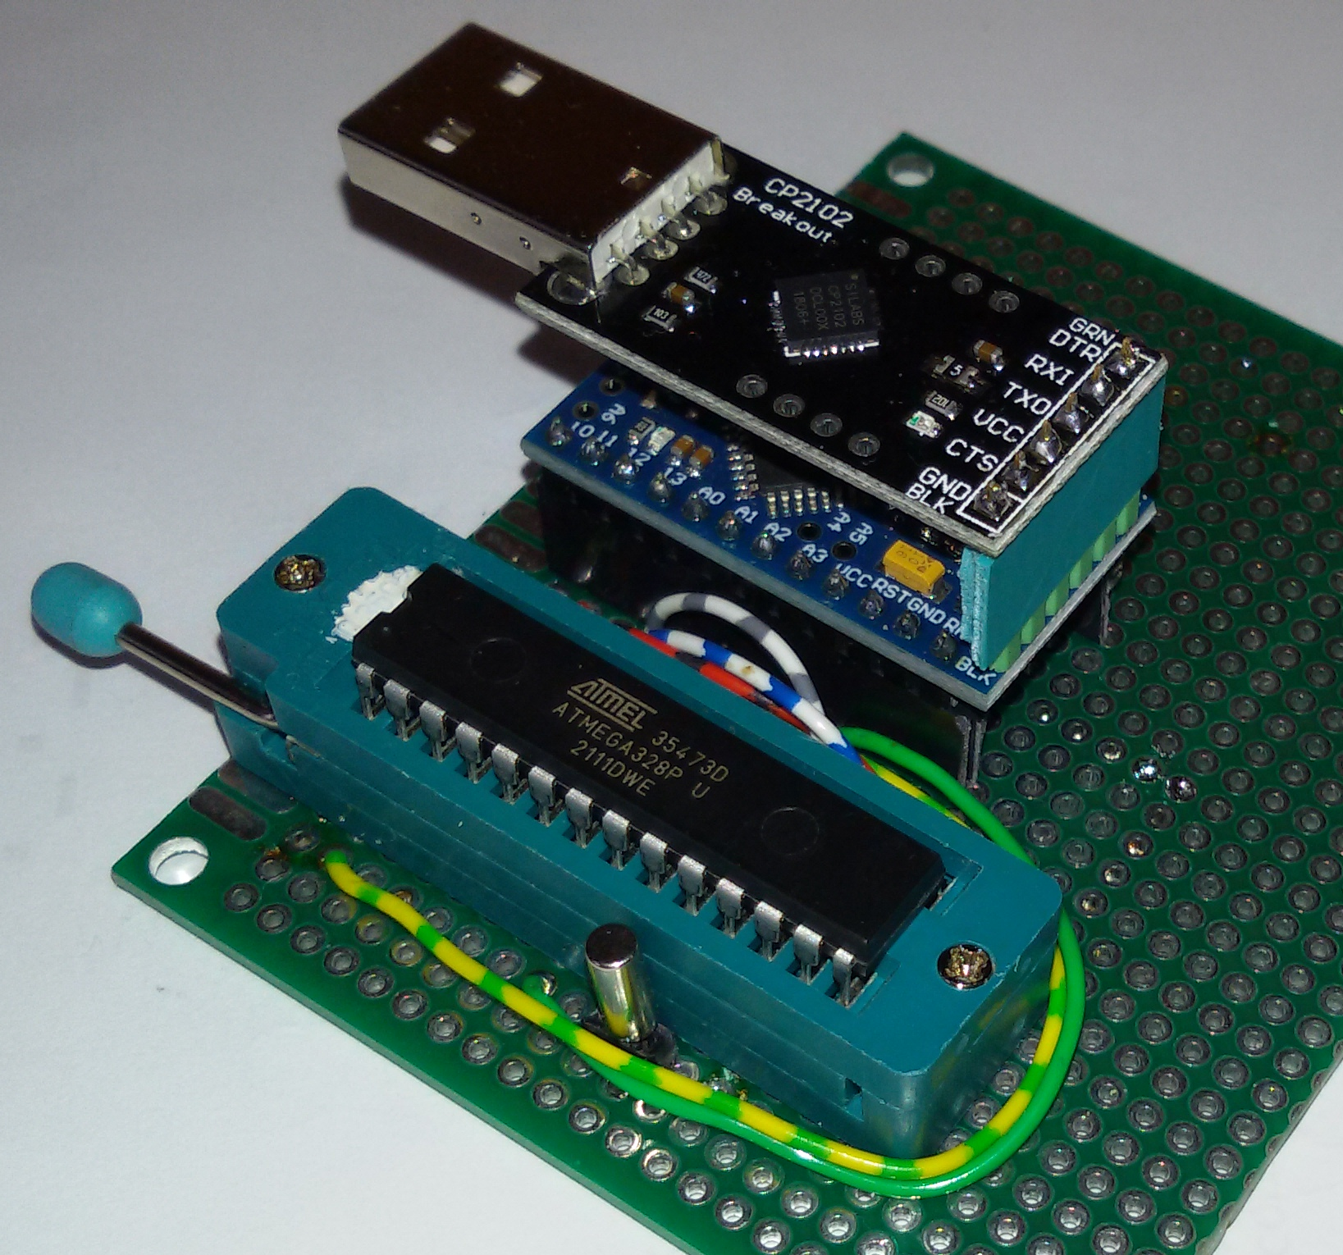  Figure 15: Hand-made Meetjestad ATmega328p programmer  using CP2102 on 3.3V and Arduino Mini Pro  Ref: https://github.com/meetjestad/mjs_programmer  (optional) | 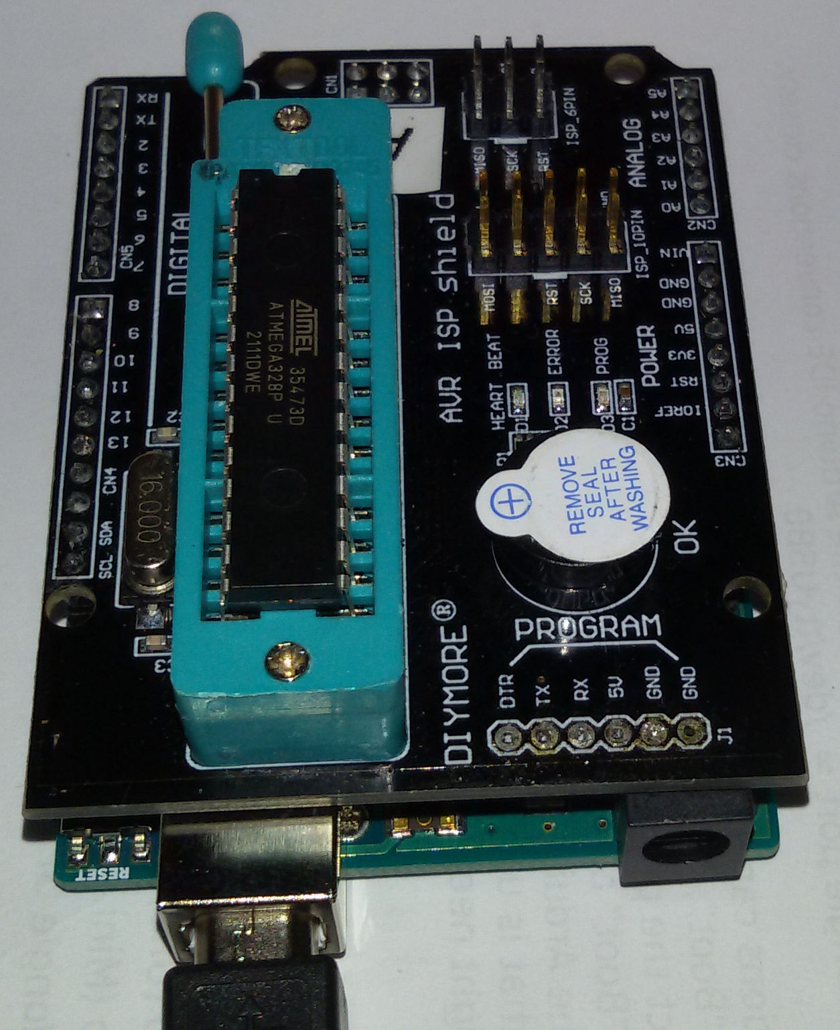Figure 16: ATmega328p fuse and EEPROM readout and control  using Arduino Uno and DIYMORE AVR ISP shield  (optional)

Table of Contents
1 Introduction 1
1.1 Purpose 1
1.2 PCB version 1
1.3 Tools 1
2 Operation history 1
2.1 Check the meetjestad website 1
3 Supply testing 1
3.1 Unbox 1
3.2 Unloaded (onbelast) battery testing 1
3.3 Battery testing under charge 2
3.4 Test voltages under load 2
3.5 Operational voltages - explanation 2
4 Connection testing 2
4.1 Connectors 2
4.2 Soldering 3
5 Tools 3
5.1 Hand tools 3
5.2 IT tools 3
5.3 Status indicator light 4
5.4 Programming tools 4
5.5 Program debugging 4
5.6 Library debugging 5
5.7 Electronic tools 5

Table of Figures
Figure 1: Battery charger and -tester 5
Figure 2: Holder bottom view, circuit board rotated 6
Figure 3: Removing the circuit board from the holder 6
Figure 4: v1 circuit board without the ATmega328p controller 6
Figure 5: v4 circuit board with SPS30 PM-sensor 6
Figure 6: Multimeter 6
Figure 7: Battery charger and -tester 7
Figure 8: Battery tester with built-in load 7
Figure 9: 33 Ohm resistor 7
Figure 10: Wire with hooks to make ad-hoc connections 7
Figure 11: 3 ways to make a serial connection via USB 8
Figure 12: the serial and power select pins 8
Figure 13: Hand-made Si7021 temperature sensor tester 8
Figure 14: v1-v3 GPS sensor tester 8
Figure 15: Hand-made SPS30 PM(fijnstof)-sensor tester 8
Figure 16: Hand-made Meetjestad ATmega328p programmer 9
Figure 17: ATmega328p fuse and EEPROM readout and control 9

.-.-.

Recently the firmware has been adjusted, so that no PM-sensor and GPS measurements are done below a certain battery voltage.
v4-v5 only
v2 only
Listed on https://github.com/meetjestad/mjs_firmware#board-status-through-led-color-mjs2020-only
I recommend using an adapter, my experience is that Dupont connectors wear out very quickly when applied to corroded pins.
https://www.arduino.cc/en/Tutorial/getting-started-with-ide-v2/ide-v2-downloading-and-installing
https://www.meetjestad.net/meten/files/arduino-bundle-v5.zip Detailed install instructions can be found at https://github.com/meetjestad/mjs_firmware.
https://github.com/meetjestad/mjs_programmer
https://forum.arduino.cc/t/avrdude-failing-to-program-a-barebones-atmega328p/559101 AVRDUDE failing to program a barebones atmega328p
On Ubuntu Linux, the command for this might look something like: /opt/install/arduino-1.8.15/hardware/tools/avr/bin/avrdude -C/opt/install/arduino-1.8.15/hardware/tools/avr/etc/avrdude.conf -v -patmega328p -cusbasp -P/dev/bus/usb/003/018 -b57600 -D -e -Uflash:w:/tmp/arduino_build_633056/mjs_firmware.ino.hex:i

