

**NAME: DANIEL KARANJA**

**REG NO.: SCT 222-0453/2017**

**COURSE: BSC. BUSINESS COMPUTING**

**UNIT: COMPUTER GRAPHICS AND ANIMATION**

**TASK: ASSIGNMENT**

1. **Consider the function y=sin(x) for the interval x[0,90].**

**Explain affine transformation required to map the graph of the function to a 640 by 480 screen**

**Answer**

Sx=A*X+B

Sy=C*+D

Therefore, A=sW/90,

B=0,

C=sH/1

D=0

1. **Develop an OpenGL function to plot the graph of the function in the interval x [0, 90].**

**Answer**

GLdouble A,B,C,D;

Glint sH, Sw;

sH=480;

sW=640;

void myDisplay(void)

(

A=sW/90.0;

B=0.0,

C=sH/1.0;

D=0.0;

glClear(GL_COLOR_BUFFER_BIT);

glBegin(GL_POLYGON);

Glint X;

For (X=0.0, X<=10;X=X+0.005)

{

glVertex2d(A*X+B, f(C*f(X)+D);

}

glEnd();

glFlush();

}

1. **Consider the translation and rotation operation below**





Develop composite matrices for two successive translations and two successive rotations

**Answer**

**Translation**

If we apply two successive Translations, then it is Composite Translation.

P’ = {T1. (T2. P)}

Suppose T1 is a translation with translation factors as tx1, ty1. While, T2 is a translation with translation factors as tx2, ty2.

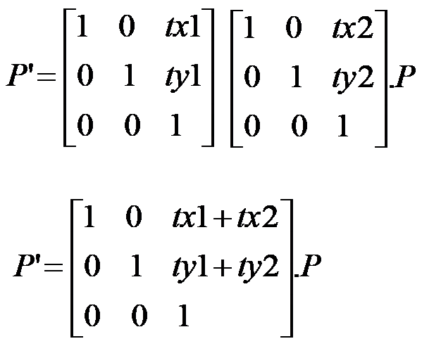

So, we can say that Composite Translations are additive. That is moving an object 10 units right and then moving it 5 units right is the same as moving an object 15 units right.

Rotation

Two successive Rotations can be applied on a single object.

P’ = R1. {R2. (P)}

