**VISVESVARAYA TECHNOLOGICAL UNIVERSITY**



Jnana Sangama, Belagavi, Karnataka – 590018

**An Internship report on**

**“PYTHON WITH MACHINE LEARNING”**

Submitted in partial fulfillment of the requirement for the INTERNSHIP of $7^{th }$ Semester Bachelor of Engineering in Computer Science and Engineering.

**SUBMITTED TO CSE DEPARTMENT**

**BY**

**7th Semester Student**

**SITESH ROY (1RI20CS048)**

**Under the supervision of**

**EXTERNAL GUIDE INTERNAL GUIDE**

**Mr. Sunil Kumar Prof. Lakshmidevi H M**

**Manager, Assistant Professor,**

**Karunadu Technology, Bengaluru Department of CSE, RRIT**



Department of Computer Science and Engineering

R.R. Institute of Technology

Bangalore, Karnataka, India-560090 2022-2023

# R R INSTITUTE OF TECHNOLOGY

#### CHIKKABANAVARA, BENGALURU – 560090

#### DEPARTMENT OF COMPUTER SCIENCE ENGINEERING

#### 



**CERTIFICATE**

This is to certify that the Internship entitled **“PYTHON WITH MACHINE LEARNING”** is a bonafide work carried out by **SITESH ROY** bearing **USN: 1RI20CS048** in partial fulfillment for the award of degree in Bachelor of Engineering in Computer Science Engineering from Visvesvaraya Technological University, Belagavi during the academic year 2023-24. It is certified that all the corrections/suggestions indicated for internal assessment have been incorporated in the report submitted in the department Library. This internship report (18CSS84) has been approved as it satisfies the academic requirements in respect of internship report prescribed for award of said degree.

|  |  |  |
| --- | --- | --- |
| ………………………….. | ...……………………..... | ………………………… |
| Signature of Guide | Signature of HOD | Signature of Principal |
| **[Prof. Lakshmidevi H M]** | **[Dr. Manjunath R]** | **[Dr. Mahendra K V]** |
| Assistant professor | Prof. and Head | Principal |
| Dept. of CSE, RRIT | Dept. of CSE, RRIT | RRIT, Bangalore |

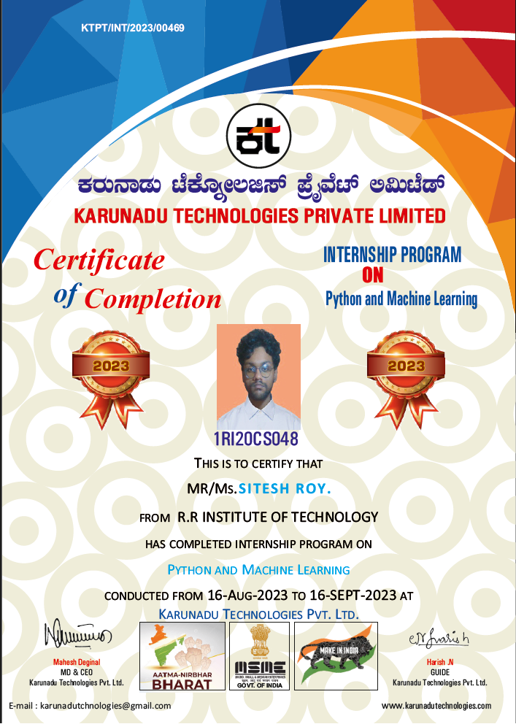

**DECLARATION**

I **SITESH ROY**, student of 7th Semester B. E in the Department of Computer Science and Engineering, RRIT, Bangalore - 560090, hereby declare that the Internship entitled **“PYTHON WITH MACHINE LEARNING”** has been carried out under the supervision of **Prof. Lakshmidevi H M** Assistant Professor of CSE, RRIT**,** submitted in partial fulfillment of the source requirements for the award of degree in Bachelor of Computer Science and Engineering **Visvesvaraya Technological University, Belagavi** during the academic year 2023-24.

**Place: Bangalore**

**Date:**

**SITESH ROY**

**[1RI20CS048]**

**ACKNOWLEDGEMENT**

I consider it a privilege to whole-heartedly express our gratitude and respect to everyone who guided and helped us in the successful completion of this report.

I am grateful to **Dr. Mahendra K V,** Principal, RRIT, Bangalore, and all staff members of the Computer Science and Engineering Department for their kind cooperation.

I am extremely grateful to **Dr. Manjunath R**, Professor and Head, Department of Computer Science and Engineering**,** for his cooperation and encouragement. I thank him for providing me with an opportunity to carry out this Internship at Karunadu Technologies Private Limited.

I express my deepest gratitude and sincere thanks to our internship coordinator **Prof. Shruthi S,** Professor, Department of Computer Science & Engineering, and our Guide **Prof Lakshmidevi H M,** Assistant Professor, Department of Computer Science and Engineering for their valuable guidance during this internship. I thank them for providing me an opportunity to carry out the internship at Karunadu Technologies Private Limited, Bengaluru.

Finally, it’s a pleasure and happiness to the friendly co-operation showed by all the staff members, friends of Computer Science and Engineering department.

**SITESH ROY (1RI20CS048)**

**TABLE OF CONTENTS**

|  |  |  |  |  |  |  |  |  |
| --- | --- | --- | --- | --- | --- | --- | --- | --- |
| **SL NO** | | | **CONTENTS** | | | **PAGE NO** | | |
| **1** | | | **CHAPTER 1: Company Profile** | | | **1** | | |
|  | | | * 1. Profile | | | 1 | | |
|  | | | 1.1.1. Vision | | | 1 | | |
|  | | | 1.1.2. Mission | | | 1 | | |
|  | | | 1.1.3. Objectives | | | 2 | | |
|  | | | 1.2. Company Products and Services Offered | | | 2 | | |
|  | | | 1.2.1. Products | | | 2 | | |
|  | | | 1.3. Contact Details | | | 4 | | |
| **2** | | | **CHAPTER 2: Department Profile** | | | **5** | | |
| **3** | | | **CHAPTER 3: Basics of Python** | | | **6** | | |
|  | | | 3.1 Introduction | | | 6 | | |
|  | | | 3.2 Use of Python | | | 6 | | |
|  | | | 3.3 Features of Python | | | 7 | | |
|  | | | 3.4 Limitations of Python | | | 7 | | |
| **4** | | | **CHAPTER 4: Machine Learning** | | | **8** | | |
|  | | | 4.1 What is Machine Learning? | | | 8 | | |
|  | | | 4.2 How does Machine Learning Work? | | | 8 | | |
|  | | | 4.3 Why is Machine Learning? | | | 8 | | |
| **5** | | | **CHAPTER 5: Algorithms** | | | **10** | | |
|  | | | 5.1 Linear Regression | | | 10 | | |
|  | | | 5.2 Multiple Linear Regression | | | 11 | | |
|  | | | 5.3 Logistic Regression | | | 12 | | |
|  | | | 5.4 KNN Algorithm | | | 13 | | |
|  | | | 5.5 Support Vector Machine | | | 14 | | |
|  | | | 5.6 Decision Tree Algorithm | | | 14 | | |
| **6** | | | **CHAPTER 6: Tasks Assigned** | | | **17** | | |
|  | | | 6.1. Introduction | | | 17 | | |
|  | | | 6.2. Project Description | | | 17 | | |
|  | | | 6.6. Programming Steps | | | 17 | | |
|  | | | 6.4. Heart Attack Prediction Using Random Forest Algorithm | | | 18 | | |
|  | | | 6.5. Pulsar Waves Classification using Logistic Regression | | | 21 | | |
| **7** | | | **CHAPTER 7: Reflection Notes** | | | **24** | | |
| **8** | | | **CHAPTER 8: Results** | | | **25** | | |
|  | | | 8.1. Heart Attack Prediction | | | 25 | | |
|  | | | 8.2. Classification of Pulsar Waves | | | 27 | | |
| **9** | | | **CHAPTER 9:** | | | **29** | | |
|  | | | Conclusion | | | 29 | | |
|  | | | Reference | | | 30 | | |

**LIST OF FIGURES**



|  |  |  |
| --- | --- | --- |
| **FIG NO** | **DESCRIPTION** | **PAGE NO** |
| 1.1 | Company logo | 1 |
| 5.1 | Regression analysis on How to obtain best fit line | 10 |
| 5.2 | Logistic Regression Graph | 13 |
| 5.3 | Support Vectors | 14 |
| 5.4 | Decision Tree | 15 |
| 6.1 | Overview dataset | 19 |
| 6.2 | Code for Heart Attack Prediction | 19 |
| 6.3 | Implementing Heart Attack Prediction in Django | 20 |
| 6.4 | Overview dataset | 22 |
| 6.5 | Code for Pulsar Waves Classification | 22 |
| 6.6 | Implementing Pulsar Waves Classification in Django | 23 |
| 8.1 | Output of Heart Attack Prediction | 25 |
| 8.2 | Output of Heart Attack Prediction web interface | 26 |
| 8.3 | Output of Pulsar Waves Classification | 27 |
| 8.4 | Django output for Pulsar Waves Classification | 28 |