Name: Tan Jin Yuan
ID Student: SCSJ2500372

Section A
No | Answer | Explanation
1. | True
2. | False | Scanner objects can use multiple in a program.
3. | True
4. | True
5. | True
6. | False | Classes can use in big letters
7. | True
8. | False | ArrayList
9. | True
10. | True

Section B
Question 1
Error | Solution | Explanation
String time, | String time; | Syntax error
note = note; | note = n; | Cannot variable
(“Reminder at” + time – “); | (“Reminder at” + t ); | Syntax error
(“Note:” + note); | (“Note:” + n); | Cannot variable
(“10AM”, “Drink water) | (“10AM”, “Drink water”); | Miss syntax
(“12AM”, “Lunch) | (“12AM”, “Lunch”); | Miss syntax
q.show(); | d.show(); | Syntax error

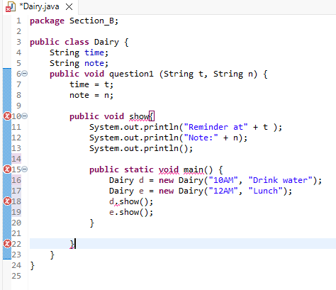

Question 2
2.1
Step | Input  (i) | Condition  (i <=5) | Process  (i % 2 ==0) | Output  (i+”-”) | i++
1. | 1 | 1 < 5, True | 1 % 2 = 0.5 | 1+0.5=1.5 | 1+1=2
2. | 2 | 2 < 5, True | 2 % 2 = 1 | 2+1=3 | 2+1=3
3. | 3 | 3 < 5, True | 3 % 2 =1.5 | 3+1.5=4.5 | 3+1=4
4. | 4 | 4 < 5, True | 4 % 2 = 2 | 4+2=6 | 4+1=5
5. | 5 | 5 < 5, True | 5 % 2 = 2.5 | 5+2.5=7.5 | 5+1=6
6.. | 6 | 6 < 5, False | -------------- | Terminated | ----------------

2.2
Final count: 7.5

2.3
Count: 2.5

2.4
If (i % 2 == 0)

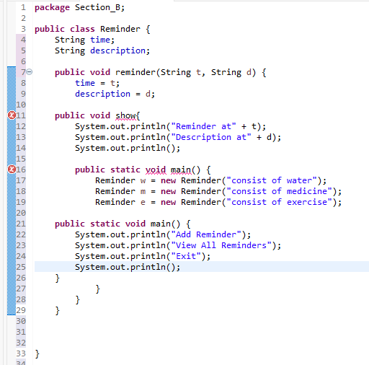
Section C

