City University of Hong Kong

CS3343 Software Engineering Practice

Group 21
Analysis and Design Report

Project Title: Roguelike Card Game

Name | Student Number
Shek King Fung | 58527549
Cheung Tin Yeung | 58582747
Kwok Hang Wai | 58534079
Ho Chun Hin | 58551795
Lam Shi Ho | 58541347
Yip Hiu Hong | 58539340

Table of Contents
1. Design Constraints 3
1.1. Programming tools 3
1.2. Schedule 3
1.3. Operating System 3
1.4. Graphical User Interface 3
1.5. Game Play 3
2. Requirement Specification 4
2.1. Use Case Diagram 4
2.2. Use Case Specification 5
3. Class Diagram 11
4. Design Principle 12
4.1 Single Responsibility Principle 12
4.2 Dependency Inversion Principle 13
5. Design Pattern 14
5.1 simple factory pattern 14
5.2 strategy pattern 14
6. Sequence Diagram 16
6.1 User Workflows 16
6.1.1. Start screen and game initialization 16
6.1.2. Playselectcard() 18
6.1.3. Calculatescore(playedcards) and evaluateHand(list<card>) 20
6.1.4. End game/level 23
6.2 System Interactions 25
6.2.1. Hand Model Management 25
6.2.2. Joker Model Effect Application 27
6.2.3. Card Model Interactions in Game Logic 29
6.2.4. CardPanel UI rendering and Interactions 31
6.2.5. AnimatedButton Effect on UI 33
6.2.6. ScoreAnimation Effect on UI 35
7.Code refactoring 37
7.1 Extract method from game window 37
7.2 Coverage 38

Design Constraints

Programming tools
The project recommends using Java for development so that code can be tested on platforms such as Eclipse. However, not all members are familiar with these software engineering(SE) tools. Therefore, additional time may be required for member training.

Schedule
The final deadline is fixed and cannot be extended, we need to make a balance between scope and cost to catch up the progress.

Operating System
This program is based on Java, which can run on both MacOS and Windows system. However, the program cannot be run on Android and iOS system devices. Extra work will be required to extend the program to other platforms.

Graphical User Interface
This program is a poker-based card game. A simple graphical user interface will help users visually view the cards and make decisions. The graphical user interface (GUI) must at least indicate the card shape and number clearly. It is not required, but a GUI could help the user to run this program more easily.

Game Play
This program is a roguelite Poker game, which highly depends on poker hand. However, considering that not every user is familiar with the combination of poker hands, it is necessary for the program to include a reference table of poker hands for the user to consult at any time.

Requirement Specification

Use Case Diagram
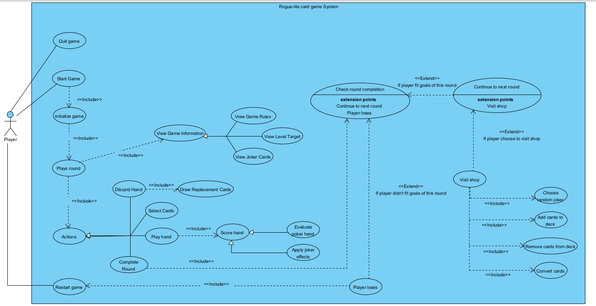

Use Case Specification
Use Case Name: | Start game
Actor(s): | Player
Description: | Starts up the game and runs the game’s initialization
Trigger: | When the player runs the game
Typical Course of Events: | Actor Action | System Response
 | Step 1: The player run the main.java file | Step 2: The game starts and runs initialization code
Alternate Courses: | None
Precondition： | The main.java file and other source files must be present, and it would only start when the player runs the main file
Post-conditions: | The game starts and runs initialization code

Use Case Name: | Restart game
Actor(s): | Player
Description: | Returns to round 1 without having to start up the game again
Trigger: | When the play presses the restart button at the loss screen
Typical Course of Events: | Actor Action | System Response
 | Step 1: The player clicks on the restart button | Step 2: The game enters round 1
Alternate Courses: | None
Precondition： | The player must have lost the game and pressed the restart button
Post-conditions: | The game returns to round 1 without having to start up the game again

Use Case Name: | Quit game
Actor(s): | Player
Description: | Quits the game and stops the game from running
Trigger: | When the player exits the game
Typical Course of Events: | Actor Action | System Response
 | Step 1: The Player exits or stops the main.java file | Step 2: The game shuts down and stops any code from running
Alternate Courses: | None
Precondition： | The game must be running
Post-conditions: | The game shuts down and stops any code from running

Use Case Name: | View game rule
Actor(s): | Player
Description: | Player views game rules
Trigger: | When the player presses the rule button
Typical Course of Events: | Actor Action | System Response
 | Step 1: The Player clicks the button for viewing game rules | Step 2: The game displays a container to show the rules
Alternate Courses: | None
Precondition： | The player is in any round of the game and hasn't yet lost.
Post-conditions: | Displays a container to show the rules

Use Case Name: | View level target
Actor(s): | Player
Description: | Player checks the score needed to reach the next stage
Trigger: | When the player presses the level target button
Typical Course of Events: | Actor Action | System Response
 | Step 1: The Player clicks the button for viewing detail of level target | Step 2: The game displays a container to show the target of each levelkl.621AS
Alternate Courses: | None
Precondition： | The player is in any round of the game and hasn't yet lost.
Post-conditions: | Displays a container to show the target of each level

Use Case Name: | View joker cards
Actor(s): | Player
Description: | Player check what kind of joker cards is given
Trigger: | This use case is involved when the player starts the game play.
Typical Course of Events: | Actor Action | System Response
 |  | Step 1: The system display a window for showing details of joker card that player owned currently
Alternate Courses: | None
Precondition： | The player is in any round of the game and hasn't yet lost.
Post-conditions: | Show a window that states the name and effects of joker cards owned by the player.

Use Case Name: | Select cards
Actor(s): | Player
Description: | Player selects which poker cards he wants to discard or play
Trigger: | This use case is involved when the player clicks on the poker card he owned
Typical Course of Events: | Actor Action | System Response
 | Step 1: The Player clicks on the poker cards he want to select | Step 2: The system highlight the cards with attractive colors for informing the player
Alternate Courses: | None
Precondition： | The player is in any round of the game and hasn't yet lost, as well as having at least one poker card.
Post-conditions: | The outer frame of the selected poker cards are highlighted.

Use Case Name: | Complete round
Actor(s): | Player
Description: | Player choose to complete this round immediately
Trigger: | This use case is involved when the player clicks on the button which state “Completer Round” or finish the last round of that level.
Typical Course of Events: | Actor Action | System Response
 | Step 1: The player clicks on the “Completer Round“ button or finish the last round of that level. | Step 2: The system immediately stop the drawing of poker card  Step 3: The system invoke the use case Check Round Completion
Alternate Courses: | Step 3a: [Extension point: If the player meet the goals of that round, invoke use case Continue to next round ]  Step 3b: [Extension point: If the player didn’t meet the goals of that round, invoke use case Player loses ]
Precondition： | The player is in any round of the game and hasn't yet lost.
Post-conditions: | The game will move to next round

Use Case Name: | Player loses
Actor(s): | Player
Description: | Player lose the game play and show the result of this game play
Trigger: | This use case is involved when the player didn’t fit the goal of this round
Typical Course of Events: | Actor Action | System Response
 | Step 1: The player can’t pass the goal of this round of game play | Step 2: The system immediately stop the compute of next round and show a window for display the player result  Step 3: The system prepare for next game play
Alternate Courses: | None
Precondition： | The player finish the game play
Post-conditions: | The game will stop and the final result will be compute

Use Case Name: | Discard hand
Actor(s): | Player
Description: | Player discards the cards selected currently in hand
Trigger: | This use case is involved when the player clicks the button for discard
Typical Course of Events: | Actor Action | System Response
 | Step 1: The Player clicks on the discard button | Step 2: The system discards the cards selected that is in player’s hand and draw new ones
Alternate Courses: | None
Precondition： | The player must have cards selected
Post-conditions: | the cards are discarded and new ones are drawn

Use Case Name: | Play hand
Actor(s): | Player
Description: | Player plays the cards selected currently in hand
Trigger: | This use case is involved when the player clicks the button for play hand
Typical Course of Events: | Actor Action | System Response
 | Step 1: The Player clicks on the play hand button | Step 2: The system plays the select cards and remove the cards from player’s hand
Alternate Courses: | None
Precondition： | The player must have cards selected
Post-conditions: | the cards are removed from the player’s hand and counted toward the score calculation

Class Diagram
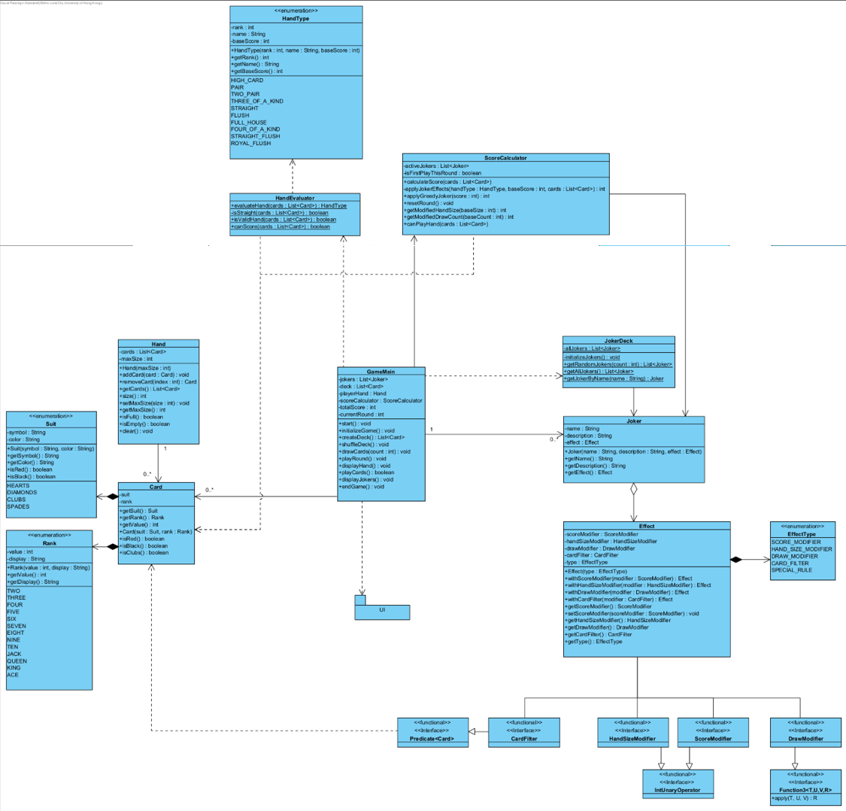

Design Principle

4.1 Single Responsibility Principle
One class is only in charge of one job/responsibility in our code. Unrelated jobs will not be involved in the same class. For example, for calculating the new score and displaying it on screen for the user to know, are separated for three classes: scorecalculator ,handevaluator and gamewindow, to handle.
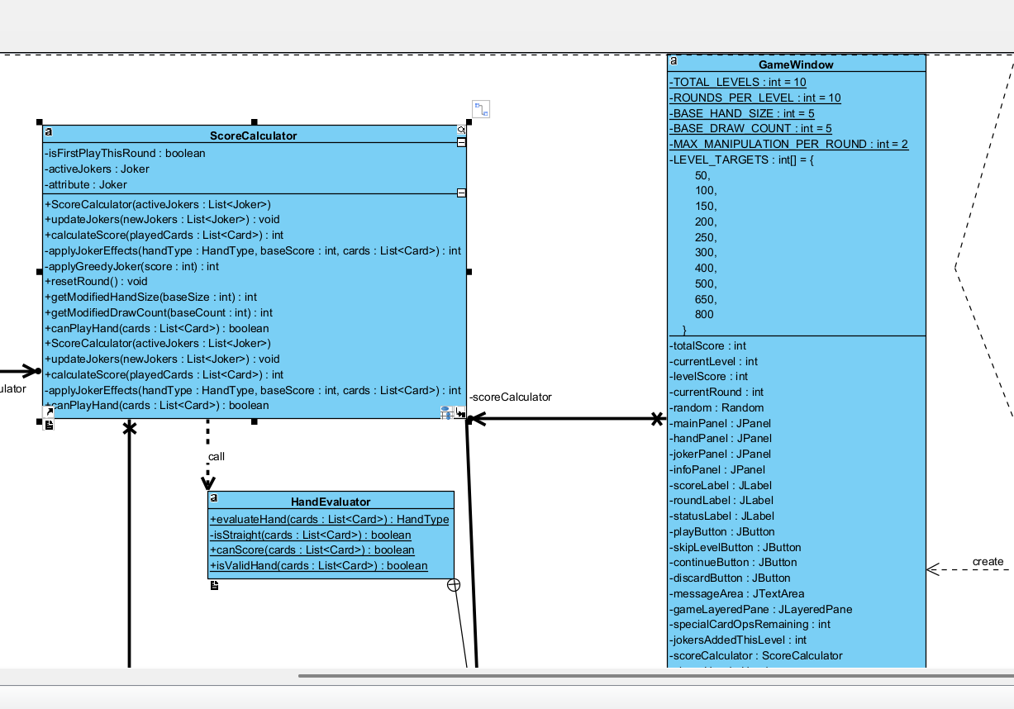

Their responsibility:
Gamewindow: display the ui
Scorecalculator: calculate the score base on joker effect/hand type of selected card
Handevaluator: identify the hand type of the selected card
No responsibility is duplicated in the design, and one class is only responsible for one job.

The reason of choosing this principle:
- It may add/change the game's elements in future(e.g: more joker cards, different score calculation rule), and we only need to modify the related class. It is more convenient and lower risk.
- Avoid problem occur in one function when we modify another function in same class

4.2 Dependency Inversion Principle
The higher level class and lower level class will rely on the same abstract/interface in our code. It shows in the flow of calculating the score with the joker effect.
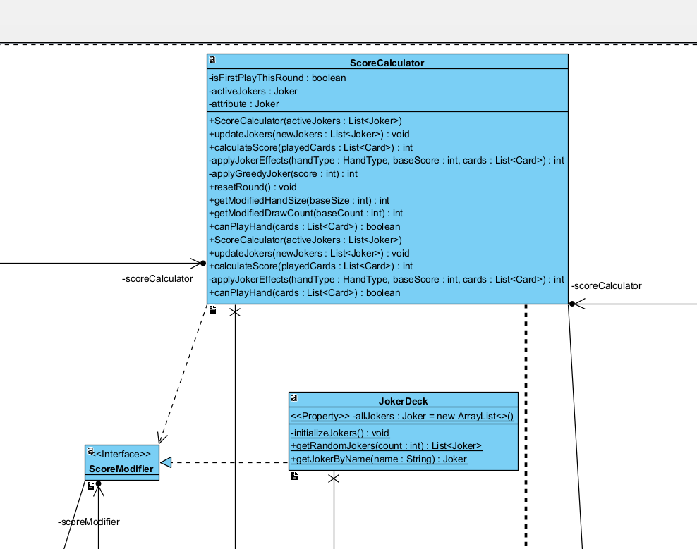
The higher level class-ScoreCalculator and the lower level class-jokerdeck will rely on the same interface called scoremodifier. The details of joker card effect will be completed in JokerDeck but not in Scorecalculator. ScoreCalculator only needs to call getScoreModifier.apply() to apply different joker card effects in jokerdeck through scoremodifier and use it to calculate the score.
The reason of choosing this principle:
- If we need to add many joker effects, then we don’t need to write all effect logic into scorecalculator, to avoid the code becoming bigger

Design Pattern

5.1 simple factory pattern
We apply the simple factory pattern on getting random joker cards when initializing the game at the beginning.
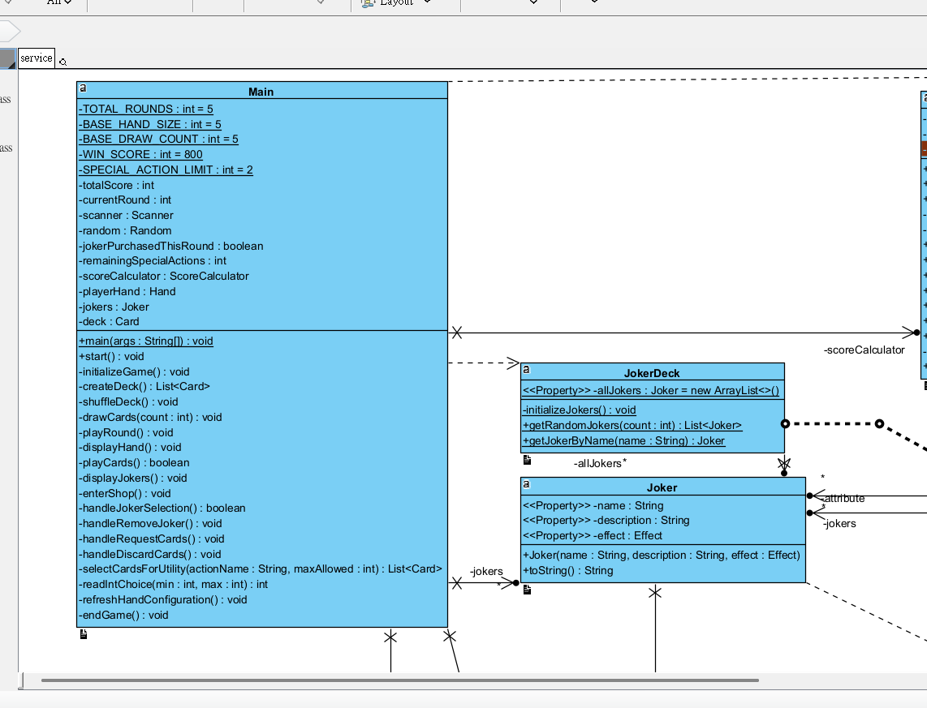
In our design, main is a client, jokerdeck is a factory and joker is a product. When main requires a new joker object during initialization of the game, it will call the method of factory jokerdeck.getrandomjokers() but will not directly create a new joker(). It means that in client slide, it will not involve any process of creating a new joker object and only need to tell how many cards are needed.

5.2 strategy pattern
We apply a strategy pattern for getting the joker effect to calculate the score of users earned in each round.
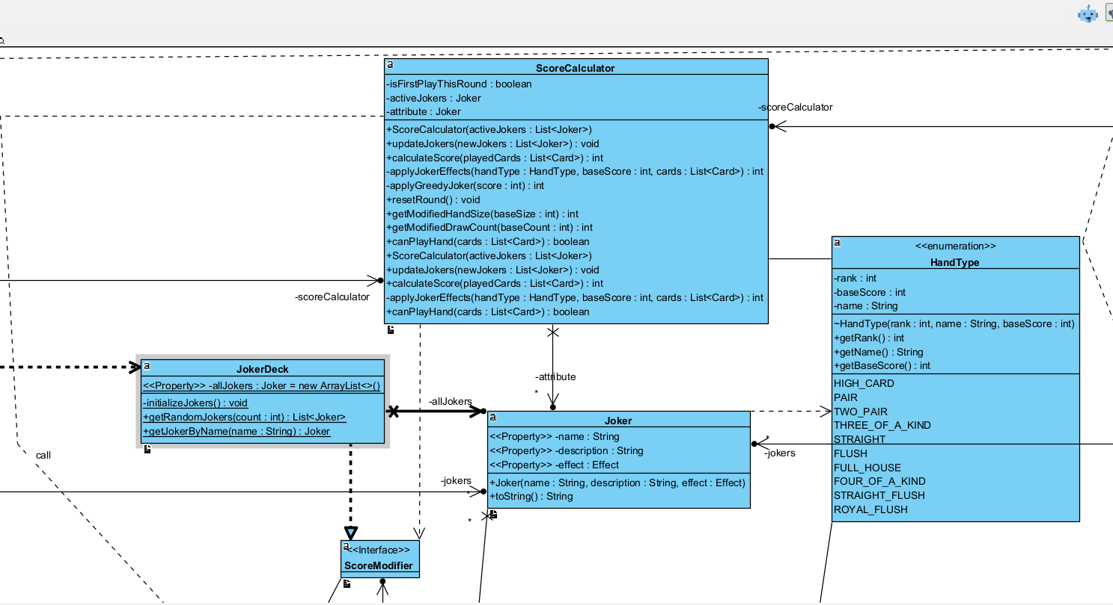
In our design, scorecalculator will call getScoremodifier().apply() to apply the joker effect to calculate the score but not directly call jokerdeck(). We don’t add a lot of if-then condition in scorecalculator to determine which joker card will use but swap to different joker effect base on the scoremodifier

Sequence Diagram

6.1 User Workflows

6.1.1. Start screen and game initialization
In this sequence diagram, when the user enters the game, he/she will see the start page on the screen. When he/she clicks the “ start the game” button, then the game controller will do the initial setup of the round. It includes setting the level, drawing the joker card and deck randomly . After the setting, the ui will be updated.

- Show the start screen
- When the user clicks the start button, do the initial setup of the game,reset the score, all cards and the info of the ui panel.
- Draw the card until the number or card in hand == the maximum number of card that user can get
- Updated the ui

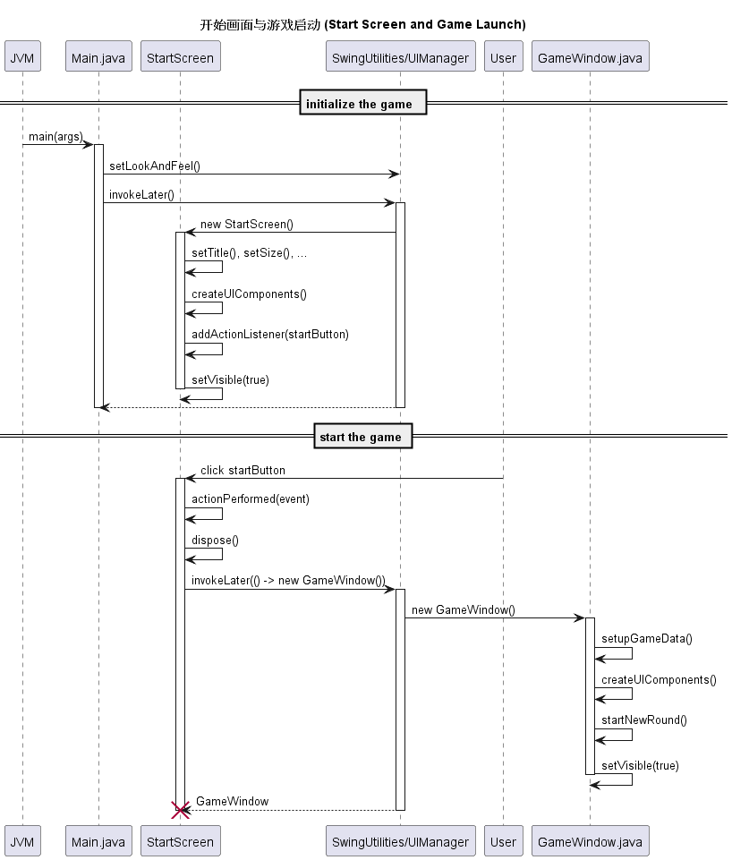
Figure 6.1.1: The sequence diagram of start screen and game initialization

6.1.2. Playselectcard()
In this sequence diagram, users need to select any cards first, and click playButton or discardButton in the user interface.When a user's card is less than the maximum of hand card, then the system will draw the card automatically.

- Select card in interface and click playbutton/discardbutton/requestbutton
- Do the validation of the selected card. If it is playable, then check which action that user takes
- If the user takes a discard action, then the selected card will be removed from the user's hand and drawn a new card from his deck.
- If the users takes play action, then it will calculate the score based on the selected card and the effect of joker card
- Update the score
- Draw the card until the number or card in hand == the maximum number of card that user can get
- Update the interface
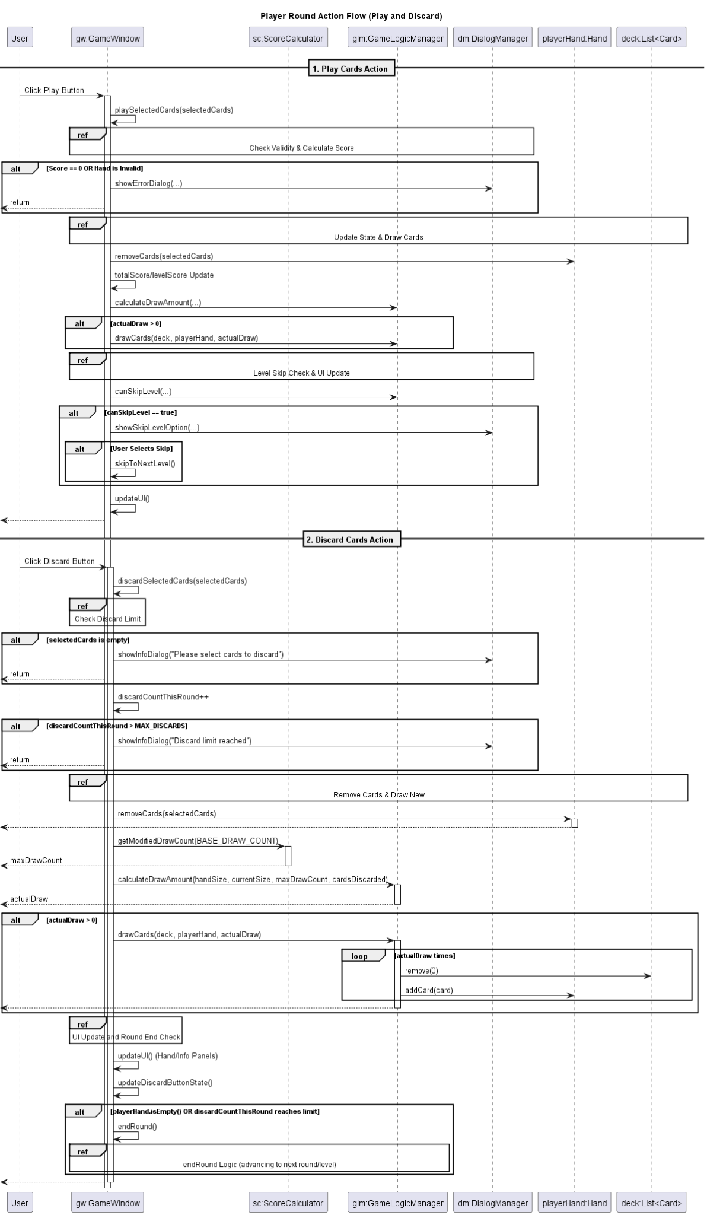Figure 6.1.2: The sequence diagram of player select card in his round

6.1.3. Calculatescore(playedcards) and evaluateHand(list<card>)
The score of the player’s selected card will be calculated during two sequence diagrams. In evaluateHand(List<card>), the selected card will do the initial check first and determine its handtype, finally return to calculatescore(playedcards); calculatescore(playedcards) will calculate the score based on the handtype and decide to apply different logic in different situation to calculate the final score

For evaluateHand(list<card>):
- Do the validation check of selected card
- Counts the ranks and the suits of the selected card and determine its handtype, return it to calculatescore()

For calculatescore(playedcards):
- Apply each joker cards’ affect to the score if it is active,based on the handtype
- Apply greedy logic to calculate the score if hasgreedyjoker() is true
- Return the final score
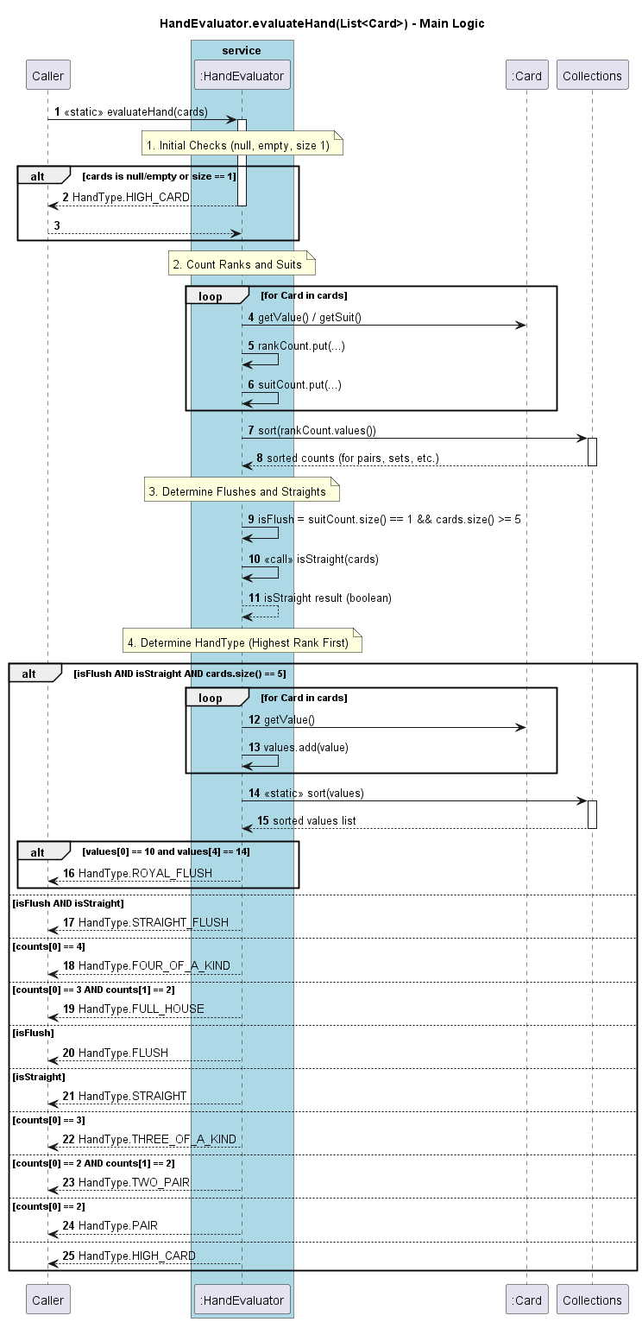
Figure 6.1.3: The sequence diagram of evaluate the selected card
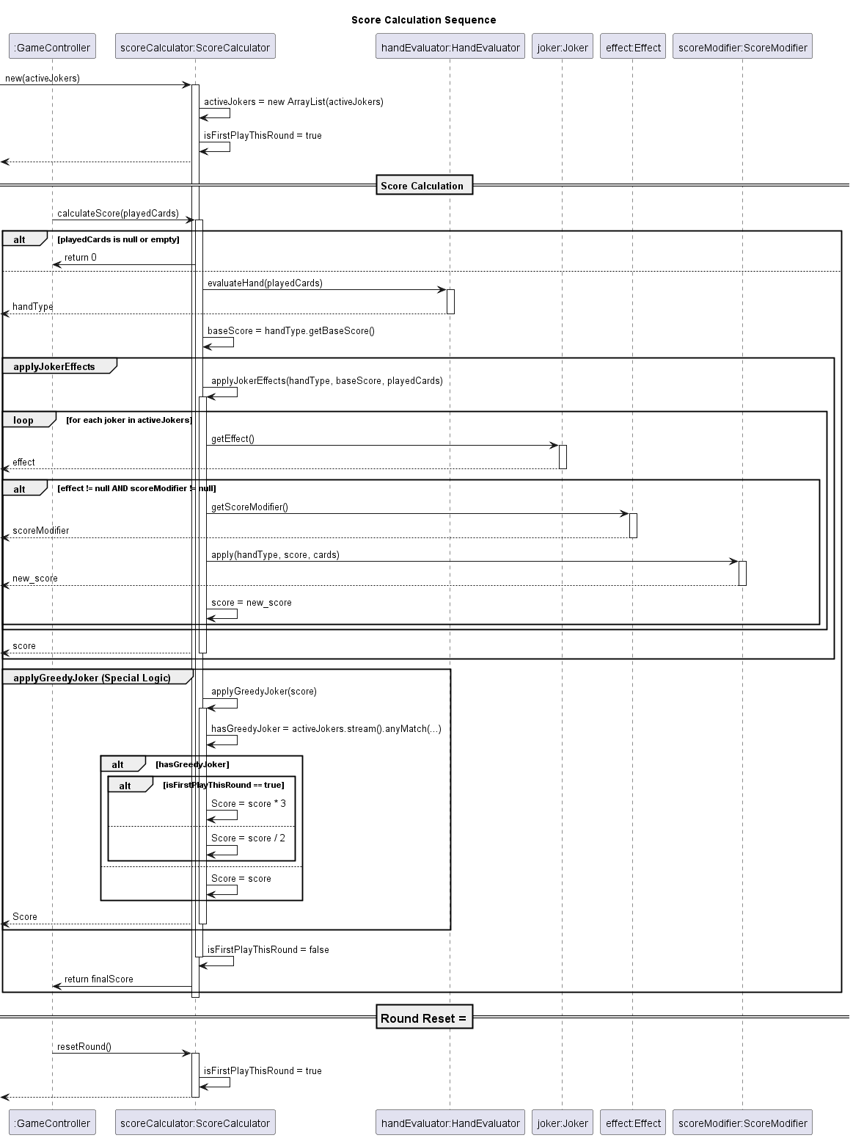
Figure 6.1.4: The sequence diagram of calculate the final score

6.1.4. End game/level
In this sequence diagram, after calculating the total score, users need to click the skipButton first if his score is qualified for entering the next level .After that, the game will initialize for the next level; if user’s score isn’t qualified for entering the next level, then game is over. After ending each level, users will earn 1 quota to request/delete the card base and it will be cumulative for the whole game.
.
- After calculating the current total score, the skipButton will appear if his total score is qualified for him to enter the new level
- If it is the final level, then the user wins and the game ends.
- If it isn’t the final level, then clear the selected card and go to the next level when the user clicks the skip button.
- When users end the recent level.The request/delete panel will appear for users to take action.
- If users select request action, then system will copy the selected card to his hand
- If users select delete action, then system will remove the selected card from his deck
- If the user's score< targetScore at the end of each level , then the user loses and game over.
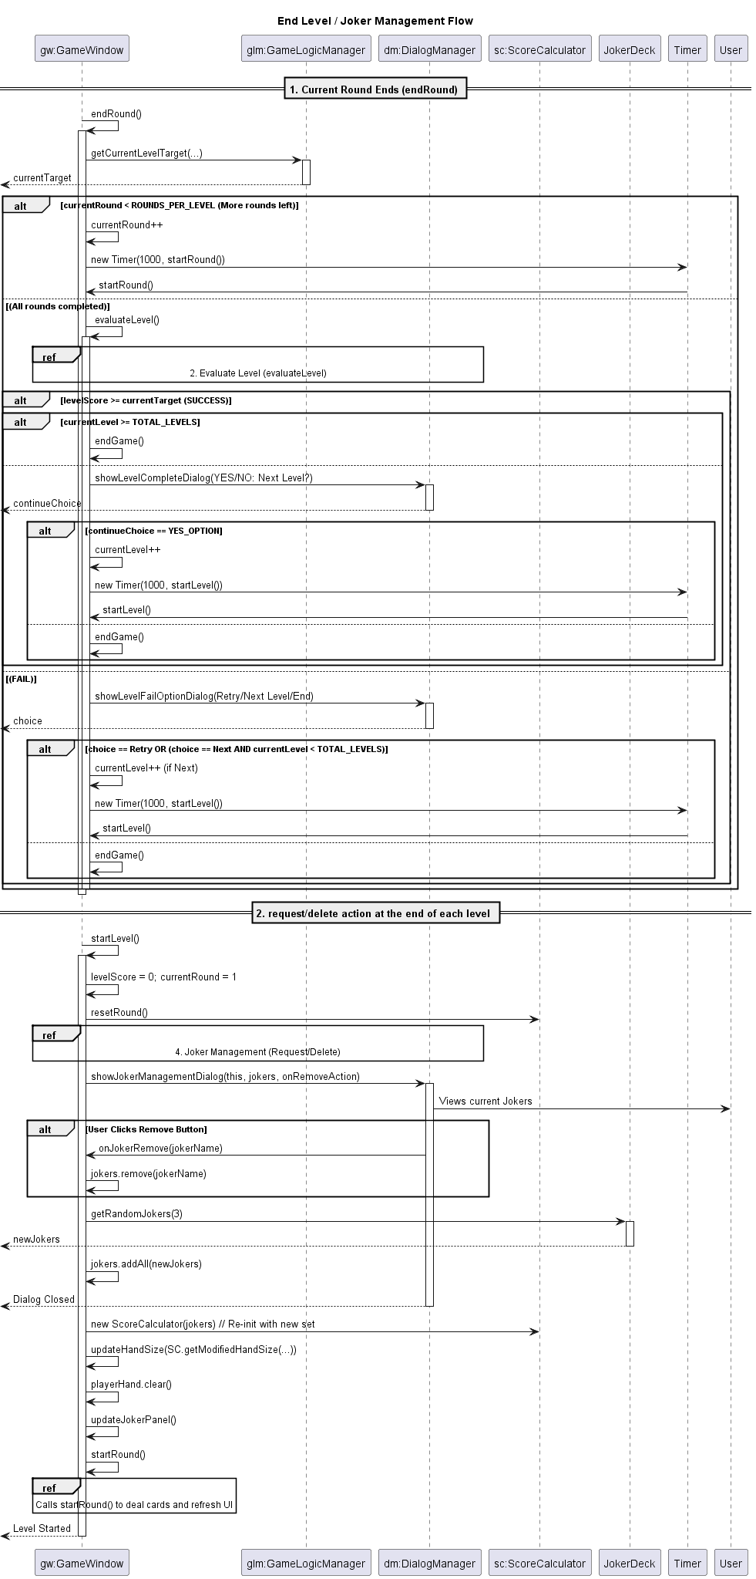Figure 6.1.5: The sequence diagram of ending the game/level

6.2 System Interactions

6.2.1. Hand Model Management
This sequence diagram illustrates how the game manages the player's card collection throughout the game lifecycle, including card manipulation, state tracking, and hand capacity management. Below are the key interaction processes:
- GameWindow creates Hand with an initial maximum size limit that gets modified by Joker effects
- ScoreCalculator determines modified hand size based on active Joker card effects
- Cards are drawn from the deck and added to Hand while respecting the maximum size constraint
- Player selects cards through CardPanel interactions, updating the selectedCards Set in GameWindow
- When Play button is activated, selected cards are validated, scored, and removed from Hand
- Discard functionality permanently removes selected cards from Hand
- Request (Duplicate) functionality increases hand size limit and adds copied cards
- Hand state properties (size, fullness, emptiness) are continuously monitored for game logic
- Hand is cleared completely when starting new levels to reset game state
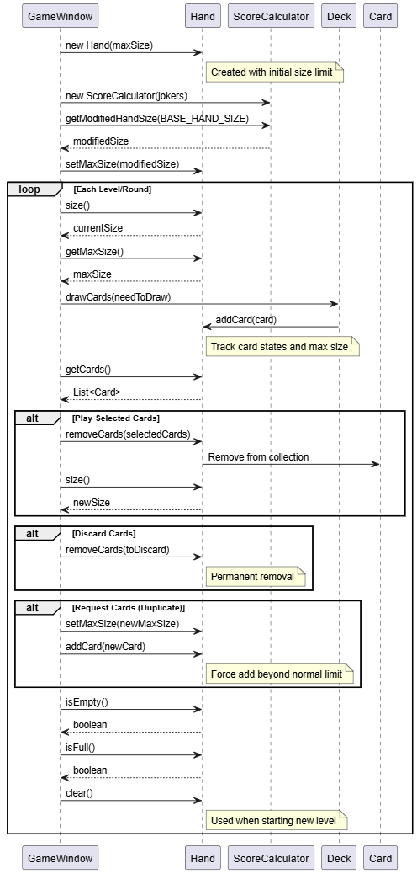
Figure 6.2.1: The sequence diagram of Hand management used to track players' card status

6.2.2. Joker Model Effect Application
This sequence diagram demonstrates how special Joker cards dynamically modify game rules by altering core gameplay mechanics through functional effect interfaces. Below are the key interaction processes:
- ScoreCalculator initializes with active Jokers and applies their effects throughout gameplay
- Joker effects are retrieved through getEffect() method calls, returning functional interfaces
- Hand size modifications are calculated by applying IntUnaryOperator from HandSizeModifier effects
- Draw count modifications are determined by applying IntUnaryOperator from DrawModifier effects
- During score calculation, each active Joker's ScoreModifier function is applied sequentially
- Score modifiers transform base scores using hand type, current score, and card data as parameters
- Card filters (Predicate<Card>) check for specific card properties like suit, color, and rank
- Special Joker logic (Greedy Joker) applies conditional multipliers based on turn order
- Joker information is displayed using toString() method for UI representation
- Active Joker list can be updated dynamically through shop interactions
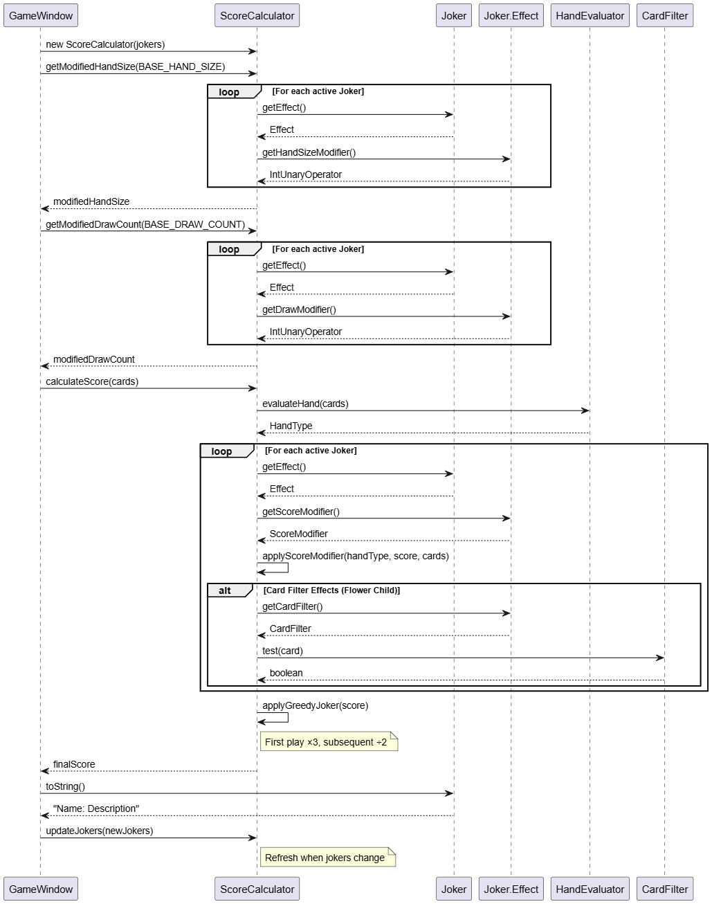
Figure 6.2.2: The sequence diagram of Joker card effect application in the gameplay

6.2.3. Card Model Interactions in Game Logic
This sequence diagram shows how Card objects interact with game systems for evaluation, scoring, and special effect processing throughout gameplay. Below are the key interaction processes:
- Card objects are instantiated with immutable suit and rank data using enum types
- Game logic extensively queries card properties (value, suit, color) for scoring calculations
- HandEvaluator examines card collections to determine poker hand types and rankings
- Card comparisons and equality checks enable duplicate detection and hand validation
- String representations are generated for display purposes and debugging
- Special properties (isRed, isBlack, isClubs) are queried for Joker-specific effects
- Ace Master Joker checks for the ACE rank to apply bonus scoring
- Lucky Sevens Joker detects SEVEN rank for additional point rewards
- Red Card Joker evaluates isRed() property for multiplier application
- Flower Child Joker uses isClubs() check for wild card functionality
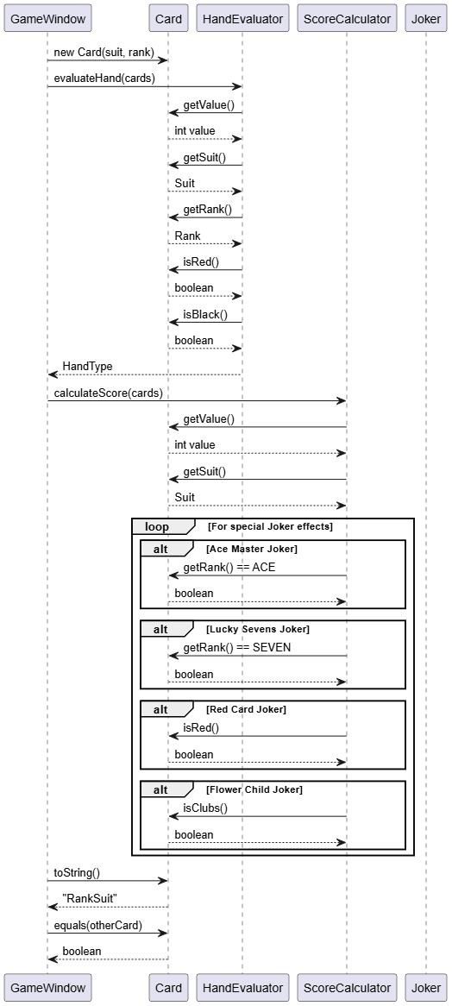
Figure 6.2.3: The sequence diagram of Card model interactions in game logic and scoring systems

6.2.4. CardPanel UI rendering and Interactions
This sequence diagram illustrates how CardPanel components handle user input and perform complex visual rendering by querying Card model data. Below are the key interaction processes:
- CardPanel components are dynamically created for each card in the player's Hand
- User click events trigger MouseAdapter callbacks that communicate with GameWindow
- Selection state changes are managed through GameWindow's selectedCards Set collection
- CardPanel queries the Card model for display data, including rank, suit symbols, and color information
- Complex font selection logic ensures Unicode symbol compatibility across different systems
- Custom painting implementation uses Graphics2D for advanced visual effects
- Gradient backgrounds create visual depth and card distinction
- Shadow effects provide a 3D-like appearance and selection highlighting
- Selection states are rendered with prominent yellow borders and highlight overlays
- Corner indicators display rank and suit in both top-left and bottom-right positions
- Tooltip text provides user guidance for card interaction
- Cursor changes to a hand pointer on hover for a better user experience
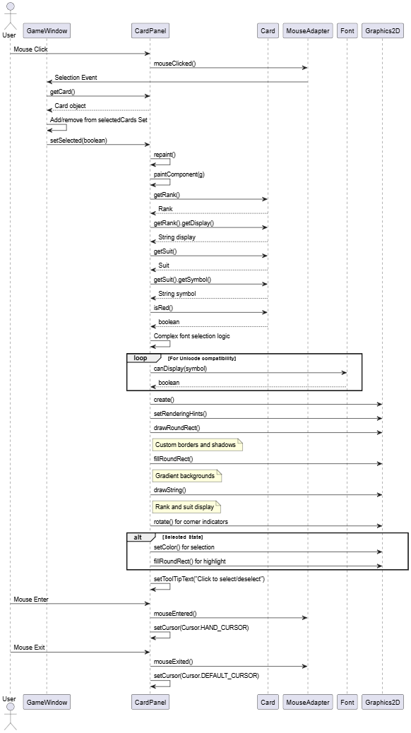
Figure 6.2.4: The sequence diagram of CardPanel UI component handling user interactions and visual rendering

6.2.5. AnimatedButton Effect on UI
This sequence diagram demonstrates how AnimatedButton components provide dynamic visual feedback and trigger game actions through sophisticated user interactions. Below are the key interaction processes:
- Buttons are instantiated with three distinct color states (normal, hover, pressed)
- Dynamic color updates occur through setter methods that trigger repaint operations
- Mouse hover events transition buttons to hover color with gradient highlights
- Mouse press events change the button's appearance to the pressed color state
- Mouse release events trigger assigned game actions through ActionListener callbacks
- Visual updates occur automatically on all state changes, including color transitions
- Game actions include Play, Discard, Request (Duplicate), and Skip Level functionality
- Custom paintComponent implementation creates rounded rectangles with gradient fills
- Border effects provide visual depth and interactive feedback
- Text rendering is centered and optimized for readability
- State management ensures consistent visual behavior across user interactions
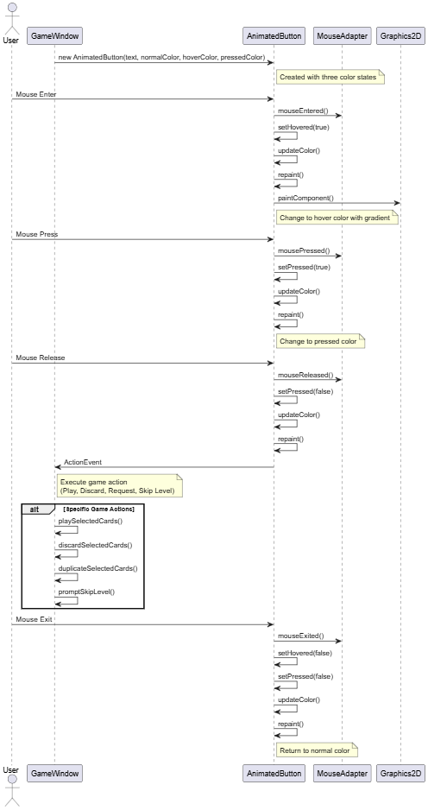
Figure 6.2.5: The sequence diagram of AnimatedButton component providing interactive visual feedback

6.2.6. ScoreAnimation Effect on UI
This sequence diagram shows how ScoreAnimation components provide celebratory visual feedback when players earn points, featuring smooth animations and automatic cleanup. Below are the key interaction processes:
- Animation is instantiated when players earn points during card play sequences
- Timer drives animation frames at approximately 60fps (16ms delay) for a smooth visual experience
- Scale increases progressively from 0.5 to 1.2 over time, creating a growth effect
- Alpha transparency decreases from 1.0 to 0.0 after reaching full scale, creating a fade-out
- Custom painting implements glowing text effects with multiple shadow layers
- Geometric transformations (translate, scale) create dynamic positioning and sizing
- AlphaComposite controls transparency levels throughout the animation lifecycle
- Animation automatically removes itself from the parent container when complete
- Thread-safe cleanup uses SwingUtilities.invokeLater for proper EDT handling
- Layered pane management ensures proper z-ordering above other game elements
- Resource management prevents memory leaks through automatic self-removal
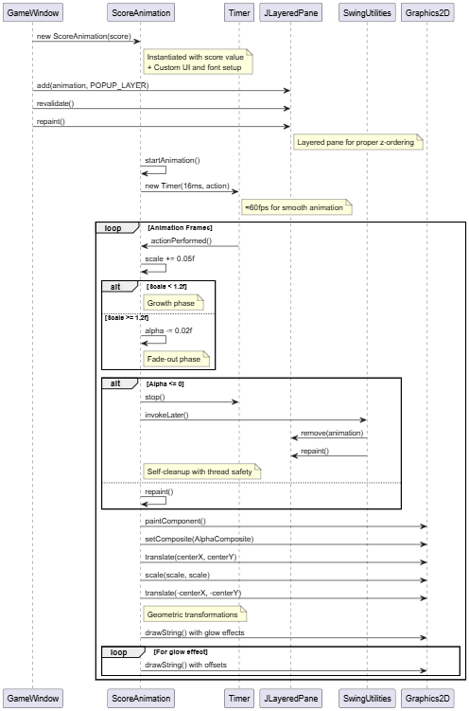
Figure 6.2.6: The sequence diagram of ScoreAnimation component providing visual feedback for scoring events

7.Code refactoring

7.1 Extract method from game window
As the gamewindow class is too large and involves too much function, we decide to extract methods from it. Two classes are extracted from gamewindow, which is GamelogicManager and DialogManager.

For GameLogicManager, It involves the function which is related to the logic of game flow, such as skip the round, detect if all rounds are completed.

For DialogManager, It incharges to showing the dialog box from the system to users, such as the request/delete dialog, joker cards shop dialog, etc.

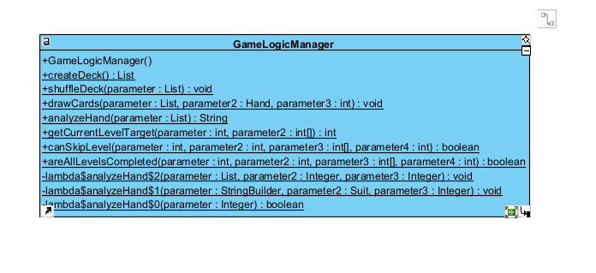
figure7.1.1 the class diagram of GameLogicManager
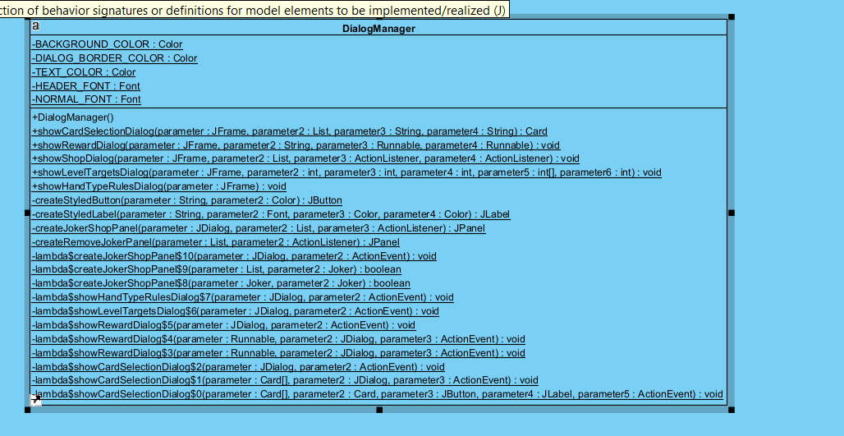
figure 7.1.2 the class diagram of DialogManager

7.2 Coverage
We did the testing before and after the code refactoring, and the coverage percentage of the test case class remained nearly the same. We also add two test class (TestDialogManager, TestGameLogicManager) for testing the two new created class

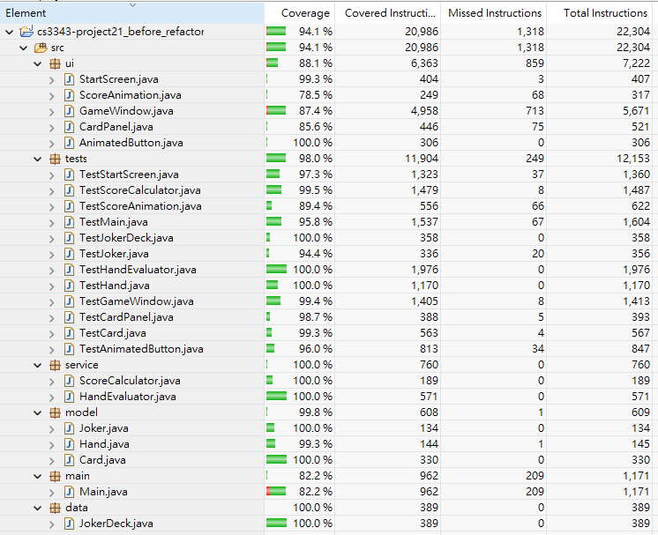
Figure 7.1 The coverage before code refactoring
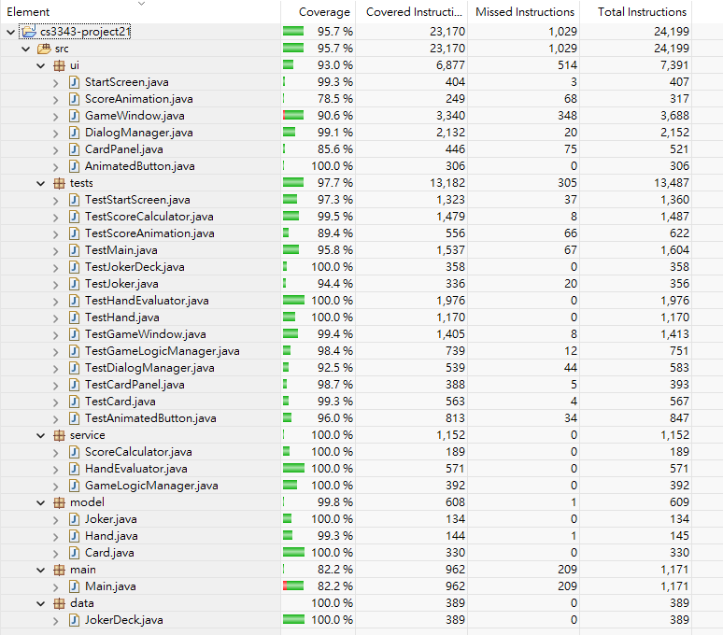
Figure 7.2 The coverage after code refactoring

