City University of Hong Kong

CS3343 Software Engineering Practice

Group 21
Test Report

Project Title: Roguelike Card Game

Name | Student Number
Shek King Fung | 58527549
Cheung Tin Yeung | 58582747
Kwok Hang Wai | 58534079
Ho Chun Hin | 58551795
Lam Shi Ho | 58541347
Yip Hiu Hong | 58539340

Table of Contents
1. Module Organization 3
2. Testing Strategies 3
Unit test: 3
Integrated test: 4
System testing: 4
3. MC/DC Coverage 4
4. Test Case 4

1. Module Organization
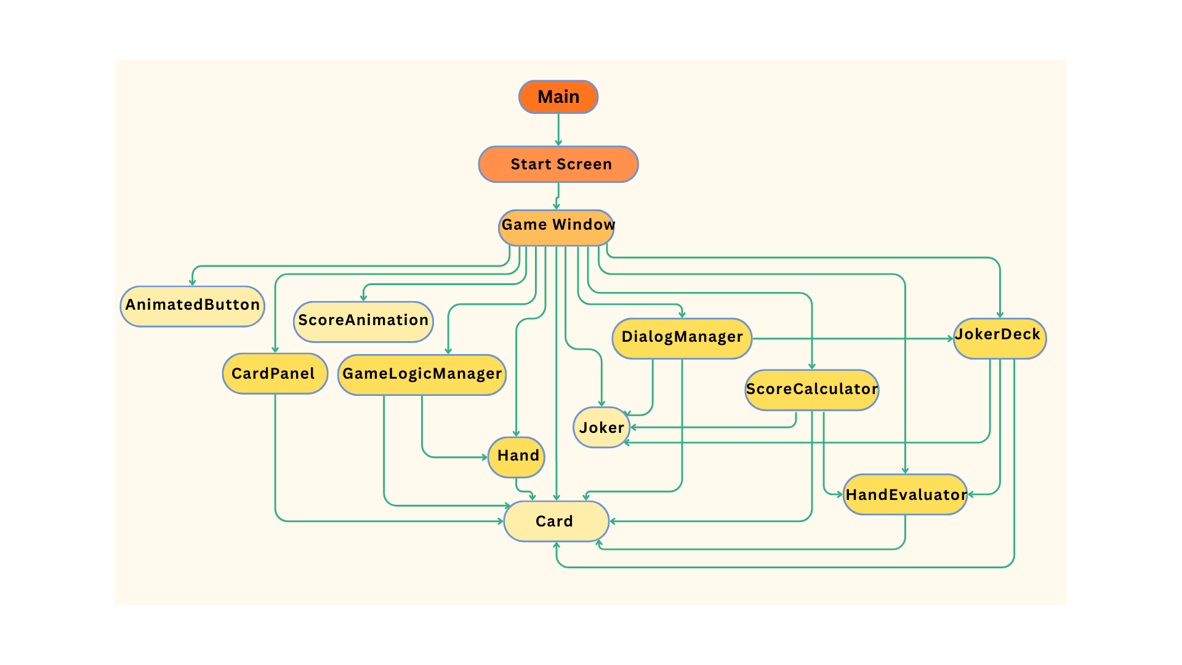
This diagram shows the structure of our system. It contains 14 classes in total.The deeper the color, the more classes it uses. By drawing the module organization, it helps us to develop the testing strategies and testing plan effectively.

2. Testing Strategies
We have used the Bottom-up approach as our testing strategies. Since Bottom-up approaches usually are late for basic working programs, the test needs to be done as soon as possible. However, by using Bottom-up approach, it will be easier for our team to plan and control, as well as testing.
From the diagram, we will start testing from the class with lighter colors. Our test sequence will be as followed:

Unit test:
1. Card (Stub: N/A)
2. Joker (Stub: N/A)
3. AnimatedButton (Stub: N/A)
4. ScoreAnimation (Stub: N/A)

Integrated test:
5. CardPanel + Card (Stub: N/A)
6. Hand + Card (Stub: N/A)
7. GameLogicManager + Hand + Card (Stub: N/A)
8. HandEvaluator + Card (Stub: N/A)
9. ScoreCalculator + Joker + Card + HandEvaluator (Stub: N/A)

10. JokerDeck + Joker + Card + HandEvaluator (Stub: N/A)
11. DialogManager + Joker + Card + JokerDeck (Stub: N/A)
12. GameWindow + AnimatedButton + CardPanel + ScoreAnimation + GameLogicManager + Hand + Joker + DialogManager + ScoreCalculator + HandEvaluator + JokerDeck + Card (Stub: N/A)
13. StartScreen + GameWindow + AnimatedButton + CardPanel + ScoreAnimation + GameLogicManager + Hand + Joker + DialogManager + ScoreCalculator + HandEvaluator + JokerDeck + Card (Stub: N/A))

System testing:
14. Main +StartScreen + GameWindow + AnimatedButton + CardPanel + ScoreAnimation + GameLogicManager + Hand + Joker + DialogManager + ScoreCalculator + HandEvaluator + JokerDeck + Card (Stub: N/A)

3. MC/DC Coverage
In the testing process, the Modified coverage / Decision coverage (MC/DC) type of predicate testing will be adopted. This stated that each condition and decision will be evaluated to be true or false. We also try to meet the statement coverage as much as possible during testing.
In the test, a total of 285 test cases are being created, all with no errors and failures. It's important to note that test cases for the GameWindow, StartScreen, and Main class require user interaction to test UI elements. Due to code implementation limitations, tests for restarting game logic must be executed with "Yes" selected.
Test Coverage:
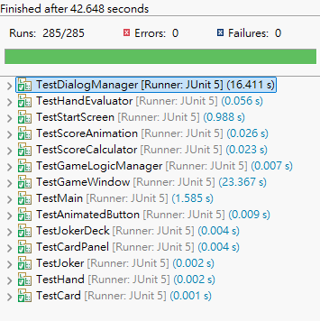
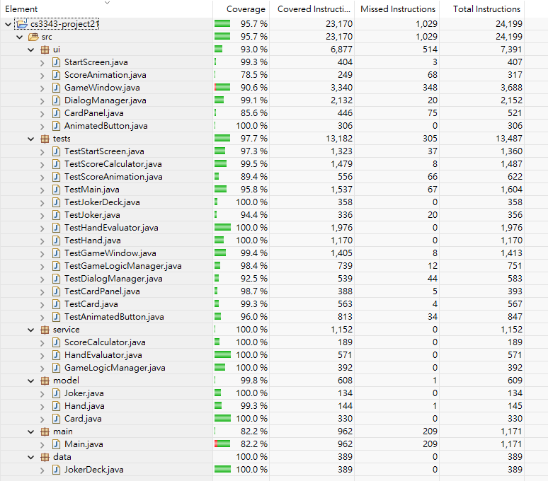

4. Test Case
TestAnimatedButton.java
Test case | Input Description | Expected Result | Actual Output
T001  testSetNormalColor | Set normal color to CYAN | Both normalColor and currentColor become CYAN | As expected
T002  testSetNormalColorWhileHovered | Set normal color while in hovered state | normalColor becomes CYAN, currentColor remains hover color | As expected
T003  testSetHoverColor | Set hover color to MAGENTA | hoverColor becomes MAGENTA, currentColor remains normal | As expected
T004  testSetHoverColorTakesEffectOnHover | Set hover color then mouse enter | currentColor becomes new hover color on hover | As expected
T005  testSetPressedColor | Set pressed color to ORANGE | pressedColor becomes ORANGE, currentColor remains normal | As expected
T006  testSetPressedColorTakesEffectOnPress | Set pressed color then mouse press | currentColor becomes new pressed color on press | As expected
T007  testMultipleColorChanges | Change all colors then test interactions | Colors update correctly through state transitions | As expected
T008  testMouseEnteredListener | Mouse enters button | isHovered = true, currentColor = hover color | As expected
T009  testMouseExitedListener | Mouse exits from hovered+pressed state | Both isHovered and isPressed = false, currentColor = normal | As expected
T010  testMousePressedListener | Mouse presses button | isPressed = true, currentColor = pressed color | As expected
T011  testMouseReleasedListener | Mouse releases from pressed state | isPressed = false, currentColor returns to hover color | As expected
T012  testCompleteMouseInteractionSequence | Full sequence: enter->press->release->exit | States and colors transition correctly through all steps | As expected
T013  testPaintComponentHoveredStateWithHighlight | Paint in hovered state | Highlight should be rendered (isHovered && !isPressed = true) | As expected
T014  testPaintComponentPressedStateNoHighlight | Paint in pressed state | No highlight rendered (isHovered && isPressed = false for highlight) | As expected
T015  testPaintComponentColorClamping | Test color calculations with edge values | Colors clamped to prevent negative values in gradients | As expected
T016  testMouseHoverTriggersHighlightRendering | Mouse enters button | Highlight condition isHovered && !isPressed = true | As expected
T017  testMousePressDisablesHighlight | Mouse presses while hovered | Highlight condition isHovered && !isPressed = false | As expected
T018  testCompleteSequencePaintStates | Test highlight condition through full sequence | Highlight shows only when hovered but not pressed | As expected
T019  testDynamicColorChangesDuringInteraction | Change colors during active interaction | New colors apply immediately in current and next states | As expected

TestJoker.java
Test case | Input Description | Expected Result | Actual Output
T001  testJokerCreation | Create a Joker with name "Test Joker", description "Doubles score", and a score modifier effect | Joker object created successfully with correct properties | As expected
T002  testEffectWithScoreModifier | Apply score modifier effect that adds 100 to base score | Score increases from 50 to 150 | As expected
T003  testEffectWithHandSizeModifier | Apply hand size modifier that increases hand size by 2 | Hand size increases from 5 to 7 | As expected
T004  testEffectWithDrawModifier | Apply draw modifier that increases draw count by 1 | Draw count increases from 3 to 4 | As expected
T005  testEffectWithCardFilter | Apply card filter that only allows red cards | Red card passes filter, black card fails | As expected
T006  testMultipleEffectTypes | Create effect with multiple modifiers | Effect type set to last modifier added, all modifiers available | As expected
T007  testToString | Call toString on Joker object | String contains name and description | As expected
T008  testEffectTypeEnum | Check all EffectType enum values | 5 effect types exist with correct names | As expected
T009  testNullSafety | Access unset modifiers in Effect object | Null values returned for unset modifiers | As expected

TestHand.java
Test case | Input Description | Expected Result | Actual Output
T001  testHandCreation | Create Hand with max size 5 | Hand created with size 0, max size 5, empty | As expected
T002  testAddCardWithinLimit | Add 2 cards to hand with max size 3 | Both cards added successfully, size increases to 2 | As expected
T003  testAddCardBeyondLimit | Add 3 cards to hand with max size 2 | Only first 2 cards added, hand becomes full | As expected
T004  testGetCards | Get list of cards from hand containing 2 cards | List with 2 cards returned containing both added cards | As expected
T005  testRemoveCards | Remove middle card from hand with 3 cards | Middle card removed, size decreases to 2 | As expected
T006  testClear | Clear hand with 2 cards | Hand becomes empty, size 0 | As expected
T007  testAddCardsPartialAddition | Add 3 cards to hand with max size 2 | Only first 2 cards added, third card rejected | As expected
T008  testForceAddCardBeyondLimit | Force add card beyond max size limit | Card added beyond normal limit, hand becomes full | As expected
T009  testSetMaxSizeEdgeCases | Set max size to various edge values | Max size updated correctly, card count unaffected | As expected
T010  testIsFullEdgeCases | Check isFull with various hand states | Correct full status returned for all scenarios | As expected
T011  testRemoveFirstCard | Remove card at index 0 from hand with 3 cards | First card removed, size decreases, order maintained | As expected
T012  testRemoveMiddleCard | Remove card at index 1 from hand with 3 cards | Middle card removed, size decreases, order maintained | As expected
T013  testRemoveLastCard | Remove last card from hand with 3 cards | Last card removed, size decreases, order maintained | As expected
T014  testRemoveCardInvalidIndex | Remove cards using invalid indices | Null returned for invalid indices, size unchanged | As expected
T015  testRemoveCardBoundaryConditions | Remove cards from single-card hand and multiple removals | Cards removed correctly, hand states updated properly | As expected
T016  testRemoveCardMaintainsOrder | Remove middle card and verify remaining order | Order of remaining cards maintained correctly | As expected
T017  testRemoveCardAndIsFullInteraction | Remove card from full hand and verify isFull status | isFull status updates correctly after removal | As expected
T018  testRemoveCardAllScenarios | Comprehensive removal scenarios including empty hand | All removal scenarios handled correctly | As expected

TestCard.java
Test case | Input Description | Expected Result | Actual Output
T001  testCardCreation | Create card with HEARTS ACE | Card created with correct suit and rank | As expected
T002  testGetValue | Get value of TWO and ACE cards | TWO = 2, ACE = 14 | As expected
T003  testIsRed | Check isRed for all suits | HEARTS and DIAMONDS red, CLUBS and SPADES not red | As expected
T004  testIsBlack | Check isBlack for all suits | CLUBS and SPADES black, HEARTS and DIAMONDS not black | As expected
T005  testIsClubs | Check isClubs for HEARTS and CLUBS | CLUBS is clubs, HEARTS is not clubs | As expected
T006  testToString | Call toString on card | String contains rank and suit symbol information | As expected
T007  testEquals | Compare equal and different cards | Equal cards equal, different cards not equal, null comparison false | As expected
T008  testSuitGetColor | Get color for all suits | HEARTS/DIAMONDS = "Red", CLUBS/SPADES = "Back" | As expected
T009  testEqualsComprehensive | Comprehensive equals testing including null and different types | All comparison scenarios handled correctly | As expected
T010  testEqualsWithNullSuitOrRank | Test equals with null parameter | equals(null) returns false without exceptions | As expected
T011  testAllRankValues | Create cards with all rank values | All ranks created successfully with correct values | As expected
T012  testAllSuitProperties | Test all suit properties comprehensively | All suits have correct symbols, English colors, and red/black status | As expected
T013  testSuitGetColorComprehensive | Comprehensive test of suit colors | English colors consistent with isRed/isBlack methods | As expected
T014  testCaseInsensitiveColorComparison | Test case-insensitive color string comparison | Color methods work correctly with case variations | As expected

TestCardPanel.java
Test case | Input Description | Expected Result | Actual Output
T001  testCardPanelCreation | Create CardPanel with HEARTS ACE card | CardPanel created with correct card, not selected, specific dimensions (80x120) | As expected
T002  testSelectionState | Change selection state multiple times | Selection state updates correctly | As expected
T003  testGetCard | Retrieve card from CardPanel | Original card returned with same reference | As expected
T004  testDifferentCards | Create CardPanels with different card types | Each panel contains correct card | As expected
T005  testSelectionIndependence | Change selection on multiple CardPanels | Selection states independent between panels | As expected
T006  testNullCard | Create CardPanel with null card | CardPanel created without exceptions, null card stored | As expected
T007  testToolTipText | Test tooltip text setting behavior | Tooltip is null initially (set in paintComponent), can be set explicitly | As expected
T008  testOpaqueProperty | Check opaque property of CardPanel | CardPanel is not opaque | As expected
T009  testMultipleSelectionChanges | Rapidly toggle selection state 10 times | Selection state tracks correctly through rapid changes | As expected
T010  testCardPanelEdgeCases | Test edge cases including same state setting | All edge cases handled correctly, tooltip remains null in test environment | As expected

TestDialogManager.java
Test case | Input Description | Expected Result | Actual Output
T001  testCardSelectionDialog_EdgeCases | parentFrame, null cards list, "Test", "Test" | Returns null | As expected
 | parentFrame, empty cards list, "Test", "Test" | Returns null | As expected
 | parentFrame, 2 test cards, "Test", "Test" | No exception thrown | As expected
T002  testRewardDialog_AllActionCombinations | parentFrame, "Test", both request and delete actions | No exception thrown | As expected
 | parentFrame, "Test", only request action (delete=null) | No exception thrown | As expected
 | parentFrame, "Test", only delete action (request=null) | No exception thrown | As expected
 | parentFrame, "Test", both actions null | No exception thrown | As expected
T003  testShopDialog_Functionality | parentFrame, 2 test jokers, both listeners | No exception thrown | As expected
 | parentFrame, empty jokers list, both listeners | No exception thrown | As expected
 | parentFrame, test jokers, null listeners | No exception thrown | As expected
T004  testLevelTargetsDialog_BoundaryConditions | parentFrame, level=1, round=1, score=0, 3 targets, 5 rounds | No exception thrown | As expected
 | parentFrame, level=5, round=3, score=500, 3 targets, 5 rounds | No exception thrown | As expected
 | parentFrame, level=1, round=1, score=0, empty targets, 5 rounds | No exception thrown | As expected
T005  testHandTypeRulesDialog | parentFrame | No exception thrown | As expected
 | null parent frame | No exception thrown | As expected
T006  testHelperMethods_ButtonAndLabel | "Test" text, blue color | Button with text "Test" | As expected
 | null text, red color | Button with empty text | As expected
 | "Test" text, null font, null colors | Label with text "Test" | As expected
T007  testJokerShopPanel_CoreScenarios | test dialog, 2 test jokers, action listener | Panel created successfully | As expected
 | test dialog, all owned jokers, action listener | Panel created successfully | As expected
T008  testRemoveJokerPanel_CoreScenarios | 2 test jokers, action listener | Panel created successfully | As expected
 | empty jokers list, action listener | Panel created successfully | As expected
T009  testNullParentHandling | null parent, test cards, "Test", "Test" | No exception thrown | As expected
 | null parent, "Test", both actions | No exception thrown | As expected
 | null parent, test jokers, both listeners | No exception thrown | As expected
 | null parent, level=1, round=1, score=0, 1 target, 5 rounds | No exception thrown | As expected
 | null parent | No exception thrown | As expected
 | null parent, test cards, "Test", "Test" | No exception thrown | As expected

TestGameWindow.java
Test case | Input Description | Expected Result | Actual Output
T001  testPlaySelectedCardsMethod | Hand contains: Ace of Hearts, Ace of Spades. Selected cards: both Aces | Method executes without exceptions | As expected
T002  testPlaySelectedCardsWithNoSelection | Selected cards set is empty | Graceful handling of no selection | As expected
T003  testPlaySelectedCardsWithInvalidHand | Hand contains: Ace of Hearts, King of Spades, Queen of Clubs. Selected: all three cards | Hand played (may score 0 points) | As expected
T004  testDirectCardPlayingLogic | Hand validation input: [Ace of Hearts, Ace of Spades]. Score calculation: same hand | Hand validation returns true, score calculation returns positive value | As expected
T005  testDiscardSelectedCardsMethod | Hand contains: Ace of Hearts, King of Spades. Selected: Ace of Hearts | Card discarded from hand | As expected
T006  testDiscardSelectedCardsWithNoSelection | Selected cards set is empty | Graceful handling | As expected
T007  testStartRoundMethod | Current game state: any valid state | Round started, message area contains text | As expected
T008  testEndRoundMethod | Current round: 5, Current level: 1 | Round progression handled without errors | As expected
T009  testEvaluateLevelMethod | Level: 1, Level score: 100 (above target 50) | Level completion handled | As expected
T010  testCompleteLevelMethod | Level: 1, Level score: 10 (below target 50) | Level failure handled | As expected
T011  testJumpToNextLevelMethod | Dialog title: "Test Complete", Message: "Level completed successfully", Level: 1 | Request delete quota increases | As expected
T012  testOpenShopDialogMethod | Prompt message: "Test jump", Current level: 1 | Level advances to next level | As expected
T013  testAddJokerFromShopMethod | No specific input parameters | Shop dialog opens without errors | As expected
T014  testRemoveJokerMethod | Joker not currently in collection (first available from JokerDeck) | Joker count increases by 1 | As expected
T015  testRefreshHandConfigurationMethod | First joker in current jokers collection | Joker count decreases by 1 | As expected
T016  testShowHandTypeRulesMethod | Current hand configuration | Hand configuration updated without errors | As expected
T017  testShowLevelTargetsMethod | No specific input parameters | Hand type rules dialog opens | As expected
T018  testOpenRewardDialogMethod | No specific input parameters | Level targets dialog opens | As expected
T019  testPerformRequestRewardMethod | Request delete quota set to 1 | Reward dialog opens | As expected
T20  testPerformDeleteRewardMethod | Hand contains: Ace of Hearts, Quota: 1 | Card duplication process initiated | As expected
T21  testBuildRewardStatusTextMethod | Hand contains: Ace of Hearts, Quota: 1 | Card deletion process initiated | As expected
T22  testShowCardSelectionDialogMethod | Current game state and quota | Non-empty status text generated | As expected
T23  testUpdateHandPanelMethod | Cards: [Ace of Hearts, King of Spades], Title: "Test", Message: "Select a card" | Card selection dialog opens | As expected
T24  testUpdateJokerPanelMethod | Current hand state | Hand panel UI updates | As expected
T25  testUpdateStatusMessageMethod | Current jokers collection | Joker panel UI updates | As expected
T26  testPromptSkipLevelMethod | Selected cards: empty set | Status message updates | As expected

TestStartScreen.java
Test case | Input Description | Expected Result | Actual Output
T001  testStartScreenCreation | StartScreen instance creation | StartScreen created with title "🃏 Joker Card Game" and not resizable | As expected
T002  testStartScreenSize | StartScreen instance | Screen size is 800x600 pixels | As expected
T003  testStartScreenInitialVisibility | StartScreen instance with setVisible(false) | Screen is not visible initially | As expected
T004  testStartScreenDefaultCloseOperation | StartScreen instance | Default close operation is EXIT_ON_CLOSE | As expected
T005  testStartScreenMainPanelStructure | StartScreen content pane | Content pane has components and first component is JPanel | As expected
T006  testStartScreenUIComponents | Main panel with BorderLayout | Layout has NORTH, CENTER, and SOUTH components | As expected
T007  testTitlePanelComponents | Title panel components | Title label shows "🃏 Joker Card Game" and subtitle shows "Balatro Style" | As expected
T008  testCenterPanelComponents | Center panel components | Contains non-editable JTextArea with description text | As expected
T009  testButtonPanelComponents | Button panel components | Contains start button with text "🎮 Start Game" and specific styling | As expected
T010  testStartButtonActionListener | Start button instance | Button has at least one ActionListener attached | As expected
T011  testStartButtonMouseListeners | Start button instance | Button has at least one MouseListener attached | As expected
T012  testStartButtonPreferredSize | Start button instance | Button preferred size is 250x60 pixels | As expected
T013  testStartButtonHoverEffect | Mouse enter/exit events on start button | Background color changes on hover and reverts on exit | As expected
T014  testStartScreenColorsAndFonts | UI components inspection | Specific colors and fonts applied to components | As expected
T015  testStartScreenBorderProperties | Main panel border | Border is EmptyBorder type | As expected
T016  testDescriptionContent | Description text area content | Text contains key phrases: "Joker cards", "scoring rules", etc. | As expected
T017  testMainMethod | StartScreen class reflection | main method exists in StartScreen class | As expected
T018  testMainMethodActualExecution | Empty string array arguments | Main method executes without exceptions | As expected
T019  testMainMethodRunnableContent | Main method logic execution | Creates StartScreen instance and sets visible | As expected
T020  testStartButtonActionPerformed | ActionEvent on start button | ActionListener handles event without errors | As expected
T021  testActionListenerStructure | Start button ActionListener | Listener exists and can handle action events | As expected
T022  testStartButtonActionPerformedWithNullEvent | Null ActionEvent | ActionListener handles null event gracefully | As expected
T023  testMouseAdapterWithNullEvents | Null MouseEvent | MouseAdapter handles null events gracefully | As expected
T024  testMainMethodWithInvalidLookAndFeel | Invalid look and feel string | Exception handled gracefully, execution continues | As expected
T025  testStartButtonMultipleClicks | Multiple rapid ActionEvents | All clicks processed without errors | As expected
T026  testMouseEventBoundaryPositions | MouseEvents at boundary positions | Hover effects handle all positions without errors | As expected
T027  testComponentHierarchyWithEmptyPanel | Content pane inspection | Handles empty component checks gracefully | As expected
T028  testFindStartButtonEdgeCases | Start button search | Start button always found with consistent properties | As expected
T029  testWindowDisposalScenario | Multiple StartScreen instances | Windows can be disposed and recreated | As expected
T030  testActionListenerWithDifferentSources | ActionEvent from different source | Listener handles events from any source | As expected
T031  testMainMethodWithNullArguments | Null arguments array | Main method handles null arguments gracefully | As expected
T032  testStartButtonWithDisabledState | Disabled start button state | Button properties accessible when disabled | As expected
T033  testMainMethodWithEmptyArguments | Empty string array arguments | Main method handles empty arguments | As expected
T034  testComponentAccessibilityAfterDisposal | Components after disposal | Component properties still accessible after disposal | As expected
T035  testMultipleStartScreenInstances | Multiple StartScreen instances | Multiple instances can coexist independently | As expected

TestMain.java
Test case | Input Description | Expected Result | Actual Output
T001  testMainMethodPaths | CLI args: ["--cli"], GUI args: [] | Both CLI and GUI paths execute without throwing exceptions | As expected
T002  testGameInitialization | No external input | All core game components (playerHand, jokers, deck) are properly initialized | As expected
T003  testDeckOperations | Standard deck creation and tiny deck exhaustion scenario | Deck created with 52 cards; handles deck exhaustion gracefully | As expected
T004  testRoundManagement | Input scenarios: "2", "99\n2", "1\n1\nn\n2" | All round scenarios handled without exceptions | As expected
T005  testCardPlayingScenarios | Input scenarios: "", "1", "1 2", "1 1", "99", "abc" | All card playing input scenarios handled without exceptions | As expected
T006  testShopOperations | Shop scenarios: ["3"], ["1","0","3"], ["2","0","3"], ["99","3"] | All shop operations complete without exceptions | As expected
T007  testJokerManagement | Input: "0" for selection and removal; all jokers unlocked scenario | Joker operations complete without exceptions | As expected
T008  testSpecialActions | Input: "1" with quota available and quota exhausted | Special actions handled with and without quota | As expected
T009  testUtilityMethods | Input: "5" for int choice; various display method calls | Utility methods execute without exceptions | As expected
T010  testCardSelectionEdgeCases | Input scenarios: "", "1 2 3", "99", "abc"; empty hand scenario | All edge case scenarios handled without exceptions | As expected
T011  testGameCompletionScenarios | Loss scenario (score=100); win scenario (score=800, round=3) | Game completion scenarios handled properly | As expected
T012  testFullHandScenario | Input: "2" with hand at maximum capacity | Round completes without auto-draw when hand is full | As expected

