Project 1:

1. Add screenshot of program run

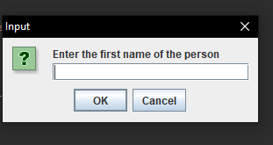

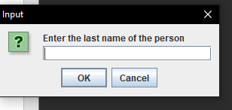

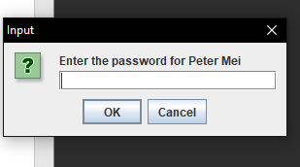

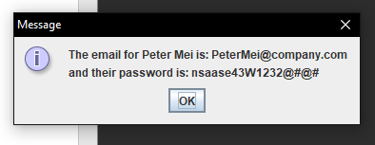

List 5 features you have worked with in this tutorial

JOptionPane

Accessors

Mutators

Constructors

The *this* operator

Describe an application you can build based on the completion of this tutorial.

An application that can use what I did in this tutorial would be a school registrar or an inventory management-based system. This is because an application like this would require the user to enter data that needs to be verified through a database. Then by submitting queries, it will allow the user to search up information through the database.