Constellation Worksheet

**Add URL for repl it**

[constellations - Replit](https://replit.com/@PeterMei/constellations#main.py)

Screenshot of Screen 1:

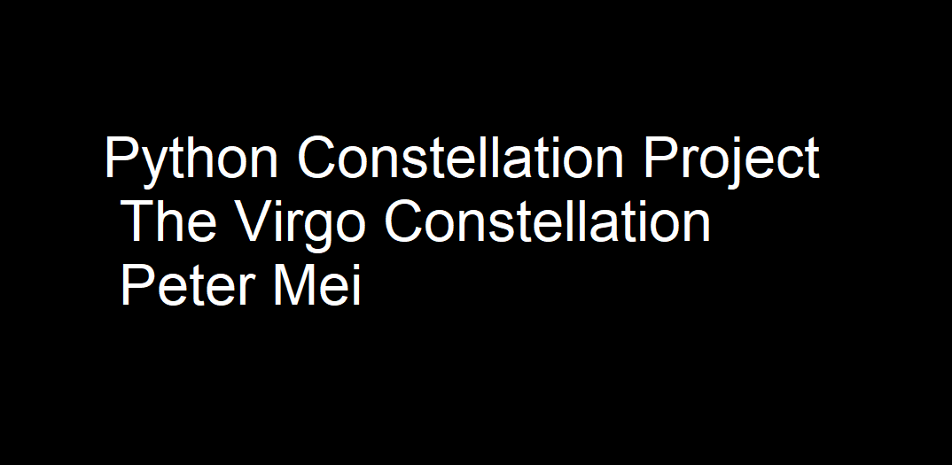

Screenshot of Screen 2:

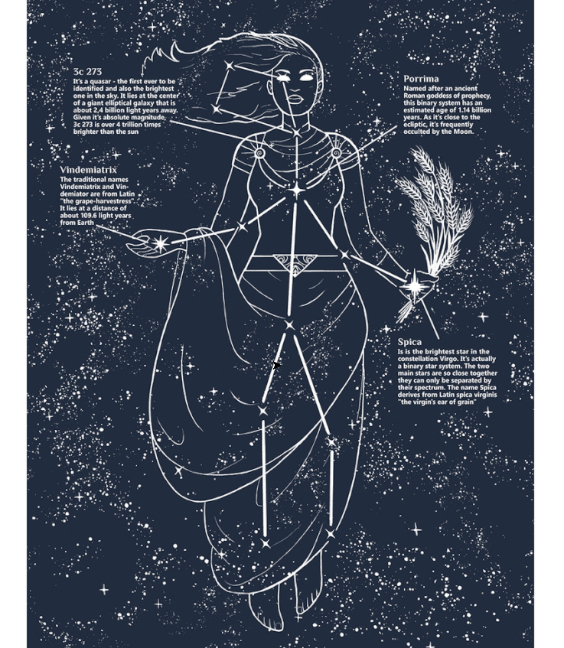

Screenshot of Screen 3:

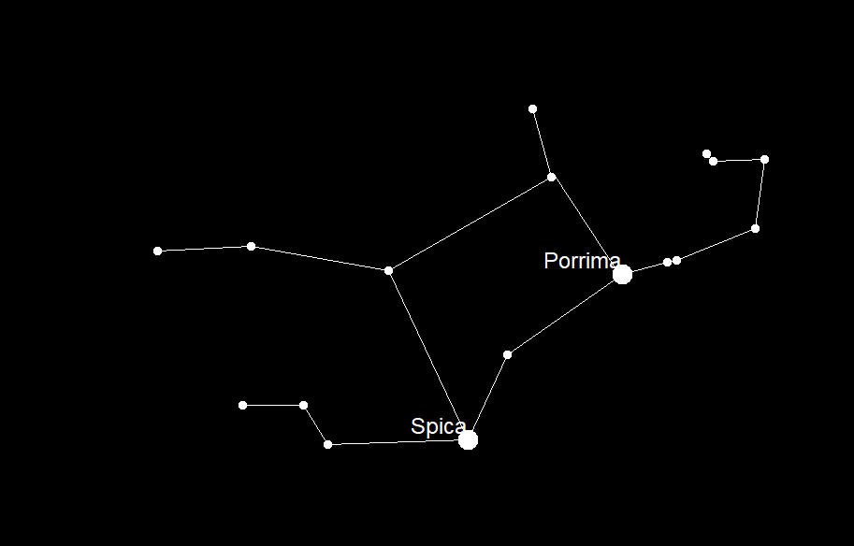

Screenshot of Screen 4:

