CIS 401

Project 3: The PyQt Framework

Part 1: Complete the **PyQt Tutorial**

Add Screenshot of the completed Tutorial

Screenshot 1: Program Run

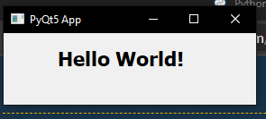

Part 2: Create a Desktop Application **A Mortgage Calculator using the PyQt Framework**

**Add repl.it link**

Screenshot 1: Add Screenshot of the Mortgage Calculator

