CIS 401

Project 4: The turtle Race

**Add a Repl it Link :**

Screenshot 1: Program Run

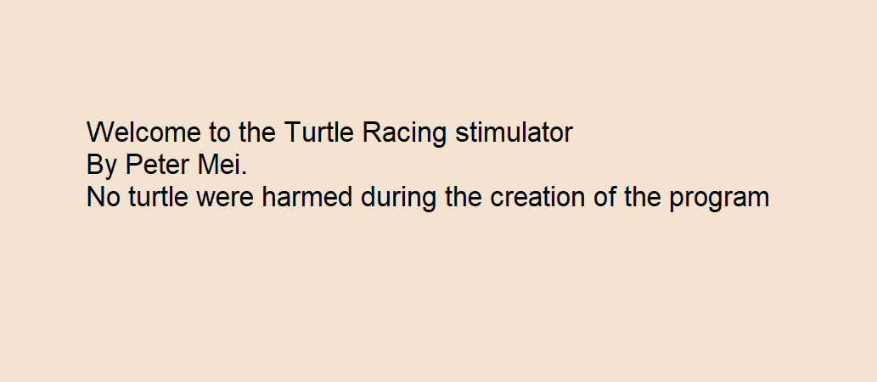

Screenshot 2: Program Run

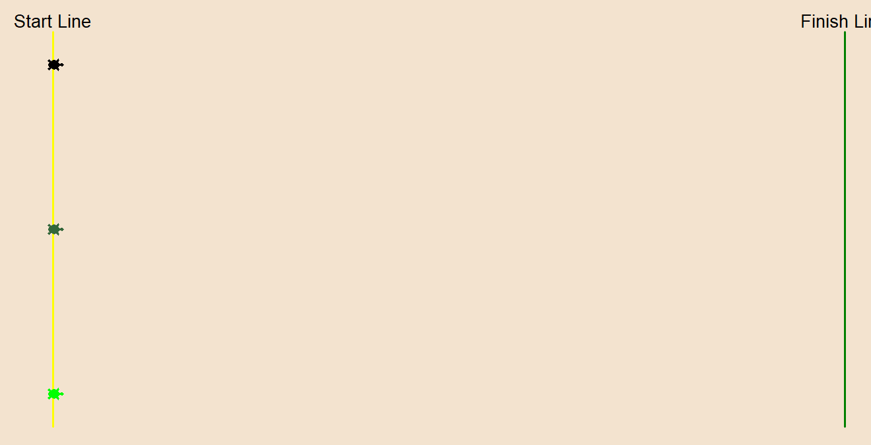

Screenshot 3: Program Run

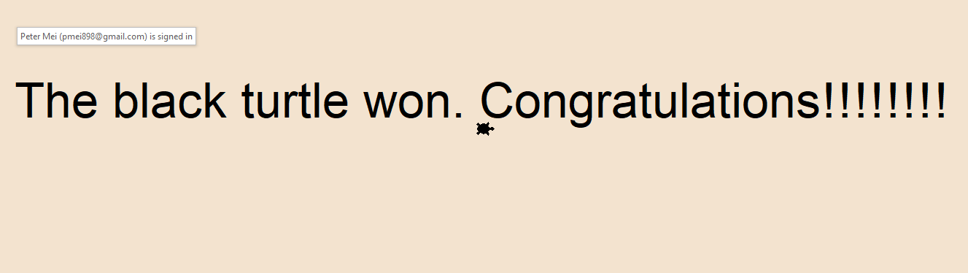

Upload source code from PyCharm