Project 2: Rock Paper Scissor

1. Add the URL of the completed Tutorial: Rock Paper Scissors
2. Also, add the URL to the comment section in Schoology

[rock,paper,scissors - Replit](https://replit.com/@PeterMei/rockpaperscissors#main.py)

1. Add a screenshot of the program run.

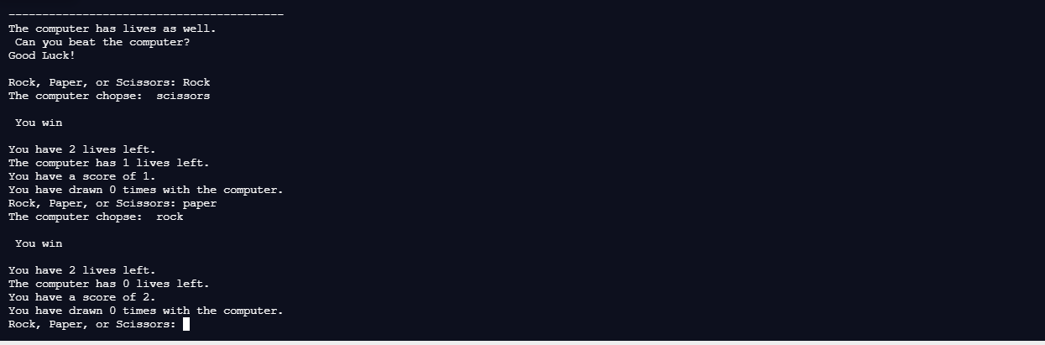

1. Optional: Make changes to the code to reflect your creativity

I made my own

1. Add a screenshot of your design.

