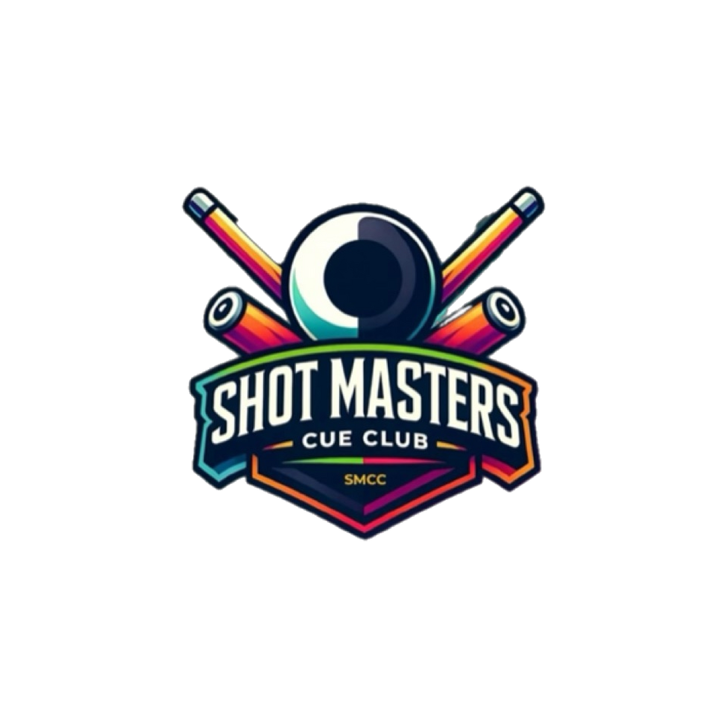

SHOT MASTERS CUE CLUB
OFFICIAL WEBSITE STRUCTURE & CONTENT BLUEPRINT
People • Play • Passion | Website planning document · October 2026

Purpose and positioning
A clear, mobile-friendly website that presents Shot Masters Cue Club (SMCC) as a professional cue-sports club, an inclusive social community and a contributor to sports tourism and positive social impact in Ghana. This document is the proposed information architecture and content brief for the website developer and Club leadership.

1 | Recommended primary navigation
Main menu | Visitor purpose
Home | First impression, news and calls to action
About SMCC | Identity, history, vision, mission, values and governance
Membership | Club culture, membership information and enquiry
Competitions & Events | League, tournaments, upcoming events and results
Gallery & Media | Authentic photos, videos and press coverage
Sports Tourism & Community | Ghanaian culture, charity, sustainability and social interventions
Partnerships | Sponsorship and institutional collaboration
Contact | Official contact form, email and social channels
Primary call-to-action buttons: JOIN / MEMBERSHIP ENQUIRY • UPCOMING EVENTS • PARTNER WITH SMCC. Keep navigation concise on mobile; place policies and less-visited items in the footer.

2 | Sitemap and page content

HOME
- Hero: authentic SMCC event photograph, official logo and People • Play • Passion.
- Introduction: concise overview of SMCC as a professional sporting and social community.
- Highlights: 2025 structured International 8-Ball League; September 2026 anniversary open play; upcoming December Cue Festival.
- Featured event panel with dates, registration link and spectator information, maintained as events change.
- Quick links: About Us, Membership, Competitions, Media and Sponsorship.
- Latest news / announcements, social-feed links and newsletter interest form (optional).

ABOUT SMCC
- Who We Are: cue-sports excellence, social connection, sustainability, charity and social intervention through sport.
- Our Story: transition from Two Shots Pool Club to Shot Masters Cue Club; recognise founders and founding members without specifying a number.
- Vision, Mission and Core Values: People, Play, Passion; use the approved Club profile wording.
- Sporting Identity: International 8-Ball rules and commitment to player education.
- Leadership & Governance: President, General Secretary, Treasurer and Executive Committee; photos and biographies only once approved.
- Key Milestones: 2024 formation and maiden tournament; successful 2025 league and rebrand; 2025 anniversary/tournament; 2026 second anniversary open play.
- Downloadable Official Club Profile in PDF.

MEMBERSHIP
- Reasons to join: structured play, learning, friendship and sportsmanship.
- Membership categories and application criteria as approved by the Club.
- How to apply: enquiry form and contact route; do not publish internal admissions policies without approval.
- Member responsibilities, code of conduct and summary of recognised playing rules.
- Frequently asked questions.

COMPETITIONS & EVENTS
- Upcoming Events: date, venue, format, registration method and spectator details.
- Shot Masters December Cue Festival 2026: Clash of the Titans; 12 December 2026; Borteyman Sports Complex; proposed event details flagged until confirmed.
- Past Events archive with separate pages for the 2025 league, tournaments and September 2026 anniversary.
- Results and recognition: league standings, winners, performance awards and photo reports.
- Rules Education: beginner-friendly International 8-Ball resources, with links to the official rules source.
- Event registration button linking only to the Club-approved ticketing page or platform.

GALLERY & MEDIA
- Photographs grouped by event with dates and captions.
- Video highlights, approved interviews and event recap films.
- Official media releases, posters and downloadable approved promotional assets.
- Image consent and copyright review before publication.

SPORTS TOURISM & COMMUNITY
- Sports tourism: sport, Ghanaian music, dance, food and cultural exchange.
- December in GH participation and Ghana Tourism Authority endorsement presented accurately for the specific festival.
- Community impact: charitable outreach and social interventions, distinguishing actual programmes from planned initiatives.
- Sustainability: responsible events and resource use; publish documented initiatives and future commitments separately.

PARTNERSHIPS
- Why partner with SMCC: tournament visibility, grassroots sporting engagement, community connection and cultural tourism.
- Sponsorship opportunities and event partnership enquiries.
- Partners and sponsors display only with permission and accurate relationship descriptions.
- Downloadable approved sponsorship material or request-a-proposal form.

CONTACT
- Club enquiry form: name, email, subject, message and consent.
- Official SMCC email and website address once confirmed.
- Verified Instagram and other social media handles.
- Location: Accra, Ghana; publish venue address only if appropriate.
- Links for general enquiries, membership, events and sponsorship.

3 | Homepage layout: proposed reading order
01 Header: Logo, navigation and primary call to action
02 Hero: SMCC value proposition and strongest authentic club image
03 Our Club: 150–200-word introduction with About link
04 Sporting Achievements: 2025 International 8-Ball league, tournaments and anniversary milestones
05 Upcoming Event: Event card and registration / attendance details
06 People • Play • Passion: Three-column interpretation of Club values
07 Sports Tourism & Community: Ghanaian cultural experiences, charity and sustainability commitments
08 Gallery: Curated photography and short event video
09 Partner / Join / Contact: Clear calls to action
10 Footer: Contacts, social media, legal information and governance links

4 | Content and branding standards
- Use the official SMCC logo consistently; do not redraw, stretch or recolour it without approval.
- Prioritise genuine, high-resolution SMCC event photography. Label event mock-ups or architectural concepts clearly.
- Visual identity: black, white and electric blue with restrained gold accents; readable typography and accessible contrast.
- Use precise terms: Shot Masters Cue Club (SMCC); International 8-Ball; People • Play • Passion.
- Keep 2026 December festival clearly categorised as upcoming until 12 December 2026; archive it after the event.
- Seek approval for leadership names, founding member attribution, partner logos, sponsor acknowledgements and official registration information.
- Provide a mobile-first layout, compressed responsive images, alt text, secure forms and simple content editing for authorised officers.

5 | Website operational requirements
Area | Minimum requirement
Administration | SMCC-controlled domain and hosting; at least two authorised executive administrators.
Security | HTTPS, multi-factor authentication, access roles, updates and backups.
Content management | Editable pages, event listings, galleries, news and document downloads.
Forms | Spam protection, appropriate privacy notice and routed enquiries.
Search and accessibility | Clear URLs, descriptive headings, image alt text, SEO metadata and keyboard-friendly design.
Analytics | Privacy-conscious site traffic and conversion monitoring.
Media | Fast loading responsive galleries; video embeds where possible.
Handover | Admin credentials, training, content ownership and maintenance plan.

6 | Content required before launch
☐ Confirm the live website domain, general club email and authorised enquiry channels.
☐ Approve official Club Profile wording and leadership information.
☐ Select and caption genuine high-resolution SMCC event photographs; secure usage permissions.
☐ Validate results and historical milestones, including 2025 structured league records.
☐ Prepare current upcoming-event details, registration links and event archive.
☐ Approve any sponsor and institutional logos and descriptions.
☐ Agree on membership enquiry workflow and responsible contact person.
☐ Publish privacy and cookie information appropriate to site operations.

7 | Governance and update workflow
Suggested approval chain: designated website/content manager prepares changes → General Secretary verifies administrative and historical accuracy → President or authorised Executive Committee representative approves sensitive or official announcements → website manager publishes. Emergency corrections should follow a documented rapid-approval process.
The website structure deliberately excludes a standalone “Future Vision” page, in line with the Club’s latest editorial instruction. Future-oriented ambitions may be mentioned briefly within approved mission and relevant programme descriptions, but should not become a separate profile section.
SHOT MASTERS CUE CLUB | PEOPLE • PLAY • PASSION

