Pivot tables in Excel 2013

Contents

1 Introduction 2

1.1 What are pivot tables? 2

1.2 Why use pivot tables? 2

2 Examples 2

3 Setting up data for pivot tables 3

4 Step-by-step instructions on how to create a first pivot table 4

4.1 Plan your table 4

4.2 Insert a pivot table 4

4.3 Initial setup 6

4.3.1 Calculate means (or averages) 7

4.4 Improve the look of the pivot table 9

4.4.1 Change the decimal places shown 9

4.4.2 Make nicer labels 9

4.4.3 Remove “Grand Totals” 10

5 Sample sizes 11

5.1 Count the number of entries before data is entered 11

5.2 Count the number of entered values 13

6 Means and standard deviations 14

6.1 Calculate means 14

6.2 Calculate standard deviations (sd) 15

7 Standard error of the mean (SEM) and coefficient of variation (%CV) 16

7.1 Coefficient of variation (%CV) 16

8 Blank rows 18

8.1 What happens if you include blank rows in the data rectangle? 18

8.2 What can you do about (blank) labels? 19

9 Create a pivot table from the values in another pivot table 20

9.1 Calculate average of sub-samples (or technical reps) 20

9.1.1 Create the first table 20

9.1.2 Hide subtotals and grand totals 22

9.1.3 Use tabular report layout 22

9.1.4 Fill in any “gaps” in the labels 23

9.2 Create a pivot table from another pivot table 24

10 Using filters with pivot tables 26

11 Sorting and changing the order of rows and columns 27

11.1 Use sort options to order row and column labels 27

11.1.1 Sort rows alphabetically in reverse 27

11.1.2 Sort rows by values 28

11.2 Manually sorting row and column labels 29

12 More complex table layouts 30

12.1 Tables with more than one summary 30

12.1.1 Several calculations for the same variable 30

12.1.2 Several variables in one table 31

12.1.3 A 3-way or 4-way table 32

13 Pivot charts? 34

14 Refreshing the pivot table 34

14.1 Manually refresh a pivot table 34

14.2 Automatically update a pivot table when file is opened 34

15 Adding to an existing table 35

15.1 Adding new rows of data 35

15.1.1 Add rows to the end of the data 35

15.1.2 Insert rows into the data source 36

15.1.3 Use an “over-size” data source range 37

15.2 Adding new columns of data 37

15.2.1 Adding new columns to the right of the data 37

15.2.2 Insert columns into the data source 38

16 Rearranging the raw data layout 39

16.1 Changing “wide” data to “long” (stacking data columns) 39

17 When Pivot tables aren’t enough 43

# Introduction

This guide gives instructions on how to use pivot tables in Excel 2013, and has been written by PFR biometricians with feedback from researchers.

## What are pivot tables?

Pivot tables are a flexible way of creating summary tables of results in Excel.

## Why use pivot tables?

The main reason to use pivot tables for data summaries is that the summaries can be obtained without rearranging the data from the ideal format ([see these guidelines](https://iplant.plantandfood.co.nz/project/datamgmt/Documents/best_practices_excel_data_file.docx)).

Another reason to use pivot tables for data summaries instead of formulae is that no formulae are needed. Although summaries are easily calculated using formulae when just a single number is needed, when summary values are required for several groups (e.g., each level of a treatment factor, perhaps at different sites) then the formulae become numerous and more difficult to maintain, and users are more likely to rearrange data into inappropriate layouts so as to accommodate this. Pivot tables don't use formulae and are much easier to modify and maintain than multiple formulae.

# Examples

The following are examples of datasets with pivot tables from research done at PFR.

Example 1

Disease incidence and severity and crop loss in grapes on several dates – the pivot table calculates means.

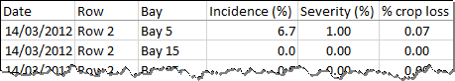

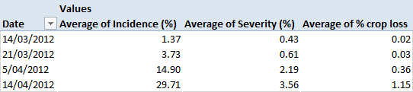

Example 2

Fungal growth under different concentrations of a fungicide – the pivot table calculates means for two experiments.

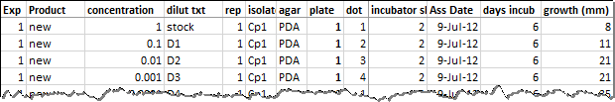

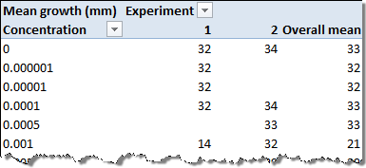

# Setting up data for pivot tables

To create a pivot table requires a dataset arranged in a single rectangle with data in a list down the columns with a row of unique column titles at the top.

Data is in lists going down columns

Every column has a title

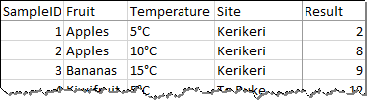

* If a column title is missing (i.e, there is a blank cell instead), then Excel will give an error.

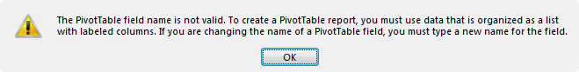

* If a column title is duplicated, then Excel will add a number to the name wherever it appears in a pivot table. For example, if there were three different columns titled “Result”, the pivot table would use “Result”, “Result1”, and “Result2” to label the pivot table output.

# Step-by-step instructions on how to create a first pivot table

## Plan your table

* First think about how you want the table arranged, and what summary you want calculated.
* In this contrived example, we want a table with Site down the rows and Fruit across the columns. The summary values will be the mean of the “Result” variable. The table might look something like this:

|  |  |  |  |
| --- | --- | --- | --- |
|  | Fruit | | |
| Site | Apples | Bananas | Kiwifruit |
| Kerikeri | - | - | - |
| Te Puke | - | - | - |
| Motueka | - | - | - |
| Clyde | - | - | - |

## Insert a pivot table

* Ensure that the data are suitably arranged for use in a pivot table (see Section 3 above). Select the data including the heading row.

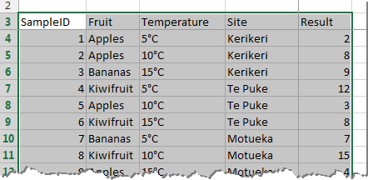

* Use the ribbon: Insert tab > Tables group > PivotTable.  
  A dialogue box will appear. By default the pivot table will be placed in a new worksheet (a new tab) in the file you are working on. This is most convenient when you are learning to use pivot tables as this means that there is no possible way the pivot table can collide with existing data. It also encourages the good practice of keeping your analysis separated from your data (something biometricians recommend you do).

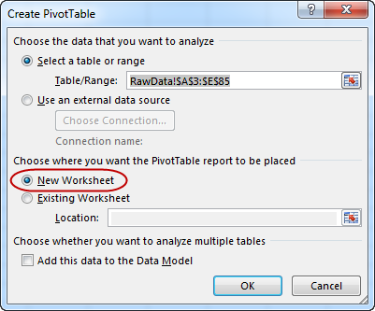

* Click [OK] or press [Enter] to continue.
* A new sheet will be created. Depending on the names of the existing sheets, the new sheet will be named either Sheet1 or Sheet2, etc. At the left of the new sheet is a blank pivot table with some brief instructions.

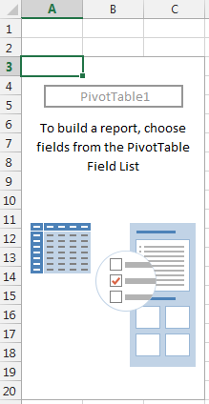

* At the right of the sheet is the pivot table Fields List. This is used to create the layout of the table.

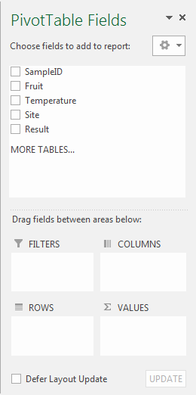

Fields for the results that will be calculated go here

Fields for the column labels go here

Fields for the row labels go here

Titles from the data that was selected

## Initial setup

* Drag-and-drop the appropriate titles (called “fields”) into the appropriate Columns, Rows, and Values boxes. In this case, drag-and-drop Fruit into the Columns area, Site into the Rows area, and Result into the values area. As each field is added, the pivot table updates to reflect the change. The PivotTable Field dialogue and the resulting pivot table are shown below with coloured circles highlighting the chosen fields.

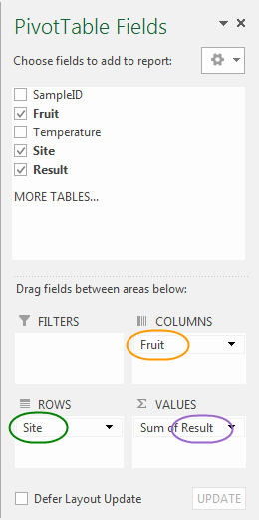

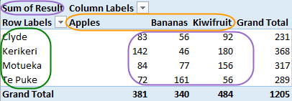

### Calculate means (or averages)

* Note that by default, Excel has calculated the **sum** of the values. To change the calculation to the average, right-click on any of the *values* in the pivot table then select: Summarize Values By > Average.

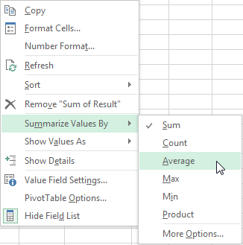

* Alternatively, use the “Value Field Settings…” dialogue by either right-click on a pivot table value > Value Field Settings…, or click on the Result dropdown (showing as “Sum of Results”) in the values box and choose Value Field Settings…  
  In the Value Field Settings dialogue box, select Summarize value field by: Average.

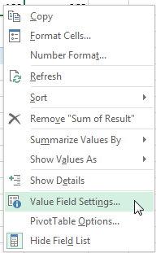 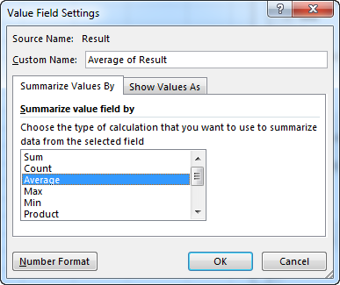

* The pivot table will now show the averages. Note that the “Grand Total” row at the bottom and column at the right are now the averages.

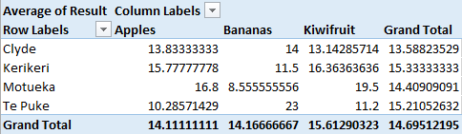

## Improve the look of the pivot table

### Change the decimal places shown

* We can improve the appearance of the pivot table by showing the means to only one decimal place. Right-click on any number in the pivot table > Number Format…, then in the Format Cells dialogue box that appears, select Number, and set Decimal places to 1.

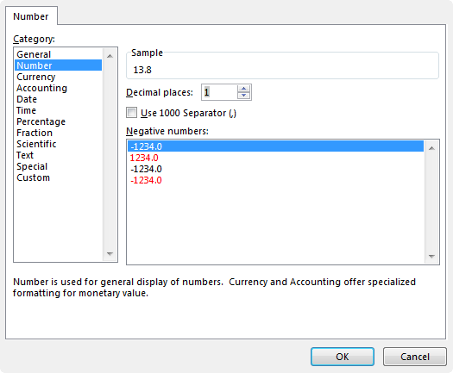

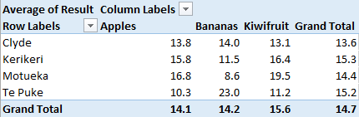

### Make nicer labels

* We can also edit the labels used on the pivot table. The pivot table has produced default labels of “Average of Result”, “Column Labels”, “Row Labels” and “Grand Total”. To edit any of these labels, simply select the cell (either by using arrow keys or by clicking on the cell) and type in the new label.

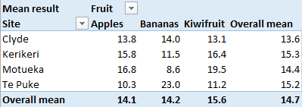

### Remove “Grand Totals”

* By default, a pivot table contains grand totals (here relabelled as “Overall mean”). These can easily be removed if needed. Ensure the pivot table tools are visible in the ribbon by clicking anywhere on the pivot table. On the ribbon: Design tab > Layout group > Grand Totals dropdown, select the option that suits. In this example, the “totals” will be removed from both rows and columns.

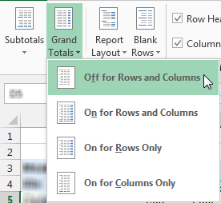

* The finished pivot table of means.

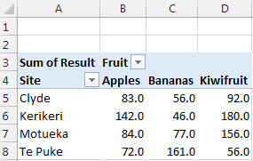

# Sample sizes

A simple use of pivot tables is to count the number of entries in a dataset. This can be done by counting either the entered result values or by counting the rows of one of the factor columns.

## Count the number of entries before data is entered

Typically, an experiment or trial is planned and the data spreadsheet can be setup before any data is collected. This may well have been done for you by a biometrician when they created the randomisation for the sampling or treatment allocations.

* In this example, we want to know how replicates there are of each of the “Fruit” and “Temperature” treatments.

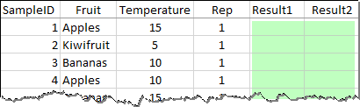

No data entered yet

* First, create the pivot table in the usual way (see Section ). For the “VALUES” field, use one of the row or column factors. In this example, we can use either “Fruit” or “Temperature”. Because the “Fruit” contains text labels, Excel will default to providing a Count of Fruit. In contrast, because “Temperature” contains only numbers, Excel defaults to providing a Sum of Temperature.

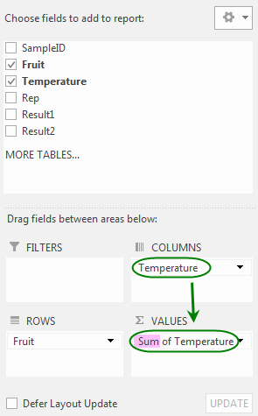

Change “Sum” to “Count”

“Temperature” is both a Column field and a Value field.

* To change the calculation from sum to the count, right-click on any of the *values* in the pivot table then select: Summarize Values By > Count.

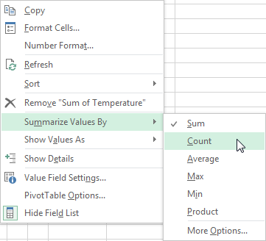

* Alternatively, use the “Value Field Settings…” dialogue by either right-click on a pivot table value > Value Field Settings…, or click on the Result dropdown (showing as “Sum of Temperature”) in the values box and choose Value Field Settings…  
  In the Value Field Settings dialogue box, select Summarize value field by: **Count**.

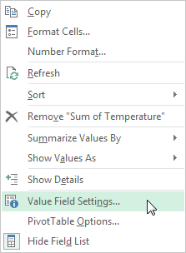 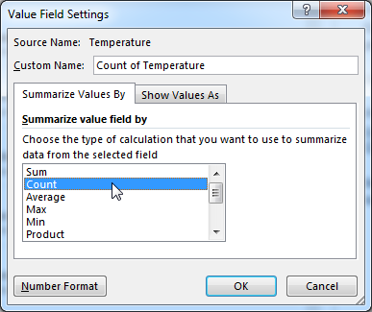

* The pivot table should now show counts of the combinations of rows and column factors. These count equal the number of rows available for data in the dataset.

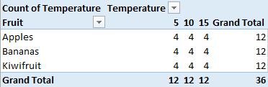

## Count the number of entered values

After data has been entered into a dataset, the number of entered values can easily be obtained using a pivot table.

* First, create the pivot table in the usual way (see Section ). Ensure that you use the data column that is the variable of interest as the “VALUES”. In this example, we want to know how many values there are for “Result2” (which has some empty cells).

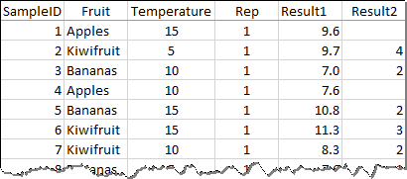

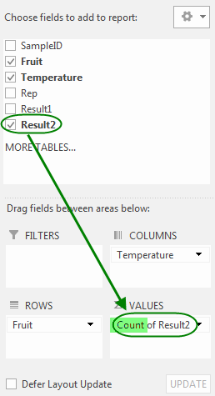

* The pivot table values may be counts already, but if not (they would likely show as a “Sum of …“, then change the calculation type to “Count” (see Section 5.1 above).
* In this case, there are several counts that are not as expected (all values should be 4 with a grand total of 36, see the pivot table in Section 5.1 above). Two of the Apple temperature treatments have 3 values instead of 4, and the Bananas, temperature 5 combination has no entered data at all. NB: any zero counts are shown as blank rather than “0”.

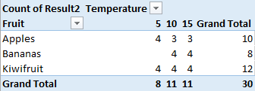

Zero counts are shown as blank

# Means and standard deviations

The default summary created by a pivot table is either the sum of the values or the count of the number of values. It is easy to change this summary to the mean or standard deviation.

## Calculate means

To calculate means, first create the pivot table in the usual way (see Section 4 above).

* Then, either right-click on any value in the pivot table > Summarize Values By > Average

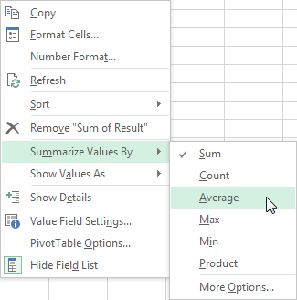

* Or, right-click on any value in the pivot table > Value Field Settings…
* In the dialogue that appears, select “Average”, the press [Enter] or click [OK].

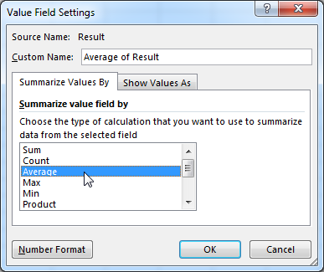

## Calculate standard deviations (sd)

To calculate standard deviations, first create the pivot table in the usual way (see Section 4 above).

* Then, either right-click on any value in the pivot table > Summarize Values By > More Options…

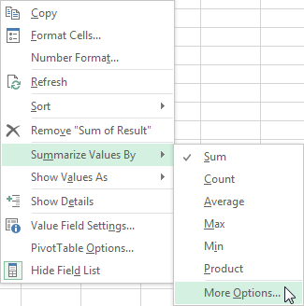

* Or, right-click on any value in the pivot table > Value Field Settings…
* In the dialogue that appears, select “StdDev”, the press [Enter] or click [OK].

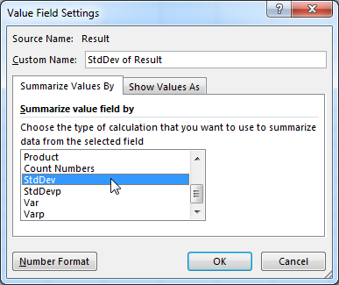

**Note:** Do NOT use “StdDevp” (which is population standard deviation). You are unlikely to ever need this value; if you think that you do, you are recommended to check this with a biometrician.

# Standard error of the mean (SEM) and coefficient of variation (%CV)

You cannot get either the standard error of the mean (SEM) or the coefficient of variation (%CV) to appear directly in a pivot table in Excel 2013. However, you can use pivot tables to help with the calculation. The SEM = and %CV = where *s* = standard deviation, *n* = sample size, and = sample mean. You can create two pivot tables, one to display the standard deviation, and for the SEM, the other to display the sample size, or for %CV the mean, and then use formulae to calculate the SEM or %CV values somewhere adjacent to the pivot tables.

## Coefficient of variation (%CV)

To create a table of %CV values (coefficient of variation) two pivot tables are needed, one showing standard deviations, the other showing means.

In this example, a pivot table of standard deviations will be created on a new sheet, then a pivot table of means will be created beside it

* First, create a pivot table showing the standard deviations (see Sections 4 and 6.2 above).

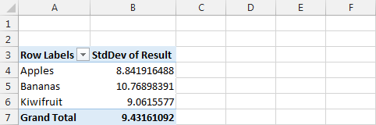

* Then, add a pivot table showing the means. In this example, we will place the means table beside the s.d. table (rather than on a separate sheet). Select the same data and use the ribbon: Insert tab > Tables group > PivotTable.
* In the “Create PivotTable” dialogue, change “New Worksheet” to “Existing Worksheet” and pick a location beside the s.d. pivot table.

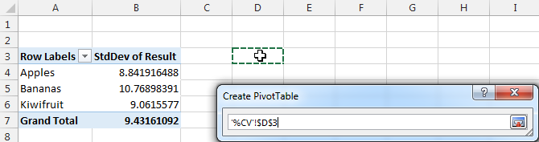

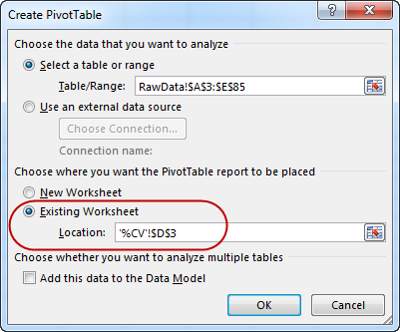

* Make a pivot table of means (see Section 6.1 above) with the **same layout** as the table of standard deviations.

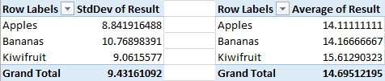

* Before making the formula for the calculation of %CV, ensure that the pivot table setting “Generate GetPivotData” is unchecked. To do this, click anywhere on any pivot table, then use the ribbon: Analyze tab > PivotTable group (which is on the very left of the ribbon) > Options dropdown. If “Generate GetPivotData” shows a tick, select this item to turn the tick off.

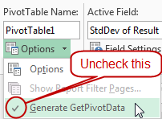 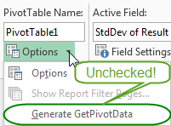

This setting applies to all pivot tables and, although not essential, it makes easier the creation of formulae that use pivot table results.

* Create the coefficient of variation formulae. In some convenient location, probably either to the right of or below the pivot tables, enter the formula to calculate .

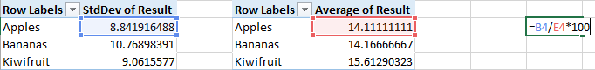

* Copy the formula to all of the appropriate cells (in this example, down the next two rows).
* You can also copy labels across (using formulae is best) and reduce the number of decimal places displayed.

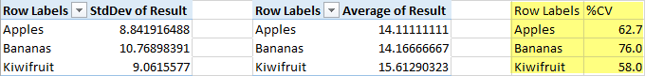

* Note, an alternative to creating two tables is to have the standard deviation and the mean both appear in the same table. This can work well for 1-way tables, but not for 2-way tables or those with more complex layouts.

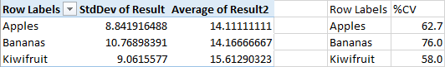

# Blank rows

Blank rows are unnecessary in a dataset – they add nothing to the data, but are sometimes added by users wanting to have visual breaks in the list of data. They can, however, be temporarily included at the bottom of a dataset in preparation for further data entry.

## What happens if you include blank rows in the data rectangle?

When blank rows are included in a dataset, then pivot tables will include an extra “(blank)” category for each row and column field.

Here is an example dataset that includes blank rows:

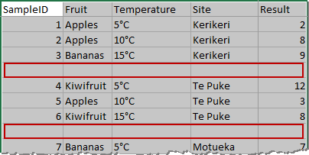

A blank row…

A 2nd blank row…

The resulting pivot table has a (blank) category added to both the rows and columns:

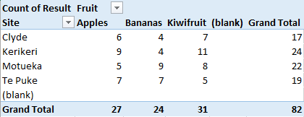

(blank)

## What can you do about (blank) labels?

If you are happy to have the “(blank)” label used in the table, you need do nothing. However, if you want to eliminate the “(blank)” labels, simply edit the dataset and delete the blank rows from within it. If the blank rows are at the bottom of the dataset in preparation for further data entry, then you can either change the pivot table data source to exclude these rows, or enter the values you know into the fields used for the pivot table rows and columns (these are usually treatment or replicate info).

Alternatively, if you must have the blank rows in the dataset yet want to remove the labels from the pivot table, then you can selectively exclude the “(blank)” labels.

* On the pivot table, click on the dropdown for the field containing the “(blank)” labels. In this example, the “Fruit” dropdown was clicked. In the dialogue box that appears, deselect “(blank)” and press [Enter] or click [OK].

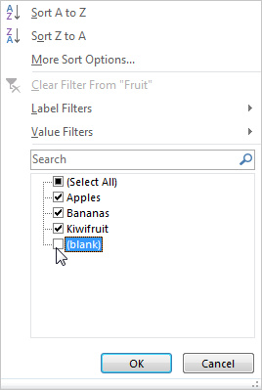

Deselect (blank)

* The pivot table is updated to exclude the “(blank)” labels from the Fruit field. Because the “(blank)” fruit are also the blank sites, using a filter on Fruit also removes the “(blank)” label from the Site rows.

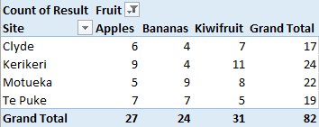

# Create a pivot table from the values in another pivot table

Sometimes you need to create a pivot table from data in another pivot table. A typical example of this is when each replicate of a treatment (sometimes known as a “biological rep”) has data collected from each of several sub-samples (sometimes known as a “technical reps” or “lab replicates”). To get the treatment means, first you would average the sub-samples (for each treatment and biological rep), then for each treatment you would calculate the mean of the sub-sample means. The two stages of calculation can be done using two pivot tables.

## Calculate average of sub-samples (or technical reps)

Collection of data from sub-samples or taking a measurement (or performing an assay) several times from the same sample is typically done when the measurement (or assay) result is known to vary, or the measurement process has some uncertainty, and so the researcher takes several measures and then averages those to get a single more reliable result for each sample. It is the averages (rather than the sub-sample results) that are then used for further analysis.

Note, if you want find out more about why you should average the results of such sub-samples or “technical” reps, please talk with any of the [PFR biometricians](https://iplant.plantandfood.co.nz/biometrics/Pages/WhoWeAre.aspx).

Some examples of research that would generates results from “sub-samples” are:

Example 1: Separate apple trees had different fungicide treatments applied to them. From each tree, 20 fruit were assessed for the effects of disease. Each apple is a sub-sample of the tree that received the treatment.

Example 2: Soil samples taken from different regions were assessed for their hydrophobicity using a test which measures the time taken for a drop of water to go into soil. Each soil sample was assessed three times.

### Create the first table

In the following example, each individual sample (denoted by SampleID) has been assessed in triplicate (as indicated by the Triplicate column in the screenshot below).

To calculate the averages:

* First create the pivot table in the usual way (see Section 4 above).
* Make the calculation be averages (see Section 6.1 above).

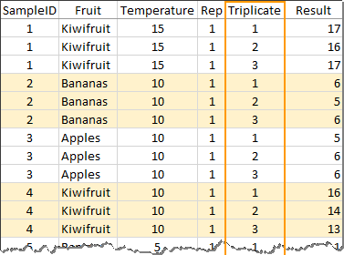

The layout of the pivot table is created by using all of the data columns that uniquely identify the samples as the Row fields. This will include any treatment factors as well as any blocking factors (such as Block, Rep, Tree, Orchard Row, Batch, Run, etc.) that describe the statistical design of the experiment.

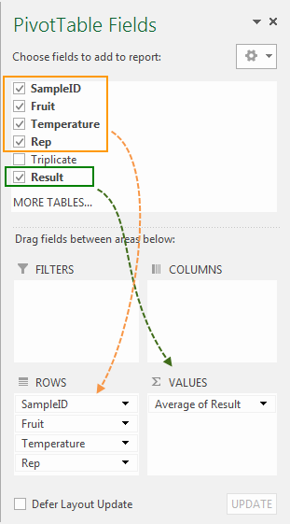 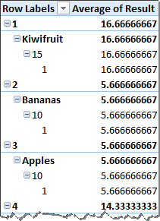

### Hide subtotals and grand totals

The subtotals and grand totals need to be removed:

* To remove or hide the subtotals, first click anywhere on the pivot table to ensure that the pivot table tools are visible in the ribbon. Then, on the ribbon: Design tab > Layout group > Subtotals dropdown > Do Not Show Subtotals.
* Similarly, to remove or hide the “grand totals” (also see Section 4.4.3) use the ribbon: Design tab > Layout group > Grand Totals dropdown > Off for Rows and Columns.

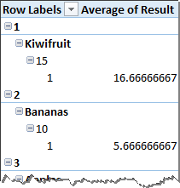

Subtotals have been hidden

### Use tabular report layout

Excel has three different forms of report layout. The default is the Compact form which puts all of the row labels into a single column. The Outline form puts the row label fields (if there are more than one) into separate columns but on different rows, and the Tabular form additionally puts the row labels into the same row. It is the tabular form that we need because this creates a rectangular data layout suitable for use in further data analysis.

* To use the tabular form, first click anywhere on the pivot table to ensure that the pivot table tools are visible in the ribbon. Then, on the ribbon: Design tab > Layout group > Report Layout dropdown > Show in Tabular Form.

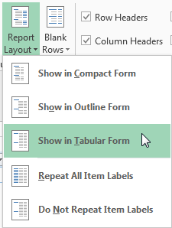

The resulting pivot table has the row fields (SampleID, Fruit, Temperature, Rep) in separate columns, and the labels for each average in the same row.

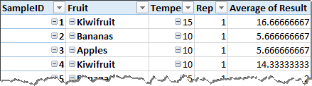

Note that a count of the Result variable shows (in a separate pivot table below) that the sample size for each row in the pivot table is 3 (because there are 3 triplicates summarised in each row value).

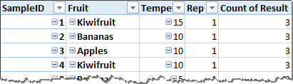

### Fill in any “gaps” in the labels

In the example above there is a single field (a column in the data) that contains a unique sample identifier (i.e., SampleID) that uniquely identifies each sample. If, for example, SampleID was not present and the samples were instead uniquely identified by the combination of two or more other columns (in this case, Fruit, Temperature and Rep), then the tabular layout will produce a pivot table with “gaps” in the labels.

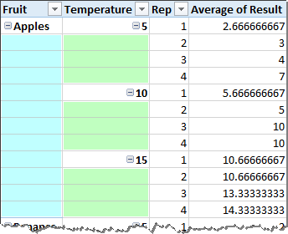

Gaps in the Fruit and Temperature labels

To fill the gaps in the labels:

* Use the ribbon: Design tab > Layout group > Report Layout dropdown > Repeat All Item Labels

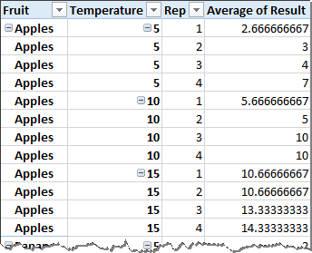

## Create a pivot table from another pivot table

**NB:** Before creating a pivot table from the values in another pivot table, **ensure that the first pivot table** is set up suitablyand **has no subtotals or grand totals showing** (see Section 9.1.2), **and uses a tabular layout** (see Section 9.1.3) **without any gaps in the row labels** (see Section 9.1.4).

To create a second pivot table from the first one:

* First make sure that you have selected a cell that is **not** part of a pivot table (otherwise the Insert PivotTable option will be greyed out).
* Use the ribbon: Insert tab > Tables group > PivotTable.
* In the Create PivotTable dialogue, you need to select the data range to be **all of the values and heading row of the first pivot table**. You are recommended to place the second pivot table on a new worksheet. Click [OK] to close the dialogue.

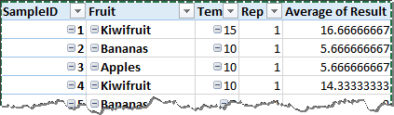

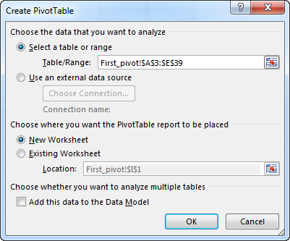

Then create the pivot table by arranging the fields into the desired columns and rows, and by selecting the appropriate calculation for the results (see Section 4.3 above). In this example, the mean result will be calculated for the combinations of Fruit and Temperature:

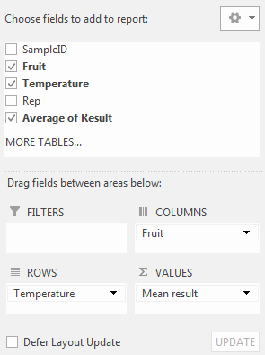 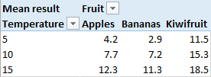

# Using filters with pivot tables

In addition to choosing which fields to use for the row or column labels, you can also choose one or more fields to be overall filters for the pivot table. In the example below, the Fruit field has been added as a filter, and the results filtered to show only those results from Apples.

* To enable filtering, click anywhere in the pivot table to make the PivotTable Fields dialogue appear, then drag-and-drop the desired filter field (in this case, “Fruit”) into the “FILTERS” area.

Pivot table without a filter

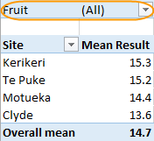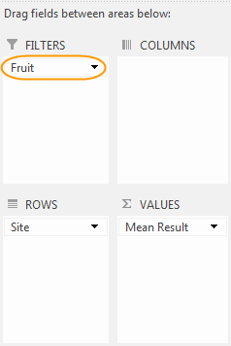

Filter enabled for “Fruit”

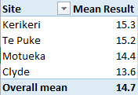

* To apply a filter, click on the filter field’s dropdown, and select from the list shown. Here “Apples” is selected.

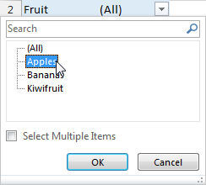

* Press [Enter] or click [OK] and the filter will be applied. The pivot table now shows a subset of the available results – only the means for Apples are shown

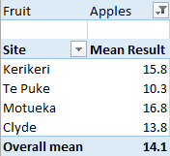

Filter is applied, limiting the results to those for “Apples”

# Sorting and changing the order of rows and columns

By default, Excel sorts column and row labels into alphabetical (or numerical) order. The order of rows (or columns) can be changed by either sorting using built-in sort options or manual rearrangement.

## Use sort options to order row and column labels

### Sort rows alphabetically in reverse

The default appearance of text labels is to sort them alphabetically from A to Z. It is easy to reverse this sorting so that the labels are sorted from Z to A instead.

To sort row labels alphabetically in reverse order:

* Create the pivot table of means.
* Either click on the dropdown for the field, then select “Sort Z to A”.

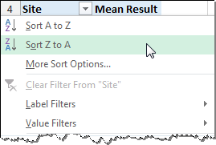

* Or, right-click on any of the labels > select Sort > “Sort Z to A”.

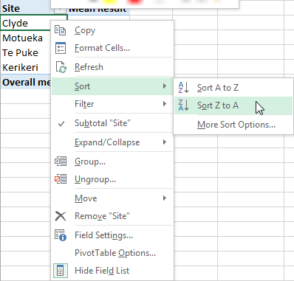

* The rows (Sites) will now be sorted in reverse alphabetical order.

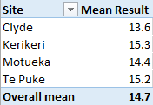 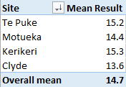

Sorted in default order:

- alphabetical

(A to Z)

Sorted in reverse order:

- alphabetical

(Z to A)

### Sort rows by values

It is possible to sort the pivot table rows (or columns) by the values themselves. For instance, you can sort a table of means to be in order of lowest to highest mean.

To sort means in order from lowest to highest:

* Create the pivot table of means.
* Right-click on any of the mean values > Sort > Sort Smallest to Largest.

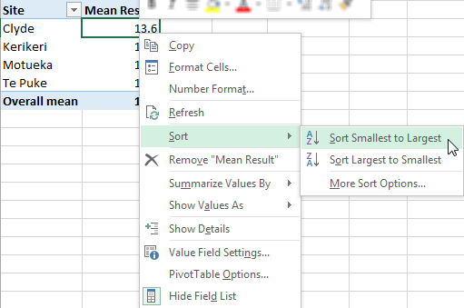

* The rows (Sites) will now be sorted in order of the means.

 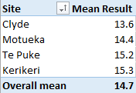

Sites sorted alphabetically

Sites sorted in increasing order of mean

## Manually sorting row and column labels

Row and column labels can be reordered manually using the mouse to drag-and-drop each label into a new position.

In this example, during the creation of the pivot table the site labels were sorted alphabetically (Clyde, Kerikeri, Motueka, Te Puke). To rearrange these so that they are in geographical order (from north to south: Kerikeri, Te Puke, Motueka, Clyde):

 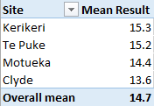

* To move “Clyde” to the bottom of the list, hover the mouse over the edge of the Clyde label cell until the “move” pointer appears (four small arrows), then click and drag the mouse down until the indicator is at the bottom of the list. Release the mouse button and Clyde will have been moved.

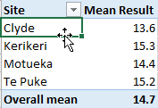 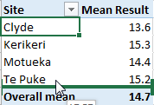 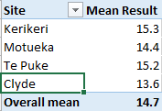

* Similarly, move “Te Puke” above “Motueka”. Hover the mouse over the edge of the Te Puke label cell until the “move” pointer appears, then click and drag the mouse up until the indicator is above Motueka. Release the mouse button and Te Puke will have been moved.

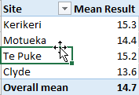 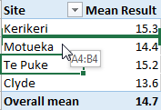 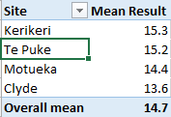

Manual sorting can be applied equally well to columns as to rows.

# More complex table layouts

## Tables with more than one summary

### Several calculations for the same variable

A variable can be added to a pivot table not just once but multiple times so that several calculations can be made on that variable within a single pivot table. For example, you can show the mean, standard deviation, and sample size for a variable all in the same pivot table.

In the following example, for each fruit type the mean, s.d. and sample size are calculated for the “Result” variable:

* To begin, create the pivot table showing the average of the variable (see Section 4 above). Note that in the pivot table shown below some of the titles have been edited and the means formatted to display only one decimal place.

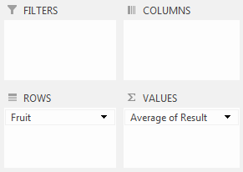 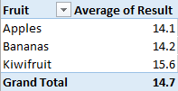

* To add the standard deviations, in the PivotTable Field dialogue, drag the “Result” variable again into the “Values” box. Then change the calculation to “StdDev” (see Section 6.2).
* To add the sample sizes, in the PivotTable Field dialogue, drag the “Result” variable into the “Values” box a third time. Then change the calculation to “Count” (see Section 5.2).

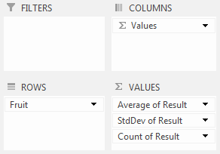

“Result” appears 3 times with a different calculation

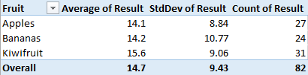

* Note that after dragging the “Result” variable into the “Values” box several times, if the calculation is the same for two or more instances of the variable, then Excel will **rename** the variable in the pivot table. For example, the second and third instance of “result” will be renamed “Result2” and “Result3”. Excel does this because it does not allow two calculated results to have the same title.

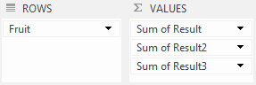

* To correct the titles, **first** change to calculation to the one desired (see Sections 6.1, 6.2 and 5.2), **then** edit the titles (see Section 4.4.2).

### Several variables in one table

A pivot table need not be limited to the results from a single variable but can include results from more than one variable. For example, for a dataset containing results for “Length”, “Weight” and “pH”, you could show the means for all three variables all in the same pivot table.

* To begin, create the pivot table by dragging-and-dropping “Site” into the Rows box, and “Length” into the Values box of the PivotTables Fields dialogue (see Section 4.3). Then, drag-and-drop the “Weight” and “pH” variables into the Values box.

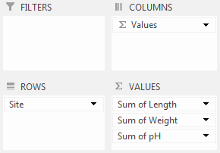

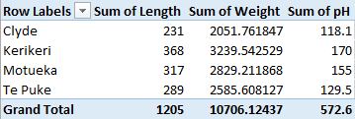

* Then change the calculation for each field from the default **Sum** to the desired **Average** (see Sections 4.3.1 or ). Note that in the pivot table shown below some of the titles have been edited, and the means formatted to display only one decimal place.

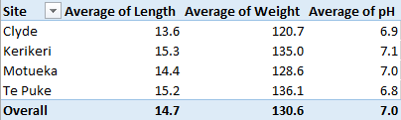

### A 3-way or 4-way table

A pivot table need not have just one row or column field, but can have several (the actual number is limited only by the computer memory available).

* To create a 3-way pivot table, either create a new table (see Section 4 above) or edit an existing table.

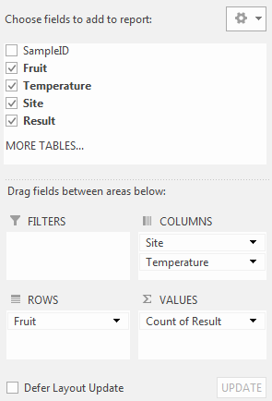

Two fields used for columns:   
“Site”, then “Temperature”

The resulting pivot table (which has been edited to remove subtotals and grand totals) has two sets of Column labels, the first row is Site, and the second row is Temperature.

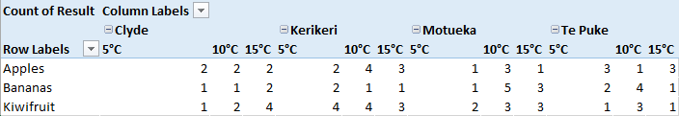

* To rearrange the pivot table, click on anywhere in the pivot table to make the PivotTable Fields dialogue appear, then drag-and-drop the fields into the new arrangement. In the example below, the Temperature field has been dragged from the Columns box to the Rows box so that the table rows are now representing both the Fruit and Temperature.

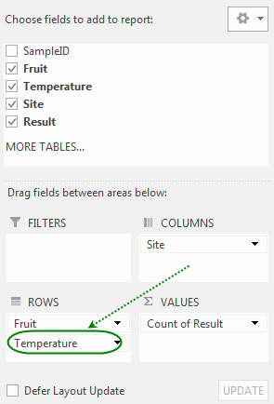

Two fields used for rows:  
“Fruit” and “Temperature”

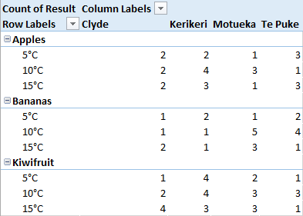

# Pivot charts?

Pivot charts do not seem to be a lot of use – a trellis plot by a statistics package is usually much better. One limitation of pivot charts is that you cannot create x-y scatter plots – Excel always uses a category-type axis which puts that categories at equal spacing from each other regardless of any numerical values involved. For example, if samples were taken at 1, 2, 4 and 8 hours, then the pivot chart would space these times equally:  rather than .

# Refreshing the pivot table

WARNING: unlike calculated formulae, pivot tables do **NOT** automatically update when the source data has been changed. They need to be refreshed in order to be recalculated.

## Manually refresh a pivot table

If you change any of the data, the pivot table needs to be refreshed before the new data can appear in the table.

To refresh a pivot table:

* Either, click anywhere in the pivot table and use the keyboard shortcut [Alt+F5].
* Or, right-click anywhere in the pivot table and select “Refresh” from the menu.



* Or, click anywhere in the pivot table and use the ribbon: Analyze tab > Data group > Refresh dropdown > Refresh.

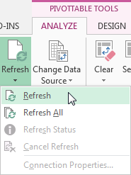

## Automatically update a pivot table when file is opened

To have a pivot table automatically refresh whenever the spreadsheet file is opened:

* Click anywhere in the pivot table and use the ribbon: Analyze tab > PivotTable group > Options dropdown > Options.

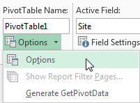

* In the PivotTable Options dialogue that appears, select the “data” tab and tick “Refresh data when opening the file”. Click [OK] or press [Enter].

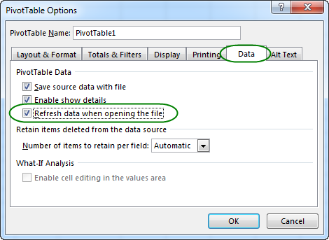

# Adding to an existing table

## Adding new rows of data

After creating a pivot table, if you add more data to the source for the pivot table then you need to ensure that this data is added to the pivot table calculations. There are several ways that this can be done.

### Add rows to the end of the data

After adding extra rows of data to the bottom of a pivot table data source, the data source needs to be updated. To update the data source:

* Click anywhere on the pivot table to ensure that the pivot table tools are visible in the ribbon.
* On the ribbon: Analyze tab > Data group > Change Data Source
* The “Change PivotTable Data Source” dialogue will appear.

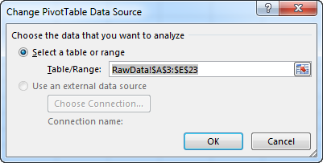

* The cells used for the data source are shown:

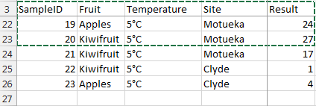

New data rows to be added

* Extend the selection to include the extra rows(**Tip**: hold down the Shift key and press [Down arrow] to extend the selection downwards):

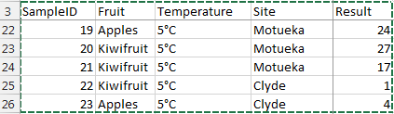

* After pressing [OK] in the dialogue box, the pivot table will be updated (the data will be added to the pivot table data source and the pivot table will be refreshed so as to include the new data in the calculations).

### Insert rows into the data source

One way to add new rows of data to a pivot table **without** changing the data source is to **insert** the new rows of data into the existing data source rows. To do this:

* In the source data for the pivot table, insert one or more blank rows ABOVE any of the existing rows. (Note that if you instead insert rows below the data range, you will need to extend the data source range as explained in Section 15.1.1 above.)
  + Either, click on a cell in one of the existing data rows, then use the ribbon: Home tab > Cells group > Insert dropdown > Insert Sheet Rows,
  + Or, click on a cell in one of the existing data rows, then right-click > Insert… > Entire row,
  + Or, click on a row number of one of the existing data rows to select the entire row, then right-click > Insert.
* Enter the data into the newly inserted rows.
* Manually refresh the pivot table (see Section 14.1 above).

### Use an “over-size” data source range

One strategy for setting up a pivot table when the data are not yet all entered is to simply include extra empty rows at the bottom of the data source for future data entry. This situation might occur when measurements or samples are taken at different times and you want to produce a pivot table for the results obtained so far. For example, if an experiment will produce 60 rows of data but so far only 20 rows of data have been entered, then when setting up the pivot table select a range of data cells that includes not only the available entered data rows but an additional 40 blank rows for data yet to be entered.

Note that as new data is entered, the pivot table **needs to be refreshed** (see Section 14.1 above) before the data appear in the table. Also note that having blank rows present in the data will cause “(blank)” to appear as a row or column label (see Section 8.1 on page ).

## Adding new columns of data

After creating a pivot table, as with adding rows (Section 15.1 above), it is possible to add further columns of data. There are a couple of ways that this can be done.

### Adding new columns to the right of the data

After creating a pivot table, further columns of data may be added, e.g., as new data is collected. After adding any columns of data to the right of a pivot table data source, the data source needs to be updated before the extra columns can be used in the table. To update the data source:

* Click anywhere on the pivot table to ensure that the pivot table tools are visible in the ribbon.
* On the ribbon: Analyze tab > Data group > Change Data Source
* The “Change PivotTable Data Source” dialogue will appear.

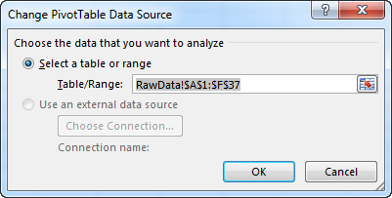

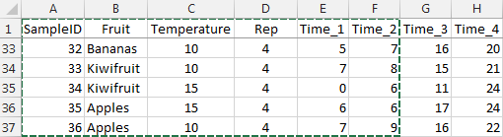

Columns to be added

* Extend the selection to include the extra columns (**Tip**: hold down the Shift key and press [Right arrow] to extend the selection to the right):

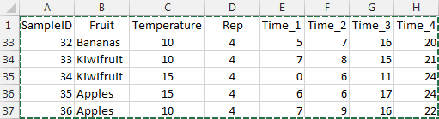

* After pressing [OK] in the dialogue box, the pivot table will be updated (the data will be added to the pivot table data source and the pivot table will be automatically refreshed so as to include the new columns in the available pivot table fields).

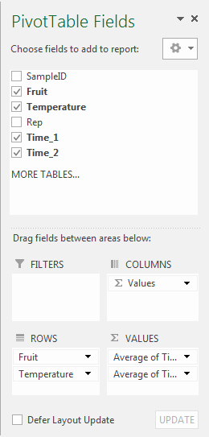 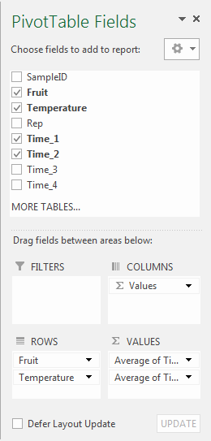

New columns are now available as fields

### Insert columns into the data source

One way to add new columns of data to a pivot table **without** changing the data source is to **insert** the new columns of data into the existing data source columns. This is particularly useful when you want to add more factors to use as either rows or columns of your pivot table. For example, you may have a column “Treatment” containing experiment treatments numbered 1-3, and want to add another column “TmtLabels” containing names for the treatments (e.g., “Low”, “Medium”, “High” etc.). To add one or more columns:

* In the source data for the pivot table, insert one or more blank columns BETWEEN any of the existing columns. (Note that if you instead insert columns to the left or to the right of the data range, you will need to extend the data source range as explained in Section 15.2.1 above.)
  + Either, click on a cell in one of the existing data columns, then use the ribbon: Home tab > Cells group > Insert dropdown > Insert Sheet Columns,
  + Or, click on a cell in one of the existing data columns, then right-click > Insert… > Entire column,
  + Or, click on a column letter of one of the existing data columns to select the entire column, then right-click > Insert.
* Enter the data into the newly inserted columns.
* Manually refresh the pivot table (see Section 14.1 above) so that the newly inserted columns become available as fields to use in the pivot table.

# Rearranging the raw data layout

## Changing “wide” data to “long” (stacking data columns)

While it is best for statistical analysis to have the results for a single variable arranged all in one column, there are occasions (e.g., with repeated measurements made on the same thing) when it may be more convenient to enter the data into several columns side-by-side. Biometricians sometimes call the single column layout a “long” format and the side-by-side columns layout a “wide” format. You can use pivot tables to rearrange “wide” format data into a “long” format, a process often referred to as “stacking” the data.

**NB: this method works only if the results are all numbers and there are no cells containing any text.** If, for example, the data columns contained labels like “low”, “medium”, “high”, then this method will not work and you should [contact a biometrician](https://iplant.plantandfood.co.nz/biometrics/Pages/WhoWeAre.aspx) to discuss how to stack your data.

In this example, the results have been entered in a “wide” format with four adjacent columns (Time_1, Time_2, Time_3, Time_4) containing the results. To stack these data:

* Select all of the data and insert a pivot table into a new worksheet.

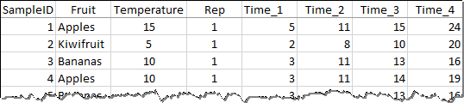

* Begin selecting the pivot table fields. For the pivot table rows, use all of the columns to the left of the results columns – these are usually factors that need to be repeated. Then for the “VALUES” fields select all of the results columns – these are the values that we wish to stack together into one column. The calculation can be any of Sum, Minimum, Maximum, or Average as these calculations will all return the original value.

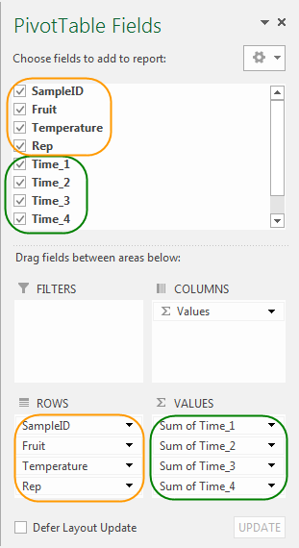

* Change to the Classic pivot table layout by clicking anywhere on the pivot table, then on the ribbon: Analyze tab > PivotTable group > Options dropdown, select Options. In the PivotTable Options dialogue box, select the Display tab and select “Classic PivotTable layout (enables dragging of fields in the grid)”. Press Enter, or click on [OK].

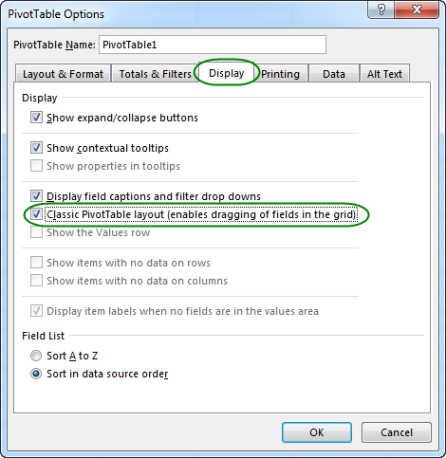

The pivot table layout will have changed.

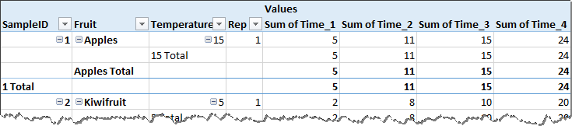

* In the PivotTable Fields dialogue, Excel has created a Columns field named “Values”. Drag-and-drop this field from Columns to Rows.

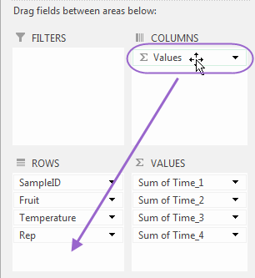 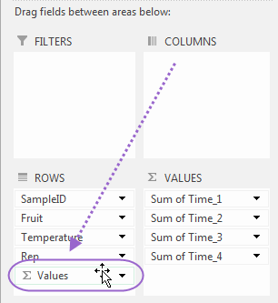

The values in the pivot table are now correct, but the appearance of pivot table needs tidying up.

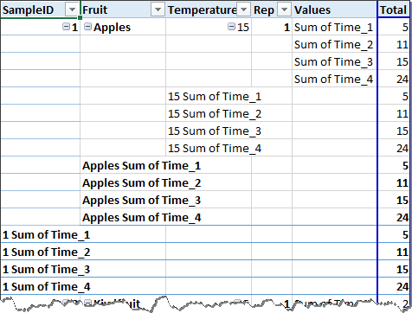

* To change the appearance of the pivot table, remove the grand totals and sub totals. Ensure the pivot table tools are visible in the ribbon by clicking anywhere on the pivot table. On the ribbon: Design tab > Layout group > Subtotals dropdown, select “Do Not Show Subtotals”.

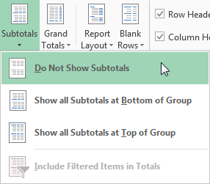

* For instructions on removing the Grand Totals see Section 4.4.3 above.
* Fill in the empty label cells by clicking anywhere on the pivot table, then on the ribbon: Design tab > Layout group > Report Layout dropdown, select “Repeat All Item Labels”.

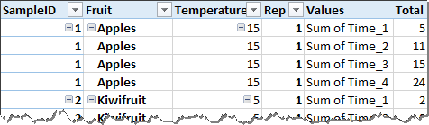

* Change the name of the “Values” column to something more meaningful, in this case “Time”. Unfortunately, the name of the “Total” column cannot be changed. The labels for the times can be improved by using Search-and-replace. In this example, “Sum of Time_” was replaced with nothing.

The resulting stacked data is now in a “long” format.

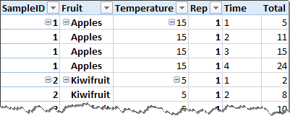

# When Pivot tables aren’t enough

A spreadsheet is very good software for generalist data handling, and can do many things. However, Excel has limitations and when those are found it can be better to use specialist software instead. Statistical software, in particular, is designed to perform complicated analysis and data manipulation. The good news is that the ideal data arrangement for pivot tables in Excel is perfect for statistical packages. The statistical packages, Genstat, and Minitab can both read Excel files directly, or data can be copied and pasted from Excel into them. The software R can import data from Excel using commands (either from base R or from one of several add-on packages). Once, you have the data into the statistics package of your choice, then you can use the facilities of the statistics package to generate your required analysis and summary. If you need help with this, please talk to any of the [PFR biometricians](https://iplant.plantandfood.co.nz/biometrics/Pages/WhoWeAre.aspx).