实验环境：

|  |  |
| --- | --- |
| 处理器 | Intel Core i5-4210H@2.9GHz~3.5GHz |
| 内存 | 8GB 1600MHz DDR3L |
| 显卡 | NVIDIA Geforce GTX960M+Intel HD4600 |
| 硬盘 | 500GB 5400rpm+128G SSD |
| 显示器 | 15.6’’ 1920x1080 |
| 操作系统 | Windows 10 Home |
| 编译环境 | Codeblocks 13.12+MingW+GCC 4.8.1 |

第1题程序：

“main.cpp”

#include<iostream>

#include<windows.h>

using namespace std;

extern void print1(void);

extern void print2(int price);

extern void print3(void);

extern void print4(void);

extern void print5(void);

int main()

{

HANDLE handle;

handle = GetStdHandle(STD_OUTPUT_HANDLE);

SetConsoleTextAttribute(handle, FOREGROUND_INTENSITY | FOREGROUND_RED | FOREGROUND_BLUE | FOREGROUND_GREEN);//设置为白色

int option, price;

while (1)

{

cout << "请选择您想阅读的故事\n";

SetConsoleTextAttribute(handle, FOREGROUND_INTENSITY | FOREGROUND_RED);//设置为红色

cout<<"1.莫名短信\n2.彩礼之忧\n3.八卦疑云\n4.亦喜亦忧\n5.故事待续\n6.欢迎欣赏，再见\n";

SetConsoleTextAttribute(handle, FOREGROUND_INTENSITY | FOREGROUND_RED | FOREGROUND_BLUE | FOREGROUND_GREEN);//设置为白色

cin >> option;

switch (option)

{

case 1:print1(); break;

case 2: cout << "请输入羊的价格";

cin >> price;

print2(price);

break;

case 3:print3(); break;

case 4:print4(); break;

case 5:print5(); break;

case 6:return 0;

}

}

}

“story1 2.cpp”

#include<iostream>

using namespace std;

#define N 100000

extern void print1(void)

{

const unsigned long long a = 0x49204c6f76652055;

cout << "0x49204c6f76652055翻译为";

for (int i = 0; i <= 8; ++i)

cout << (char)(a >> (((8 - i) * (1 << 3))) & 0xff) << " ";

cout << endl;

system("pause");

return;

}

extern void print2(int price)

{

int f[3], i = 2;

f[0] = 1; f[1] = 1;

while (1)

{

f[i % 3] = f[(i + 2) % 3] + f[(i + 1) % 3];

if ((f[i % 3] << 1)*price >= N) break;

i++;

}

cout << "共需要：" << i + 1 << "个月才能凑齐彩礼\n";

system("pause");

return;

}

“story3 4 5.cpp”

#include<iostream>

using namespace std;

extern void print3(void)

{

cout << "#八卦疑云#" << endl;

system("pause");

return;

}

extern void print4(void)

{

cout << "#亦喜亦忧#" << endl;

system("pause");

return;

}

extern void print5(void)

{

cout << "#故事待续#" << endl;

system("pause");

return;

}

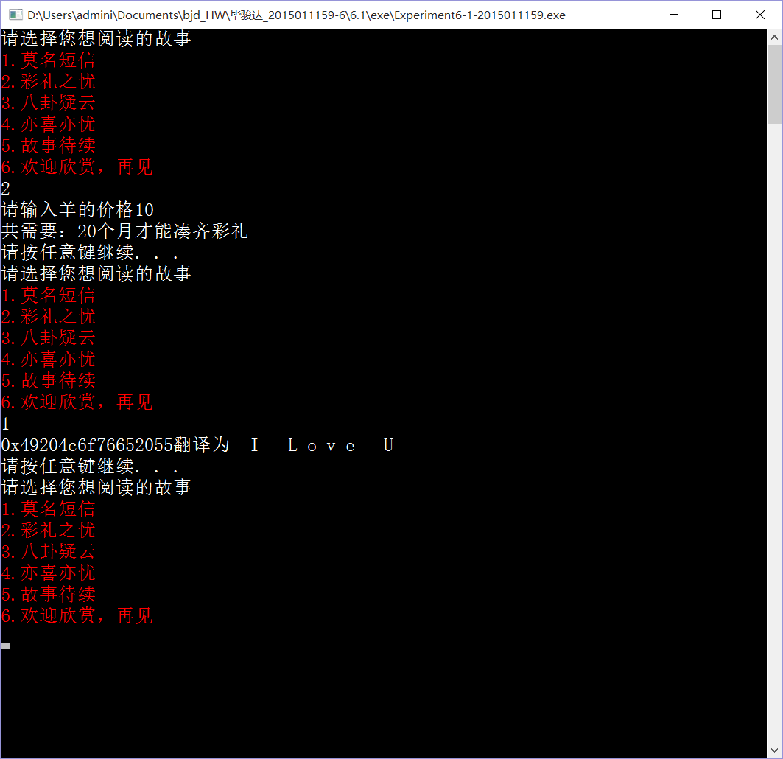运行结果：