Examples for Barcodes
The barcodes were made using the Zint Barcode Studio 2.4.3, made by Robin Stuart. You'll find this nice tool on http://www.sourceforge.net/projects/zint .

Code-128

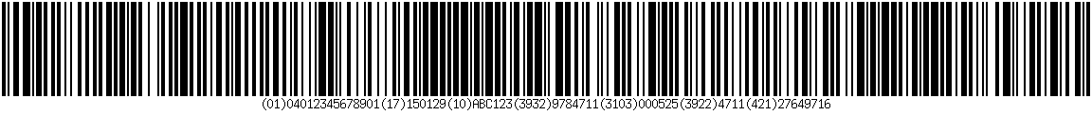

DataMatrix

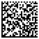

QR-Code

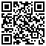

Test codes (see README.md)

