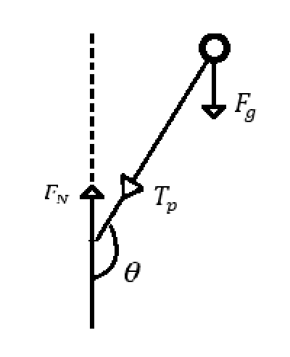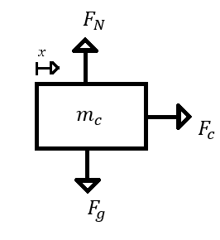Equation of motion - Cart:

Different properties:

Potential energy:

Kinetic energy

Equation of motion - Pendulum

The velocity only for the pendulum is given by:

The velocity for the pendulum can be rewritten as:

The total kinetic energy will then be:

We can reduce the equation due to the idiot formula :

Now we have the kinematic energy and the potential energy, we can use the lagrangian equation. We start by finding the lagrangian without taking reference to the force applied to the system. The force will be added afterwards.

We have the value for L now. This we insert into the lagrangian model:

We have two parts. One for the x position and one for the position.

Disturbance force: approximately 8.2.

and , b are the damping constants.

For the translational coefficient

For the rotational coefficient

First we calculate the translational coefficient

The second part of the equation needs the product rule and the chain rule

The final equation of the lagrangian for the x is:

Where . is the friction between the Teflon band and the aluminum. We do the same for

Equations before linearization

**Isolating and for the nonlinear equations**

The entire equation does not fit the page. Therefore we have split it up.

and

The entire equation does not fit the page. Therefore we have split it up.

Reduction for linearization of the nonlinear system.

Conditions:

We can assume that the system is linearized between an angle of from the inverted position.

This yields:

Anticipating this we get the following equations:

Solving for the and we get:

We calculate the state space model:

State space model:

Transfer function

The function has been calculated using MATLAB

given with inputs: and

PID controller

PD or P controller

Bode diagram and Root locus

Simulink autotune function for PID controller

Pendulum needs disturbance force

Apply different control strategies.

Look into transferring the simulation to a PLC. Describe that and that’s fine.  
Write corona happened in the discussion

# Equations of motion WITH disturbance force

Isolating for and

*Differensligninger:*

Parallel control

Difference equation

Implement difference equation in Simulink?

Do we make a difference equation from the equations of motion? And can I just use the ones I have from matlab?

Do we add an additional pole / zero?

Can i use K from our Simulink PID?

Root locus?

Is our integral control correct?

Bare skriv det ind, som vi har. Jeg skal ikke arbejde mere på den.  
Lav en PID controller ud fra det linære system.