**This Program Developed in C++/OpenCV and QT Framework for GUI**

Program Function:

* Open
* Save
* Undo
* Revert [Return Original Image Before Editing]
* Validate inputs to make sure everything works correctly
* Showing Coordinates of Image 
* Zooming in Workspace
* Information of Image
* Transformation Functions:
* Gamma
* Power Law
* Equalization
* Negative
* Translation Functions:
* Rotation
* Resizing
* Crop and Resizing
* Skewing
* Translation
* Flipping
* Slicing
* Filters:
* Blur
* Gaussian
* Sobel
* Laplacian
* Median
* Segmen

Program Interfaces

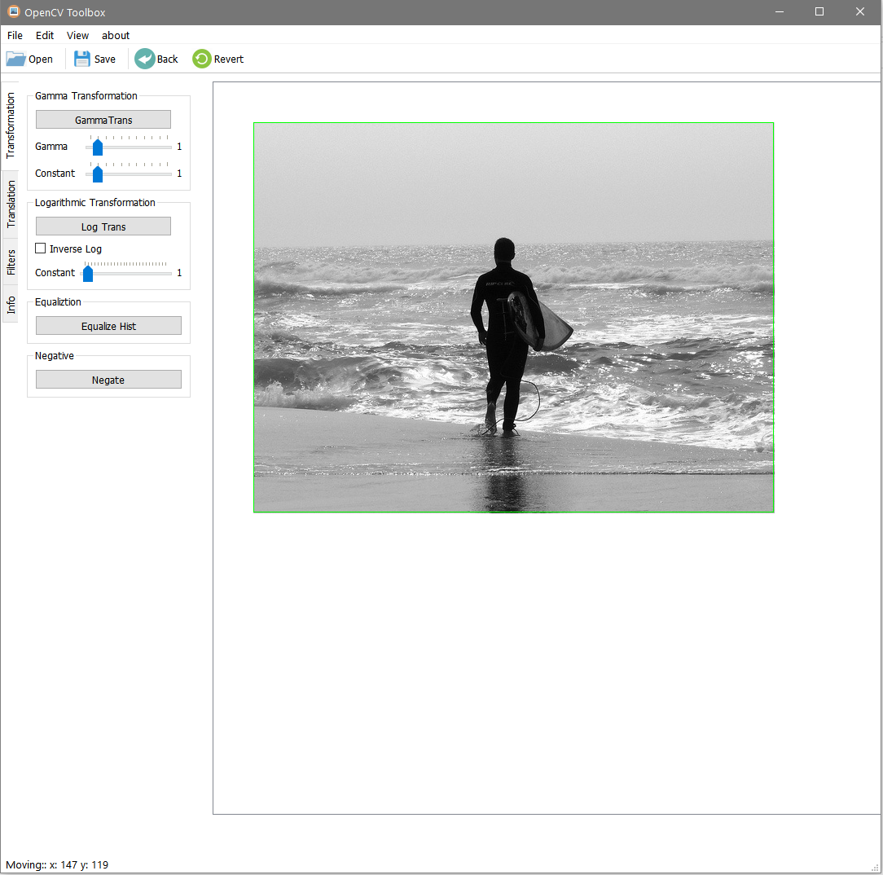

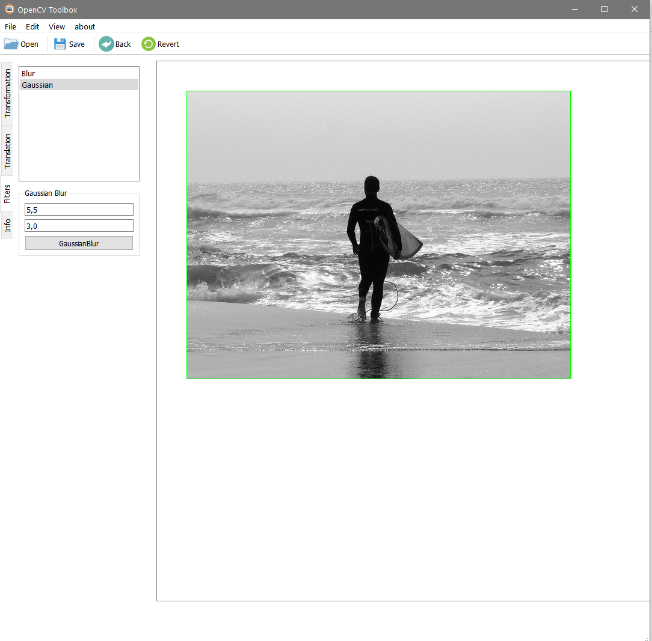

Steps for Editing

1. Browse Folders

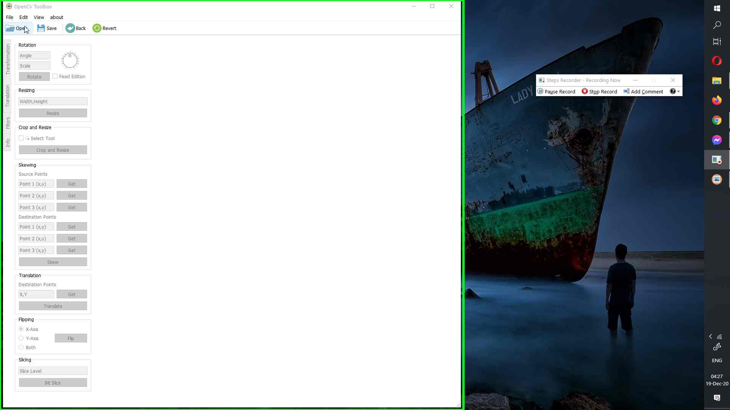

1. Select Image to Process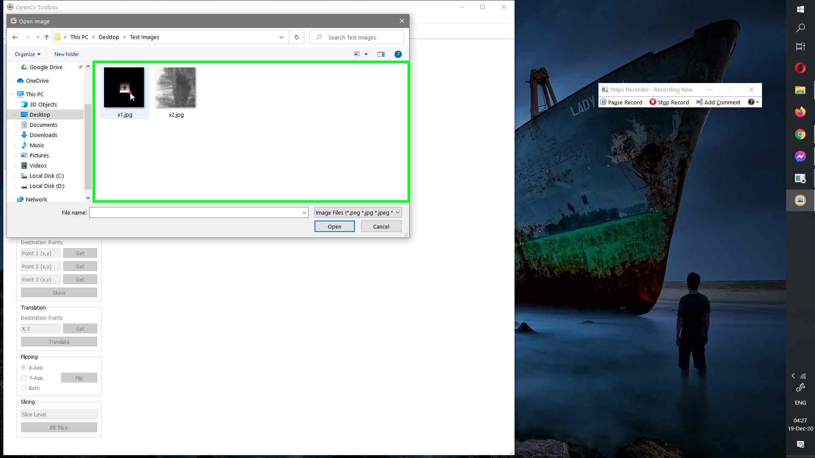
2. Select Appropriate Process Algorithm

[Crop and Resize, Flip around x-axis, equalizesHist]

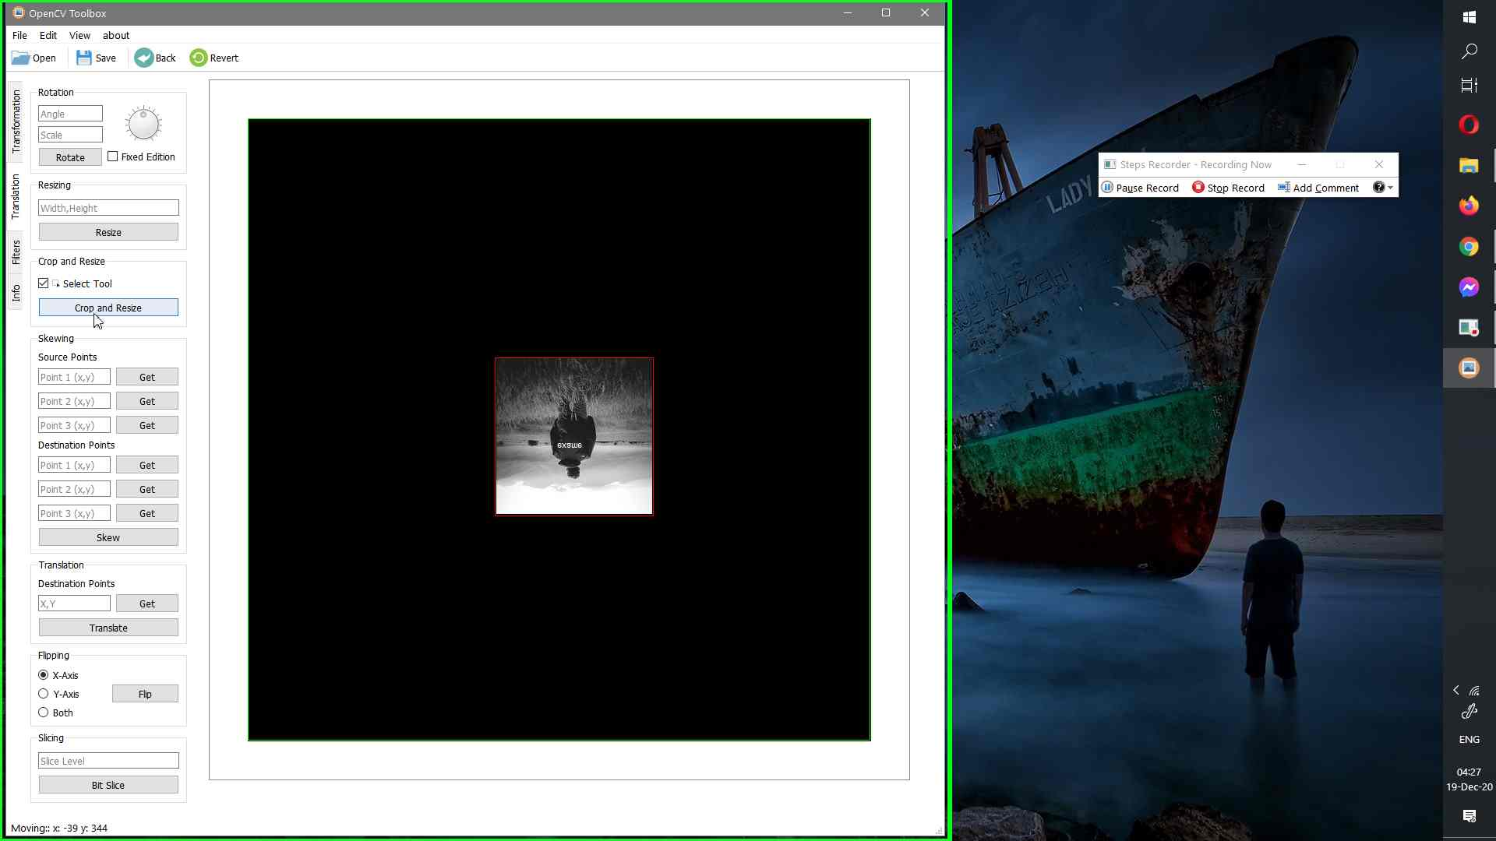

* Edited Image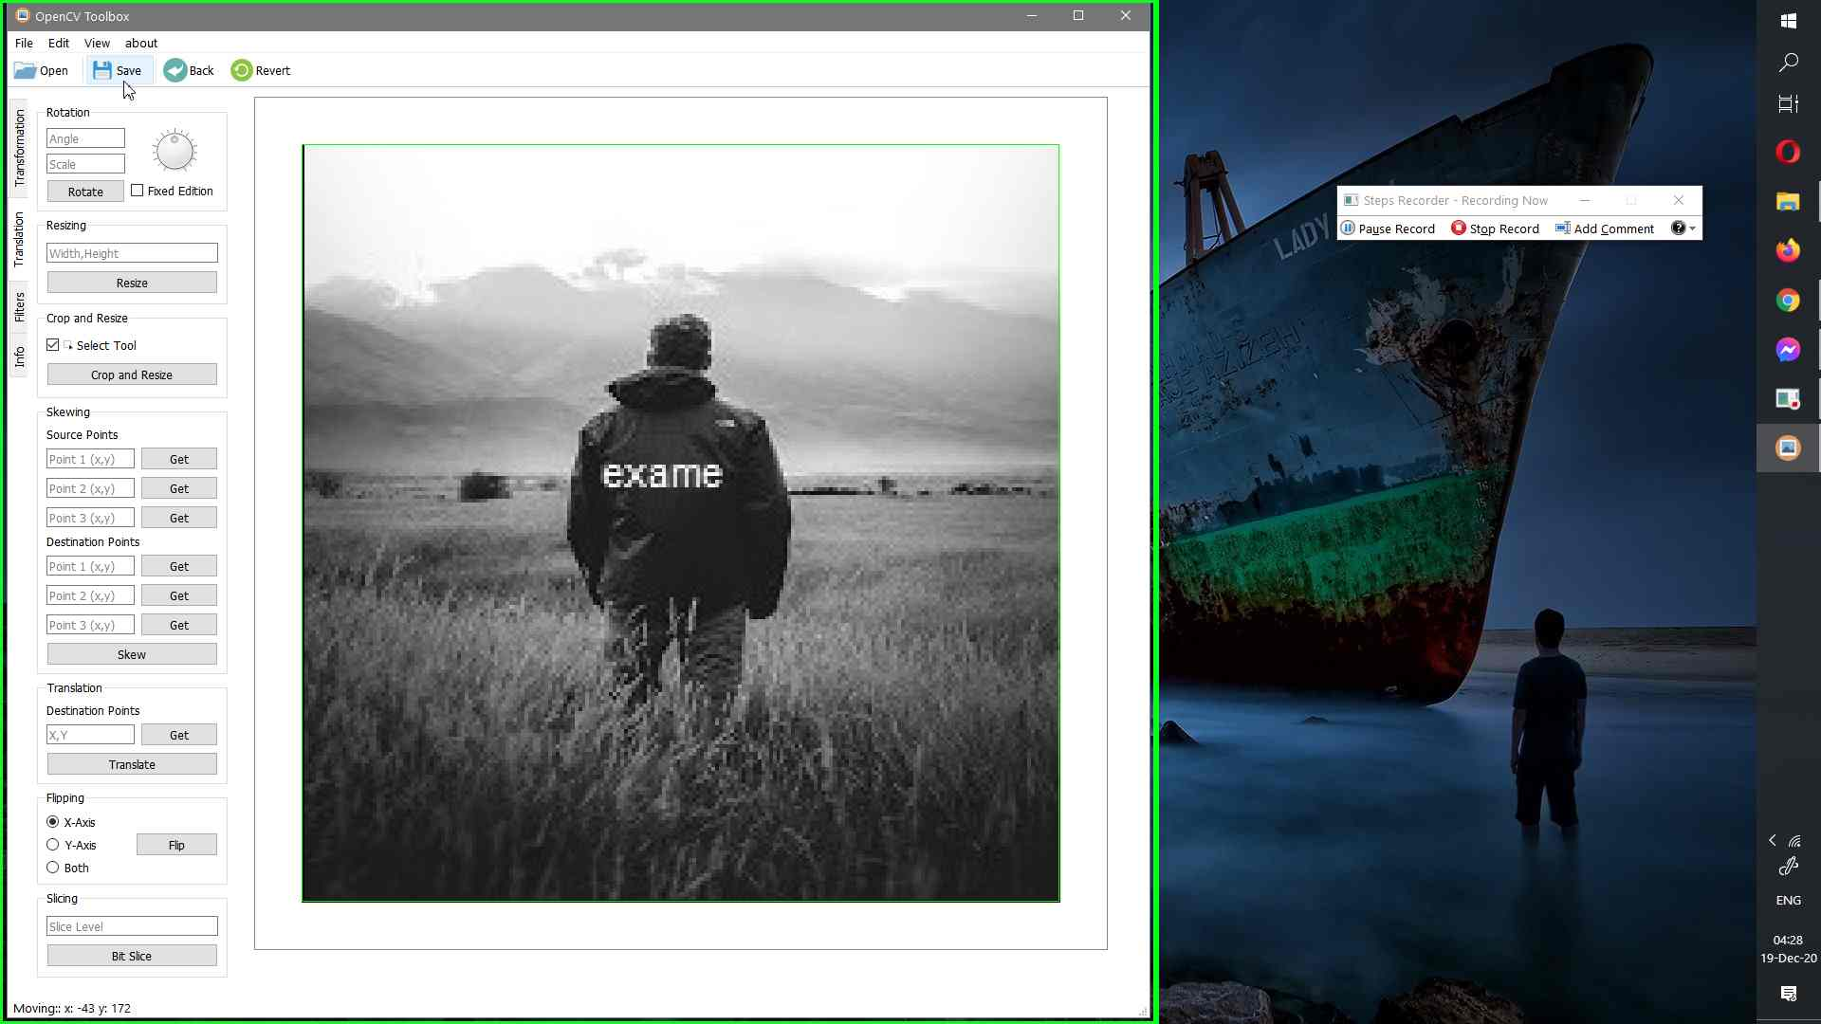

1. Save Processed Image

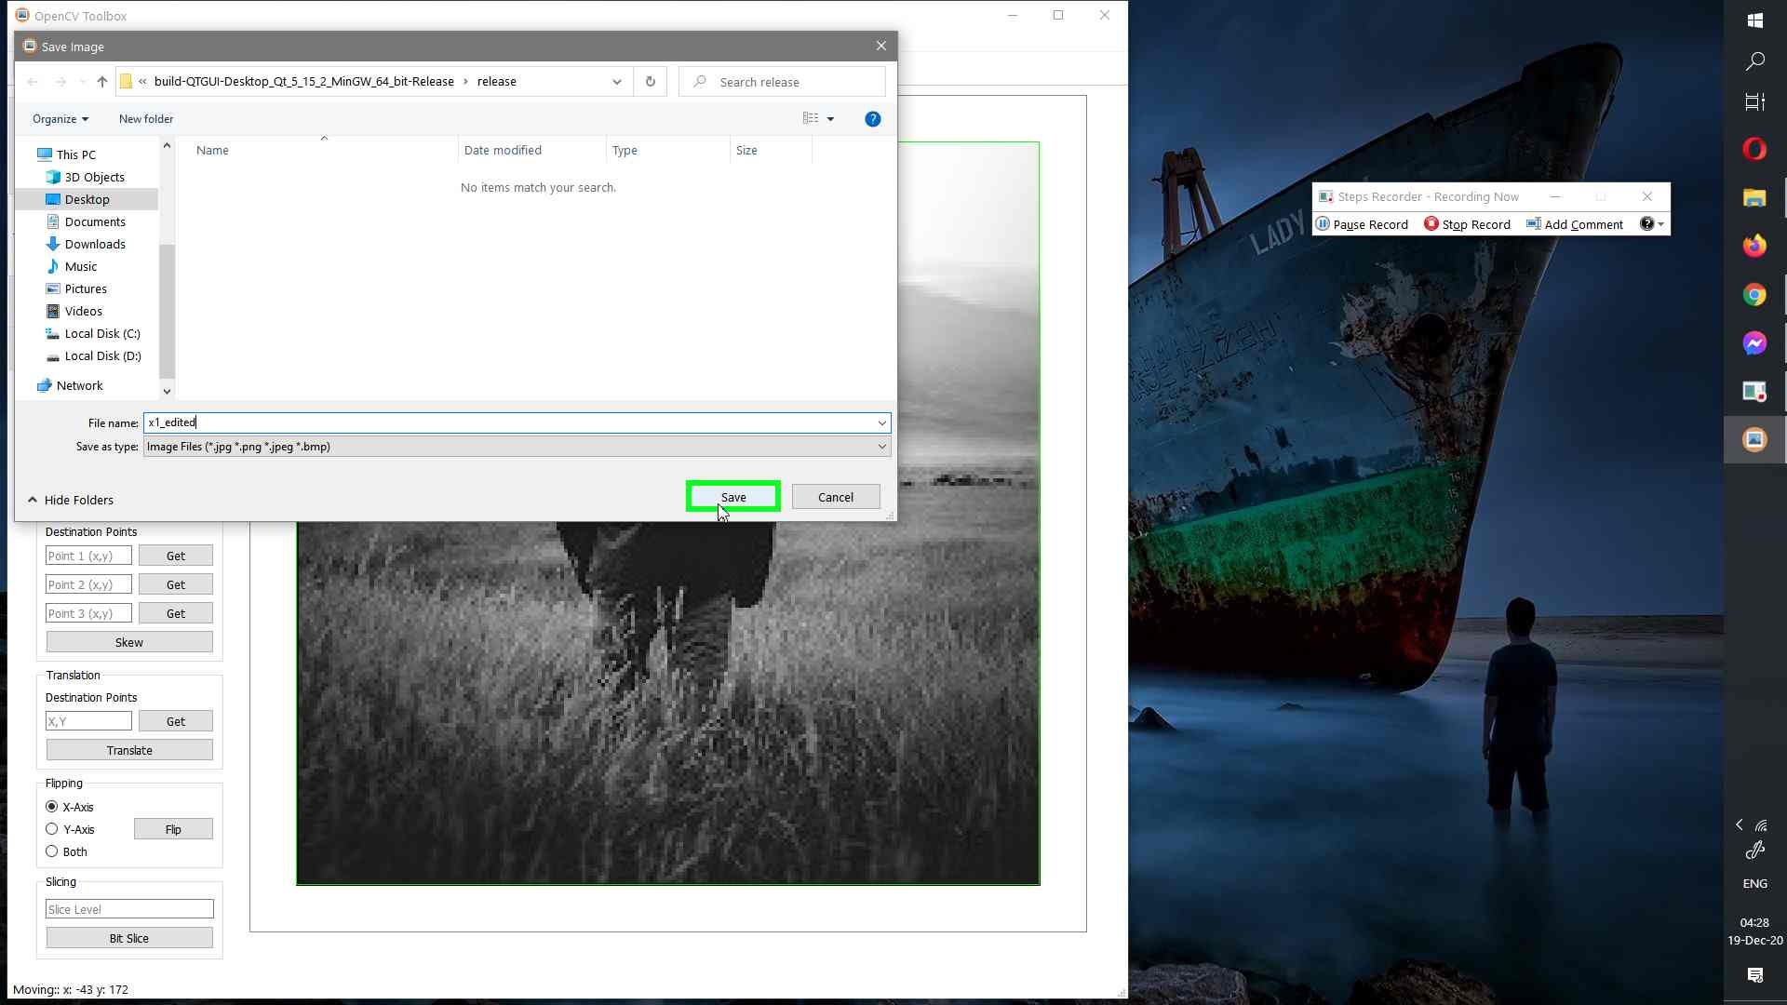Final Result

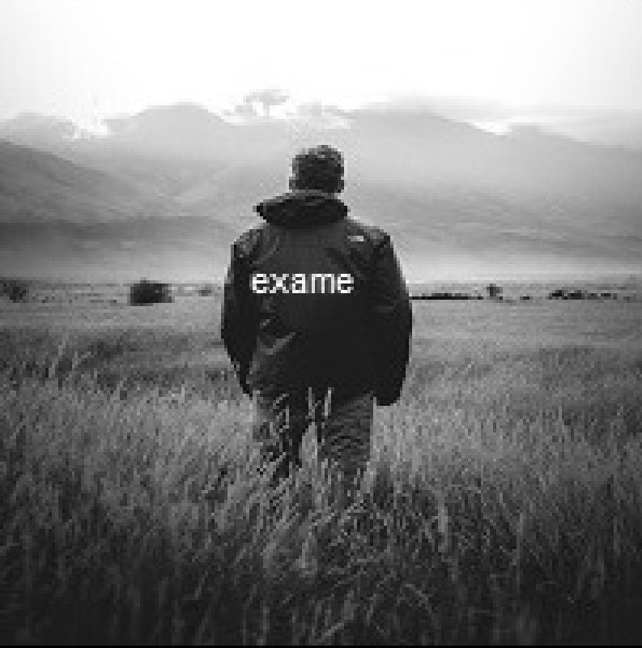

Second Image:

* Resize if we want Bigger Image
* Rotate -90 degree
* Equalize Hist
* Blurring to Remove Noise

Final Result

