# SubmissioN

In this assignment, you need to submit a single file which will include your name and the screen shots of your MySQL practices which are explained below. You need to submit your answers in either Word or PDF file format to Blackboard as “lab_2_firstname_lastname.doc”. EX: “lab_2_john_doe.doc”

If you need help, please write on discussion board and connect with each other to set it up. If you cannot get any help from discussion board, then send me an Email or schedule a meeting with me in person.

## MySQL Server and MySQL Workbench Installation

1. 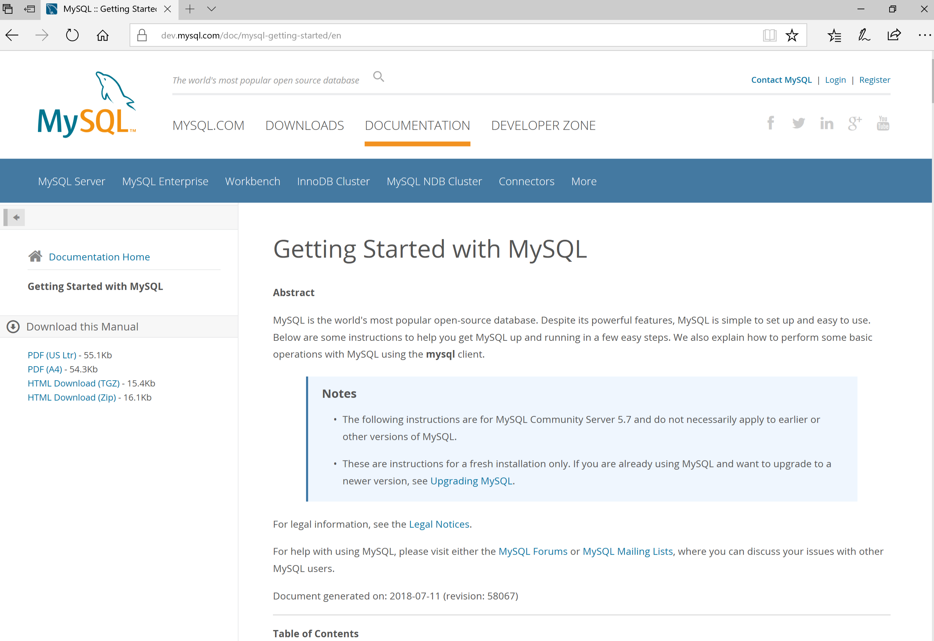Install MySQL Server and MySQL Workbench, (take a screen shot during any point during your installation and place it in the screenshots section below.)  
   Visit <https://dev.mysql.com/doc/mysql-getting-started/en/> and install MySQL for your OS Platform. Make sure to install the Community Edition. **Include a screenshot that shows that the installation of MySQL was completed.**

Additionally, you will need to install MySQL Workbench for your OS Platform as well.

1. Learn how to open MySQL from “Workbench”.

## Introduction to some MySQL Commands and Statements

1. Practice the following command by typing the exact same words below (only red colors) on the command line or workbench in MySQL. Use the following  to run all commands in a worksheet. Use the following  to run just the current command where your cursor is located. **Include a screenshot of the results of each command.**   
     
   SHOW databases; //This command shows you the databases.
2. CREATE DATABASE IF NOT EXISTS hellodatabase; //This command creates the database if it doesn’t exist already
3. SELECT DATABASE(); //This command shows you which database you are using.  
     
   USE hellodatabase; //This command connects you to the database to be used.
4. USE mysql; //This will connect you to the system database. Do not make changes.  
     
   SHOW tables; //This command shows the tables inside the mysql system database.  
     
   SELECT * FROM db; //This statement shows the content of the db table.  
     
   DESCRIBE db; //This command describes the tables columns and their types.  
     
   quit //This command will quit you from the database. Only if you use the command line interface, doesn’t work for Workbench.

## Screen Shots go Here

1. {Place your Installation Screen Shot here]

I forgot to take a picture when I installed the program but I have a picture of the home page of MySQL workbench.

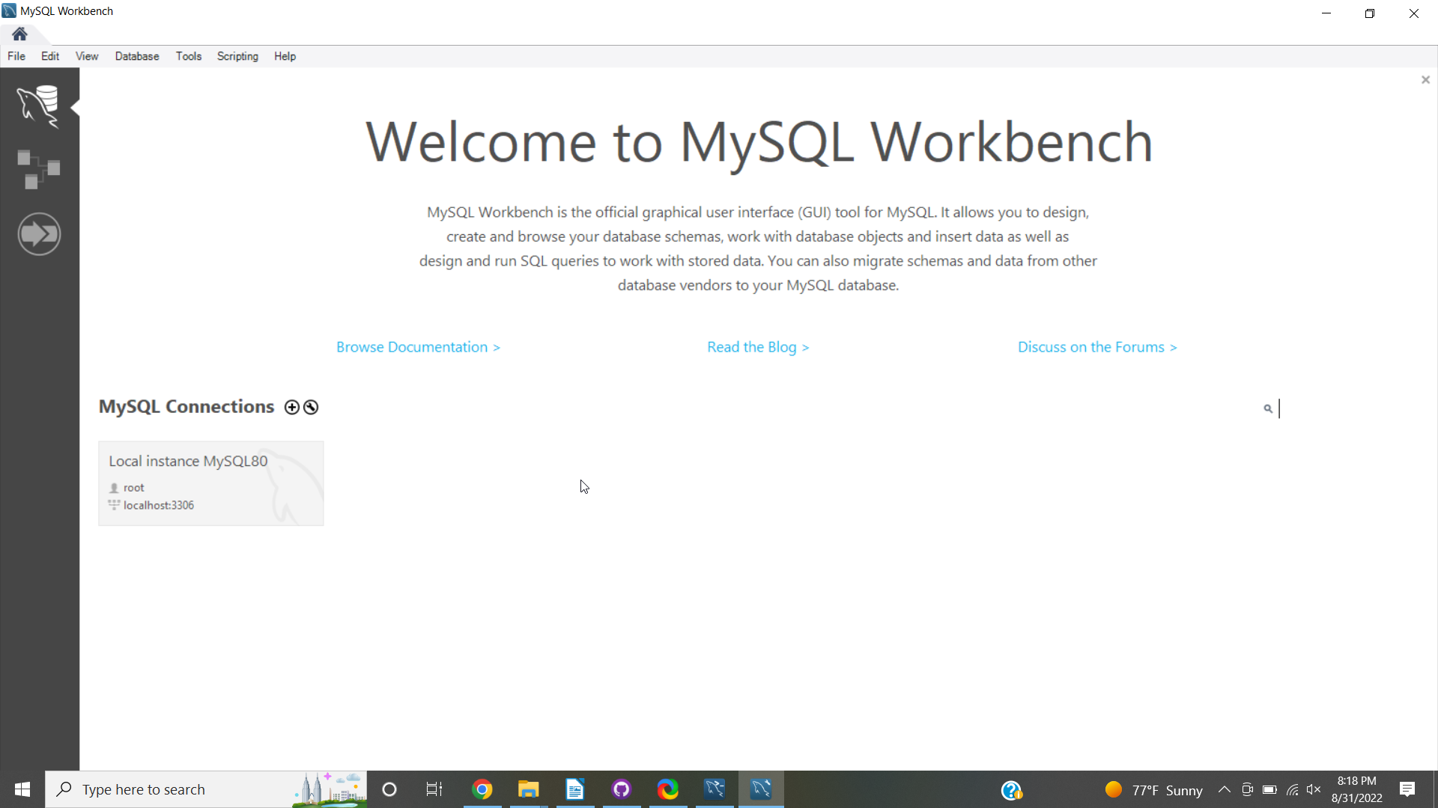

1. [command 1]
2. [command 2]
3. [command 3]
4. [command 4]
5. [command 5]
6. [command 6]
7. [command 7]

## Study the following data types

|  |  |
| --- | --- |
| **Data type** | **Description** |
| CHAR(size) | Holds a fixed length string (can contain letters, numbers, and special characters). The fixed size is specified in parenthesis. Can store up to 255 characters |
| VARCHAR(size) | Holds a variable length string (can contain letters, numbers, and special characters). The maximum size is specified in parenthesis. Can store up to 255 characters. **Note:** If you put a greater value than 255 it will be converted to a TEXT type |
| TINYTEXT | Holds a string with a maximum length of 255 characters |
| TEXT | Holds a string with a maximum length of 65,535 characters |
| BLOB | For BLOBs (Binary Large OBjects). Holds up to 65,535 bytes of data |
| MEDIUMTEXT | Holds a string with a maximum length of 16,777,215 characters |
| MEDIUMBLOB | For BLOBs (Binary Large OBjects). Holds up to 16,777,215 bytes of data |
| LONGTEXT | Holds a string with a maximum length of 4,294,967,295 characters |
| LONGBLOB | For BLOBs (Binary Large OBjects). Holds up to 4,294,967,295 bytes of data |
| ENUM(x,y,z,etc.) | Let you enter a list of possible values. You can list up to 65535 values in an ENUM list. If a value is inserted that is not in the list, a blank value will be inserted. Note: The values are sorted in the order you enter them. You enter the possible values in this format: ENUM('X','Y','Z') |
| SET | Similar to ENUM except that SET may contain up to 64 list items and can store more than one choice |
| TINYINT(size) | -128 to 127 normal. 0 to 255 UNSIGNED*. The maximum number of digits may be specified in parenthesis |
| SMALLINT(size) | -32768 to 32767 normal. 0 to 65535 UNSIGNED*. The maximum number of digits may be specified in parenthesis |
| MEDIUMINT(size) | -8388608 to 8388607 normal. 0 to 16777215 UNSIGNED*. The maximum number of digits may be specified in parenthesis |
| INT(size) | -2147483648 to 2147483647 normal. 0 to 4294967295 UNSIGNED*. The maximum number of digits may be specified in parenthesis |
| BIGINT(size) | -9223372036854775808 to 9223372036854775807 normal. 0 to 18446744073709551615 UNSIGNED*. The maximum number of digits may be specified in parenthesis |
| FLOAT(size,d) | A small number with a floating decimal point. The maximum number of digits may be specified in the size parameter. The maximum number of digits to the right of the decimal point is specified in the d parameter |
| DOUBLE(size,d) | A large number with a floating decimal point. The maximum number of digits may be specified in the size parameter. The  maximum number of digits to the right of the decimal point is specified in the d parameter |
| DECIMAL(size,d) | A DOUBLE stored as a string , allowing for a fixed decimal point. The maximum number of digits may be specified in the size parameter. The maximum number of digits to the right of the decimal point is specified in the d parameter |
| DATE() | A date. Format: YYYY-MM-DD Note: The supported range is from '1000-01-01' to '9999-12-31' |
| DATETIME() | *A date and time combination. Format: YYYY-MM-DD HH:MI:SS Note: The supported range is from '1000-01-01 00:00:00' to '9999-12-31 23:59:59' |
| TIMESTAMP() | *A timestamp. TIMESTAMP values are stored as the number of seconds since the Unix epoch ('1970-01-01 00:00:00' UTC). Format: YYYY-MM-DD HH:MI:SS Note: The supported range is from '1970-01-01 00:00:01' UTC to '2038-01-09 03:14:07' UTC |
| TIME() | A time. Format: HH:MI:SS Note: The supported range is from '-838:59:59' to '838:59:59' |
| YEAR() | A year in two-digit or four-digit format. Note: Values allowed in four-digit format: 1901 to 2155. Values allowed in two-digit format: 70 to 69, representing years from 1970 to 2069 |

The following information was obtained from <http://www.w3schools.com/sql/sql_datatypes.asp>