University Accommodations Office Case Study

Submitted By: Peter Cullen Burbery

List your Group Members Below

Peter Cullen Burbery

# [ The User Selected Goes Here ]

[Fill in the specific user above and provide the user requirements specifications below.]

# User’s Conceptual Model

## Required Entity Types

| Entity Name | Description | Aliases | Occurrence |
| --- | --- | --- | --- |
| Student | a student |  |  |
| Advisor | the advisor for a student | student advisor |  |
| Residence Hall | the residence hall a student lives in | Hall of Residence, hall |  |
| Residence Hall room | a room in a residence hall |  |  |
| Student Apartment | a student apartment or a student flat | student flat |  |
| Apartment Bedroom | a bedroom in a student apartment that a student rents | bedroom |  |
| Lease | a lease |  |  |
| Invoice | the invoice for a rental period where a student rents an apartment or a residence hall room |  |  |
| Student apartment inspection | the inspection of the student apartment | inspection |  |
| Residence staff | the staff that work at the residence office | staff, residence Office Staff |  |
| Courses | the courses offered by the university |  |  |
| Next of kin | the students next-of-kin such as father or mother | primary contact |  |
|  |  |  |  |

## First-cut ER diagram

[Draw your diagram here (should contain entities and relationships, no attributes)]

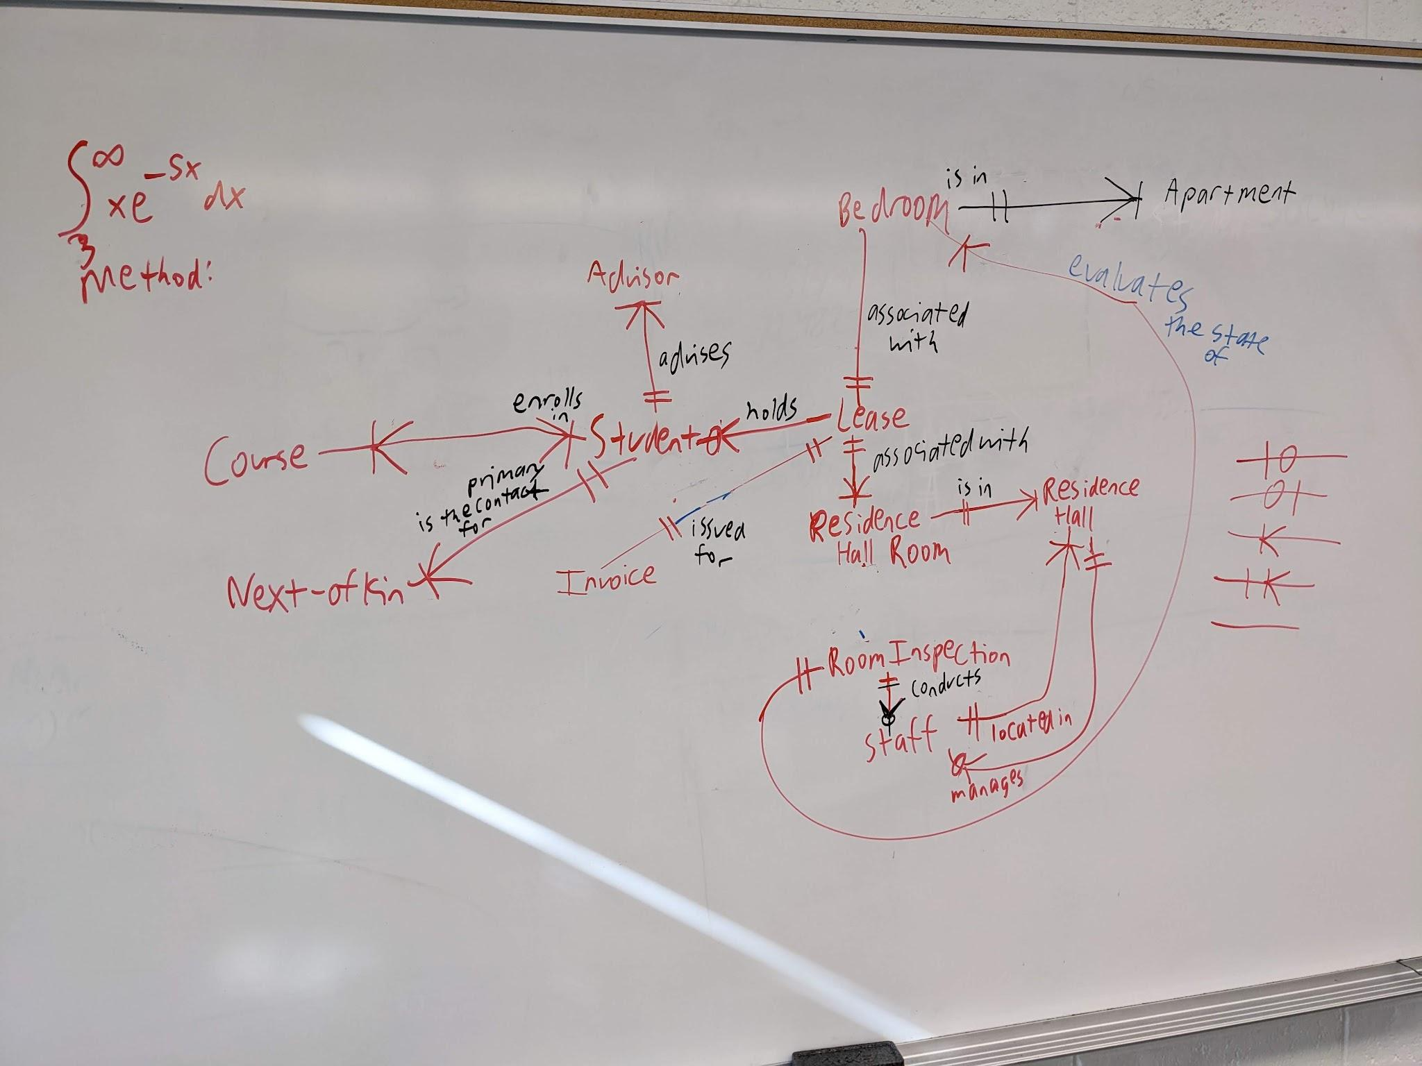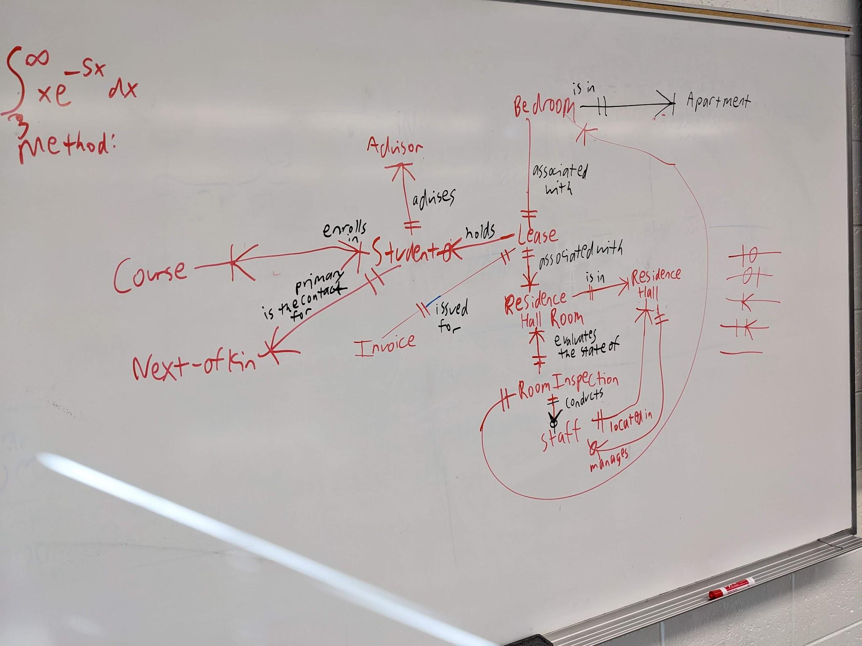

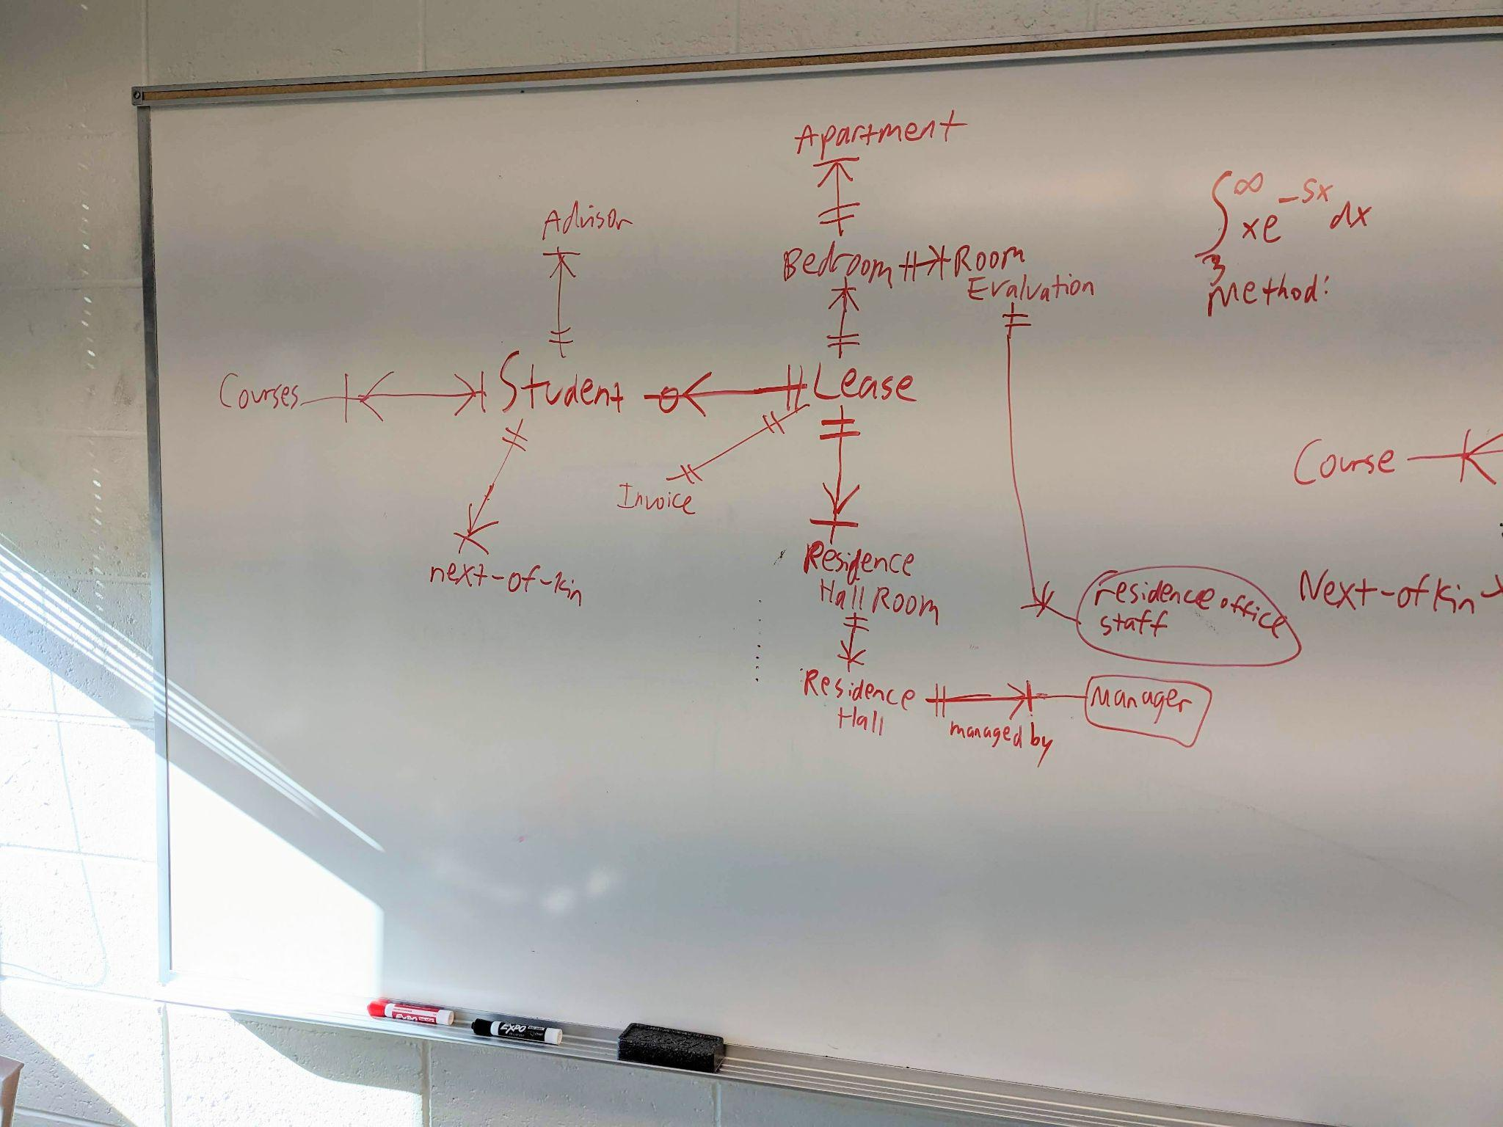

## Relationship Types

| Entity Name | Multiplicity | Relationship | Multiplicity | Entity name |
| --- | --- | --- | --- | --- |
| Advisor | 1 to many | works to advise | 1 only | Student |
| Residence Hall | 1 to many | is the sleeping location for | 0 or 1 | Student |
| Student Apartment | 1 to many | is the sleeping location for | 0 or 1 | Student |
| Residence Hall | 1 to many | has | 1 only | Residence Hall Room |
| Student Apartment | 1 to many | has | 1 only | Apartment Bedroom |
| Student | 0 to many | holds | 1 only | Lease |
| Residence Hall room or Apartment bedroom | 1 to many | associated with | 1only | Lease |
| Lease | 1 only | associated wtih | 1 only | Invoice |
| Residence Staff | 0 to many | conducts | 1 only | Student Apartment Inspections |
| Residence Hall room | 1 to many | is the location of | 1 only | Student Apartment Inspection |
| Apartment bedroom | 1 to many | is the location of | 1 only | Student Apartment Inspection |
| Student | 0 to many | is evaluated in a | 1 only | Student Apartment Inspection |
| Student | 1 to many | enrolls in | 1 to many | Courses |
| Next of kin | 1 to many | serves as the primary contact for | 1 only | Student |
| Residence Office Staff | 1 to many | manages | 1 | Residence Hall |
| Residence Office Staff | 1 only | is located in | 1 to many | Residence Hall |
|  |  |  |  |  |

I'

## Description of Attributes

| Entity Name | Attributes | Description | Data Type & Length | Nulls | Multi-Valued | Is Computed | How to compute | Default value |
| --- | --- | --- | --- | --- | --- | --- | --- | --- |
| Student | Banner number | the banner # for the student | int sufficiently long such that the banner # is guaranteed to be unique | no | no | no |  |  |
| Student | Name | a compound attribute with first and possibly middle name or middle initial and last name of the student | text sufficiently long that a long name will fit | no | no | no |  |  |
| Student | Home Address | a compound attribute that describes the student address with street city and postal code | street text, city text, postal code int with checks that the integer is a valid zip code | no | no | no |  |  |
| Student | Mobile Phone Number | the phone number the student can be contacted by | int with length 11 for example +1 650-513-0514 | yes | no | no |  |  |
| Student | Email | the students email (their university email or their personal email)? I think their university email | text with regular expressions checks to see if the entry is a valid email address | no | N | N |  |  |
| Student | Date of birth | the student’s date of birth |  | no | N | N |  |  |
| Student | Gender | the students gender | male or female, categorial string attribute | no | N | N |  |  |
| Student | Category of Student | how many years they have been in school including four years undergraduate, graduate masters, graduate PhD and postgraduate | categorical: 1 year undergraduate,2 year undergraduate,3 year undergraduate,4 year undergraduate, masters program graduate, PhD program graduate, postgraduate | no | N | Y | get the date difference when they joined the university and how long they’ve been there for undergraduate years 1-4 and for graduate masters or PhD or postgraduate, check what they will graduate with using the banner # for example |  |
| Student | Nationality | the country the student has citizenship in | text | yes | Y | N |  |  |
| Student | Special needs | any special medical needs the student has | text | yes | Y | N |  |  |
| Student | comments | any comments related to the student | text | yes | Y | N |  |  |
| Student | Current Status | the status of the student such as placed or waiting | text | no | N | N |  | waiting |
| Student | Major | the major the student will graduate with | text | no | Y | Y | use the students banner # to check their major |  |
| Student | Minor | the minor the student will graduate with | text | yes | Y | Y | use the students banner # to check their minor |  |
| Advisor | full name | the first, middle, and last name of the advisor | text | no | N | N |  |  |
| Advisor | Position | the position of the advisor | text | no | N | N |  |  |
| Advisor | Name of department | the name of the department the advisor works in | text | no | N | N |  |  |
| Advisor | Internal Telephone number | the advisors university telephone extension | int | no | N | N |  |  |
| Advisor | email | the advisors email | text | no | N | N |  |  |
| Advisor | room # | the advisors room # | int | N | N | N |  |  |
| Residence Hall | name | the name of the residence hall | text | N | N | N |  |  |
|  | address | the address of the residence hall | text | N | N | N |  |  |
|  | telephone # | the telephone # of the residence hall | int | N | N | N |  |  |
|  | Hall manager | the manager of the residence hall | text | N | N | N |  |  |
| Residence Hall Room | Room # | the room # of the residence hall room | int | N | N | N |  |  |
|  | place # | the place # of the residence hall room | int | N | N | N |  |  |
|  | Monthly rent rate | the monthly rent rate of the residence hall room | float like 100.99 | N | N | N |  |  |
| Student Apartment | apartment # | the apartment # of the student apartment | int | N | N | N |  |  |
|  | address | the student apartment’s address | text | N | N | N |  |  |
|  | # of single bedroom | the # of single bedrooms in the student apartment | int | N | N | Y | count the number of apartment bedrooms that are in an apartment |  |
| Apartment Bedroom | Rent Rate | the cost of renting the bedroom | text | N | N | N |  |  |
|  | Room # | the room # of the bedroom | int | N | N | N |  |  |
|  | Place # | the unique identifier for the bedroom in the apartment | int | N | N | N |  |  |
| Lease | # of semesters | the duration of the lease agreement given in semesters including semester 1 and 2 and the summer semester | int | N | N | N |  |  |
|  | Student name | the full name of the student agreeing to the lease | text | N | N | N |  |  |
|  | Student # | the students banner # | int | N | N | N |  |  |
|  | Place # | the place # of the student apartment | int | N | N | N |  |  |
|  | Room # | the room # the student rents | int | N | N | N |  |  |
|  | Address detail for hall or student apartment | the full address details for the residence hall or student apartment | text | N | N | N |  |  |
|  | date student will enter | date student will enter the room | date | N | N | N |  |  |
|  | date student will leave | if known the date the student will leave | date | Y | N | N |  |  |
| Invoice | Invoice # | invoice # | int | N | N | N |  |  |
|  | Lease # | Lease # | int | N | N | N |  |  |
|  | semester | semester the invoice is issued during | categorical text | N | N | Y | check the date of the invoice and then cross correlate with the academic calendar to determine what semester the invoice was issued during |  |
|  | payment due | payment due in dollars | float | N | N | Y | compute the different between rent cost for room and payment made by student |  |
|  | student’s full name | student’s full name | text | N | N | N |  |  |
|  | student banner # | student banner # | int | N | N | N |  |  |
|  | place# | place# | int | N | N | N |  |  |
|  | room # | room # | int | N | N | N |  |  |
|  | address of hall or apartment | address of hall or apartment | text | N | N | N |  |  |
|  | date | date | date | N | N | N |  |  |
|  | method of payment | method of payment such as Visa, cash, check, etc. | text with categories | N | N | N |  |  |
|  | date first reminder | the date the first reminder to pay was sent | date | Y | N | Y | it could be sent a fixed amount of time after the date of the lease such as one month after the payment isn’t made |  |
|  | date second reminder | the date the second reminder to pay was sent | date | Y | N | Y | it could be sent a fixed amount of time after the date of the lease such as two months after the payment isn’t made |  |
| Student Apartment Inspections | who carried out the inspection | which staff member carried out the inspection | text | N | N | N |  |  |
|  | inspection date | inspection date | date | N | N | N |  |  |
|  | satisfactory yes or no | if the student maintained the apartment well | boolean | N | N | N |  | yes |
|  | additional comments | additional comments by the staff member | text | Y | Y | N |  |  |
| Residence Staff | staff # | staff # | int | N | N | N |  |  |
|  | name | name | text | N | N | N |  |  |
|  | email | email | text with regex checks | N | N | N |  |  |
|  | home address | home address | text | N | N | N |  |  |
|  | date of birth | date of birth | date | N | N | N |  |  |
|  | gender | gender | categorical text Male or Female | N | N | N |  |  |
|  | position | position | text, possibly categorical | N | N | N |  |  |
|  | location | location where they work mainly for example residence hall or apartment | categorical text | N | N | N |  |  |
| Courses | course # | course # | int | N | N | N |  |  |
|  | course title | course title | text | N | N | N |  |  |
|  | course instructor | the instructor for the course | text | N | Y | N |  |  |
|  | instructors telephone # | instructors telephone # | int | N | N | N |  |  |
|  | instructor email | instructor’s email | text | N | Y | N |  |  |
|  | room # | room # | int | N | N | N |  |  |
|  | department name | department name | text | N | N | N |  |  |
|  | study association | what area of study the course is for | text | N | N | N |  |  |
| Next of kin | name | name | text | N | N | N |  |  |
|  | relationship | relationship | text | N | N | N |  |  |
|  | address | address | text | N | N | N |  |  |
|  | street | street | text | N | N | N |  |  |
|  | city | city | text | N | N | N |  |  |
|  | postcode | postcode | int with checks | N | N | N |  |  |
|  | contact phone # | contact phone # | int | N | Y | N |  |  |
|  |  |  |  |  |  |  |  |  |

## Final Conceptual Data Model

[Place Diagram Here. This should contain all entities, attributes, relationships, generalization/specializations]

<https://drive.google.com/file/d/1KfySaO5z9No1GgeO3RSCoPRFkSxTtW00/view?usp=sharing>