**Project 3: Sharing the ADC**

unityID: zchen45 name: Zhiyu Chen

1. **Objective**

The project implements the buck converter controller and the touchscreen function which will compete for the ADC resource. The based code will start at controlling the buck converter and flashing the HBLED. However, as soon as the screen is touched, the code will read the location of the touch point using the ADC which will conflict with the buck converter. In this case, the project needs to be modified to share the ADC between the 2 functions correctly.

1. **Waveform**
   1. **Logic Waveform**

The figures below indicates the case that the screen has been touched. The ADC’s channel will switch between the buck converter and the screen and continue processing.

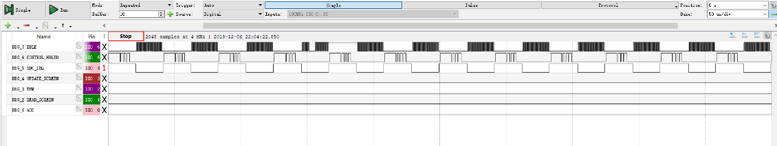

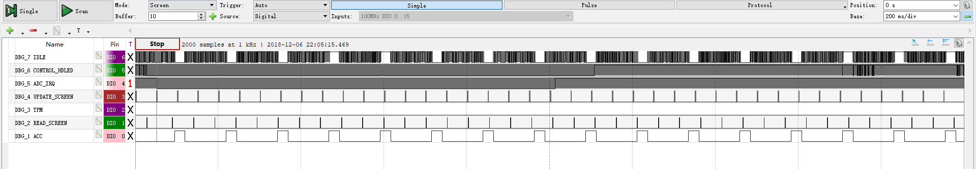

* 1. **Scope**
     1. **Default**

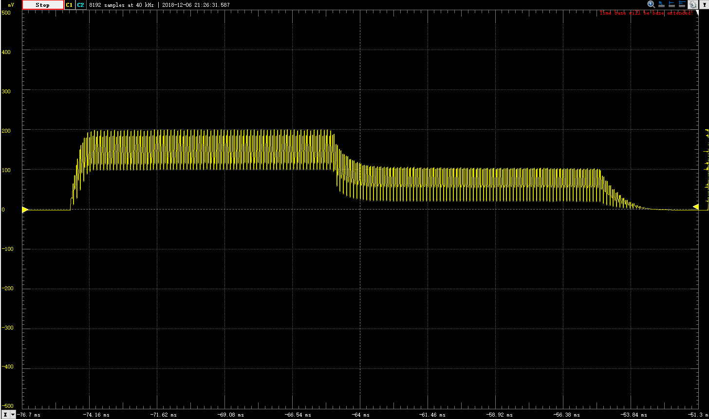

The waveform without setting the g_peak_set_current.

First Half (mV):

Average: 149 Peak2Peak: 100.11

Second Half:

Average: 70.02 Peak2Peak: 89.90

* + 1. **g_peak_set_current = 21**

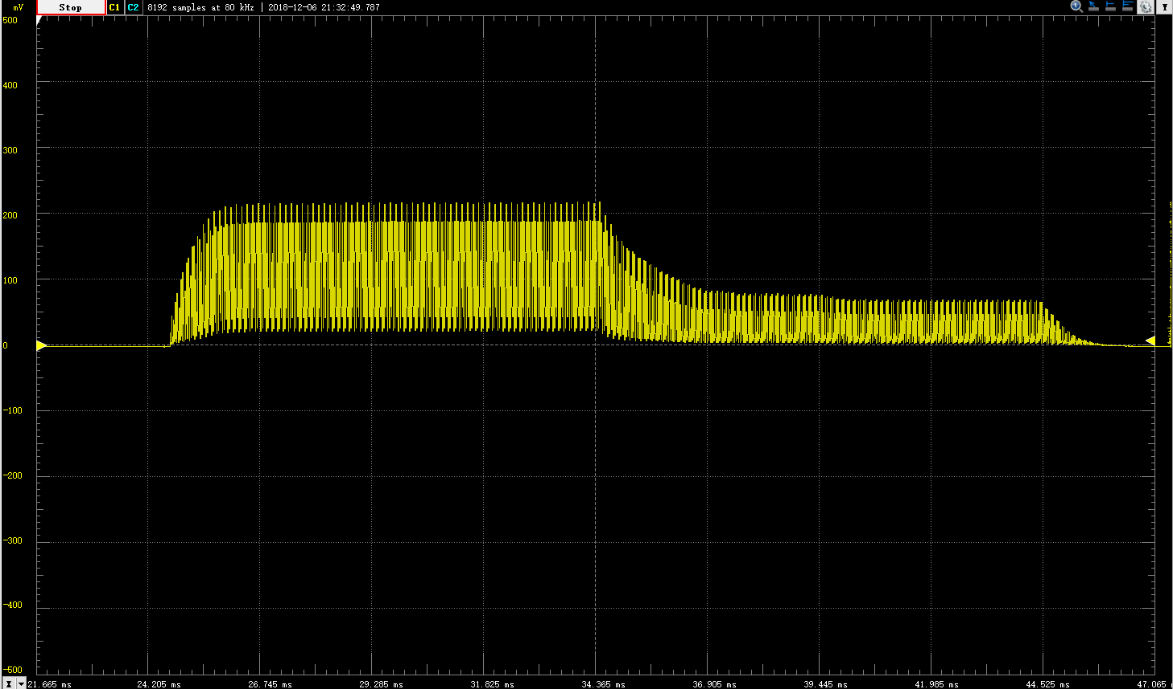

The waveform with setting g_peak_set_current as 21

First Half:

Average: 109 Peak2Peak: 194.91

Second Half:

Average: 28.28 Peak2Peak: 74.84

* + 1. **g_peak_set_current = 220**

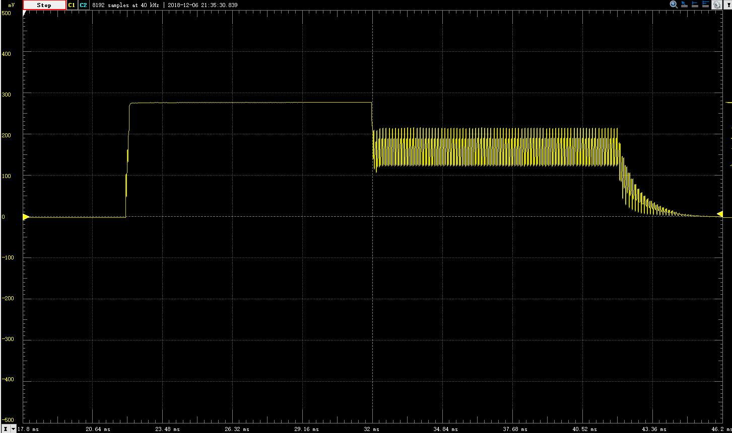

The waveform with setting g_peak_set_current as 220

First Half:

Average: 276

Second Half:

Average 163 Peak2Peak: 93

1. **Implementation Result**

