Agile Project

Task 1

Meeting with customer notes

The customer would like us to create an app for purchasing coffee.

* It should allow customers to login
* It should allow customers to create a login
* Customers credit should be preloaded on their account
* Allows customers to transfer money from their bank account to the app
* Select a kind of coffee and order it (black, flat white, cappuccino)
* Notification with daily specials
* User page with remaining balance and loyalty card
* History of transactions

Kick Start Meeting – Developing user stories

(Time blocking in brackets)

As a user I want to log into a personal account (5)

As a user I want to be able to create an account (5)

As a user I want to be able to transfer funds from my bank account into my coffee app account (3)

As a user I want to be able to order a coffee of my choice (3)

As a user I want to see a notification that confirms my coffee order has been successful (1)

As a user I want to receive a notification informing me of in store specials for the day (1)

As a user I want to have a personal page that details remaining balance (2)

As a user I want to have a personal page that details the number of coffees that can be purchased (2)

As a user I want to have a personal page that details progress on my loyalty card (2)

As a user I want to have a personal page that details my purchase history (3)

Total story points =27

1st Planning Session

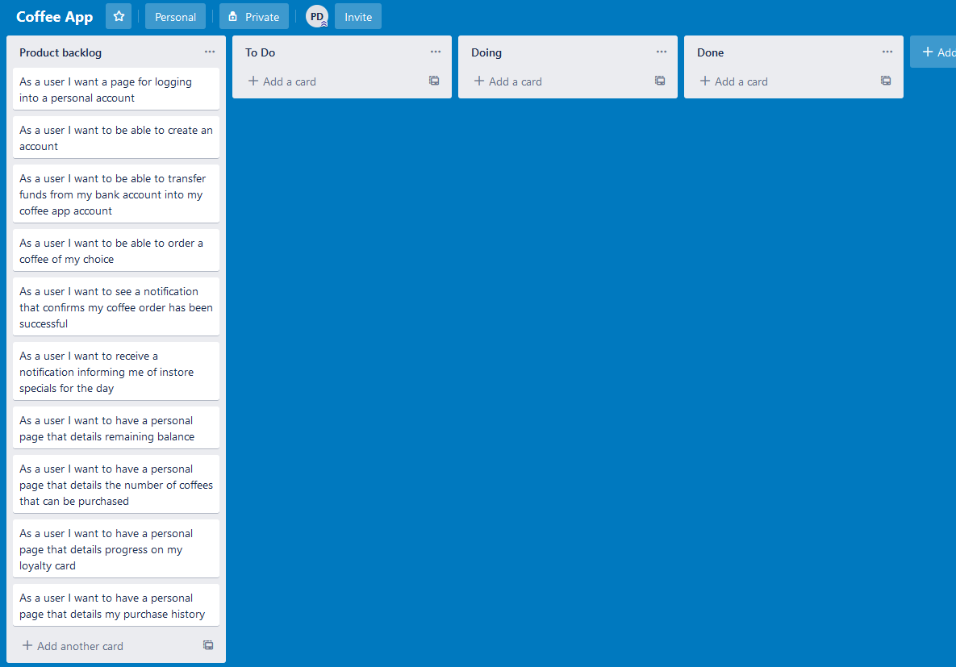

Meeting notes

* Established that almost all features of the app are reliant on input from a database and user accounts to function correctly
* Even most that do not rely on these rely on other functions that do
* Therefore the team spent some time designing the database for the app

Database:

Account

* AccountId (primary key)
* Password?(depends on login system used)
* Name
* Funds
* Loyalty

Orders

* OrderId (primary key)
* AccountId (Foreign key)
* Coffee
* Cost
* Date

We also established that the team was not sure of the best way to iumplement a log in system for the app. So we decided that one of the first things for us to do would be to do some research into how this could be achieved.

Disscussion of the app lead to the team coming up with some additional questions they wanted to ask the client.

* Should the notification received to confirm your order also display details about the order?
* What other in store specials would be available?
* What are the prices of the coffee and will this be likely to change in future?
* Is it really necessary to tell the user how many coffees they could order as well as their remaining balance? As these provide the same information
* What is the name of the Coffee app?
* Will the app be required to implement functionality for giving the customer a free coffee when they reach enough loyalty points?

As the rest of the app relies so heavily on a database and a log in system the team decided that these would be the first things to work on. So we moved the user stories “As a user I want to log into a personal account” and “As a user I want to be able to create an account” into the To Do section on the Kanban board. Completing these will lay the ground for future features that rely on these, so they must be prioritised. Additionally these user stories contribute to 10/27 of the total story points which keeps us on track for completing the project on schedule.

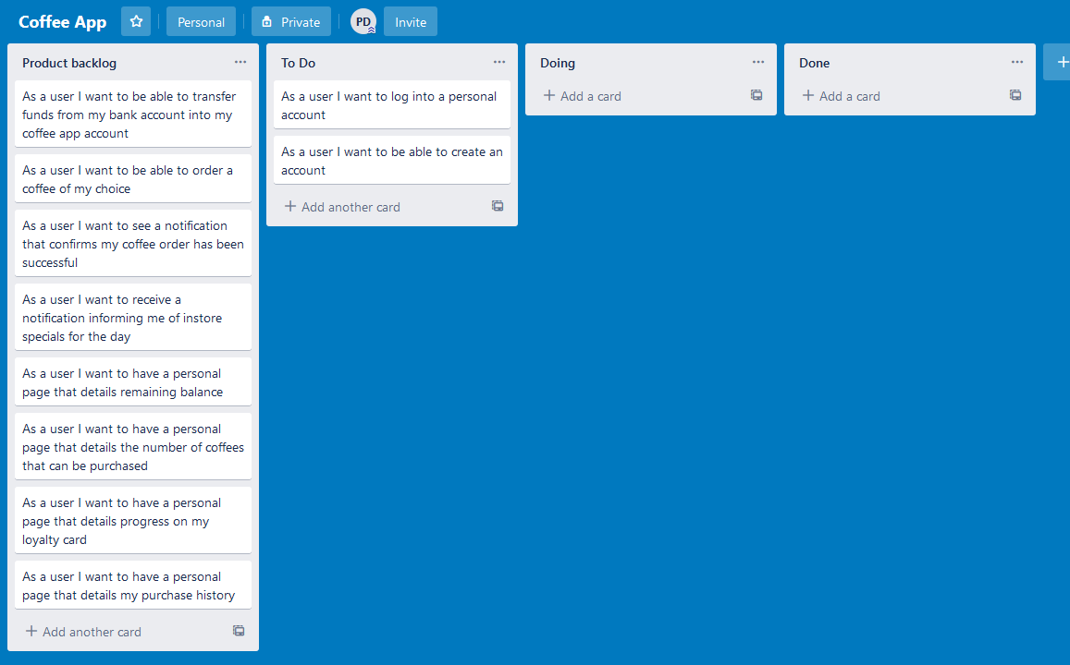

2nd Planning Session

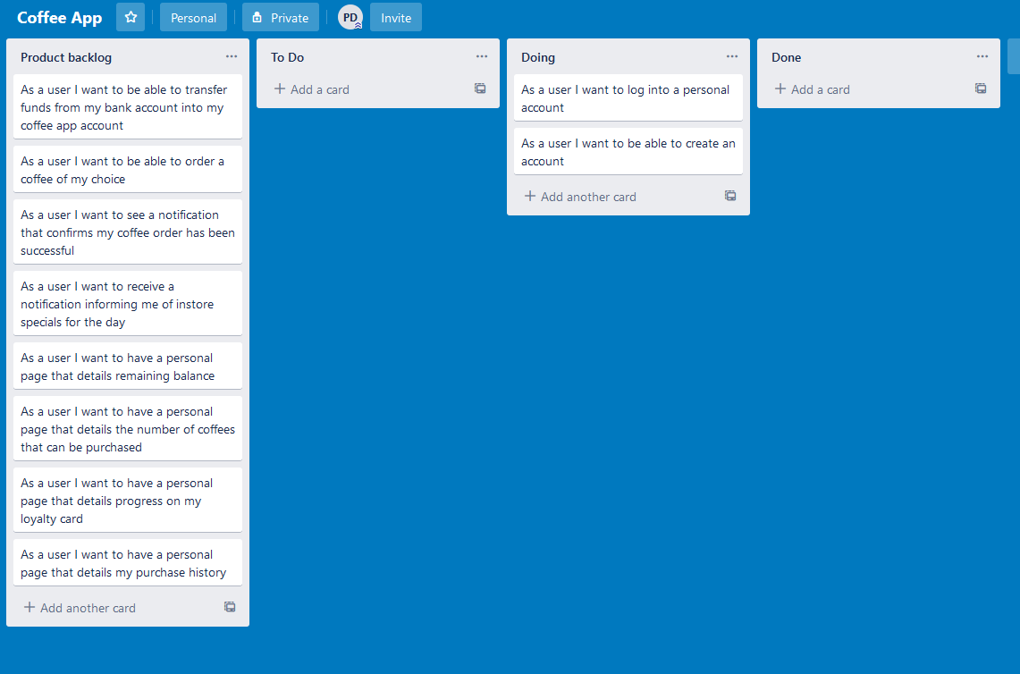

Meeting Notes

Sprint Retrospective

We realised that while the features that we were working on during the last sprint had been implemented, we weren’t confident enough in them to be able to call them “Done”. As a result of this we decided to add a “Testing” column to our Kanban board. That way we could spend some time ensuring that the features performed in exactly the way that we wanted them to.

The team’s implementation of the login feature is not as secure as it could be. This is because passwords for accounts were being stored in a plain text format. This was brought up to the client as something that should be addressed in a future release.

Due to the team having to do research about how to implement these features before actually beginning to work on them, it took longer to implement than was originally thought. The team should make sure to take this into account for future sprints.

Sprint Planning

The client noted during the demo process that it was difficult for them to tell what was happening in this early stage of development. Perhaps some more output should be given by the app to not only assist in demoing to the client but also to assist with testing.

We reviewed the client’s responses to our questions

Should the notification received to confirm your order also display details about the order?

* No a simple confirmation is adequate

What other in store specials would be available?

* Placeholder data is fine for now, this will be addressed later in development

What are the prices of the coffee and will this be likely to change in future?

* All coffee costs $5 each, this may change in the future though

Is it really necessary to tell the user how many coffees they could order as well as their remaining balance? As these provide the same information

* Both are necessary, we want to encourage topping up by showing how many coffees can be bought

What is the name of the Coffee app?

* My Coffee Buddy

Will the app be required to implement functionality for giving the customer a free coffee when they reach enough loyalty points?

* Yes, this should also reset the clients loyalty points

For the next sprint we decided to do the user stories “As a user I want to be able to transfer funds from my bank account into my coffee app account”, “As a user I want to be able to order a coffee of my choice” and “As a user I want to see a notification that confirms my coffee order has been successful”. This was because these are the most core features of the apps functionality so they should be prioritised. Additionally these functioning correctly is necessary for implementing some of the other user stories. We also made sure to select a smaller amount of story points to work on this sprint as the workload was struggled with in the previous sprint and we still had testing work to do on the previous items.

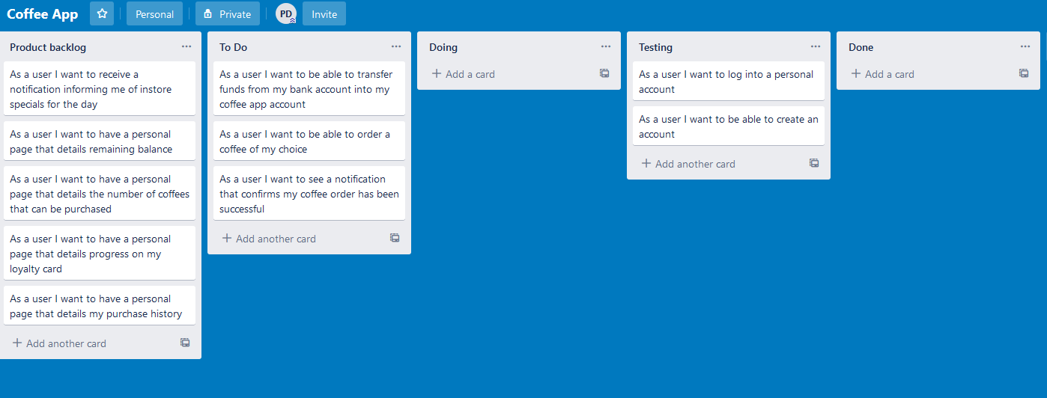

3rd Planning session

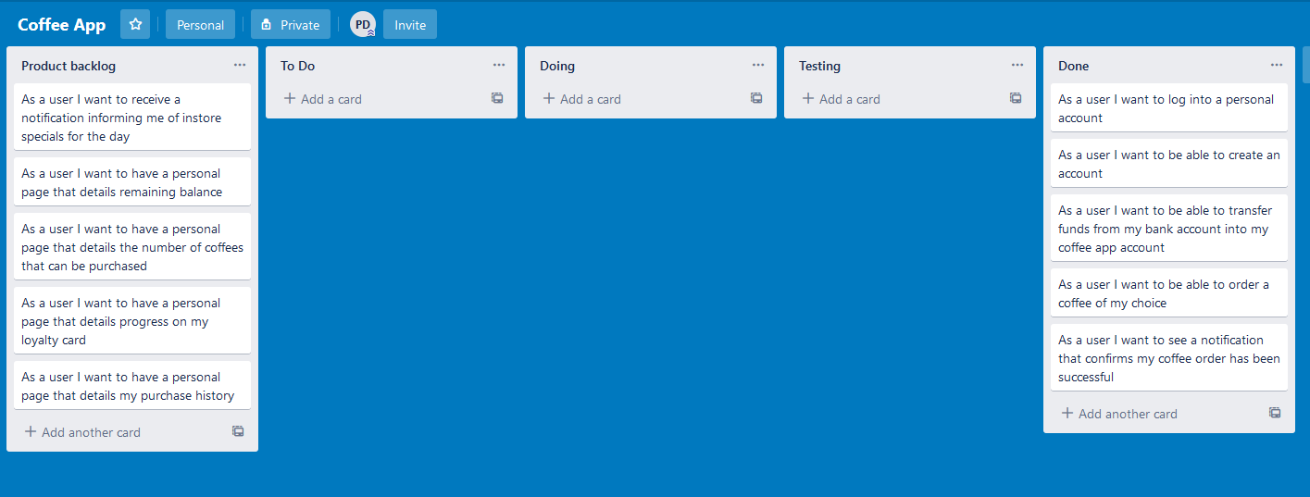

Meeting Notes

Sprint retrospective

The team really appreciated the reduced workload and all tasks were able to be completed in good time.

The addition of a dedicated testing process in the development paid dividends. We were able to find issues with features already considered done while testing later features. This meant we could make fixes to those as well as test our new features.

The team noted that should changes will have to be made to the currently written code to accommodate some of the later features when they are added. Such as when records of orders are implemented. The team decided that this was ok though because the envisioned changes were more additions to the code already there rather than having to actually rewrite anything.

Sprint Planning

The client came to us with a proposed change to the app. They would like the app to also offer the option to order doughnuts of either plain, chocolate or strawberry flavours.

The team asked the client some questions about the proposed change.

What is the price of the doughnuts?

* $5 same as the coffee

Confirmation notification for ordering doughnuts?

* Yes, in the same format as ordering coffee

Where in the app should the user be prompted to order a doughnut?

* There should be a separate page linked to from the coffee ordering page to order doughnuts from

Will doughnuts also need to appear in a user’s order history?

* Yes, but as separate entries to coffee orders

The team advised the client that implementing this feature would likely take almost an entire sprint to itself. Therefore it would push back the completion date of the project significantly.

The client was ok with this so the team began developing user stories additional user stories for this feature

As a user I want to be able to order a doughnut after ordering a coffee (3)

As a user I want to be able to see a notification that confirms my doughnut order (1)

For this sprint the team decided to complete the user stories “As a user I want to be able to order a doughnut after ordering a coffee”, “As a user I want to be able to see a notification that confirms my doughnut order” and “As a user I want to receive a notification informing me of instore specials for the day”. This was so that this sprint could take care of the new feature brought up by the client as well as the other smaller user stories left in the backlog. This means that the remaining user stories in the backlog are all related to each other so it will be easier to work on them together during the next sprint.

The team realised that they needed more information from the client about the user story “As a user I want to receive a notification informing me of instore specials for the day”. So they asked:

When and where in the app should the user receive this notification?

* After logging in, on the home page

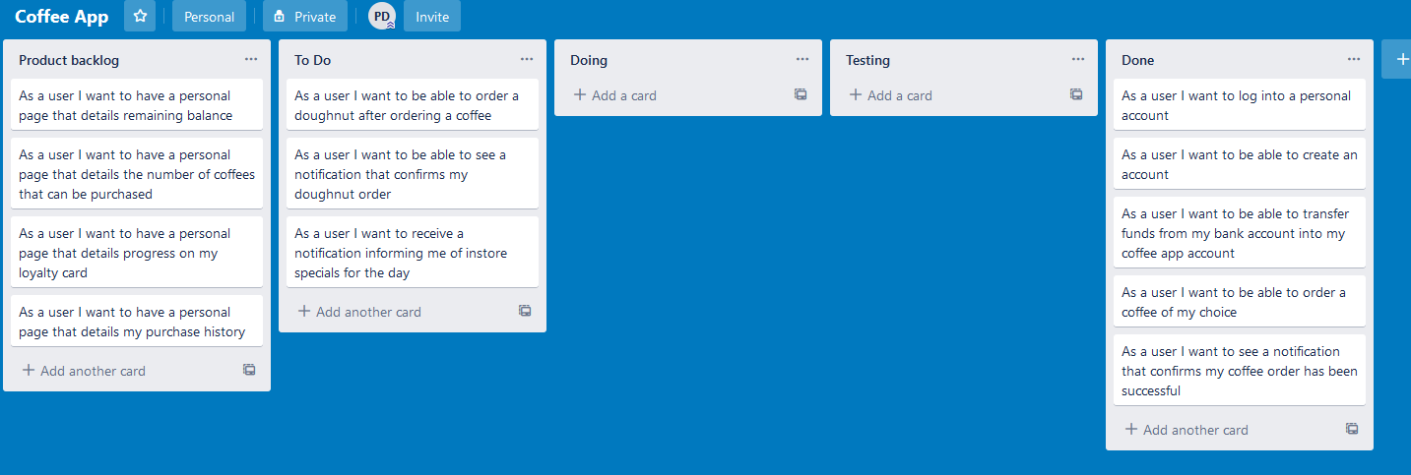

Meeting Notes

Sprint Retrospective

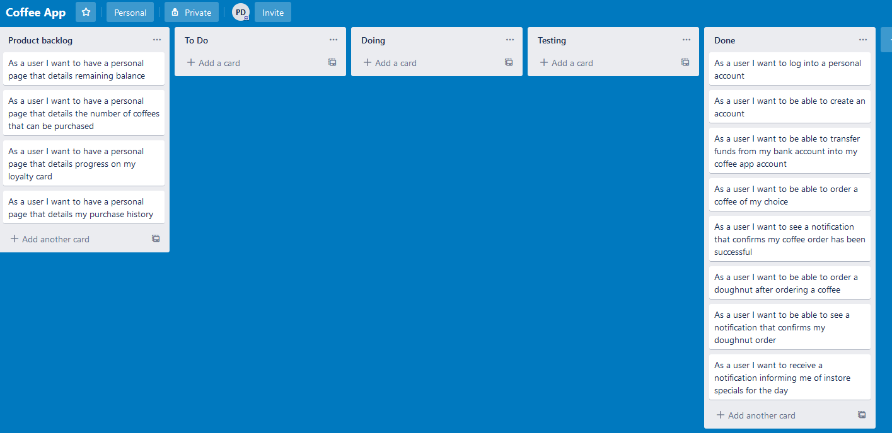

For this sprint the team really overestimated the amount of work there was to be done. This was because they didn’t account for the amount of code they would be able to reuse while implementing these features. While this was great for completing the sprint on schedule, the team was a bit regretful about not adding more work into the sprint. This was because the new feature already put a delay on the project and the team missed a chance to get more work done.

The team had a really easy time implementing these features and because of the amount of code reused there were also very few errors in the code. This meant that testing was also an easy process.

In future the team will look to estimate how much code could be reused to complete the tasks in a sprint and adjust the workload of the team accordingly.

This was particularly regrettable as the team was now out of time for completing the project on schedule.

Final Presentation

* The client was happy with how the currently implemented features are handled.
* The client was disappointed that not all of the project was completed on schedule
* They were happy that their additional feature of purchasing doughnuts was able to be easily implemented

With the addition of the doughnuts requirement and the poor time allocation during the final sprint, the team was unable to complete the project on time. However the features that were able to be implemented were met with positivity by the client. This I believe shows that the team was producing good work. The team did let themselves down with time management for the project. Therefore that would be the are to focus on for future projects with the team.