## Constraining isotope disequilibrium in speleothems

Peter E Carlson, Alexandraa,1 L Noronhaa, Corinne I Wong, Jay L Bannera, Benjamin F Hardta,[1], Eric W Jamesa, John W Jensonb, Mark W Moorea, Judson W Partinc, Michael Deiningerd

*aJackson School of Geosciences, University of Texas at Austin, 78712, USA*

*bWater and Environmental Research Institute of the Western Pacific, University of Guam, Mangilao, Guam 96923, USA*

*cInstitute for Geophysics, Jackson School of Geosciences, University of Texas at Austin,* *Austin, Texas 78758, USA*

*dSchool of Earth Sciences, University College Dublin, Belfield, Dublin 4, Ireland*

### Introduction

Speleothem calcite *δ*18O records have historically been the focus of the majority of speleothem-based paleoclimate studies (Fairchild et al., 2006; Fairchild and Baker, 2012), and continue to be among the most commonly reported geochemical proxy records, even as the number of speleothem proxy techniques grows. In order to inform robust interpretations of speleothem *δ*18O time-series, a wide variety of cave monitoring studies have been undertaken in caves globally (Wong and Breecker, 2015).

Measured cave calcite *δ*18O is rarely in agreement with theoretically derived predictions of equilibrium isotopic fractionation (i.e. Horita and Clayton, 2007 and Chacko and Deines, 2008), nor with the experimental determinations which are in good agreement with the theoretical models (i.e. Jiménez-López et al., 2001 and Kim and O’Neil, 1997). Studies of calcite precipitating slowly from thin films (Affek and Zaarur, 2014; Day and Henderson, 2011; Polag et al., 2010) confirm that the commonly used equilibrium values derived from calcite precipitated rapidly from bulk solution (e.g. Kim and O’Neil, 1997), are not applicable to speleothems. This discrepancy between field measurements and calculated isotopic equilibrium has lead researchers to question both the assumption of equilibrium isotopic fractionation in cave calcite precipitation (Mickler et al., 2006), as well as the validity of accepted equilibrium values (Coplen, 2007).

The inability to constrain the degree to which isotope fractionation (equilibrium or non-equilibrium) is driven by site-specific effects is a further limitation in speleothem *δ*18O records. Recent laboratory precipitation experiments and theoretical models predict a dependence of the fractionation of isotopes between calcite and water (∆18*Oc*−*w*) on calcite growth rate, with higher calcite growth rates driving kinetic isotope effects, and slower growth rates allowing for isotope fractionation nearer to calculated equilibrium values. The effect of calcite growth rate on ∆18*Oc*−*w* is often invoked in the literature to explain observed offsets in cave calcite *δ*18O (e.g. Johnston et al., 2013, Stoll et al., 2015), but to date, the effect has not been thoroughly documented in cave calcite (Feng et al., 2012). Stoll et al. (2015) demonstrated good agreement between five speleothem calcite *δ*18O records when adjusted for growth-rate-dependent isotope fractionation, but did not include measurements of ∆18*Oc*−*w* values. While Baker et al. (2014) and Feng et al. (2012) presented calcite accumulation rate data and modern ∆18*Oc*−*w* values, their interpretations were complicated by variable temperatures.

Dreybrodt (2008) describes two models of isotope evolution during calcite precipitation: 1) a continuous-flow model (FLOW; Romanov et al., 2008) where calcite grown near the drip axis is in in near oxygen-isotope equilibrium with the dripping water and 2) a stagnant pool model, where a static pool of water on the speleothem surface undergoes Rayleigh fractionation before being replenished by the next drip. The latter situation has been extensively modeled (Deininger et al., 2012; (???)). Watkins et al. (2014) models ∆18*Oc*−*w* as a function of the growth rate rather than as a function of the drip rate using an ion-by-ion crystal growth model that distinguishes between the attachment of carbonate and bicarbonate ions to the crystal surface, as well as the oxygen-isotope composition of each.

Here, we use the results of seven years of detailed monitoring at Jinapsan Cave, Guam, including calcite grown on glass plates at four sites with growth rates ranging from 0.05-20 mg/day, to build a model of oxygen isotope fractionation, employing existing models of speleothem calcite growth rates and fractionation dependence on growth rate during calcite precipitation. This tropical cave is an ideal site to consider growth-rate-driven kinetic isotope effects, because the minimally-variable annual temperature and constant high humidity of the tropical cave allow us to confidently ignore temperature- and evaporation-driven effects on ∆18*Oc*−*w*. Furthermore, Day and Henderson (2011) demonstrated that growth-rate-driven changes in ∆18*Oc*−*w* are largest at higher temperatures, and Jipansan Cave has a relatively high temperature (∼25◦C).

### Site Description

The island of Guam (13.4◦N, 144.5◦E) is the largest and southernmost island in the Mariana Island volcanic island arc. Guam lies within the West Pacific Warm Pool and receives 2000-2500 mm of rainfall annually over distinct wet and dry seasons, with ∼70% of annual precipitation occurring during the July-December wet season (Lander and Guard, 2003). The dry season is characterized by persistent northeasterly trade winds, with most rain falling as light showers. The wet season begins when the trade winds slacken, and typically shift southeastward, resulting in more humid and unstable atmospheric conditions over the island. Formation of convective clouds drive moderate to heavy downpours, which are responsible for the majority of wet-season precipitation (Lander et al., 2001). Wet-season precipitation is also affected by tropical cyclone activity, with ∼30% of Guam’s wet-season precipitation induced by tropical cyclones (Kubota and Wang, 2009). Mean daily temperature is 27◦C and is constant throughout the year.

The northern half of the island comprises an uplifted carbonate plateau containing numerous caves. Jinapsan Cave is a progradiational collapse cave located on the northernmost point of the island, near Ritidian Point. The cave is located within 500 m of the beach in limestone forest. The cave has a single restricted opening, which is the highest point of the cave, and comprises a single chamber, though large flowstones and stalagmites form walls which give the illusion of multiple rooms. At the base of the cave is a pool that is hydrologically connected to the ocean.

### Methods

#### Cave Sample Collection

Sampling of cave drip water at Jinapsan Cave began in early 2008 and a routine monthly collection program was established in August of 2008 and was completed in September 2016. Samples have been collected at seven drip sites and the cave pool since the monitoring program was initiated (Partin et al., 2012). This work presented in this manuscript considers samples from four drip sites: Flatman, Station 1, Station 2, and Stumpy. Station 2 is the site of a stalagmite that has been previously been reported on and referred to as “Big Guam” or “Shakey” (Sinclair et al., 2012). The monthly monitoring program includes collection of water and drip rate data, calcite grown on glass plates, and deployment/collection of continuous loggers that record cave atmosphere *p*CO2, temperature, barometric pressure, and relative humidity.

Drip water is collected in pre-weighed wide-mouthed HDPE Nalgene bottles that are deployed under the drip and left for ∼24 hours. Collection bottles are weighed and water is decanted in the cave into bottles and pretreated for a suite of geochemical analyses. Aliquots of drip water for *δ*18O analysis are stored in 4 mL glass dram vials with no headspace. These aliquots are refrigerated until analysis, with the exception of the time spent in transit from University of Guam to the University of Texas at Austin. Aliquots of drip water for analysis of cation concentrations are stored in acid-washed 30 mL HDPE Nalgene bottles and preserved with 60 *µ*L of Seastar nitric acid. When sufficient water remains after aliquots have been decanted, pH, conductivity, and water temperature are measured using a Myron Ultrameter II - 6P (Myron L Company, Carlsbad, CA, USA).

Calcite is grown on 10 x 10 cm glass substrates that are frosted using glass beads to facilitate calcite nucleation. Glass substrates were weighed with a Sartorius MCI RC 210P electronic balance (Sartorius, Goettingen, Germany) before and after deployment in the cave to determine calcite growth rate. A standard plate is weighed to reduce variability in plate weight measurements associated with static electricity, humidity, and other environmental variables, following the methods established by Banner et al. (2007). Long-term variability in standard plate weight measurements is ∼0.5 mg. Glass substrates were left in place for 3-12 weeks and were removed and replaced during 24-hour water collection period. In January 2012, PVC holders for the glass substrates were installed under each drip site to ensure consistent plate orientation.

#### Cave Environmental Measurements

Cave *p*CO2 was logged at 1-hour intervals using a Vaisala GM70 CO2 probe (0-5000 ppm measurement range) and a Vaisala M170 data logger (Vaisala Corp, Helsinki, Finland). Beginning in 2012, the CO2 logging assembly has been deployed in a modified Pelican dry box (Pelican Products, Inc., Torrance, CA, USA) with ∼ 500 g of desiccant (Drierite desiccant (W.A. Hammond Drierite Co. Ltd., Xenia, OH, USA) or generic vermiculite). Cave air temperature, pressure, and relative humidity are logged at 1-hour intervals using HOBO Micro-Station Data Loggers (HOBO, Onset, Bourne, MA, USA).

Drip rates are calculated by measuring the time elapsed between drips with a chronometer. Standard protocol is to measure the interval between four consecutive drips three times and to report the average of these measurements as the drip interval. When the drip interval is >300 seconds, the long drip interval is noted, but no measurement of drip interval is taken.

#### Stable Isotope Analysis

A total of 140 glass substrate calcite samples (Flatman, n=35; Station 1, n=32; Station 2, n=41; Stumpy, n=32) and 278 drip water samples were analyzed (Flatman, n=62; Station 1, n=82; Station 2, n=72; Stumpy, n=62) for carbon and oxygen stable isotope ratios. All stable isotope analyses were carried out in facilities at the University of Texas at Austin (UT). New water *δ*18O measurements presented in this manuscript were analyzed on a Thermo-Finnigan MAT-253 equipped with a Gas Bench II via CO2 equilibration at the UT Stable Isotope Lab for Critical Zone Gases. For each measurement, 1 mL of water was added to 12 mL LabCo Exetainer vials which are sealed and purged with 3% CO2 in He and equilibrated at 40◦C for 8 hours. Results are normalized based on replicate measurements of an internal laboratory standard calibrated on the VSLAP-VSMOW scale with a long-term analytical precision of ±0.2‰ (2*σ*). Methods used for previously-published water *δ*18O measurements considered in this manuscript are described by Partin et al. (2012).

Glass plate calcite samples were analyzed for *δ*18O values using a Thermo-Finnigan MAT-253 equipped with a Gas Bench II or a Thermo-Finnigan Delta V equipped with Kiel IV device. Approximately 300 *µ*g of calcite was collected from the center of the glass substrate with a scalpel and transferred to 12 mL LabCo Exetainer vials. Vials were flushed with He, and calcite samples were converted to CO2 via reaction with 103% H3PO4 for 2 hours at 50◦C. Results were calculated using a two-point calibration method using NBS-18 and NBS-19 IAEA standards, following a correction for run drift with an internal reference standard of Cararra marble. Fifteen samples were analyzed in the UT Analytical Laboratory for Paleoclimatic Studies on a Thermo Finnigan Delta V equipped with Kiel IV device using 30-50 *µ*g of calcite using the carbonate analyses methods described by Partin et al. (2012).

#### Data Analysis

∆18*Oc*−*w* values are calculated using the measured *δ*18O*calcite* for each glass substrate and the average of all *δ*18O*water* measurements made at the corresponding site while the plate was deployed. In cases where measured drip interval is unavailable, drip interval is calculated from the mass of water collected, using a density of 1.0 g/mL, and assuming a constant drip volume of 0.07 mL. This data reduction was done using Python scripts, which are available for download at github.com/anoronha.

#### Rayleigh Fractionation Calculations

To model the degree of Rayleigh distillation occurring between drips, we calculated equilibrium Ca2+ concentrations, speciated dissolved inorganic carbon, and estimated the rates of evaporation, CO2 degassing, and calcite precipitation occurring between each drip. The model, which is primarily based on ISOLUTION (Deininger et al., 2012) calculates equilibrium fractionation assuming that the water film is static between drips. The HCO3- pool is assumed to be in equilibrium with the H2O pool, then altered by CO2 degassing and calcite precipitation between drips.

Equilibrium Ca2+ concentrations were determined using PHREEQC (Parkhurst and Appelo, 1999), with measured cave pCO2 and cave air temperature as inputs, and assuming a drip water pH of 8.0. Calcite deposition rates were in turn calculated using a modified version of ISOLUTION (Deininger et al., 2012) altered to accept measured drip-water [Ca2+] rather than soil pCO2, and to use the calcite growth rate constant αp from Hansen (2013).

Wo = (Cameas – Caequil) * (δ/Drip_Interval) * (1 - e-αp/δ * Drip_Interval))

Drip_Interval = seconds between drips

αp = (0.52 + 0.04T + 0.004T2) * 1e-5

δ = water film thickness 0.01 cm

Growth Rate (mg/day) = Wo*100.09 g/mol * 86,400 s/day *Voldrop/δ

The evaporation rate and CO2-degassing rate calculations of ISOLUTION remained unaltered, but because humidity in this cave is ~100% (Partin et al., 2012), 99% humidity was used as an input parameter to decrease the effects of evaporative δ18O enrichment in ISOLUTION. Additionally, options were added to ISOLUTION to allow for calcite precipitation according to Kim and O’Neil (1997), Affek and Zaarur (2014), or Coplen (2007) equilibrium relationships.

### Results

#### 4.1 Drip Rate Measurements

The four drip sites considered here represent a broad range of drip rates and drip rate variabilities (Fig. 1). The fastest dripping site, Flatman, has a mean drip rate of 4.00 drips/min, ranging from 2.27 to 5.78 drips/min and has a normalized drip rate variability of 0.0727 over the monitored period (Fall 2008 -Summer 2016). The slowest drip site, Stumpy, has a mean drip rate of 0.16 drips/min, ranging from 0.04 to 0.24 drips/min, and has a normalized drip rate variability of 0.139. The two intermediate sites, Stations 1 and 2, have similar mean drip rates of 1.00 and 0.86 drips/min, ranging from 0.29 to 2.17 and 0.44 to 2.03 drips/min, respectively. Stations 1 and 2 have very similar raw normalized drip rate variabilities of 0.189 and 0.192, respectively, but the drip rate timeseries of Station 2 is dominated by a long-term drying trend (p << 0.05) that is not apparent in the other drip rates (p > 0.1 for each). When this trend is removed, the normalized drip rate variability of Station 2 drops from 0.192 to 0.069.

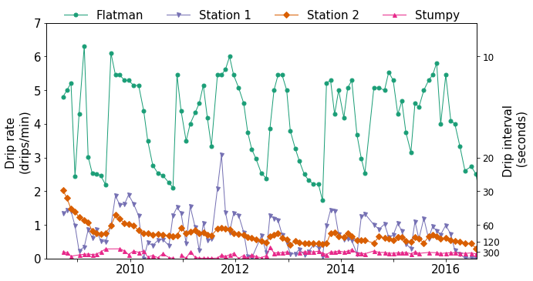

Figure 1. Measurements of drip interval and calculated drip rates for drip sites Flatman, Station 1, Station 2, and Stumpy. Higher drip rates (shorter drip intervals) correspond to increased water flux, whereas lower drip rates (longer drip intervals) correspond to decreased water flux.

#### 4.2 Drip Water and Calcite δ18O Measurements

Multi-year trends in drip water δ18O values are recorded in substrate calcite δ18O values, but seasonal signals in drip water δ18O values may not be accurately translated into the speleothem record (Fig. 2). The calcite δ18O record may add a seasonal component to the record (Station. 2, Stumpy) or obfuscate high-resolution signals in the drip-water δ18O record (Flatman, Station. 1).

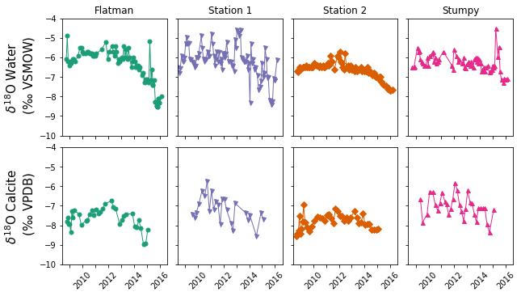 Figure 2. Measurements of drip water and calcite δ18O. In each case, the multi-year trend of the drip water signal is recorded in the calcite.

The relationships between the drip water δ18O signals and the calcite δ18O records can be further examined by calculating apparent fractionation factors (1000*lnα*) between each (Fig. 3). These apparent fractionation factors range from 28.02 to 30.58, with a mean 1000*lnα* near the equilibrium fractionation factors predicted by Coplen (2007) and by Affek and Zaarur (2014) for ambient Jinapsan cave air temperatures (25.9 ± 0.1°C; Noronha et al., 2016). These apparent fractionation factors are significantly higher than the fractionation factors predicted by Kim and O’Neil (1997) over the same temperature range. The range of apparent fractionation factors is also significantly larger than the range of equilibrium fractionation factors calculated using Kim and O’Neil (1997; 27.49 to 27.91), Affek and Zaarur (2014; 28.70 to 29.10), or Coplen et al. (2002; 29.22 to 29.62).

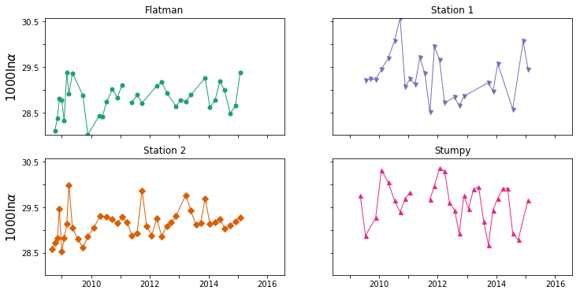

Figure 3. Apparent fractionation factors calculated using averaged drip δ18O and calcite δ18O. Drip δ18O values are averaged from all measurements taken during the calcite growth period for a corresponding calcite δ18O measurement.

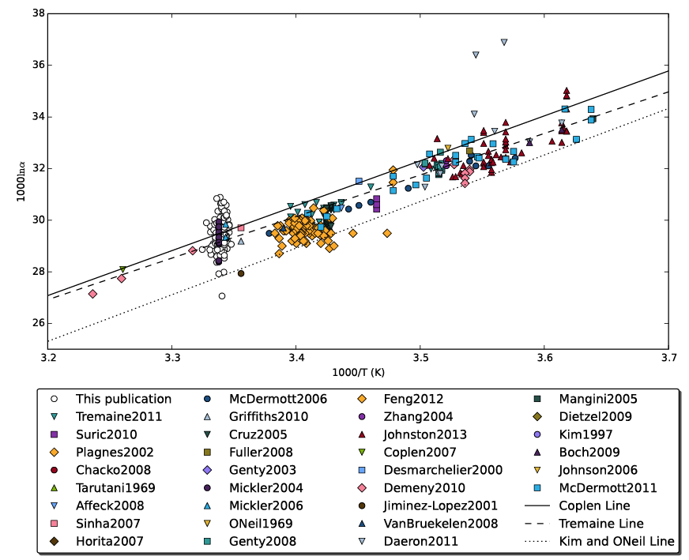

Fractionation factors calculated for these data range from […], with a mean 1000lna near the equilibrium fractionation factors predicted by Coplen (2007) and by Affek and Zaarur (2014) for ambient cave air temperature. They are significantly higher than the fractionation factors predicted by Kim and O’Neil (1997) for ambient cave air temperature.

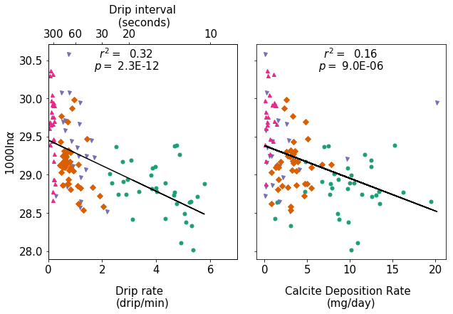

We find a significant correlation (r2 = 0.32, p ≪ 0.05) between 1000lna and drip rate, where increasing drip rate (decreasing interval between drips) is associated with decreasing oxygen-isotope fractionation factors. We find a lower correlation (r2 = 0.16, p ≪ 0.05) between 1000lna and calcite deposition rate, with increasing deposition rates associated with decreasing oxygen-isotope fractionation factors.

#### 4.2 Modeled Rayleigh Fractionation Results

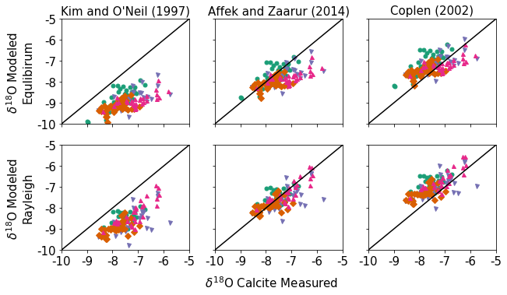

This takes into account drip rate, evaporation, calcite growth (temperature + Ca + drip rate, + cave PCO2), and CO2 degassing. The primary change to isolution is allowing it to use Coplen (2007) or Affek and Zaarur (2014).

We find that accounting for Rayleigh fractionation improves model performance. Affek and Zaarur (2014) equilibrium fractionation factors, when used as a baseline, best predict measured calcite d18O.

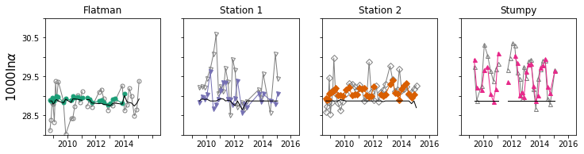

Comparison between modeled and measured fractionation factors. Each panel shows Affek and Zaarur (2014) equilibrium fractionation (black line), modeled apparent fractionation, based on Affek and Zaarur (2014) fractionation and Rayleigh distillation (colored lines and symbols, and measured fractionation between water and substrate calcite (gray lines and symbols). The Rayleigh Fractionation model significantly out-performs equilibrium fractionation for the site with the lowest drip rate (Stumpy) and moderate drip rates (Stations 1 and 2), but does not significantly improve predictions at the high drip-rate site (Flatman). Of the moderate drip rate sites, the Rayleigh fractionation model performs better in the site with less drip rate variability (Station 2).

### Discussion

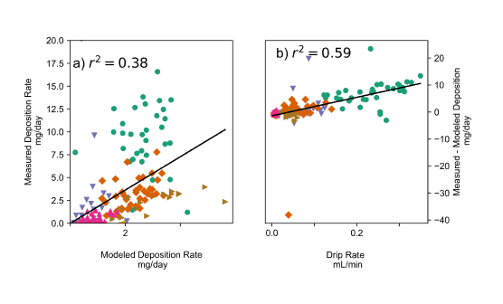

The Rayleigh fractionation model performs best at slower drip rates. Similarly, the growth rate model performs best at slower drip rates

[G3? GCA? GRL?]

GRL if short.



### References

Affek, H. P., Bar-Matthews, M., Ayalon, A., Matthews, A., Eiler, J. M. 2008. Glacial/interglacial temperature variations in Soreq cave speleothems as recorded by 'clumped isotope' thermometry. Geochimica et Cosmochimica Acta 72. 5351-5360.

Affek, H. P., Zaarur, S., 2014. Kinetic isotope effect in CO2 degassing: insight from clumped and oxygen isotopes in laboratory precipitation experiments. Geochimica et Cosmochimica Acta. 143, 319-330.

Baker, A. J., Mattey, D. P., Baldini, J. U. L., 2014. Reconstructing modern stalagmite growth from cave monitoring, local meteorology, and experimental measurements of dripwater films. Earth and Planetary Science Letters 392, 239–249.

Banner, J. L., Guilfoyle, a., James, E. W., Stern, L. a., Musgrove, M., 2007. Seasonal Variations in Modern Speleothem Calcite Growth in Central Texas, U.S.A. Journal of Sedimentary Research 77 (8), 615–622.

Boch, R., Spötl, C. Kramers, J. 2009. High-resolution isotope records of early Holocene rapid climate change from two coeval stalagmites of Katerloch Cave, Austria. Quat. Sci. Rev. 28, 2527–2538.

van Bruekelen M. R., Vonhof, H. B., Hellstrom, J. C., Wester, W. C. G., Kroon, D., 2008. Fossil dripwater in stalagmites reveals Holocene temperature and rainfall variation in Amazonia. Earth and Planetary Science Letters 275 (1-2), 54-60.

Chacko, T., Deines, P., 2008. Theoretical calculation of oxygen isotope fractionation factors in carbonate systems. Geochimica et Cosmochimica Acta 72 (15), 3642–3660.

Coplen, T. B., 2007. Calibration of the calcite-water oxygen-isotope geothermometer at Devils Hole, Nevada, a natural laboratory. Geochimica et Cosmochimica Acta 71, 3948–3957.

Cruz Jr., F. W., Karmann I., Viana Jr., O., Burns, S. J., Ferrari, J. A., Vuille, M., Moriera, M.Z., Sial, A. N., 2005. Stable isotope study of cave percolation waters in subtropical Brazil: Implications for paleoclimate inferences from speleothems. Chemical Geology 220, 245-262.

Daëron, M., Guo, W., Eiler, J., Genty, D., Blamart, D., Boch, R., Drysdale, R., Maire, R., Wainer, K., Zanchetta, G., 2011. 13C18O clumping in speleothems: Observations from natural caves and precipitation experiments. Geochimica et Cosmochimica Acta 75 (12), 3303-3317.

Day, C. C., Henderson, G. M., 2011. Oxygen isotopes in calcite grown under cave-analogue conditions. Geochimica et Cosmochimica Acta 75 (14), 3956–3972.

Dee, S., Emile-Geay, J., Evans, M. N., Allam, A., Steig, E. J., Thompson, D., 2015. PRYSM: An open-source framework for PRoxY System Modeling, with applications to oxygen-isotope systems. Journal of Advances in Modeling Earth Systems.

Demény A., Kele S., Siklósy Z., 2010. Empirical equations for the temperature dependence of calcite‐water oxygen isotope fractionation from 10 to 70°C. Rapid Communications in Mass Spectrometry 24 (24), 3521-3526.

Deininger M., Fohlmeister J., Scholz D., Mangini A., 2012. Isotope disequilibrium effects: the influence of evaporation and ventilation effects on the carbon and oxygen isotope composition of speleothems—A model approach. Geochim. Cosmochim. Acta, 96, 57-79.

Desmarchelier, J. M., Goede, A., Ayliffe, L. K., McCulloch, M. T., Moriarty, K., 2000. Stable isotope record and its paleoenvironmental interpretation for a late Middle Pleistocene speleothem from Victoria Fossil Cave, Naracoorte, South Australia. Quaternary Science Reviews 19, 763-774.

Dietzel, M., Tang, J., Leis, A., Ko¨hler, S. J., 2009. Oxygen isotopic fractionation during inorganic calcite precipitation—Effects of temperature, precipitation rate and pH. Chemical Geology 268 (1-2), 107–115.

Dreybrodt, W., 2016. Problems in using the approach of Rayleigh distillation to interpret the 13C and 18O isotope compositions in stalagmite calcite. Acta Carsologica, 45 (3), 287-293.

Dreybrodt, W., Hansen, M., Scholz, D., 2016. Processes affecting the stable isotope composition of calcite during precipitation on the surface of stalagmites: Laboratory experiments investigating the isotope exchange between DIC in the solution layer on top of a speleothem and the CO2 of the cave atmosphere. Geochim. Et Cosmochim. Acta 174, 247-262.

Dreybrodt, W., Scholz, D., 2011. Climatic dependence of stable carbon and oxygen isotope signals recorded in speleothems: From soil water to speleothem calcite. Geochimica et Cosmochimica Acta 75 (3), 734–752.

Fairchild, I. J., Baker, A., 2012. Chapter 1: Introduction to Speleothems and Systems. In: Speleothem Science: From Process to Past Environment. John Wiley & Sons, Ltd, Chichester, UK, pp. 368–370.

Fairchild, I. J., Smith, C. L., Baker, A., Fuller, L., Spötl, C., Mattey, D. P., McDermott, F., 2006. Modification and preservation of environmental signals in speleothems. Earth-Science Reviews 75 (1-4), 105–153.

Feng, W., Banner, J. L., Guilfoyle, A. L., Musgrove, M., James, E. W., 2012. Oxygen isotopic fractionation between drip water and speleothem calcite: A 10-year monitoring study, central Texas, USA. Chemical Geology 304320 305, 53–67.

Fuller, L., Baker, A., Fairchild, I. J., Spötl, C., Marca-Bell, A., Rowe, P., Dennis, P. F., 2008. Isotope hydrology of dripwaters in a Scottish cave and implications for stalagmite palaeoclimate research. Hydrology and Earth System Sciences Discussions, European Geosciences Union 5 (2), 547-577.

Gabitov, R. I., Watson, E. B., Sadekov, A., 2012. Oxygen isotope fractionation between calcite and fluid as a function of growth rate and temperature: An in situ study. Chemical Geology 306-307, 92–102.

Genty, D., Blamart, D., Ouahdi, R., Gilmour, M., Baker, A., Jouzel, J., Van-Exter, S., 2003. Precise dating of Dansgaard-Oeschger climate oscillations in Western Europe from speleothem data, Nature, 421, 833-837.

Genty, D., 2008. Palaeoclimate Research in Villars Cave (Dordogne, SW-France), International Journal of Speleology, 37 (3), 173-191.

Griffiths, M. L., Drysdale, R. N., Vonhof, H. B., Gagan, M. K., Zhao, J.-X., Ayliffe, L. K., Hantoro, W. S., Hellstrom, J. C., Cartwright, I., Frisia, S., Suwargadi, B. W., 2010. Younger Dryas-Holocene temperature and rainfall history of southern Indonesia from δ18O in speleothem calcite and fluid inclusions. Earth and Planetary Science Letters 295, 30-36.

Horita, J., Clayton, R. N., 2007. Comment on the studies of oxygen isotope fractionation between calcium carbonates and water at low temperatures by Zhou and Zheng (2003; 2005). Geochimica et Cosmochimica Acta 71 (12), 3131–3135.

James, E. W., Banner, J. L., Hardt, B., 2015. A global model for cave ventilation and seasonal bias in speleothem paleoclimate records. Geochemistry, Geophysics, Geosystems 16 (4), 1044–1051.

Jiménez-López, C., Caballero, E., Huertas, F., Romanek, C., 2001. Chemical, mineralogical and isotope behavior, and phase transformation during the precipitation of calcium carbonate minerals from intermediate ionic solution at 25C. Geochimica et Cosmochimica Acta 65 (19), 3219–3231.

Johnson, K. R., Hu, C., Belshaw, N. S., Henderson, G. M. 2006. Seasonal trace-element and stable-isotope variations in a Chinese speleothem: the potential for highresolution paleomonsoon reconstruction. Earth Planet. Sc. Lett. 244: 394-407.

Johnston, V. E., Borsato, A., Spötl, C., Frisia, S., Miorandi, R., 2013. Stable isotopes in caves over altitudinal gradients: fractionation behaviour and inferences for speleothem sensitivity to climate change. Climate of the Past 9 (1), 99–118.

Kaufmann, G., 2003. Stalagmite growth and palaeo-climate: the numerical perspective. Earth Planet. Sci. Lett. 214, 251–266.

Kaufmann, G., Dreybrodt, W., 2004. Stalagmite deposition and paleo-climate: an inverse approach. Earth Planet. Sci. Lett. 224, 529–545

Kim, S.-T. T., O’Neil, J. R., 1997. Equilibrium and nonequilibrium oxygen isotope effects in synthetic carbonates. Geochimica et Cosmochimica Acta 61 (16), 3461–3475.

Kubota, H., Wang, B., 2009. How much do tropical cyclones affect seasonal and interannual rainfall variability over the western North Pacific? Journal of Climate 22 (20), 5495–5510.

Lander, M. A., Guard, C. P., 2003. Creation of a 50-Year Rainfall Database, Annual Rainfall Climatology , and Annual Rainfall Distribution Map for Guam. Forecast (102).

Lander, M. A., Jenson, J. W., Beausoliel, C., 2001. Responses of Well Water Levels on Northern Guam to Variations of Rainfall and Sea Level. Tech. rep.

Mangini, A., Spötl, C., Verdes, P., 2005. Reconstruction of temperature in the Central Alps during the past 2000 yr from a δ18O stalagmite record. Earth and Planetary Science Letters 235 (3-4), 741-751.

McDermott, F., Schwarcz, H., Rowe, P. J., 2006. Isotopes in speleothems. In: Isotopes in Paleoenvironmental Research, Leng, M. J. (Ed.), Springer, Dordrecht, 185-225.

McDermott, F., Atkinson, T., Fairchild, I. J., Baldini, L. M., Mattey, D. P., 2011. A first evaluation of the spatial gradients in δ18O recorded by European Holocene speleothems. Global and Planetary Change 79 (3-4), 275-287.

Mickler, P. J., Banner, J. L., Stern, L., Asmerom, Y., Edwards, R. L., Ito, E. 2004. Stable isotope variations in modern tropical speleothems: Evaluating equilibrium vs. kinetic isotope effects. Geochim. Cosmochim. Acta, 68(21): 4381–4393.

Mickler, P. J., Stern, L. A., Banner, J. L., 2006. Large kinetic isotope effects in modern speleothems. Bulletin of the Geological Society of America 118 (1), 65–81.

Noronha, A. L., Hardt, B. F., Banner, J. L., Jenson, J. W., Partin, J.W., James, E. J., Lander, M. A., Bautista, K. K., 2016. Trade winds drive pronounced seasonality in carbonate chemistry in a tropical Western Pacific island cave-Implications for speleothem paleoclimatology. Geochemistry, Geophysics, Geosystems. 18. 10.1002/2016GC006644.

O'Neil, J. R., Clayton, R. N. Mayeda, T. K., 1969. Oxygen isotope fractionation in divalent metal carbonates. Journal of Chemical Physics, 51, 5547-5558.

Parkhurst, D. L., Appelo, C. A. J., 1999, Users’s guide to PHREEQC (Version 2) – a computer program for speciation, batch-reaction, one-dimensional transport, and inverse geochemical calculations. Water-Resources Investigations Report 99-4259. U.S. Geological Survey.

Partin, J. W., Jenson, J. W., Banner, J. L., Quinn, T. M., Taylor, F. W., Sinclair, D. J., Hardt, B., Lander, M. A., Bell, T., Miklavǐc, B., Jocson, J. M. U., Taborǒsi, D., 2012. Relationship between modern rainfall variability, cave dripwater, and stalagmite geochemistry in Guam, USA. Geochemistry, Geophysics, Geosystems 13 (3), Q03013.

Plagnes, V., Causse, C., Genty, D., Blamart, D., Paterne, M., 2002. A stalagmite record from 187 to 74 ka in Clamouse Cave (South of France), Earth and Planetary Science Letters 201, 87-103.

Polag, D., Scholz, D., Mühlinghaus, C., Spötl, C., Schröder-Ritzrau, A., Segl, M., Mangini, A., 2010. Stable isotope fractionation in speleothems: Laboratory experiments. Chemical Geology 279 (1-2), 31–39.

Romanov, D., Kaufmann, G., Dreybrodt, W., 2008. δ13C profiles along growth layers of stalagmites: comparing theoretical and experimental results. Geochim. et Cosmochim. Acta, 72, 438–448.

Sinclair, D. J., Banner, J. L., Taylor, F. W., Partin, J. W., Jenson, J., Mylroie, J., Goddard, E., Quinn, T., Jocson, J., Miklavǐc, B., 2012. Magnesium and strontium systematics in tropical speleothems from the Western Pacific. Chemical Geology 294-295, 1–17.

Sinha, A., Cannariato, K. G., Stott, L. D., Cheng, H., Edwards, R. L., Yadava, M.G., Ramesh, R., and Singh, I. B., 2007. A 900 Year (600 to 1500 AD) record of the Indian Summer Monsoon Precipitation from the Core Monsoon Zone of India, Geophysical Research Letters, 34, L1670.

Stoll, H.M., Müller, W., Prieto M., 2012. I-STAL, a model for interpretation of Mg/Ca, Sr/Ca and Ba/Ca variations in speleothems and its forward and inverse application on seasonal to millennial scales. Geochem. Geophys. Geosystems, 13, Q09004.

Stoll, H. M., Mendez-Vicente, A., Gonzalez-Lemos, S., Moreno, A., Cacho, I., Cheng, H., Edwards, R. L., 2015. Interpretation of orbital scale variability in mid-latitude speleothem *δ*18O: Significance of growth rate controlled kinetic fractionation effects. Quaternary Science Reviews, 1–14.

Surić, M., Roller-Lutz, Z., Mandić, M., Bronić, I. K., Juračić, M., 2010. Modern C, O, and H isotope composition of speleothem and dripwater from Modrič Cave, eastern Adriatic coast (Croatia). International Journal of Speleology 39 (2), 91-97.

Tarutani T., Clayton, R. N., Mayeda, T. K., 1969. The effect of polymorphism and magnesium substitutions on oxygen isotope fractionation between calciu carbonate and water. Geochimica et Cosmochimica Acta, 33 (8), 987-996.

Tremaine, D. M., Froelich, P. N., Wang, Y. 2011. Speleothem calcite farmed in situ: Modern calibration of δ18O and δ13C paleoclimate proxies in a continuously-monitored natural cave system. Geochimica et Cosmochimica Acta 75: 4929-4950.

Wackerbarth, A. K., 2012. Towards a better understanding of climate proxies in stalagmites—Modelling processes from surface to cave. Ph.D. thesis.

Watkins, J. M., Hunt, J. D., Ryerson, F. J., DePaolo, D. J., 2014. The influence of temperature, pH, and growth rate on the *δ*18O composition of inorganically precipitated calcite. Earth and Planetary Science Letters 404, 332–343.

Watson, E. B., 2004. A conceptual model for near-surface kinetic controls on the trace- element and stable isotope composition of abiogenic calcite crystals. Geochimica et Cosmochimica Acta 68 (7), 1473–1488.

Wong, C. I., Breecker, D. O., 2015. Advancements in the use of speleothems as climate archives. Quaternary Science Reviews.

Zhang, M., Yan, D., Lin, Y., Qin, J., Bin, Li, Cheng, H., Edwards, R. L., 2004. A 6000-year high-resolution climatic record from a stalagmite in Xiangshui Cave, Guilin, China. Holocene 14 (5), 697-702.

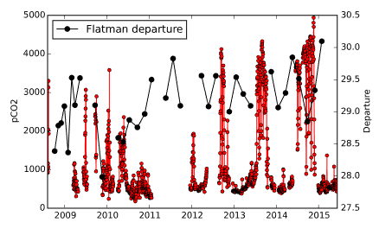

These are all labeled as departure, but I would guess that they’re actually 1000lnalpha. I haven’t found the code that makes these yet. We should not include the pre-2012 CO2 data (per Noronha et al., 2017).

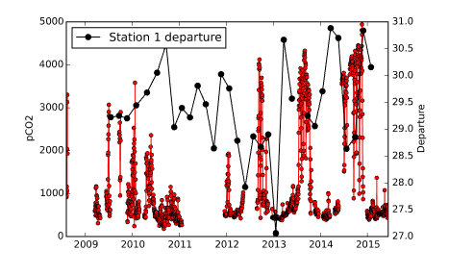

In general, periods of high pCO2 are associated with increasing fractionation factors.

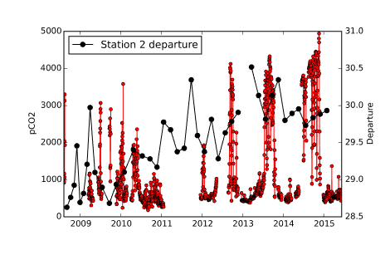

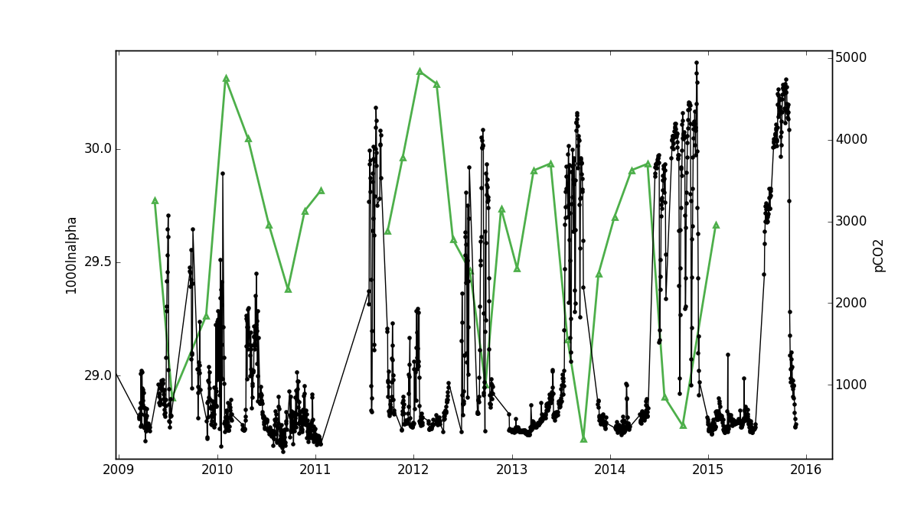

Time series of daily average cave pCO2 (black) and 18Oc-w at slowest growth site (green triangles).

**Observation**

Slow growth rate site has strongly seasonal calcite deposition, with low growth rate during the high pCO2 wet season, and nearly all calcite deposition occurring during the low pCO2 dry season. 18Oc-w also shows a distinct seasonal cycle, with higher 18Oc-w values during low pCO2/high growth rate intervals, and lower 18Oc-w during high pCO2/low growth rate intervals.

**Inference**

Because drip rate is relatively invariable at this site, we consider that this observed affect is driven entirely by cave pCO2. During intervals of high pCO2, less calcite degassing can occur, therefore inducing less fractionation in the DIC pool that calcite precipitates from. In the model proposed by Watkins2014, the measurements made on the Devil's Hole calcite by Coplen (2007) are taken to be representative of equilibrium fractionation, an assertion which is supported by recent clumped isotope measurements of the Devil's Hole calcite Kluge2014a. In this model, higher 18Oc-w are generally representative of less growth rate induced kinetic fractionation, while lower 18Oc-w are characteristic of more growth rate induced kinetic fractionation. The relationship observed at this slow growth rate site is the inconsistent with existing models of the effect of growth rates on 18Oc-w. This relationship is opposite of what would be predicted by the Watkins2014 growth rate model as well as the Watson2004 surface entrapment model. This is also the first demonstration of an effect of cave pCO2 on cave calcite 18O.

1. Now at Massachusetts Institute of Technology, EAPS Department, E25-610, 45 Carleton St, Cambridge, MA 02142, USA

   *Preprint submitted to Geochimica et Cosmochimica Acta March 9, 2016*