**Linguistic rules (pg 498)**

Rule i: If x is A, then f(x) is B, (I = 1,2,….,N)

Where x and f(x) are indepenedetn variables, and N the number of experimental data.

These rules are referred to as IF-THEN rules because of there form.

Antecedent – IF clause

Consequent – THEN clause

eg) If x is -2, then f(x) is 25/30

Four inputs:  
θ -Pole angle antecedent

θ̇ -Pole angle antecedent

$x$-Distance from a set point antecedent

- Distance from a set point antecedent

Reduction of fuzzy IF-THEN rules

Yamakawa states with four inputs (θ, θ̇, $x$, $ẋ$) used in the antecedent and five labels, there are 54 rules = 625 rules. He suggests reducing hem to:

X = Aθ1 + Bθ̇1 -Measure of emergency in the angle

Y = C $x$ +D $ẋ$-Measure of emergency in the position

Thus, the above fuzzy rules can be reduced to just 13 and assigned to the rule map:

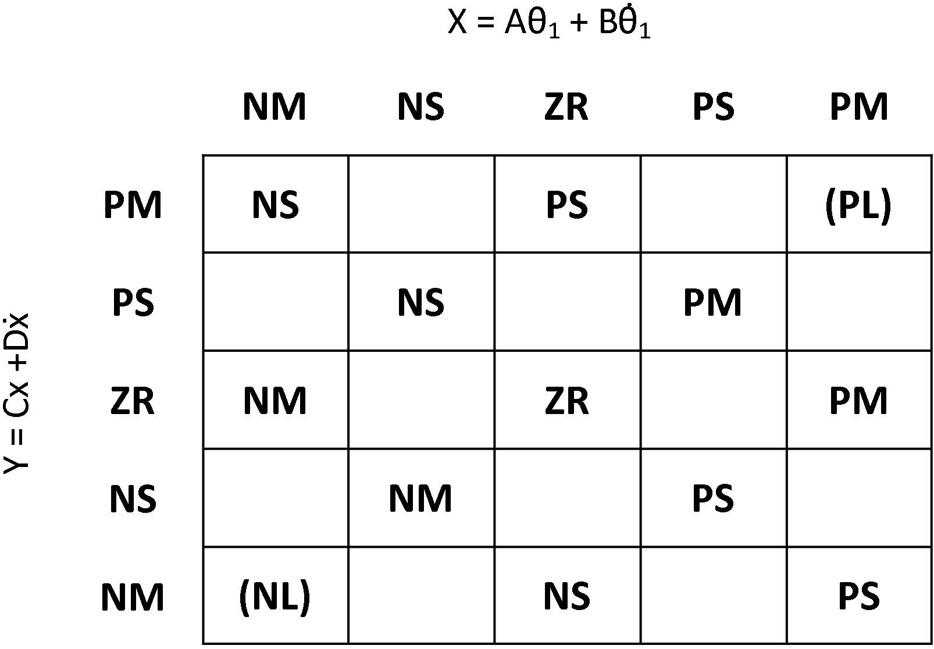

Rule set:

Rule1: If X is Negative Medium and Y is Positive Medium then output is Negative Small

Rule2: If X is Zero and Y is Positive Medium then output is Negative Small

Rule3: If X is Positive Medium and Y is Positive Medium then output is Positive large

Rule4: If X is Negative Small and Y is Positive Small then output is Negative Small

Rule5: If X is Positive Small and Y is Positive Small then output is Positive Medium

Rule6: If X is Negative Medium and Y is Zero then output is Negative Medium

Rule7: If X is Zero and Y is Zero then output is Positive large

Rule8: If X is Positive Negative and Y is Zero then output is Negative Medium

Rule9: If X is Negative Small and Y is Negative Small then output is Negative Small

Rule10: If X is Positive Small and Y is Negative Small then output is Positive Medium

Rule11: If X is Negative Medium and Y is Negative Medium then output is Positive large

Rule12: If X is Zero and Y is Negative Medium then output is Negative large

Rule13: If X is Positive Medium and Y is Negative Medium then output is Positive Small

Membership Functions

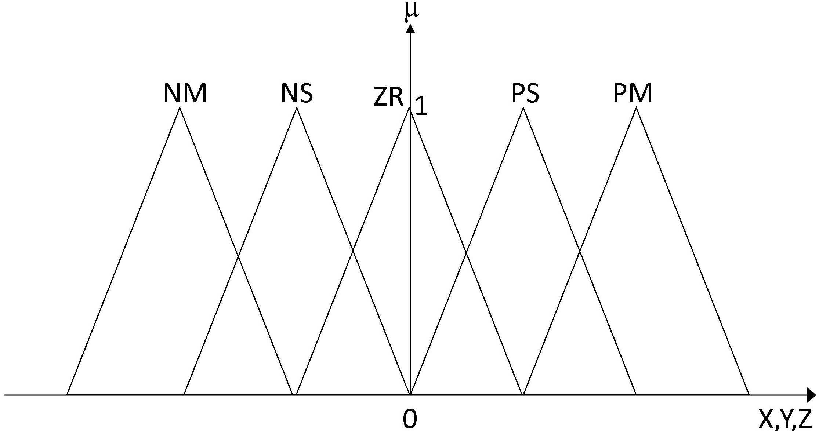

Excel representation

