Chapter 5 program 2 – Sum of Numbers.

//Name: Peter G Rutherford

//Date: 5/2/21

//Purpose: To get a good grade, and to learn c++.

//IDE: Visual Studio 2019

#include <iostream>

using namespace std;

int main() {

int a;

int b = 0;

cout << "Enter the number you want sum of: ";

cin >> a;

for (int i = 1; i <= a; i++) {

b = b + i;

}

cout << b;

return 0;

}

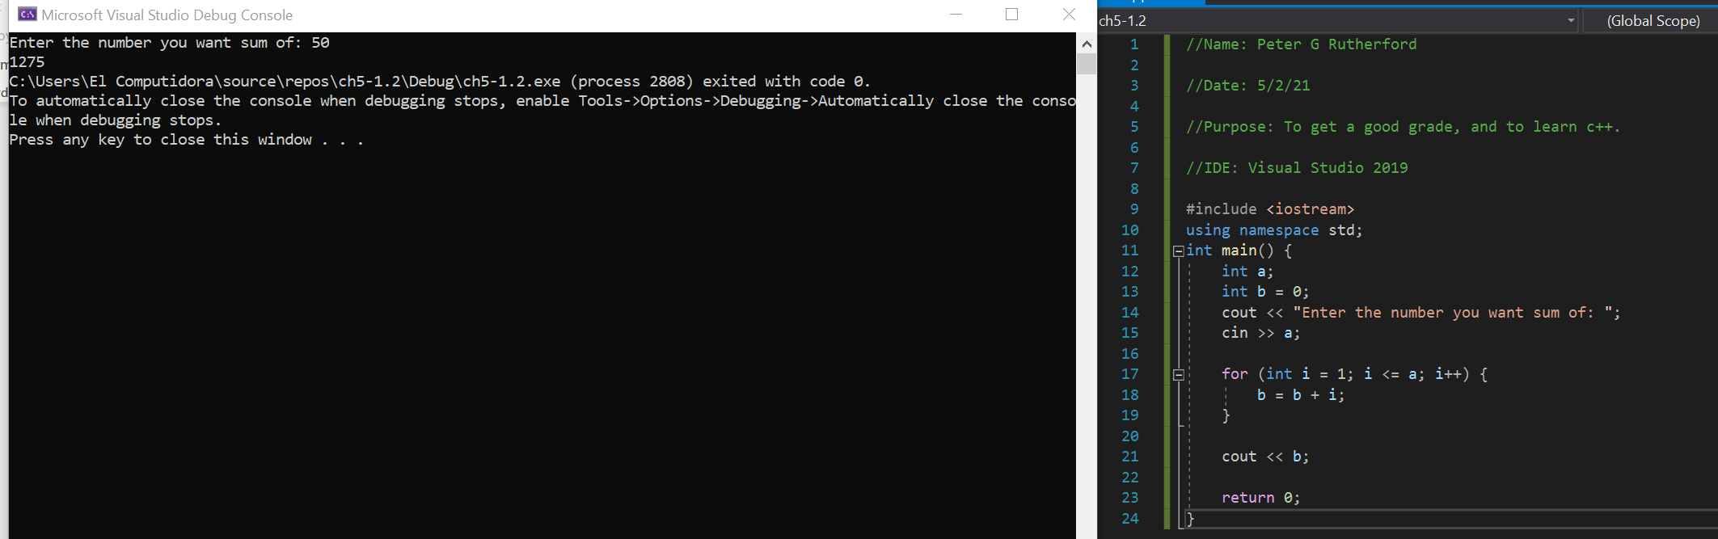

Program 8 – Pennies for Pay

#include <iostream>

using namespace std;

int main() {

int a;

double b = .01;

cout << "Enter the number of days you worked in this month: ";

cin >> a;

if (a < 32 && a > 0) {

for (int i = 1; i <= a; i++) {

cout << "Day: " << i << " | Salary = $" << b << endl;

b = b + b;

}

}

else {

cout << "Enter a valid number";

exit(0);

}

return 0;

}

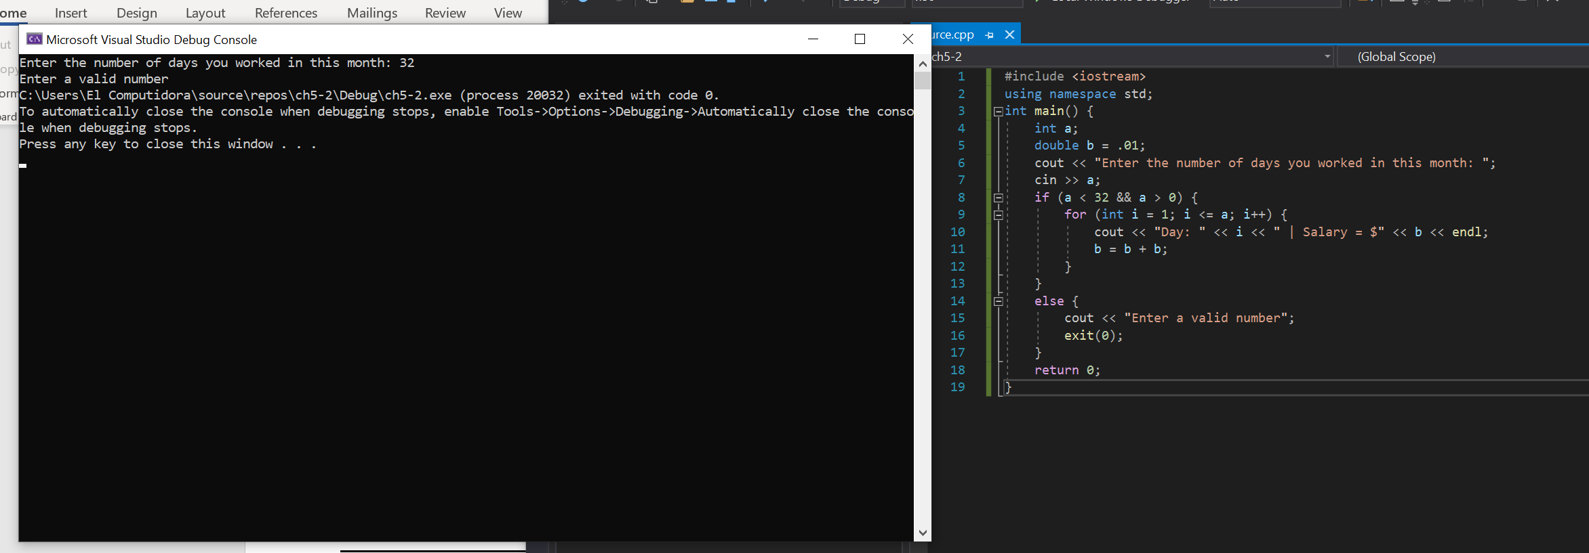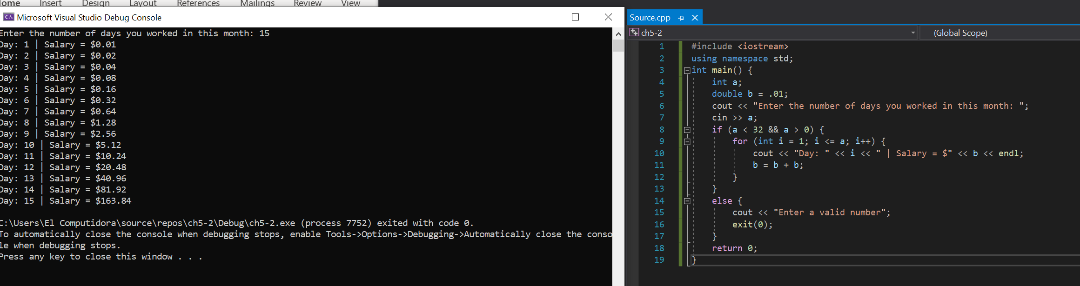

15 – Student lineup.

#include <iostream>

#include <string>

using namespace std;

int main() {

int a;

int i;

string students[20] = {"Amy", "Jack", "Amanda", "Tommy", "Angela", "Ben", "Jordan", "Jenna", "Roland", "Netasha", "Connor", "Betty", "Alex", "Cory", "Nick", "Sharon", "Phil", "Phile" , "Amy2", "Yolanda"};

cin >> a;

cout << "/n";

for(i = 0; i <= a; i++) {

cout << "Position: " << i << " Student: " << students[i] << endl;

}

return 0;

}

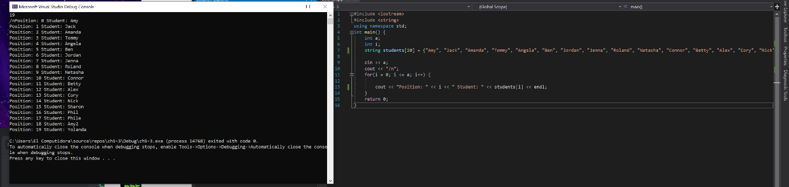

24 – Sales Bar Chart

#include <iostream>

#include <string>

#include <sstream>

using namespace std;

int main() {

double a;

double b;

double c;

double aa = 0;

double bb = 0;

double cc = 0;

string aaa = "";

string bbb = "";

string ccc = "";

string d = "\*";

cout << "Enter today's sales for store 1, rounded to nearest $100: ";

cin >> a;

cout << "\nEnter today's sales for store 2, rounded to nearest $100: ";

cin >> b;

cout << "\nEnter today's sales for store 3, rounded to nearest $100: ";

cin >> c;

cout << "\n DAILY SALES";

while (aa < a) {

aa += 100;

aaa.append("\*");

}

while (bb < b) {

bb += 100;

bbb.append("\*");

}

while (cc < c) {

cc += 100;

ccc.append("\*");

}

cout << "Store 1: " << aaa << "\nStore 2: " << bbb << "\nStore 3: " << ccc;

return 0;

}

