Challenge 2 – Celsius temperature table

// Programmer: Peter Rutherford

// Purpose: To get a good grade, and to learn C++ as best as I can.

// Date modified: 5/23/2021

//Compiler used: MS VC++ 2019

#include <iostream>

#include <string>

using namespace std;

double Celsius(double a1) {

a1 -= 32;

a1 = a1 \* 5 / 9;

return a1;

}

int main() {

double temp;

cout << "Enter temperature in fahrenheit: ";

cin >> temp;

cout << "\n" << Celsius(temp);

return 0;

}

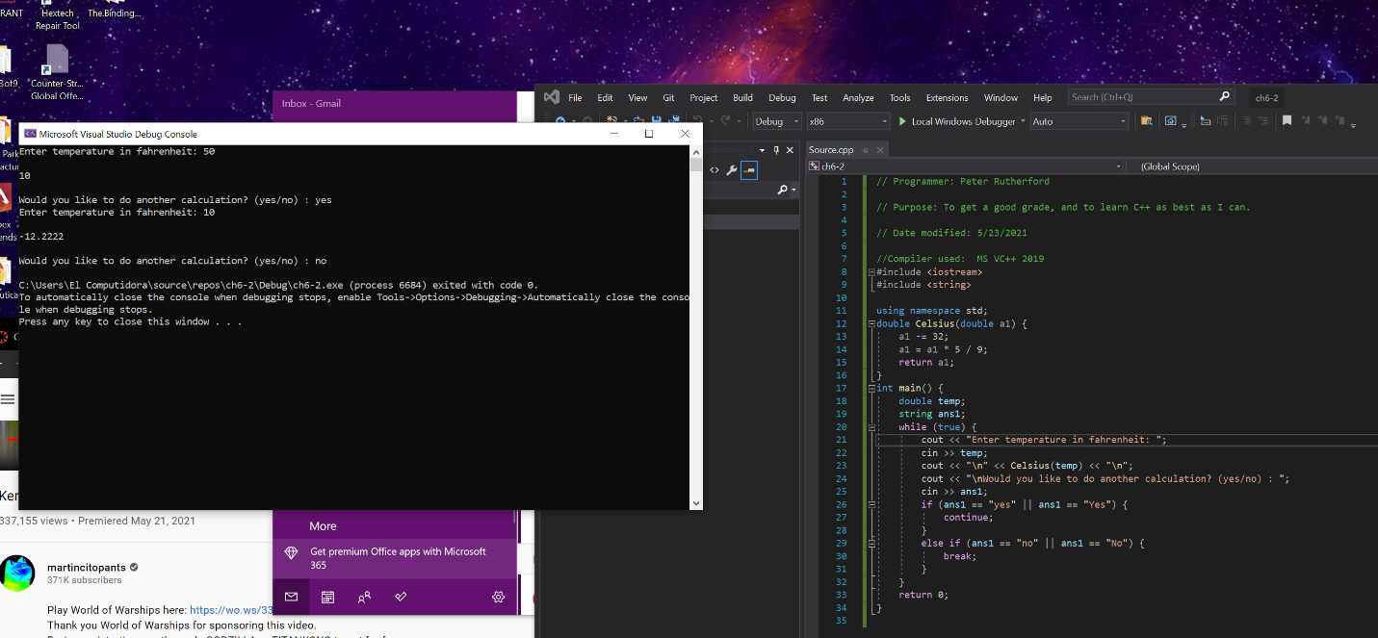

Challenge 3 – Falling Distance

#include <iostream>

#include <string>

using namespace std;

double fallingDistance(double a1) {

a1 = a1 \* a1;

a1 = a1 \* 9.8;

a1 = a1 / 2;

return a1;

}

int main() {

double fall;

while (true) {

string question;

cout << "Enter falling time (in seconds) : ";

cin >> fall;

cout << fallingDistance(fall) << " meters\n";

cout << "\nWould you like to do another calculation?(yes/no) : ";

cin >> question;

cout << "\n";

if (question == "yes" || question == "Yes") {

continue;

}

else if (question == "no" || question == "No") {

break;

}

}

return 0;

}

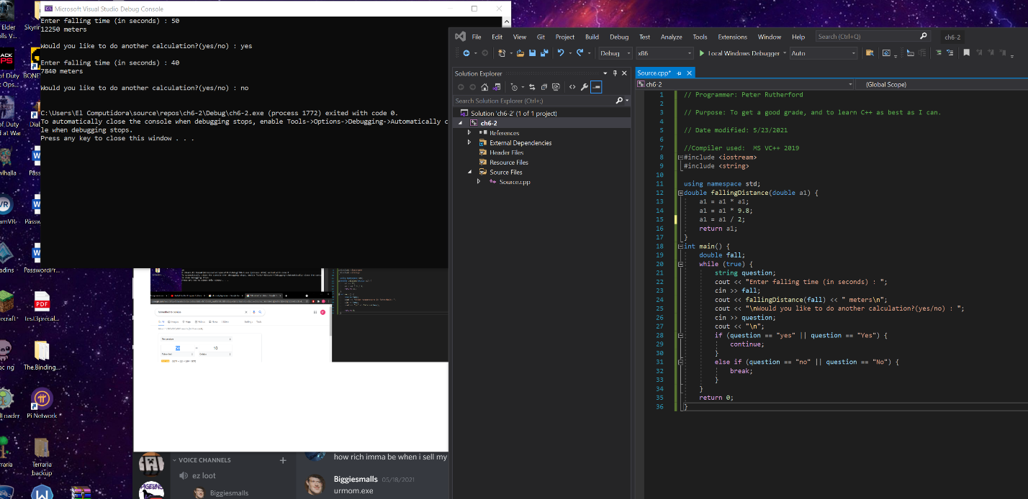

Challenge 10 – isprime

#include <iostream>

#include <string>

using namespace std;

bool isPrime(int a1) {

int counter;

if (a1 == 0 || a1 == 1) {

return false;

}

for (int i = 2; i <= a1/2; i++) {

if (a1 % i == 0) {

return false;

}

else {

return true;

}

}

return true;

}

int main() {

int num;

cout << "Enter in a number you want checked : ";

cin >> num;

if (isPrime(num)) {

cout << "Number is prime.\n";

}

else if (isPrime(num) == false) {

cout << "Number is not prime.\n";

}

return 0;

}

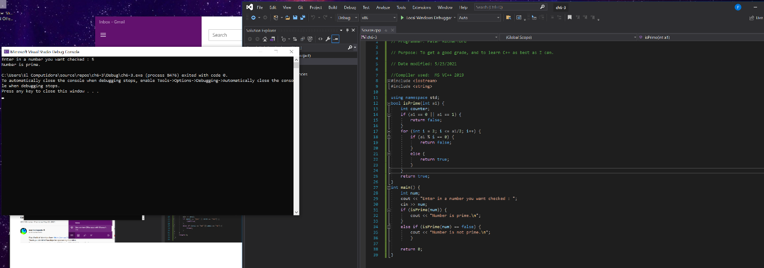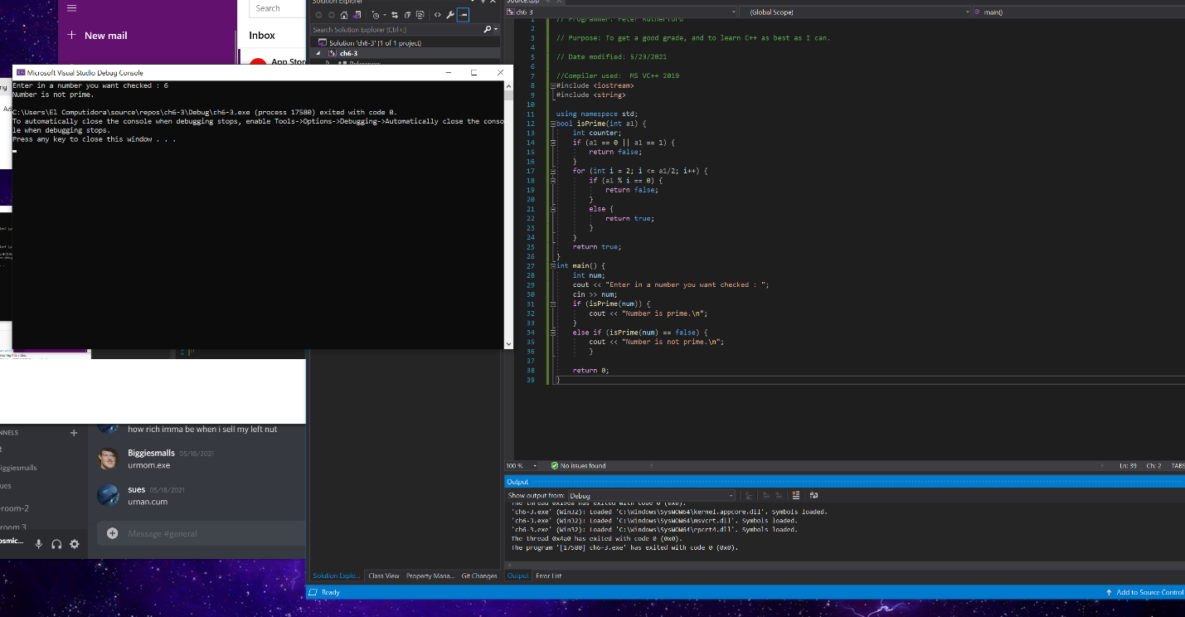

Challenge 13 – Stock Profit

#include <iostream>

#include <string>

using namespace std;

double stockProfit(int shares, double price, double com, double salep, double salecom) {

double c1 = shares \* price;

c1 = c1 + com;

double c2 = shares \* salep;

c2 = c2 - salecom;

return c2 - c1;

}

int main() {

int shares;

double price;

double com;

double salep;

double salecom;

cout << "Enter amount of shares : ";

cin >> shares;

cout << "\nEnter price per share : ";

cin >> price;

cout << "\nEnter purchase commission paid : ";

cin >> com;

cout << "\nEnter sale price per share : ";

cin >> salep;

cout << "\nEnter sale commission paid : ";

cin >> salecom;

cout << "\n\nStock Profit/Loss = $" << stockProfit(shares, price, com, salep, salecom);

return 0;

}

