Challenge 4 – car class

// Programmer: Peter Rutherford

// Purpose: To get a good grade, and to learn C++ as best as I can.

// Date modified: 5/23/2021

//Compiler used: MS VC++ 2019

#include <iostream>

#include <string>

using namespace std;

class car {

private:

int year;

string make;

int speed = 0;

public:

void setYear(int);

void setMake(string);

void Accelerate();

void Break();

int getYear();

string getMake();

int getSpeed();

};

void car::setYear(int y) {

if (y >= 1940)

year = y;

}

void car::setMake(string m) {

make = m;

}

string car::getMake(){

return make;

}

int car::getYear(){

return year;

}

int car::getSpeed(){

return speed;

}

void car::Accelerate () {

speed += 5;

}

void car::Break() {

speed -= 5;

}

int main(){

car Car1;

Car1.setMake("car that drives");

Car1.setYear(1992);

Car1.Accelerate();

cout << Car1.getMake() << "\n" << Car1.getYear() << "\n" << Car1.getSpeed();

return 0;

}

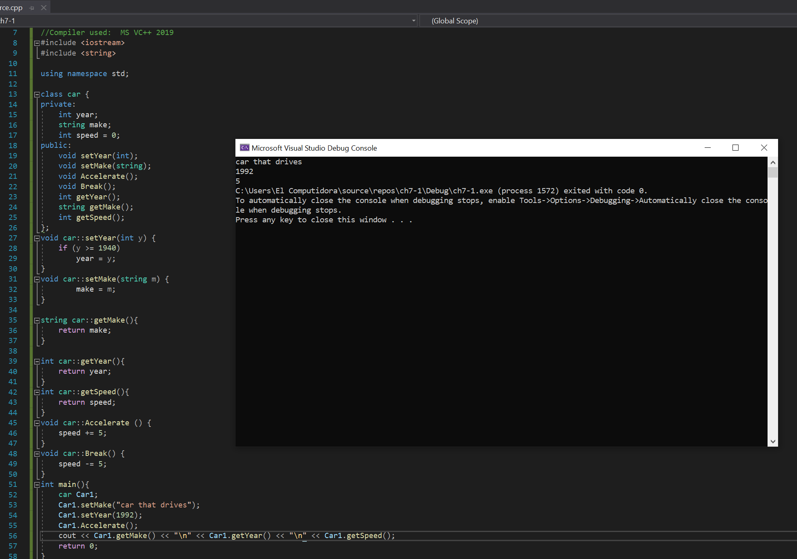

Challenge 5 – Population

#include <iostream>

#include <string>

using namespace std;

class Population {

public:

double pop = 0.0;

double birth = 0.0;

double death = 0.0;

Population(int x, int y, int z) {

pop = x;

birth = y;

death = z;

}

void setPopulation(int);

void setBirths(int);

void setDeaths(int);

double getBirthrate();

double getDeathrate();

};

void Population::setPopulation(int y) {

if (y < 0)

y = 0;

cout << "Error, population cannot be less than 0";

pop = y;

}

void Population::setBirths(int m) {

if (m < 2)

m = 2;

birth = m;

}

void Population::setDeaths(int y) {

if (y > 2)

y = 2;

death = y;

}

double Population::getBirthrate() {

double rate;

rate = (birth / pop);

return rate;

}

double Population::getDeathrate() {

double rate;

rate = (death / pop);

return rate;

}

int main() {

Population popu(100.0, 5.0, 5.0);

popu.setBirths(55.0);

cout << popu.getBirthrate() << "\n" << popu.getDeathrate();

return 0;

}

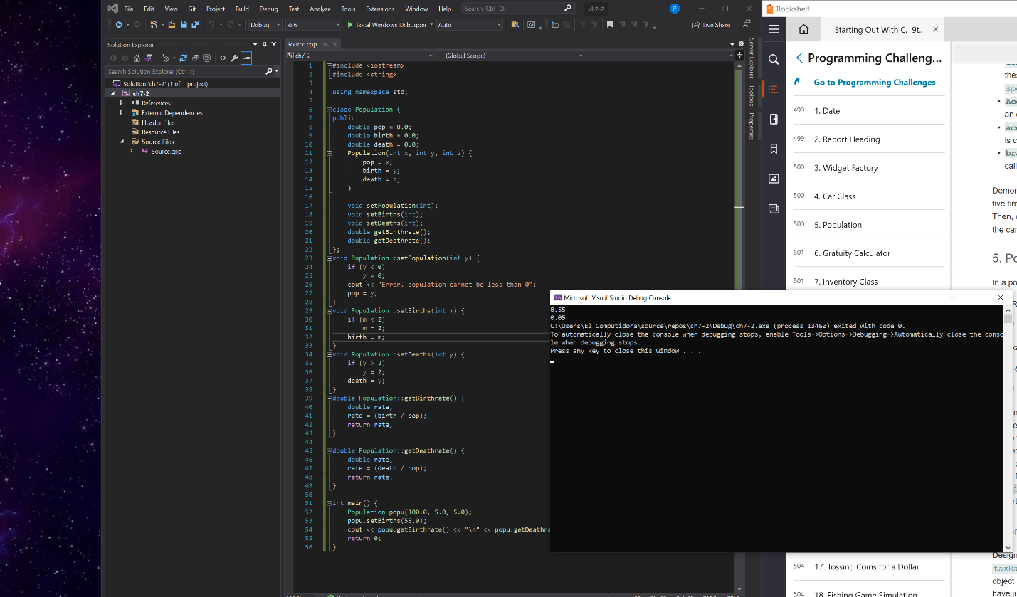

Challenge 8 – Movie Data – I did the best I could, but the instructions weren’t very clear to me on the format of the function.

#include <iostream>

#include <string>

using namespace std;

class MovieData {

public:

string title;

string director;

int year;

double time;

MovieData(string w, string x, int y, double z) {

title = w;

director = x;

year = y;

time = z;

}

void getFormat();

void getFormat2();

};

void MovieData::getFormat() {

cout << "Title: " << title << " - Directed By " << director << "\nRelease Year: " << year << "\nRun Time: " << time;

}

void MovieData::getFormat2() {

cout << title << "\n" << director << "\n" << year << "\n" << time;

}

int main() {

MovieData popu("The Stoplight", "Gabe Rutherford", 2020, 90.0);

popu.getFormat();

cout << "\n________________________________________________\n";

popu.getFormat2();

return 0;

}

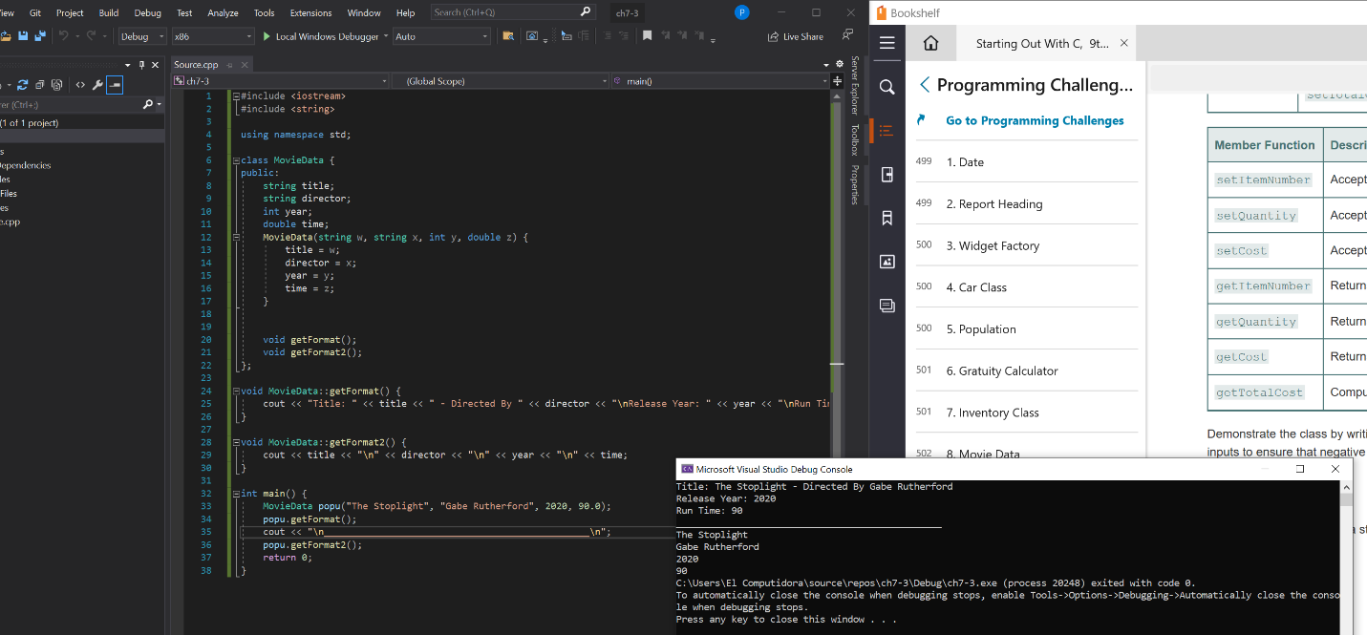

Challenge 10 – corporate sales data

#include <iostream>

#include <string>

using namespace std;

class CorpData {

public:

string name;

double sales1;

double sales2;

double sales3;

double sales4;

void setData();

void getInfo();

};

void CorpData::setData() {

cout << "Enter Division Name: ";

cin >> name;

cout << " \nEnter First Quarter Sales: ";

cin >> sales1;

cout << "\nEnter Second Quarter Sales: ";

cin >> sales2;

cout << "\nEnter Third Quarter Sales: ";

cin >> sales3;

cout << "\nEnter Fourth Quarter Sales: ";

cin >> sales4;

}

void CorpData::getInfo() {

cout << "\nDivision Name: " << name;

double total = sales1 + sales2 + sales3 + sales4;

cout << " Total sales = " << total << "\n\n";

double sales = sales1 + sales2 + sales3 + sales4;

sales = sales / 4;

cout << "Quarterly Average = " << sales;

}

int main() {

CorpData c1;

CorpData c2;

CorpData c3;

CorpData c4;

c1.setData();

c1.getInfo();

c2.setData();

c2.getInfo();

c3.setData();

c3.getInfo();

c4.setData();

c4.getInfo();

return 0;

}

