Tree.java – I also need to say that trees have two rings per year and not one.

package ch13;

/*

Programmer: Peter G Rutherford

Assignment Chapter: Chapter 13

Purpose: My purpose is to learn Java and get a good grade.

Date modified: 02/12/2021

IDE/Toool used: NetBeans IDE 8.2

*/

import javax.swing.*;

import java.awt.*;

public class Tree extends JApplet{

public void init(){

getContentPane().setBackground(Color.WHITE);

}

public void paint(Graphics g){

super.paint(g);

g.setColor(Color.BLACK);

g.drawOval(370, 280, 200, 200);

g.drawOval(400, 300, 150, 150);

g.drawOval(410, 320, 125, 125);

g.drawOval(420, 330, 100, 100);

g.drawOval(430, 340, 75, 75);

g.drawString("1", 475, 370);

g.drawString("2", 509, 370);

g.drawString("3", 520, 370);

g.drawString("4", 540, 370);

g.drawString("5", 555, 370);

}

}

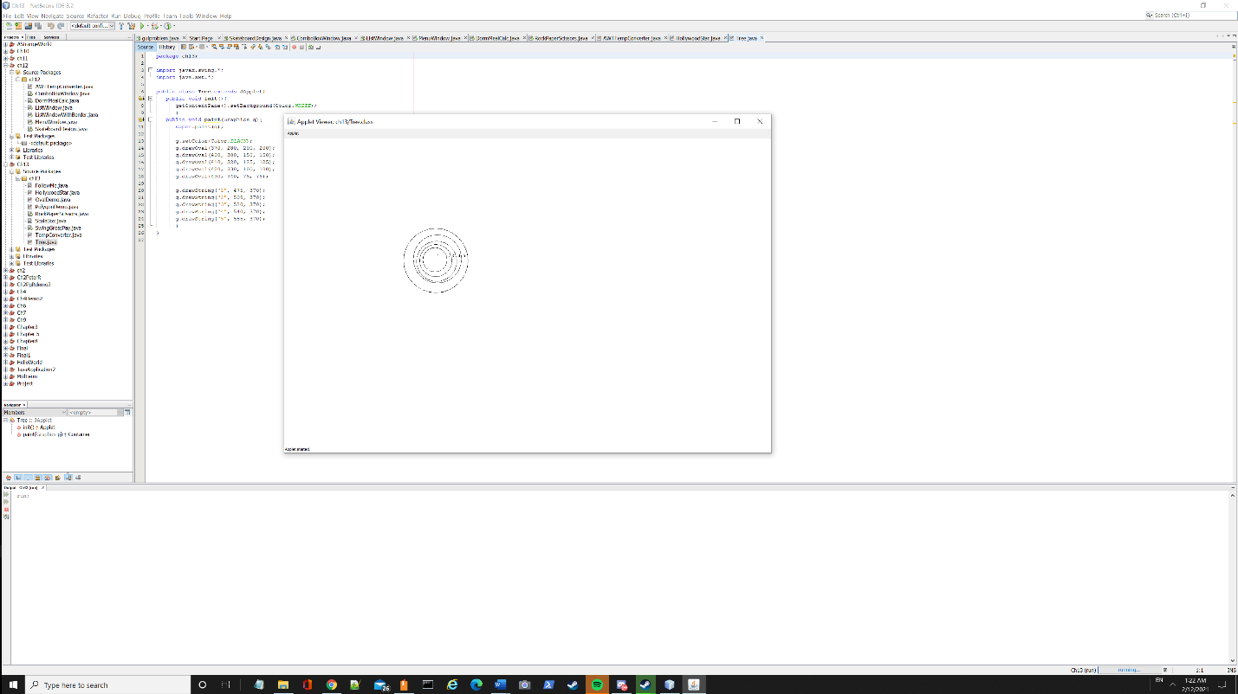

HollywoodStar.java

package ch13;

import javax.swing.*;

import java.awt.*;

import javafx.scene.text.Text;

public class HollywoodStar extends JApplet

{

private Text text;

public void init(){

getContentPane().setBackground(Color.WHITE);

}

public void paint(Graphics g){

int[] xCoords = {500, 600, 700, 675, 775, 650, 600, 550, 425, 525};

int[] yCoords = {500, 400, 500, 325, 225, 225, 50, 225, 225, 325};

super.paint(g);

g.setColor(Color.YELLOW);

g.fillPolygon(xCoords, yCoords, 10);

g.setColor(Color.BLACK);

g.drawString("Peter Rutherford", 555, 270);

}

}

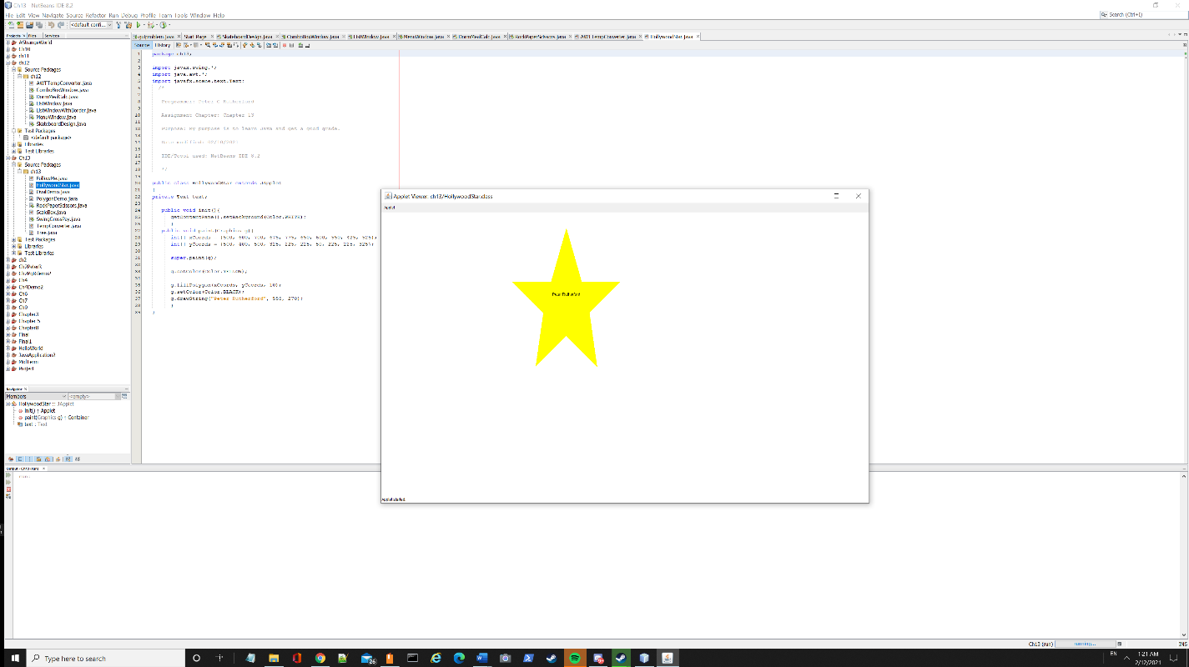

RockPaperScissors.java – this one took a while but was a lot of fun!

package ch13;

import java.awt.*;

import java.awt.event.ActionEvent;

import java.awt.event.ActionListener;

import javax.swing.*;

import java.util.Random;

public class RockPaperScissors extends JFrame{

JButton rockb;

JButton paperb;

JButton Scissorb;

ImageIcon rocki;

ImageIcon paperi;

ImageIcon Scissori;

Random random;

int randomInt;

int player;

JPanel buttonpic;

JPanel outcomep;

JTextField botjt;

JTextField playerjt;

JTextField outcome;

JLabel botlabel;

JLabel playerlabel;

JLabel outcomelabel;

public RockPaperScissors(){

super("Rock, Paper, Scissors! ");

setDefaultCloseOperation(JFrame.EXIT_ON_CLOSE);

setLayout(new BorderLayout());

outcome();

picButtons();

random = new Random();

randomInt = random.nextInt(2);

add(buttonpic, BorderLayout.NORTH);

add(outcomep, BorderLayout.SOUTH);

setSize(1000, 1000);

setVisible(true);

}

public void picButtons(){

buttonpic = new JPanel();

rocki = new ImageIcon("C:\\Pictures\\Rock.jpg");

paperi = new ImageIcon("C:\\Pictures\\Paper.jpg");

Scissori = new ImageIcon("C:\\Pictures\\Scissors.jpg");

rockb = new JButton(rocki);

paperb = new JButton(paperi);

Scissorb = new JButton(Scissori);

rockb.addActionListener(new ButtonListener());

paperb.addActionListener(new ButtonListener());

Scissorb.addActionListener(new ButtonListener());

buttonpic.add(rockb);

buttonpic.add(paperb);

buttonpic.add(Scissorb);

}

public void outcome(){

outcomep = new JPanel();

botjt = new JTextField(10);

playerjt = new JTextField(10);

outcome = new JTextField(10);

botjt.setEditable(false);

playerjt.setEditable(false);

outcome.setEditable(false);

botlabel = new JLabel("Opponent's Draw: ");

playerlabel = new JLabel("Player's Draw: ");

outcomelabel = new JLabel("Player Outcome: ");

outcomep.add(botlabel);

outcomep.add(botjt);

outcomep.add(playerlabel);

outcomep.add(playerjt);

outcomep.add(outcomelabel);

outcomep.add(outcome);

}

private class ButtonListener implements ActionListener{

@Override

public void actionPerformed(ActionEvent a) {

if(rockb.isSelected()){

player = 0;

}else if(paperb.isSelected()){

player = 1;

}else if(Scissorb.isSelected()){

player = 2;

}

if(player == 0 && randomInt == 0){

botjt.setText("Rock");

playerjt.setText("Rock");

outcome.setText("Draw!");

}else if(player == 1 && randomInt == 1){

botjt.setText("Paper");

playerjt.setText("Paper");

outcome.setText("Draw!");

}else if(player == 2 && randomInt == 2){

botjt.setText("Scissors");

playerjt.setText("Scissors");

outcome.setText("Draw!");

}

else if(player == 0 && randomInt == 1){

botjt.setText("Paper");

playerjt.setText("Rock");

outcome.setText("Bot Wins!");

}else if(player == 0 && randomInt == 2){

botjt.setText("Scissors");

playerjt.setText("Rock");

outcome.setText("You Win!");

}else if(player == 1 && randomInt == 0){

botjt.setText("Rock");

playerjt.setText("Paper");

outcome.setText("You Win!");

}else if(player == 1 && randomInt == 2){

botjt.setText("Scissors");

playerjt.setText("Paper");

outcome.setText("Bot Wins!");

}else if(player == 2 && randomInt == 0){

botjt.setText("Rock");

playerjt.setText("Scissors");

outcome.setText("Bot Wins");

}else if(player == 2 && randomInt == 1){

botjt.setText("Paper");

playerjt.setText("Scissors");

outcome.setText("You Win!");

}

}}

public static void main(String[] args) {

RockPaperScissors jbtn = new RockPaperScissors();

}

}

