Task 1:

ReadBinaryFile.java – If you take out the try/catch block, the while loop will only activate once before “endOfFile = true”. This causes the file to output the first number only, instead of the whole file.

WriteBinaryFile.java-If you take out the Numbers.dat file, it will simply not work. You could just put a “Numbers” and it will automatically search for the file type, but not if you take it out.

TestScore.java

package ch10;

/*

Programmer: Peter G Rutherford

Assignment Chapter: Chapter 10

Purpose: My purpose is to learn Java and get a good grade.

Date modified: 01/24/2021

IDE/Toool used: NetBeans IDE 8.2

*/

import java.io.*;

import java.util.*;

public class TestScore {

private double[] Score = new double[2];

public TestScore(double[] Score){

this.Score = Score;

}

public double[] setScore(double a1, double a2){

this.Score[0] = a1;

this.Score[1] = a2;

if (a1 < 0 || a2 < 0){

throw new IllegalArgumentException("Error: One of the grades entered is below 0.");

}if (a1 > 100 || a2 > 100){

throw new IllegalArgumentException("Error: One of the grades entered is above 100.");

}

return Score;

}

public double getAverage() {

double e = (Score[0] + Score[1] / 2);

return e;

}

public String toString(){

return "Score 1 = " + Score[0] + "\nScore 2 = " + Score[1];

}

}

TestScoreMain.java

package ch10;

import java.util.*;

import java.io.*;

public class TestScoreMain {

public static void main(String[] args) throws Exception {

Scanner scanner = new Scanner(System.in);

double[] Score = new double[2];

TestScore testscore = new TestScore(Score);

testscore.setScore(9, 101);

System.out.println(testscore);

}

}

­working

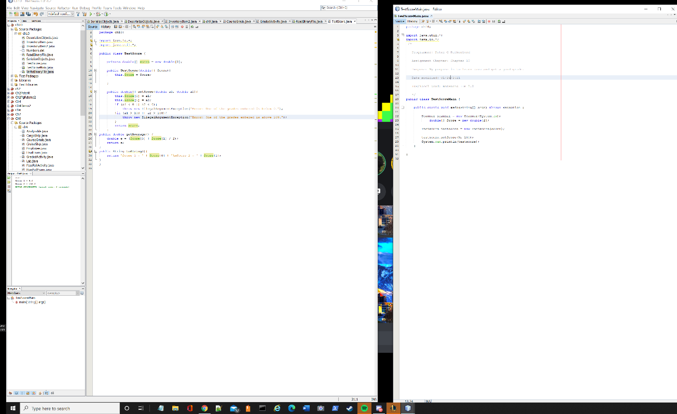

Not working

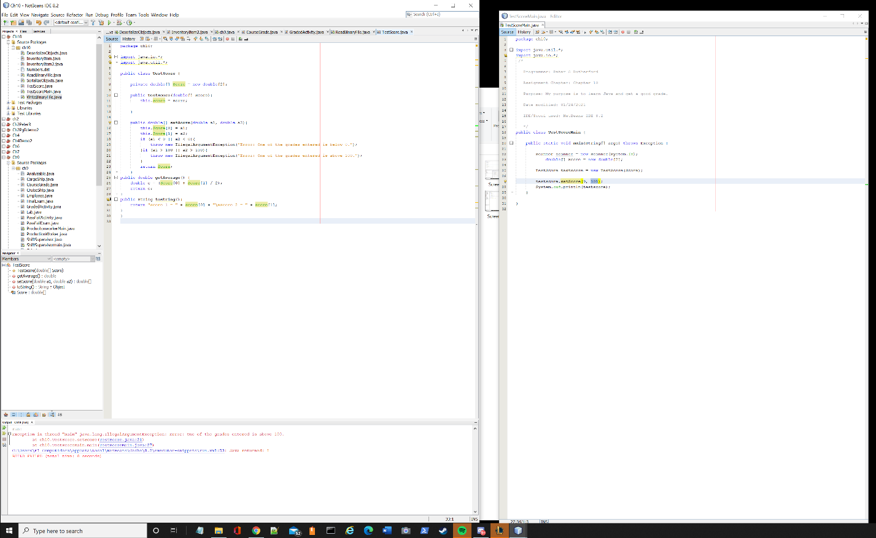

Modified testscore.java

package ch10;

/*

Programmer: Peter G Rutherford

Assignment Chapter: Chapter 10

Purpose: My purpose is to learn Java and get a good grade.

Date modified: 01/24/2021

IDE/Toool used: NetBeans IDE 8.2

*/

import java.io.*;

import java.util.*;

public class TestScore implements Serializable {

private double[] Score = new double[2];

public TestScore(double[] Score){

this.Score = Score;

}

public double[] setScore(double a1, double a2){

this.Score[0] = a1;

this.Score[1] = a2;

if (a1 < 0 || a2 < 0){

throw new IllegalArgumentException("Error: One of the grades entered is below 0.");

}if (a1 > 100 || a2 > 100){

throw new IllegalArgumentException("Error: One of the grades entered is above 100.");

}

return Score;

}

public double getAverage() {

double e = (Score[0] + Score[1] / 2);

return e;

}

public String toString(){

return "Score 1 = " + Score[0] + "\nScore 2 = " + Score[1];

}

}

Serialize testscore.java

package ch10;

import java.util.*;

import java.io.*;

public class TestScoreObjects {

public static void main(String[] args) throws Exception {

Scanner scanner = new Scanner(System.in);

double[] Score = new double[2];

double[] Score2 = new double[2];

double[] Score3 = new double[2];

double[] Score4 = new double[2];

double[] Score5 = new double[2];

TestScore testscore = new TestScore(Score);

TestScore testscore2 = new TestScore(Score2);

TestScore testscore3 = new TestScore(Score3);

TestScore testscore4 = new TestScore(Score4);

TestScore testscore5 = new TestScore(Score5);

testscore.setScore(9, 100);

testscore2.setScore(8, 1);

testscore3.setScore(7, 99);

testscore4.setScore(6, 98);

testscore5.setScore(5, 97);

TestScore[] testscorearray = new TestScore[5];

testscorearray[0] = testscore;

testscorearray[1] = testscore2;

testscorearray[2] = testscore3;

testscorearray[3] = testscore4;

testscorearray[4] = testscore5;

File f = new File("testscore1.txt");

FileOutputStream outStream =

new FileOutputStream(f);

ObjectOutputStream objectOutputFile =

new ObjectOutputStream(outStream);

for (int i = 0; i < testscorearray.length; i++)

{

objectOutputFile.writeObject(testscorearray[i]);

}

objectOutputFile.close();

System.out.println("The serialized objects were written to the " +

"testscore.txt file.");

}

}

Deserialize testscore.java

package ch10;

import java.util.*;

import java.io.*;

public class deserializeScore {

public static void main(String[] args)throws Exception {

final int NUM_ITEMS = 5;

FileInputStream inStream =

new FileInputStream("testscore1.txt");

ObjectInputStream objectInputFile =

new ObjectInputStream(inStream);

TestScore[] testscorearray = new TestScore[NUM_ITEMS];

for (int i = 0; i < testscorearray.length; i++)

{

testscorearray[i] =

(TestScore) objectInputFile.readObject();

}

objectInputFile.close();

for (int i = 0; i < testscorearray.length; i++)

{

System.out.println(

testscorearray[i].toString());

System.out.println(

testscorearray[i].toString());

System.out.println(

testscorearray[i].toString());

System.out.println(

testscorearray[i].toString());

System.out.println(

testscorearray[i].toString());

}

}

}

