UML diagram

|  |
| --- |
| Password |
| -passreq: JLabel  -passreq2: JLabel  -checklabel: JLabel  -randpassbuttonlabel: JLabel  -why12: JLabel  -why122: JLabel  -why123: JLabel  -why124: JLabel  -or: JLabel  -lyes: JLabel  -lno: JLabel  -lrandomcheck: JLabel  -botcounter: JLabel  -playercounter: JLabel  -randomoutcome: JLabel  -blank1: JLabel -blank2: JLabel -error1: String -error2: String -error3: String -error4: String -error5: String -syes: String -sno: String -srandomcheck: String -enterpass2: String -enterpass3: String -randStr: String -randchars: String -randpasslabel: JTextField -enterpass: JTextField -errormessage: JTextField -errormessage2: JTextField -errormessage3: JTextField -errormessage4: JTextField -errormessage5: JTextField -typepass: GridLayout -why: GridLayout -randomgrid: GridLayout -rightgrid: GridLayout -buttoncheckgrid: GridLayout: -bot: JPanel -left: JPanel -right: JPanel -buttonCheck: JPanel  -checkbutton: JButton -genbutton: JButton -byes: JButton -bno: JButton -random: Random -ch: char[] -i: int |
| +Password()  +whyPanel():void  +centralPanel():void  +errorPanel():void  +buttonCheckPanel():void |

|  |
| --- |
| ButtonListener |
| -enterpass2: String  -enterpass3: String  -checkbutton: JButton  -genbutton: JButton  -enterpass: JTextField  -errormessage: JTextField -errormessage2: JTextField -errormessage3: JTextField -errormessage4: JTextField -errormessage5: JTextField |
| +actionPerformed(a:ActionEvent):void |

Password.java

import javax.swing.*;

import java.awt.*;

import java.awt.event.ActionEvent;

import java.awt.event.ActionListener;

import java.util.Random;

import javax.swing.border.LineBorder;

/*

Programmer: Peter G Rutherford

Assignment Chapter: Chapter 14

Purpose: My purpose is to learn Java and get a good grade.

Date modified: 02/23/2021

IDE/Toool used: NetBeans IDE 8.2

*/

public class Password extends JFrame{

//Finally figured out that putting all the values & objects at the beginning

//makes life so much easier when you make a UML.

JPanel bot;

JPanel left;

JPanel right;

JPanel buttonCheck;

JLabel passreq;

JLabel passreq2;

JLabel checklabel;

JLabel randpassbuttonlabel;

JLabel why12;

JLabel why122;

JLabel why123;

JLabel why124;

JLabel or;

JLabel lyes;

JLabel lno;

JLabel lrandomcheck;

JLabel botcounter;

JLabel playercounter;

JLabel randomoutcome;

JLabel blank1;

JLabel blank2;

JButton checkbutton;

JButton genbutton;

JButton byes;

JButton bno;

JTextField randpasslabel;

JTextField enterpass;

JTextField errormessage;

JTextField errormessage2;

JTextField errormessage3;

JTextField errormessage4;

JTextField errormessage5;

Random random;

String error1;

String error2;

String error3;

String error4;

String error5;

String syes;

String sno;

String srandomcheck;

String enterpass2;

String enterpass3;

String randStr;

String randchars;

GridLayout typepass;

GridLayout why;

GridLayout randomgrid;

GridLayout rightgrid;

GridLayout buttoncheckgrid;

char[] ch;

int i = 0;

StringBuilder randstring;

public Password(){

super("Create A Password!");

setDefaultCloseOperation(JFrame.EXIT_ON_CLOSE);

setLayout(new GridLayout());

setSize(500, 500);

setVisible(true);

whyPanel();

centerPanel();

buttonCheckPanel();

errorPanel();

add(left, BorderLayout.WEST);

add(bot, BorderLayout.CENTER);

add(buttonCheck, BorderLayout.CENTER);

add(right, BorderLayout.CENTER);

}

public void whyPanel(){

left = new JPanel();

why = new GridLayout(4,1);

why.setVgap(-1000);

why12 = new JLabel(" Your password must be 15 characters long because: ");

why122 = new JLabel("it would take 200 years to crack your password without");

why123 = new JLabel("a supercomputer or a quantum computer.");

why124 = new JLabel("any less could drastically change your chances of safety!");

why12.setFont(new Font("Times New Roman", Font.PLAIN, 30));

why122.setFont(new Font("Times New Roman", Font.PLAIN, 30));

why123.setFont(new Font("Times New Roman", Font.PLAIN, 30));

why124.setFont(new Font("Times New Roman", Font.PLAIN, 30));

why12.setForeground(Color.green);

why122.setForeground(Color.green);

why123.setForeground(Color.green);

why124.setForeground(Color.green);

left.setLayout(why);

left.setBackground(Color.BLACK);

left.add(why12);

left.add(why122);

left.add(why123);

left.add(why124);

}

public void centerPanel(){

bot = new JPanel();

or = new JLabel();

typepass = new GridLayout(7,1);

typepass.setVgap(20);

passreq = new JLabel("Type a password in the box with at least 15 characters"

+ "(letters or numbers),");

passreq2 = new JLabel("\none character must be a number."

+ " You must have a capital letter as well.");

passreq.setFont(new Font("Times New Roman", Font.PLAIN, 30));

passreq2.setFont(new Font("Times New Roman", Font.PLAIN, 30));

passreq.setForeground(Color.green);

passreq.setBackground(Color.BLACK);

passreq2.setForeground(Color.green);

passreq2.setBackground(Color.BLACK);

checklabel = new JLabel("Click to check password");

checklabel.setFont(new Font("Times New Roman", Font.PLAIN, 50));

checkbutton = new JButton();

checkbutton.add(checklabel);

checkbutton.setBackground(Color.green);

checkbutton.addActionListener(new ButtonListener());

enterpass = new JTextField(12);

enterpass.setBackground(Color.BLACK);

enterpass.setForeground(Color.green);

enterpass.setBorder(new LineBorder(Color.green));

enterpass.setFont(new Font("Times New Roman", Font.PLAIN, 50));

randpassbuttonlabel = new JLabel("Click for random password game!");

randpassbuttonlabel.setFont(new Font("Times New Roman", Font.PLAIN, 50));

randpassbuttonlabel.setBackground(Color.green);

genbutton = new JButton();

genbutton.add(randpassbuttonlabel, BorderLayout.CENTER);

genbutton.setBackground(Color.green);

genbutton.addActionListener(new ButtonListener());

randpasslabel = new JTextField();

randpasslabel.setForeground(Color.green);

randpasslabel.setBorder(new LineBorder(Color.green));

randpasslabel.setBackground(Color.black);

randpasslabel.setFont(new Font("Times New Roman", Font.PLAIN, 50));

bot.setLayout(typepass);

bot.setVisible(true);

bot.setBackground(Color.BLACK);

bot.add(passreq);

bot.add(passreq2);

bot.add(enterpass);

bot.add(checkbutton);

bot.add(or);

bot.add(randpasslabel);

bot.add(genbutton);

}

public void errorPanel(){

right = new JPanel();

rightgrid = new GridLayout(7,1);

error1 = new String("*Password is too short!");

error2 = new String("*Password needs an uppercase!");

error3 = new String("*Password needs a number!");

error4 = new String("Your password is strong!");

error5 = new String("*Remove the space!");

errormessage = new JTextField(error1);

errormessage2 = new JTextField(error2);

errormessage3 = new JTextField(error3);

errormessage4 = new JTextField(error4);

errormessage5 = new JTextField(error5);

errormessage.setFont(new Font("Times New Roman", Font.PLAIN, 30));

errormessage2.setFont(new Font("Times New Roman", Font.PLAIN, 30));

errormessage3.setFont(new Font("Times New Roman", Font.PLAIN, 30));

errormessage4.setFont(new Font("Times New Roman", Font.PLAIN, 30));

errormessage5.setFont(new Font("Times New Roman", Font.PLAIN, 30));

errormessage.setForeground(Color.green);

errormessage2.setForeground(Color.green);

errormessage3.setForeground(Color.green);

errormessage4.setForeground(Color.green);

errormessage5.setForeground(Color.green);

errormessage.setBorder(new LineBorder(Color.black));

errormessage2.setBorder(new LineBorder(Color.black));

errormessage3.setBorder(new LineBorder(Color.black));

errormessage4.setBorder(new LineBorder(Color.black));

errormessage5.setBorder(new LineBorder(Color.black));

errormessage.setBackground(Color.BLACK);

errormessage2.setBackground(Color.BLACK);

errormessage3.setBackground(Color.BLACK);

errormessage4.setBackground(Color.BLACK);

errormessage5.setBackground(Color.BLACK);

errormessage.setVisible(false);

errormessage2.setVisible(false);

errormessage3.setVisible(false);

errormessage4.setVisible(false);

errormessage5.setVisible(false);

errormessage.setEditable(false);

errormessage2.setEditable(false);

errormessage3.setEditable(false);

errormessage4.setEditable(false);

errormessage5.setEditable(false);

right.setLayout(rightgrid);

right.setBackground(Color.BLACK);

right.add(errormessage);

right.add(errormessage2, BorderLayout.CENTER);

right.add(errormessage3, BorderLayout.CENTER);

right.add(errormessage4, BorderLayout.CENTER);

right.add(errormessage5, BorderLayout.CENTER);

}

public void buttonCheckPanel(){

buttonCheck = new JPanel();

buttoncheckgrid = new GridLayout(8,1);

syes = ("YES");

sno = ("NO");

srandomcheck = ("<<< Is the random password secure? ^^^");

botcounter = new JLabel();

playercounter = new JLabel();

lyes = new JLabel(syes);

lno = new JLabel(sno);

lrandomcheck = new JLabel(srandomcheck);

randomoutcome = new JLabel();

blank1 = new JLabel();

blank2 = new JLabel();

byes = new JButton();

bno = new JButton();

byes.add(lyes, BorderLayout.CENTER);

bno.add(lno, BorderLayout.CENTER);

byes.setBorder(new LineBorder(Color.black));

bno.setBorder(new LineBorder(Color.black));

lyes.setFont(new Font("Times New Roman", Font.PLAIN, 50));

lno.setFont(new Font("Times New Roman", Font.PLAIN, 50));

lrandomcheck.setFont(new Font("Times New Roman", Font.PLAIN, 40));

botcounter.setFont(new Font("Times New Roman", Font.PLAIN, 50));

playercounter.setFont(new Font("Times New Roman", Font.PLAIN, 50));

lyes.setForeground(Color.black);

lno.setForeground(Color.black);

lrandomcheck.setForeground(Color.green);

byes.setBackground(Color.green);

bno.setBackground(Color.green);

botcounter.setForeground(Color.green);

playercounter.setForeground(Color.green);

lrandomcheck.setForeground(Color.green);

buttonCheck.setLayout(buttoncheckgrid);

buttonCheck.setBackground(Color.black);

buttonCheck.add(blank1);

buttonCheck.add(botcounter);

buttonCheck.add(playercounter);

buttonCheck.add(randomoutcome);

buttonCheck.add(byes,BorderLayout.PAGE_END);

buttonCheck.add(bno,BorderLayout.SOUTH);

buttonCheck.add(lrandomcheck,BorderLayout.SOUTH);

buttonCheck.setVisible(true);

}

private class ButtonListener implements ActionListener{

@Override

public void actionPerformed(ActionEvent a) {

//If check password button is clicked, it will check if the text entered

//has any errors, and will show messages depending on the answer.

if(a.getSource().equals(checkbutton)){

enterpass2 = enterpass.getText();

ch = enterpass2.toCharArray();

enterpass3 = enterpass2.toLowerCase();

if(enterpass2.contains(" ")){

errormessage5.setVisible(true);

}else if(!enterpass2.contains(" ")){

errormessage5.setVisible(false);

}

if(enterpass2.contains("1") || enterpass2.contains("2")

|| enterpass2.contains("3")|| enterpass2.contains("4")

|| enterpass2.contains("5")|| enterpass2.contains("6")

|| enterpass2.contains("7")|| enterpass2.contains("8")

|| enterpass2.contains("9")|| enterpass2.contains("0")){

errormessage3.setVisible(false);

} else if(!enterpass2.contains("1") || !enterpass2.contains("2")

|| !enterpass2.contains("3")|| !enterpass2.contains("4")

|| !enterpass2.contains("5")|| !enterpass2.contains("6")

|| !enterpass2.contains("7")|| !enterpass2.contains("8")

|| !enterpass2.contains("9")|| !enterpass2.contains("0")){

errormessage3.setVisible(true);

}

if(enterpass2 == enterpass3){

errormessage2.setVisible(true);

}else if(enterpass2 != enterpass3){

errormessage2.setVisible(false);

}

if(ch.length < 15){

errormessage.setVisible(true);

}else if(ch.length >= 15){

errormessage.setVisible(false);

}

if(errormessage.isShowing() == false && errormessage2.isShowing() == false &&

errormessage3.isShowing() == false && errormessage4.isShowing() == false){

errormessage4.setVisible(true);

}}

if(a.getSource().equals(genbutton)){

randchars = ("abcdefghijklmnopqrstuvwxyzABCDEFGHIJKLMNOPQRSTUVWXYZ1234567890");

randstring = new StringBuilder();

random = new Random();

while (randstring.length() < 15) {

int index = (int) (random.nextFloat() * randchars.length());

randstring.append(randchars.charAt(index));

}

randStr = randstring.toString();

randpasslabel.setText(randStr);

}}}

public static void main(String[] args) {

Password pass = new Password();

}

}

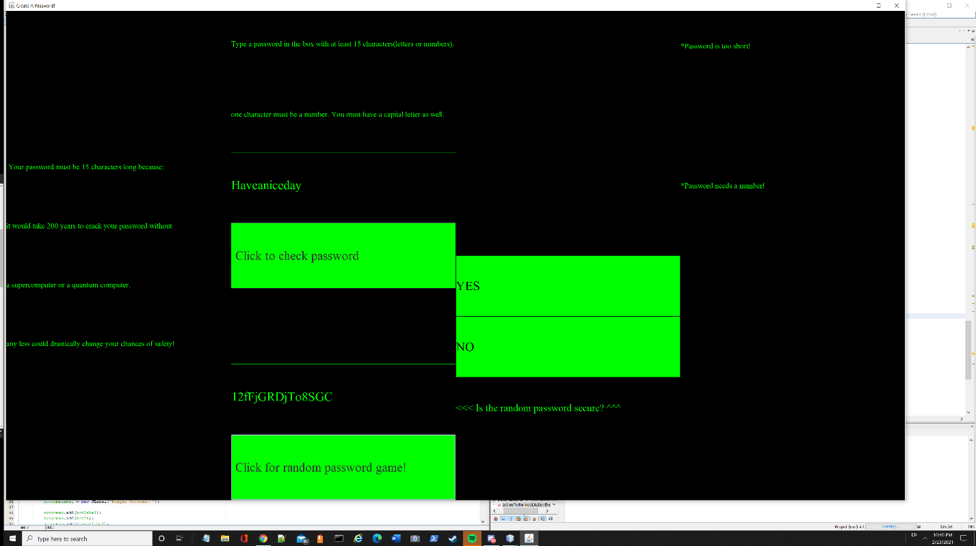

The check password button works fully, it will check if the password entered(Haveaniceday) has a capital, a number, 15 characters, or if it a good password. It will display what you need on the right.

The password game doesn’t work yet, but I made it so it generates a random 15 character password with numbers, characters, and capitals.