CourseGrade & Analyzable

/\*

Programmer: Peter G Rutherford / Trent

Assignment Chapter: Chapter 9

Purpose: My purpose is to learn Java and get a good grade.

Date modified: 01/15/2021

IDE/Toool used: NetBeans IDE 8.2

\*/

package ch9;

import java.util.\*;

public class CourseGrade extends GradedActivity implements Analyzable{

private int labp;

private int passfailq = 10;

private int passfailmis;

private double passfailmin = 70;

private int essayscore;

private int finalq = 50;

private int finalm;

double highest;

double lowest;

private GradedActivity[] grades = new GradedActivity[4];

public CourseGrade(){}

public void setLab(GradedActivity laba){

grades[0] = laba;

}

public void setPassFailExam(PassFailExam pf){

grades[1] = pf;

}

public void setEssay(GradedActivity es){

grades[2]= es;

}

public void setFinalExam(FinalExam fs){

grades[3]= fs;

}

@Override

public String toString()

{

return "Lab " + grades[0].getScore() + " letter grade" + grades[0].getGrade() + " \nPass/Fail Exam " + grades[1].getScore()

+ " letter grade " + grades[1].getGrade() + " \nEssay " + grades[2].getScore() + " letter grade " + grades[2].getGrade() +

"\nFinal Exam " + grades[3].getScore() + " letter grade " + grades[3].getGrade();

}

@Override

public double getAverage() {

double e = (grades[0].getScore() + grades[1].getScore() + grades[2].getScore() + grades[3].getScore() / 4);

return e;

}

@Override

public GradedActivity getHighest() {

GradedActivity highest;

highest = grades[0];

for(int i = 0;i >=3; i++){

if(grades[i].getScore() > highest.getScore())highest = grades[i];

}System.out.println("highest = " + highest.getScore());

return highest;

}

@Override

public GradedActivity getLowest() {

GradedActivity lowest;

lowest = grades[0];

for(int i = 0;i >=3; i++){

if(grades[i].getScore() < lowest.getScore())lowest = grades[i];

}

System.out.println("lowest = " + lowest.getScore());

return lowest;

}}

CourseGrade and Analyzable Main

package ch9;

import java.util.ArrayList;

public class ch9 {

public static void main(String[] args) {

GradedActivity lab = new GradedActivity();

int passfailq = 10;

int passfailmis;

double passfailmin = 70;

int finalq = 50;

PassFailExam passfail = new PassFailExam(passfailq, 20, passfailmin);

GradedActivity essay = new GradedActivity();

FinalExam finalex = new FinalExam(finalq, 0);

Scanner scanner = new Scanner(System.in);

CourseGrade grades = new CourseGrade();

grades.setLab(lab);

grades.setPassFailExam(passfail);

grades.setEssay(essay);

grades.setFinalExam(finalex);

System.out.println(grades.getAverage());

System.out.println(grades.getHighest());

System.out.println(grades.getLowest());

}

}

Ship.java

/\*

Programmer: Peter G Rutherford

Assignment Chapter: Chapter 9

Purpose: My purpose is to learn Java and get a good grade.

Date modified: 01/16/2021

IDE/Toool used: NetBeans IDE 8.2

\*/

package ch9;

public class Ship {

private String sName;

private String sDate;

public String setShipName(String sN){

this.sName = sN;

return sName;

}

public String setShipYear(String sY){

this.sDate = sY;

return sDate;

}

public void getShipName(){

System.out.print("Ship Name: " + sName);

}

public void getShipYear(){

System.out.print("Ship Year " + sDate);

}

public Ship(String sN, String sY){

sDate = sY;

sName = sN;

}

public String toString(){

return "Cargo Ship Name: " + sName + "\nCargo Ship Year: " + sDate + "\n";

}

}

CruiseShip.java

package ch9;

public class CruiseShip extends Ship{

private int passengers;

public CruiseShip(String sN, String sY, int pa) {

super(sN, sY);

passengers = pa;

}

public int setPassengers(int p){

this.passengers = p;

return passengers;

}

public void getPassengers(){

System.out.print("Passengers: " + passengers);

}

@Override

public String toString(){

return "Passengers: " + passengers + "\n " + super.toString();

}

}

CargoShip.java

package ch9;

public class CargoShip extends Ship{

private int capacity;

public int setCapacity(int ca){

this.capacity = ca;

return capacity;

}

public void getCapacity(){

System.out.println("Cargo Capacity(In Tons): " + capacity);

}

public CargoShip(String sN, String sY, int cap) {

super(sN, sY);

capacity = cap;

}

@Override

public String toString(){

return "Cargo Capacity(In Tons): " + capacity + "\n" + super.toString();

}

}

ShipMain.java

package ch9;

import java.util.\*;

public class Ships {

public static void main(String[] args) {

Scanner scanner = new Scanner(System.in);

Ship[] dock = new Ship[2];

dock[0] = new CruiseShip("yatch", "1993", 92);

dock[1] = new CargoShip("Cargob", "2003", 193);

System.out.println("Cruise Ship: " + dock[0].toString() + "\nCargo Ship: " + dock[1].toString());

}

}

CouseGrade.java

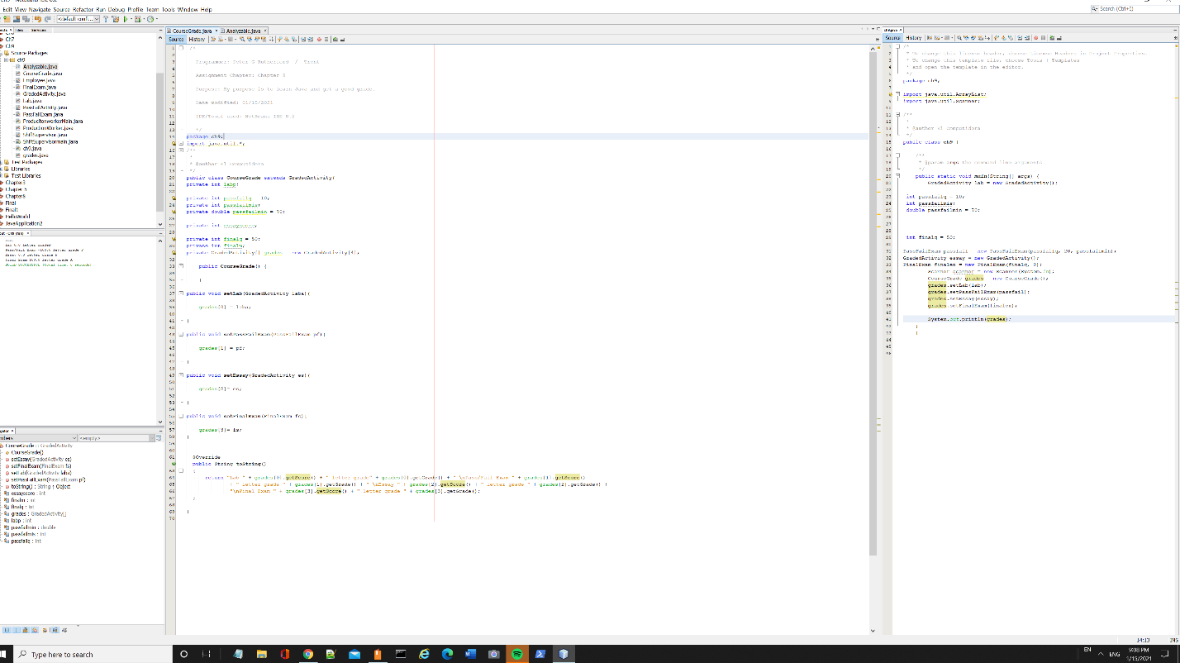

Analyzable Interface.java

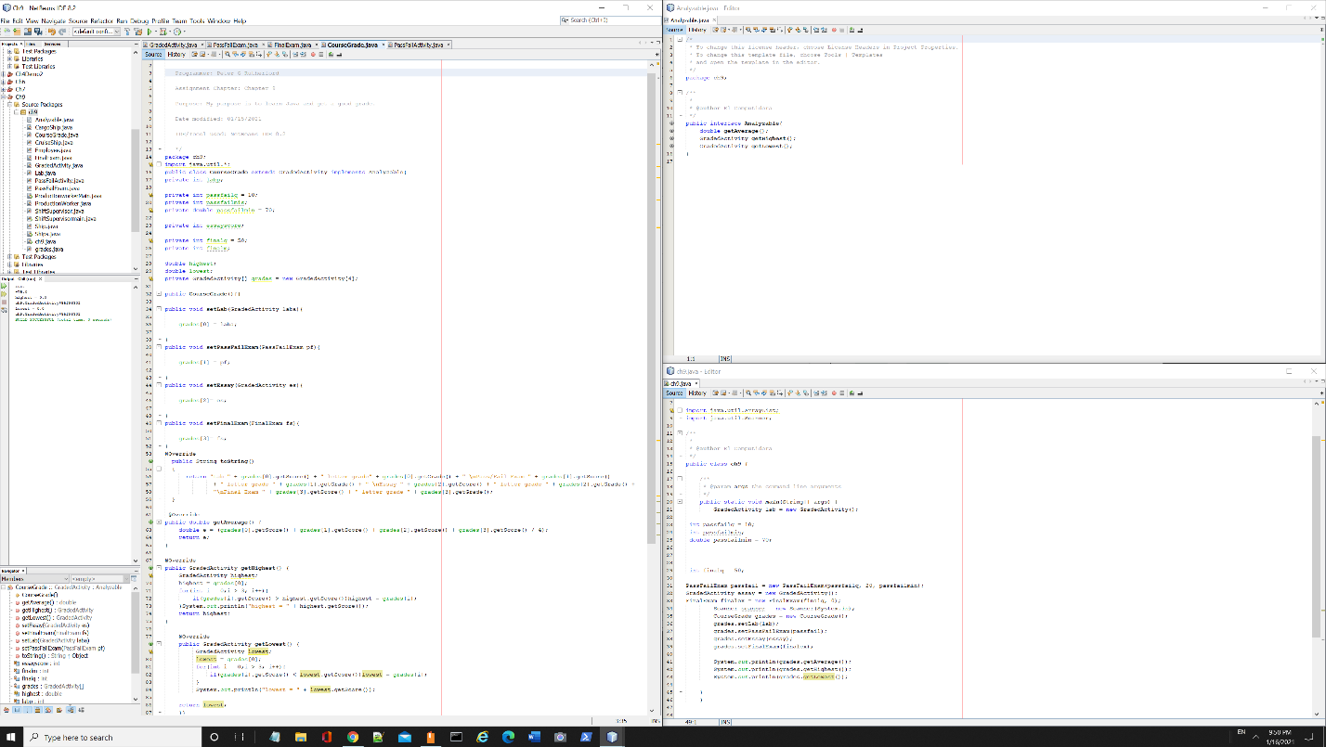

Ships.java

