- Present the criteria the define a detection
  - show examples of correct, invalid and missed detections
- Evaluate performance of linking together of consecutive positions of the same object
  - explain the cause of broken and incorrect tracking
- Describe how finding the highest point from the object works
  - how often does it get this wrong
- Describe which features we use to recognise balls from other objects

Introduction: an overview of the main concepts ideas used in the approach

Methods: Explain vision techniques used. Give a functional outline on how they were implemented and structure of the code. Explain how each part is meant to work. Justify any functional decisions made (and why anything we did try didn’t work).

Results: Provide actual data results of our method and describe how well it performed. Show examples of what did and didn’t work (broken paths etc).

Discussion: Explain any limitations or problems.

Code: The code.

Introduction

This report will discuss the detection of moving objects in a static scene. “Detection” here covers a few concepts which will be more strongly illustrated throughout the report. The system (which we will henceforth refer to as the ‘implementation’) to which this report is supplementary takes as input a set of video frames upon which analysis is made to find moving objects in the video and output useful information to the screen about those objects; the maximum height of the object, the path of the object, and whether or not the object is a ball.
The initial set of video frames features a static background shown for a short period, followed by a few objects of various attributes being projected through the air by an unseen coordinator. The implementation makes use of the short period of background frames in order to establish a median frame trusted to act as the background for the remainder of the experiment. This background frame is subtracted from all other frames of the video in order to isolate objects making recognition possible.
Now that the stage has been set (or rather removed!) we can shift our focus to the real actors of the show; the moving objects. At this point, directly after background removal, the objects are isolated in a raw colour form which is difficult to use for feature extraction purposes. This is why various processes are run to make the object easier to recognize.
After processing, features are extracted for each object seen in the frame. Some other stuff.

- Assignment made in order to detect moving objects over a static (mostly) background.
- Background removed by subtracting the median of frames known to contain only the empty room.
- Remaining image data processed before image detection (erode, blur, binarize(?)).
- Object feature extraction.
- Recognising whether or not an object is a ball.
- Continuity of objects between frames.
- Recognising the max height of an object.
Results

The finished implementation was then run over the supplied videos to test. A few issues were found in this process.

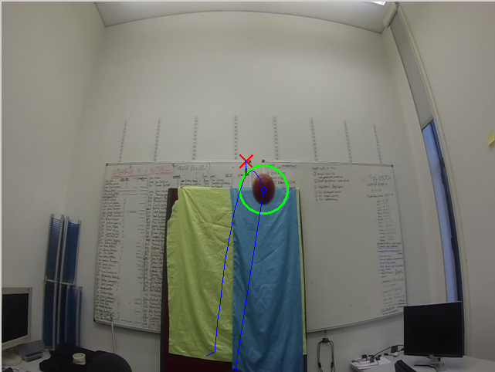
Issues:

Occasionally an object’s maximum height will be incorrect due to

