- Present the criteria the define a detection
  - show examples of correct, invalid and missed detections
- Evaluate performance of linking together of consecutive positions of the same object
  - explain the cause of broken and incorrect tracking
- Describe how finding the highest point from the object works
  - how often does it get this wrong
- Describe which features we use to recognise balls from other objects

Introduction: an overview of the main concepts ideas used in the approach

Methods: Explain vision techniques used. Give a functional outline on how they were implemented and structure of the code. Explain how each part is meant to work. Justify any functional decisions made (and why anything we did try didn’t work).

Results: Provide actual data results of our method and describe how well it performed. Show examples of what did and didn’t work (broken paths etc).

Discussion: Explain any limitations or problems.

Code: The code.

Introduction

- Assignment made in order to detect moving objects over a static (mostly) background.
- Background removed by subtracting the median of frames known to contain only the empty room.
- Remaining image data processed before image detection (erode, blur, binarize(?)).
- Image detection

Method
- Look through the first 25 frames of video and create a median image based on those frames.
- For each frame, subtract the median (background) image from it and then threshold the result to create a binary image that masks the object(s) in the scene.
- Perform an erode convolution on the binary image to remove erroneous regions from the image.
- Use the regionprops function to receive a list details about all of the contiguous regions in the scene – hopefully these will correspond 1-to-1 with the objects in the scene (if the subtraction and thresholding works optimally).
- For each region in the current scene, create a struct to hold important information about it including: its position, if it is a ball, the average normalised rgb colour, and its maximum height.
- Determining if a region is a ball or not is done by calculating the convexity of the region and checking if it is below a certain threshold, and by checking that the eccentricity of the region is also below a certain threshold.
- Given all of the objects in this frame, we then try to match them with objects in the previous frame – based on position and colour. If no previous object can be found then it is a new object.
- Once we have matched up the objects we draw the path that object has taken in the scene.
- If the object has reached its maximum height, we draw a cross to mark it on the path.

The first step in the algorithm is to determine the median background image. This is achieved by looking at the first twenty five frames of the video feed and finding the median value for each pixel in the frames. This median frame is subtracted from each of the video frames as the video plays, leaving only the foreground objects in the frame. After doing the median subtraction, a binary image is created via thesholding. This standard binary image can contain small erroneous regions and random noise, in order to combat this a motion blur filter is applied before the thresholding. This serves two purposes: firstly it blurs out the noise and small regions that are wrongly detected, and secondly it can blur two regions of the same object together into the one region – this can be a problem when the object’s colour closely matches the background at certain points.

Once the binary image is established an erode filter is applied to further reduce the chance of an erroneous region being detected. After the erode, the function regionprops() is used to obtain important information from each of the detected regions: centroid position, area of the convex hull, area of the region, eccentricity, and the list of points that make up the region. Each of these values are used for different purposes:

- the centroid is used to display the path of the object on top of the frame. It is also used to determine if the object has reached its maximum height; once the height of the object starts decreasing then it has reached its maximum height.
- The area of the convex hull and the area of the region itself are used to determine the convexity of the region using the convexity formula:
  - Convexity = Area(ConvexHull) / Area(Region)
- The eccentricity is used along with the convexity of the region to determine if the region represents a ball. Each of the values are compared against thresholds, and only if both are below their values is the object considered a ball. When an object is considered as a ball, a green circle is drawn around it in the video frame.
- The list of points that makes up each region is used to determine the average normalised RGB colour for that region, by looking at the pixels in the current frame of video that are in the list of pixels for that region.

Once the properties of the region have been determined they are placed in a struct and the regions found in the current frame are matched against the regions in the previous frame, this is to track objects between frames. The criteria for an object being considered the same between frames is that the position has not changed by much, and the average normalised colour of the region is similar. If the object is matched then we keep track of the points it has been through in its lifetime and plot the path it takes through the frame, this path is destroyed when the object leaves the frame. When the object has been detected to be at its maximum height, a red cross is drawn to mark the position, and a small pause is included to highlight the detection.

The detection of the maximum height is achieved by tracking the minimum y-value that the region reaches (minimum because the y-axis grows down in matlab figures). If the current y-position of the object is larger than its minimum y-position then the object is moving to the floor and it has reached its maximum height.

Here are some visual examples of various stages of the algorithm, using test data set two:

Background Subtraction
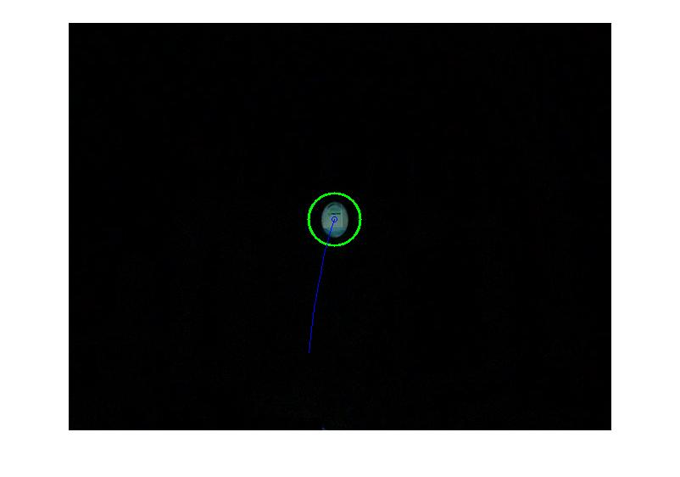

Binary Image

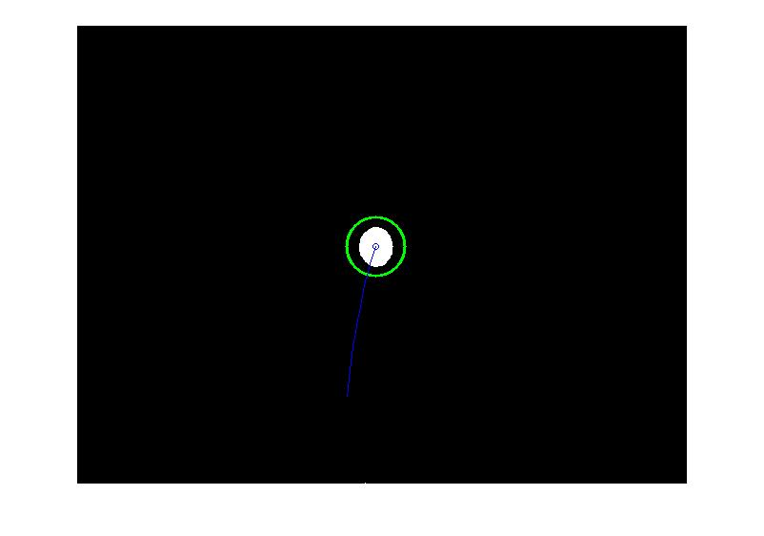
Reached Maximum Height

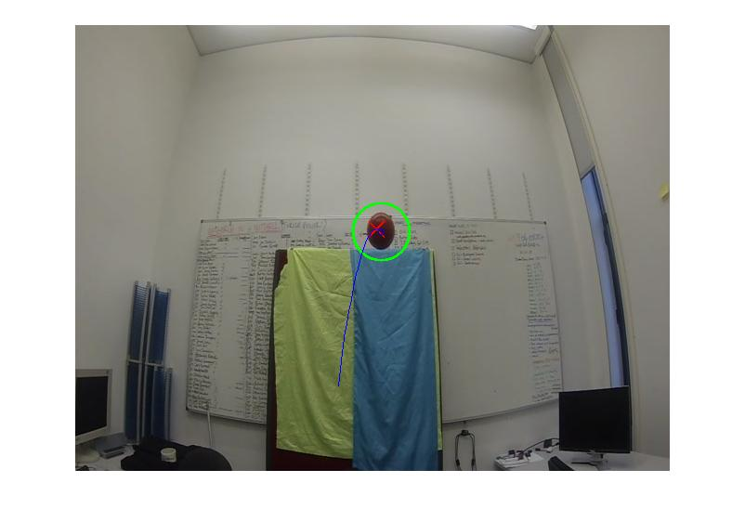
Where our detection has trouble is with more than one object in the scene, and with objects that are close to the background colour in some areas. While the detection of the regions is reliable, if part of the ball or other object being thrown in the air matches the background image at any point, the object will be detected as multiple regions instead of the single region it should be. We have attempted to account for this with blurring the image to attempt to remove these inconsistencies, however it does not work in all cases.

The problem with more than one object in the scene is that sometimes when they cross paths, the path tracking does not work as expected. We believe this is due to the way we are matching objects between frames, where sometimes the objects will pass closely together and be confused for one another. This could be improved by using more sophisticated tracking algorithms for the objects between frames, that perhaps considered their velocity and/or acceleration between frames.

