IVR Assignment 1 - Report

Authors: s1117205, s1126144

Introduction

This report will discuss the detection of moving objects in a static scene. “Detection” here covers a few concepts which will be more strongly illustrated throughout the report. The system (which we will henceforth refer to as the ‘implementation’) to which this report is supplementary takes as input a set of video frames upon which analysis is made to find moving objects in the video and output useful information to the screen about those objects; the maximum height of the object, the path of the object, and whether or not the object is a ball.
The initial set of video frames features a static background shown for a short period, followed by a few objects of various attributes being projected through the air by an unseen coordinator. The implementation makes use of the short period of background frames in order to establish a median frame trusted to act as the background for the remainder of the experiment. This background frame is subtracted from all other frames of the video in order to isolate objects making recognition possible.
Now that the stage has been set (or rather removed!) we can shift our focus to the real actors of the show; the moving objects. At this point, directly after background removal, the objects are isolated in a raw colour form which is difficult to use for feature extraction purposes. This is why various processes are run to make the object easier to recognize.
After processing, features are extracted for each object seen in the frame.

Method

The first step in the algorithm is to determine the median background image. This is achieved by looking at the first twenty five frames of the video feed and finding the median value for each pixel in the frames. This median frame is subtracted from each of the video frames as the video plays, leaving only the foreground objects in the frame. After doing the median subtraction, a binary image is created via thesholding. This standard binary image can contain small erroneous regions and random noise, in order to combat this a motion blur filter is applied before the thresholding. This serves two purposes: firstly it blurs out the noise and small regions that are wrongly detected, and secondly it can blur two regions of the same object together into the one region – this can be a problem when the object’s colour closely matches the background at certain points.

Once the binary image is established an erode filter is applied to further reduce the chance of an erroneous region being detected. After the erode, the function regionprops() is used to obtain important information from each of the detected regions: centroid position, area of the convex hull, area of the region, eccentricity, and the list of points that make up the region. Each of these values are used for different purposes:

- The centroid is used to display the path of the object on top of the frame. It is also used to determine if the object has reached its maximum height; once the height of the object starts decreasing then it has reached its maximum height.
- The area of the convex hull and the area of the region itself are used to determine the convexity of the region using the convexity formula:
  - Convexity = Area(ConvexHull) / Area(Region)
- The eccentricity is used along with the convexity of the region to determine if the region represents a ball. Each of the values are compared against thresholds, and only if both are below their values is the object considered a ball. When an object is considered as a ball, a green circle is drawn around it in the video frame.
- The list of points that makes up each region is used to determine the average normalised RGB colour for that region, by looking at the pixels in the current frame of video that are in the list of pixels for that region.

Once the properties of the region have been determined they are placed in a struct and the regions found in the current frame are matched against the regions in the previous frame in order to track objects between frames. The criteria for an object being considered the same between frames is that the position has not changed by much, and the average normalised colour of the region is similar. This matching allows the system to cope with frames where the object is not detected properly, without losing track of the object through the scene.

If the object is matched then we keep track of the points it has been through in its lifetime and plot the path it takes through the frame, this path is destroyed when the object leaves the frame. When the object has been detected to be at its maximum height, a red cross is drawn to mark the position, and a small pause is included to highlight the detection.

The detection of the maximum height is achieved by tracking the minimum y-value that the region reaches (minimum because the y-axis grows down in matlab figures). If the current y-position of the object is larger than its minimum y-position then the object is moving to the floor and it has reached its maximum height.

Here are some visual examples of various stages of the algorithm, using test data set two:

Background Subtraction
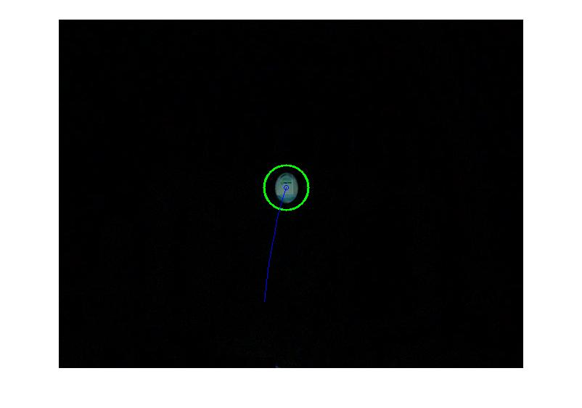
Binary Image

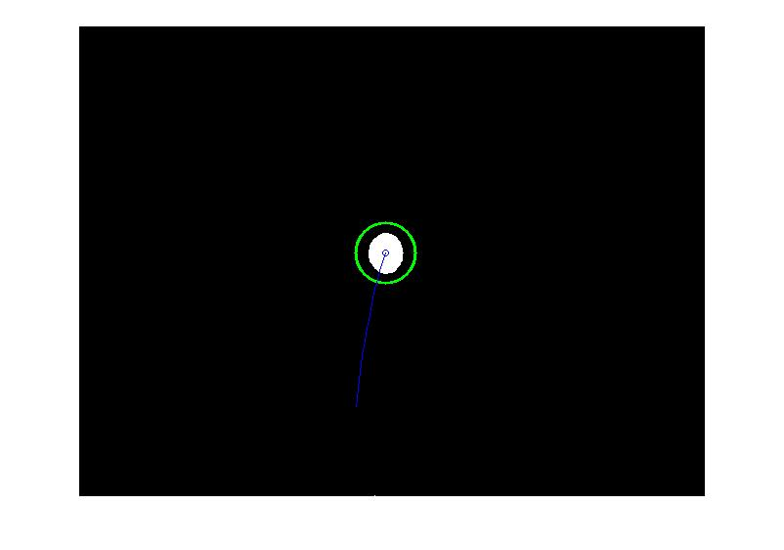
Reached Maximum Height

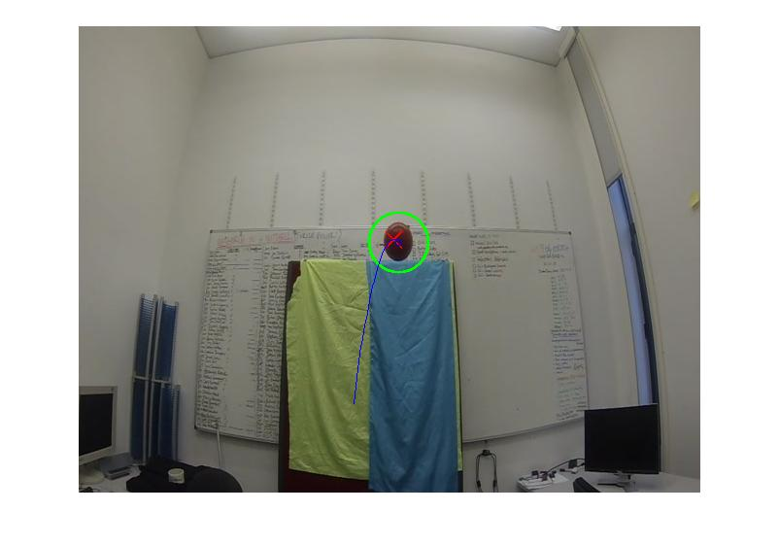
Discussion

Where our detection has trouble is with more than one object in the scene, and with objects that are close to the background colour in some areas. While the detection of the regions is reliable, if part of the ball or other object being thrown in the air matches the background image at any point, the object will be detected as multiple regions instead of the single region it should be. We have attempted to account for this with blurring the image to attempt to remove these inconsistencies, however it does not work in all cases.

The problem with more than one object in the scene is that sometimes when they cross paths, the path tracking does not work as expected. We believe this is due to the way we are matching objects between frames, where sometimes the objects will pass closely together and be confused for one another. This could be improved by using more sophisticated tracking algorithms for the objects between frames, that perhaps considered their velocity and/or acceleration.

Another limitation of our system is that while almost all real balls are detected, sometimes a non-ball object is falsely detected as a ball. This is usually due to the object being split into more than one region, and the broken off section has a circular shape, leading to detection as a ball. The other time this is a problem is during the first and last few frames each object enters the scene; In these frames the object is moving at its maximum velocity and appears stretched from its normal shape in the frame, this can lead to a false detection, or a ball not being detected properly. The way to fix this is either to tweak the thresholds for ball detection, or better yet to use a more robust system for determining if the region is a ball or not. This could be achieved with something like shape signatures or rotation invariant moments.

Overall we feel that our implementation is robust enough to carry out the task well, but could be improved with more complex ball detection algorithms and/or better background removal such that parts of objects are not removed along with the background.

How the work was shared

We worked well together on this task and both feel that the work was shared as follows:

- s1117205 : ?? %
- s1126144 : ?? %

