Project 2 Write-Up

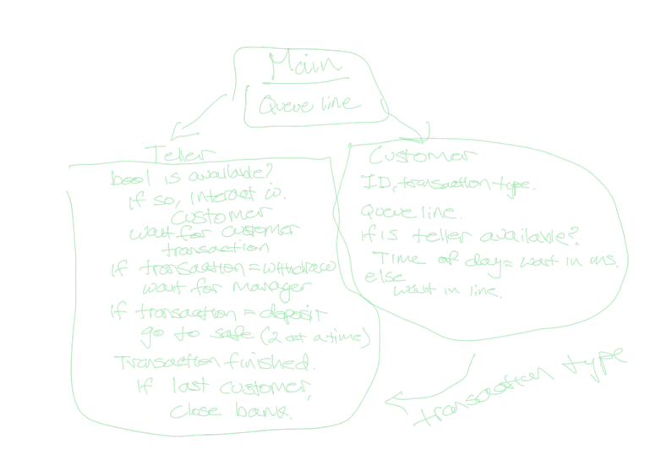

I have approached this project with the idea of this diagram above. Approaching this project with 2 classes with teller and customer, has made the logic of this project easier than I anticipated. I organized this project by initializing the 2 classes with 1 teller and customer to make a connection while using numerous semaphores. I have organized this project like this to make sure that the communication between 2 threads is efficient and working. Some problems I have encountered are initializing semaphores in c++, which has crashed numerous tomes, due to syntax and logical errors. By examining the sample code in java, I switched to Java language, and was able to effectively initialize semaphores I needed.

I learned how the semaphores are able to communicate between multiple threads, without the need of initialization in the main class. I was able to fulfill all the requirements and features as listed in the rubric.