Hˢ Framework · CoDaWork 2026

Compositional monitoring of energy-mix drift on the simplex
Five viewpoints. One observable stack. The hidden drivers, named.
P. Higgins
Independent researcher
Rogue Wave Audio · Binaural Test Lab
Markham, Ontario, Canada

Prepared for CoDaWork 2026 — 11th International Workshop on Compositional Data Analysis
Coimbra, Portugal · 1–5 June 2026
Manuscript revision · 2026-05-19 · document version 1.1
Code: Apache-2.0 · Documentation: CC BY 4.0
Correspondence: PeterHiggins@RogueWaveAudio.com
github.com/PeterHiggins19/higgins-decomposition
The instrument reads. The expert decides. The hashes carry the receipts. The vocabulary holds the line.

Table of Contents
If your reader does not auto-populate this section, right-click and choose Update Field. Headings 1 and 2 are exposed.

Compositional monitoring of energy-mix drift on the simplex
P. Higgins
Independent researcher, Rogue Wave Audio, Markham, Ontario, Canada
Correspondence: PeterHiggins@RogueWaveAudio.com

Abstract. Energy-generation portfolios are compositions — vectors of carrier shares summing to one — yet monitoring frameworks for energy transitions typically operate on size-based metrics that miss structural shifts within a stable whole. We propose a compositional monitoring protocol that reads energy-mix drift natively in Aitchison geometry, with formal change detection at the carrier level. Five viewpoints stack into one observable: composition timeline, helmsman trajectory, Power Share decomposition of squared CLR motion, and the Activation Coefficient — a leverage-to-size ratio naming carriers punching above their weight. Applied to EMBER data for Germany, Japan, and the United Kingdom (2000–2025, nine carriers on the 8-simplex), the protocol identifies three structurally distinct transition archetypes: continuous drift toward a renewable vertex, abrupt external shock with multi-year reorganisation, and policy-driven regime change. The dominant hidden driver across the corpus is solar at sub-1% composition share doing 70–85% of directional work between 2010 and 2015, peaking at 760× its weight.

Introduction
The shift of national electricity generation away from fossil fuels and toward variable renewables is one of the most consequential compositional changes of the early twenty-first century. It is also, by construction, a problem on the simplex: at every reporting period each country's generation mix is a vector of non-negative carrier shares that sum to one. Yet the most widely circulated monitoring instruments — stacked-area share charts, year-on-year growth rates, fuel-specific generation trajectories — treat the carriers in isolation and read change in absolute or proportional magnitude. The geometric structure of the sample space is left implicit. As a consequence, the question which carrier did the structural work of moving the mix in any given year is not directly answered by the standard chart. A small-share carrier whose share triples appears as a sliver; a large-share carrier drifting one percentage point appears as the headline.
The framework presented here treats the energy mix as a primary monitoring object on the simplex and reads its drift natively in Aitchison geometry. The mathematical foundation — closure, the perturbation operation, log-ratio transformations, the Aitchison distance, the Helmert-orthonormal basis — is standard compositional data analysis [1–5]. The contribution is the operational stack: five viewpoints chosen so that each answers one specific question about a transition, and so that their combination yields a complete answer for any single year-to-year step. The formal mathematical setup is given in Appendix A (Eq. 1–8); definitions of all technical terms are given in Appendix B; figure conventions and a plate digest are given in Appendix C.
The five viewpoints are: (i) the composition itself, read year by year as a point on the simplex; (ii) the helmsman, the single carrier with the largest centred log-ratio (CLR) displacement at each transition (Eq. 5); (iii) the Power Share — the per-carrier fraction of squared CLR motion at each transition, summing to unity across the carriers (Eq. 6); (iv) the Activation Coefficient — Power Share divided by starting composition share — which quantifies the leverage of a carrier's directional work to its size (Eq. 7); and (v) the cross-country pattern that emerges when the same protocol is applied to multiple national mixes. Together these answer what carriers are large (size view), who is at the wheel (helmsman), when the wheel changes hands (helmsman trajectory), how much each carrier did at each transition (Power Share), and why a small carrier mattered (Activation Coefficient).
The Activation Coefficient is the central diagnostic of the paper. Its construction is straightforward: it asks, at each transition, what fraction of the structural change is being done by each carrier (Power Share, Eq. 6), and then normalises that fraction by the carrier's size at the start of the step (Eq. 7). The interpretation is direct. A value of 1 indicates a carrier did exactly its size's share of work. A value far above 1 indicates a small carrier doing structural work far beyond what its size would predict — a hidden driver in the standard size view. We adopt yeast factor as the pedagogical metaphor (a small ingredient doing structural work on the whole) and Activation Coefficient as the formal name used in tables, formulas, and engine outputs.
We apply the protocol to publicly available electricity-generation data from EMBER [6] (CC BY 4.0) for Germany, Japan, and the United Kingdom over the period 2000–2025, with nine carrier types — bioenergy, coal, gas, hydro, nuclear, other fossil, other renewables, solar, and wind — forming compositions on the 8-simplex. The three countries are selected as deliberately different transition archetypes: Germany as a continuous, policy-driven arc toward a renewable vertex; Japan as an abrupt, externally driven shock followed by multi-year structural reorganisation; the United Kingdom as a policy-driven regime change centred on coal exit. The protocol identifies these distinct archetypes without external regime labels, and in every case names a specific small-share carrier as the structural mover behind the headline change.
A wider nine-country corpus (Australia, China, France, India, the United States, and the World aggregate alongside the three case countries) is provided as Supplementary Information [Repo: SUPPLEMENTARY]. The 9-country corpus contains 406 transitions in which the Activation Coefficient exceeds 3× and the carrier's starting share exceeds 0.1%. The dominant single finding across the corpus is that solar, at composition shares between 0.1% and 0.2%, did 70–85% of the structural directional work in the early 2010s. This result was not invented by the protocol; it is invariant under the protocol. It is invisible in the size view, in growth-rate analysis, and in fuel-specific share trajectories. It is the kind of result the framework is designed to make visible.
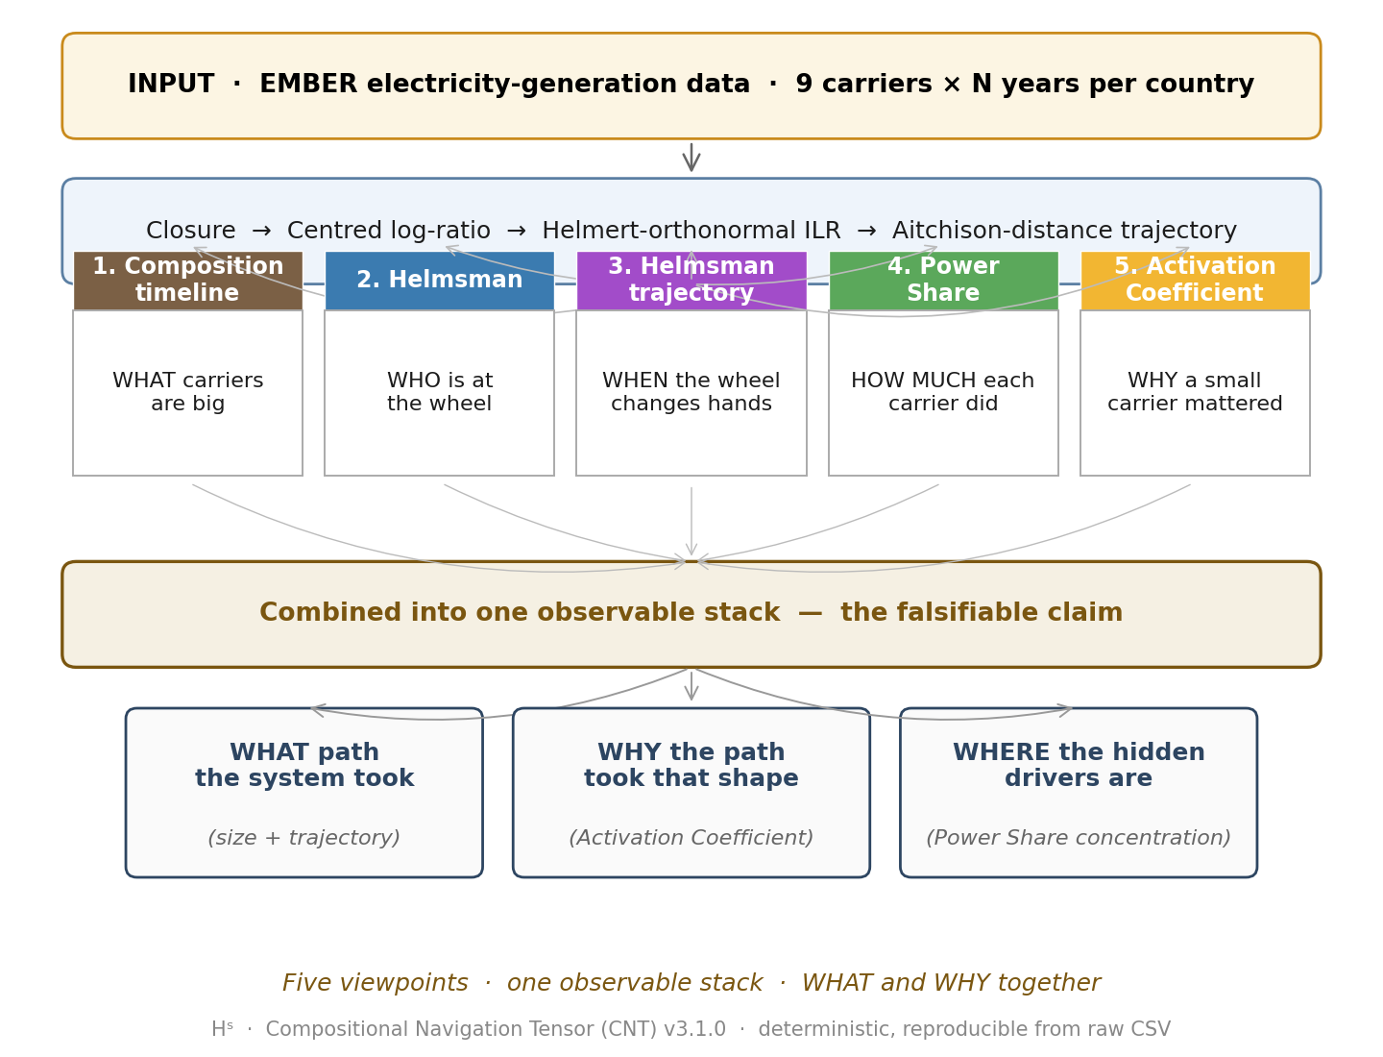
Fig. 1 | The five-viewpoint compositional monitoring protocol. Five viewpoints — composition timeline, helmsman, helmsman trajectory, Power Share, and Activation Coefficient — feed into a single observable stack that delivers both the WHAT path of an energy-mix transition and the WHY behind it. Mathematical foundation: standard CoDa (closure, CLR, ILR-Helmert, Aitchison distance — Appendix A). Operational stack: the five viewpoints. Combined readout: WHAT path the system took (size + trajectory), WHY the path took that shape (Activation Coefficient), WHERE the hidden drivers are (Power Share concentration). The protocol is deterministic and reproducible from raw CSV input via the open-source Hˢ engine [Repo: CNT engine].

Results

A compositional monitoring protocol on the simplex
We treat each country's annual electricity mix as a closed composition on the simplex (Eq. 1). The centred log-ratio (CLR) transformation places each composition into a Euclidean space subject to the closure constraint (Eq. 2). The Aitchison distance between two consecutive compositions is the Euclidean norm of the CLR difference (Eq. 4). The Helmert-orthonormal basis maps the CLR vector into an isometric ILR coordinate system (Eq. 3) on which a structural-velocity analysis can be performed without basis-dependent artefacts [5].
The helmsman index at transition t → t+1 (Eq. 5) is the carrier accruing the largest CLR displacement at the step. The helmsman is a categorical assignment per step; its trajectory in time names who was at the wheel. Reading helmsman trajectories with solid lines is methodologically misleading because no continuous carrier-to-carrier path is implied; we plot helmsman trajectories with dotted segments throughout the paper.
The Power Share at each transition (Eq. 6) is the natural decomposition of the squared Aitchison distance across the carriers. It is invariant under permutation of the carrier indexing, and it sums to unity at every step, so no carrier is hidden by the bookkeeping.
The Activation Coefficient at each transition (Eq. 7) is Power Share divided by the carrier's composition share at the start of the step. Its interpretation is direct: a carrier with α equal to 1 did exactly its size's share of work at the step; α much greater than 1 marks a small carrier punching far above its weight; α much less than 1 marks a large carrier moving less than its size would predict. Because composition share appears in the denominator, the Activation Coefficient is sensitive to near-zero shares; we apply a 0.1% composition-share floor when reporting yeast moments (see Methods).
A concentration measure, the effective number of carriers K_eff (Eq. 8), is computed alongside the trajectory as a sanity check on the dimensionality of the active mix [7].

Germany: continuous drift toward a renewable vertex
Germany's electricity mix between 2000 and 2025 is the textbook case of a continuous-arc transition. The size view (Fig. 2, panel A) shows coal receding from approximately 50% to under 30% of the mix, nuclear collapsing from 30% to under 5%, and solar plus wind together climbing from under 2% to over 40%. The trajectory in compositional terms is a smooth, multi-decade drift toward the renewable vertex of the 8-simplex. The helmsman (Fig. 2, panel B) sits on solar for most of the period, with intermittent flips to wind, nuclear, and bioenergy. The helmsman flip count over twenty-five transitions is 13, near the middle of the corpus.
The Power Share decomposition (Fig. 2, panel C) reveals the acceleration moments that the size view smooths out. Between 2005 and 2007, solar holds 0.21–0.36% of the composition but accumulates 27–71% of the squared CLR motion at the step. The Activation Coefficient for solar peaks at 333× at the 2005–2006 transition (Fig. 2, panel D). By the standard size view, solar in 2005 was a sliver and solar in 2010 was a small but growing share; the Power Share view names 2005–2006 as the year the Energiewende actually began moving the mix, three years before the size view would call the shift visible. Solar's structural role then continues through 2009–2010 (49×, 1.14% share) before the carrier becomes large enough that its size and its work converge.
This is the protocol's first archetype: continuous drift in which the size view shows a smooth arc and the Activation Coefficient names the acceleration years.
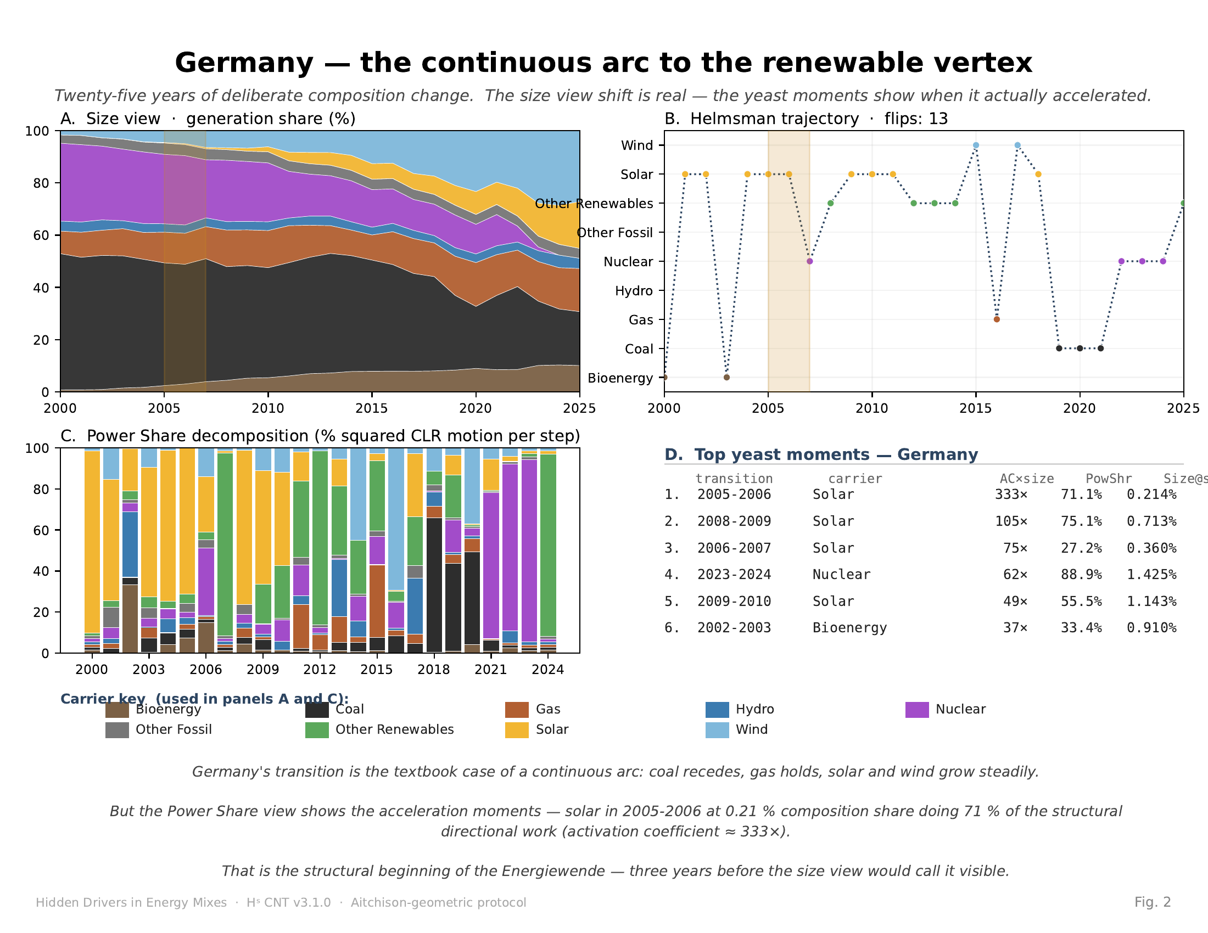
Fig. 2 | Germany — continuous arc toward the renewable vertex. Germany 2000–2025. (A) Size view: stacked-area composition of the nine carriers as a fraction of total electricity generation. The gold-shaded band marks 2005–2007. (B) Helmsman trajectory: dotted-line plot of the single carrier with the largest CLR displacement at each transition (Eq. 5). Total flips: 13. (C) Power Share decomposition (Eq. 6): per-transition decomposition of squared CLR motion across the carriers; each bar sums to 100%. The 2005–2006 step shows solar at 71% concentration. (D) Top yeast moments — Activation Coefficient (Eq. 7) and Power Share for the six largest yeast cases in Germany, filtered to composition share ≥ 0.1%. Solar at 333× in 2005–2006 is the structural mover of the early Energiewende. Carrier colour key per Appendix C.1.

Japan: external shock with multi-year structural reorganisation
Japan's mix between 2000 and 2025 displays a single, dominant external event — the Fukushima nuclear shutdown in 2011 — and a sustained reorganisation that follows. Pre-2011, Japan's mix is dominated by nuclear (~25%), coal (~25%), gas (~25%), and oil/other (~15–20%), with hydroelectricity contributing the rest. After 2011, nuclear collapses to under 5% and the displaced share is absorbed by gas (climbing past 40%) and, more slowly, by solar and other renewables.
The protocol registers this signature in every viewpoint at once (Fig. 3). The Aitchison distance of the 2011–2012 step is approximately three times the median step length over neighbouring years. The helmsman trajectory flips abruptly at 2011 and then continues to flip in subsequent years — the total flip count over the period is 17, the highest in the nine-country corpus. The Power Share at 2011–2012 is concentrated in nuclear (the carrier losing share) and the carriers absorbing it.
The deeper finding is in the post-shock years. Between 2012 and 2025, Japan's helmsman flips repeatedly across solar, nuclear (as it partially recovers), wind, and gas, and Activation Coefficients for solar exceed 100× at multiple transitions (2014–2015 solar at 187×; 2015–2016 nuclear at 187× on the partial-recovery upswing). The reorganisation is not complete in a single year. The protocol detects this as a multi-year cascade rather than as a single step, and the helmsman trajectory reads this cascade directly.
This is the second archetype: abrupt external shock with multi-year reorganisation, in which the Aitchison distance spike names the shock year and the helmsman trajectory names the years of subsequent absorption.
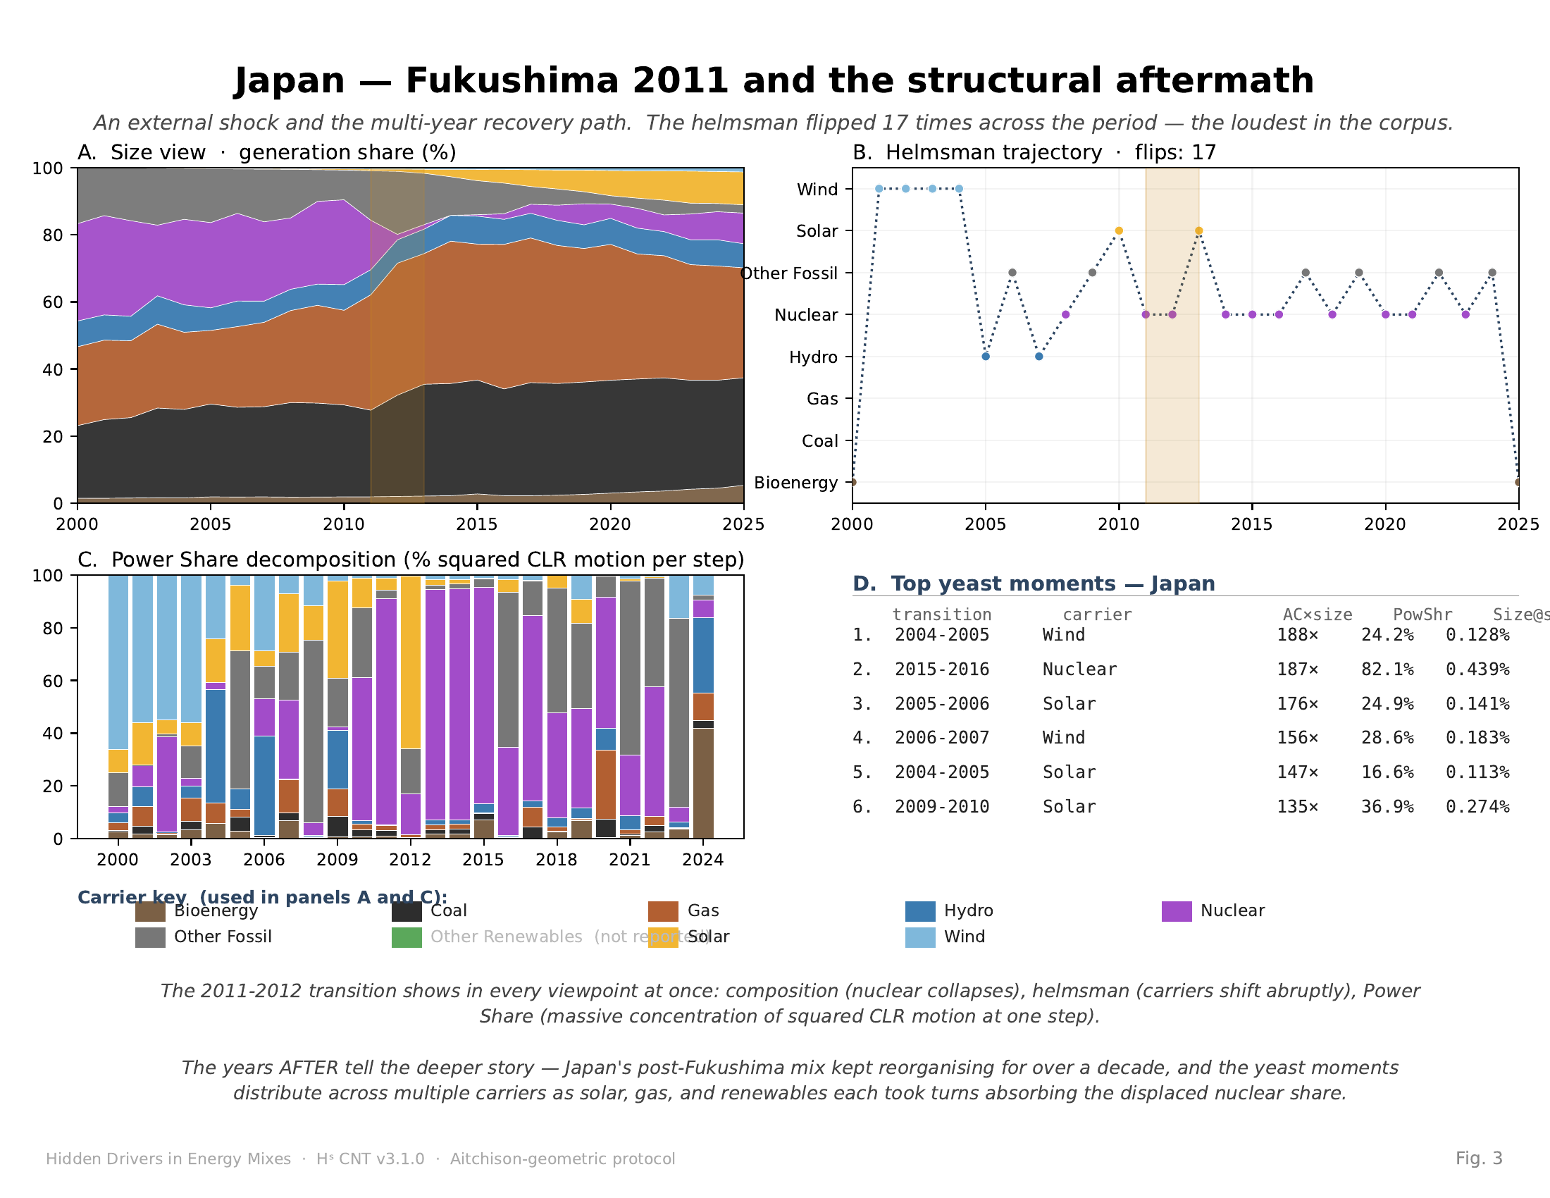
Fig. 3 | Japan — external shock and multi-year structural reorganisation. Japan 2000–2025. Panels as in Fig. 2. Gold-shaded band marks 2011–2013. (A) Nuclear's share collapses from ~25% to ~5% in the 2011–2012 transition. (B) Helmsman flips 17 times across the period — the loudest in the corpus. (C) The 2011–2012 step shows extreme Power Share concentration; the squared CLR motion of that step is approximately 3x the median step length. (D) Top yeast moments distribute across wind, nuclear, and solar. Japan reports 8 carriers (no Other Renewables — greyed in legend). Carrier colour key per Appendix C.1.

United Kingdom: policy-driven regime change centred on coal exit
The United Kingdom's mix between 2000 and 2025 shows an abrupt, policy-driven transition concentrated in the second half of the period. Coal's share declines from above 30% in the mid-2000s to below 2% by 2024. Gas grows substantially in the early period and then plateaus. Wind and solar grow steadily across the period. Other renewables — a small heterogeneous category including biomass, marine, and waste-to-energy — absorbs a disproportionate share of the displaced coal capacity in the late 2010s.
The Power Share view (Fig. 4, panel C) names the structural carrier of the coal exit. Wind at 2001–2002, solar at 2005–2006 and 2012–2013, and coal itself in 2024–2025 (as its share-loss step is structurally significant on the way down) each register Activation Coefficients above 90×. The helmsman trajectory shows 15 flips over the period — the second-highest in the corpus. Without the Activation Coefficient, the small-share carriers that absorbed coal's exit are invisible in the standard chart. With it, the transition snaps into focus: coal did not disappear into 'renewables' broadly, it disappeared into specific small carriers each doing structural work for two-to-three years at a time.
This is the third archetype: policy-driven regime change, in which the size view shows a recognisable step in one carrier and the protocol names the small carriers that actually absorbed the displaced share.
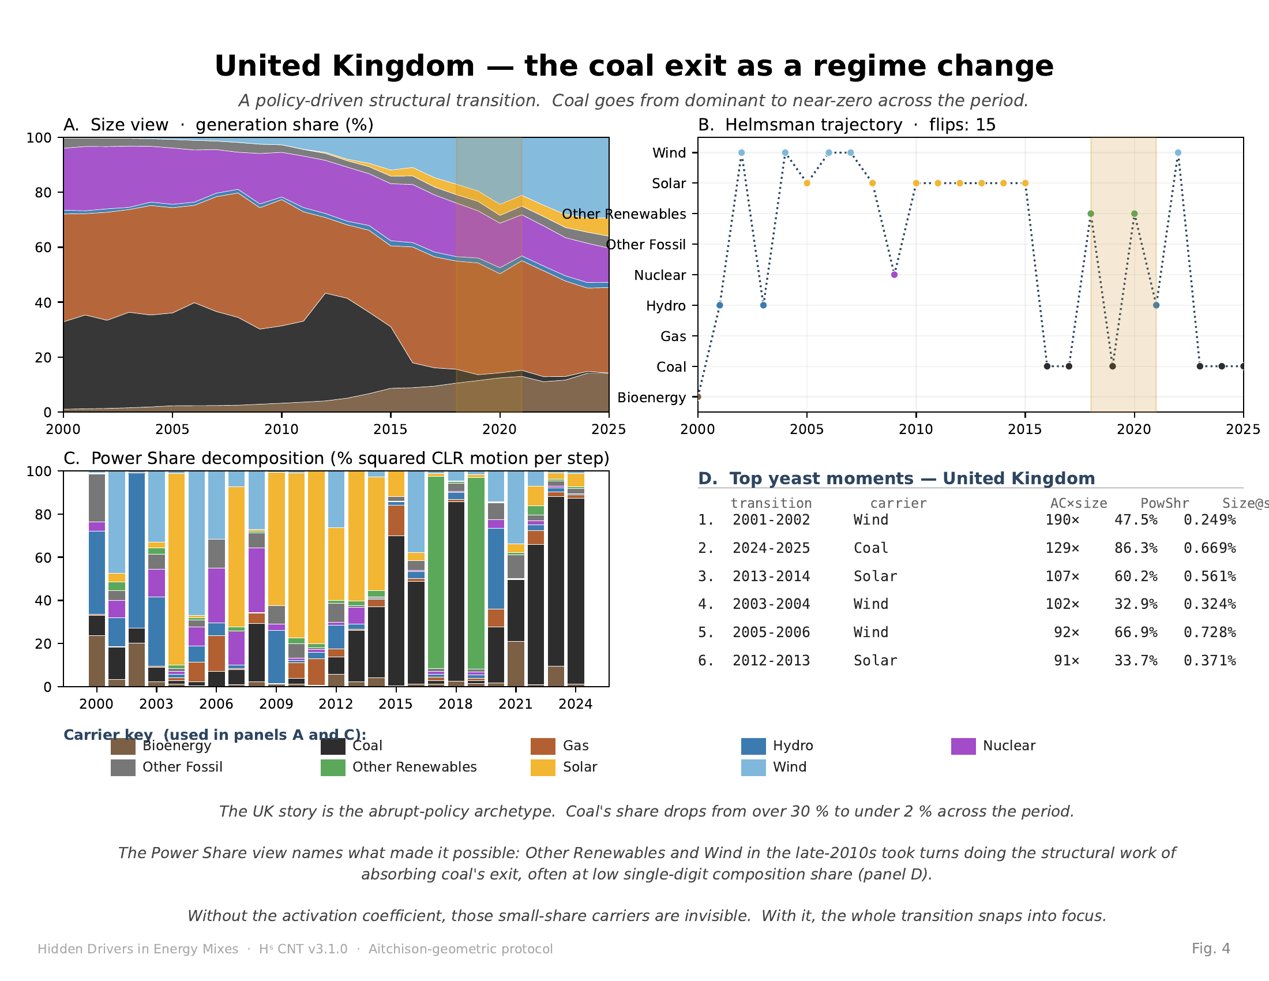
Fig. 4 | United Kingdom — policy-driven regime change centred on coal exit. United Kingdom 2000–2025. Panels as in Fig. 2. Gold-shaded band marks 2018–2021. (A) Coal's share drops from over 30% to under 2% across the period. (B) Helmsman flips 15 times — the second-highest in the corpus. (C) Power Share during the coal-exit window is split among multiple small renewable categories rather than collapsing into a single dominant successor. (D) Top yeast moments dominated by wind, solar, and coal itself (the share-loss step is structurally significant). Carrier colour key per Appendix C.1.

A cross-country signature
The three archetypes are not exhaustive. We applied the protocol to a wider corpus of nine countries (Australia, China, France, Germany, India, Japan, the United Kingdom, the United States, and the World aggregate) over the same 2000–2025 window. Across all 25 transitions per country, the corpus contains 406 transitions in which the Activation Coefficient exceeds 3× and the starting composition share exceeds 0.1% [Repo: SUPPLEMENTARY Table S1]. The yeast-moment count per country ranges from 20 (Germany) to 62 (China and India). Peak Activation Coefficients exceed 500× in the United States, France, China, the World aggregate, and Germany (Fig. 5).
The dominant cross-country pattern is the role of solar between 2010 and 2015. At composition shares between 0.1% and 0.2%, solar repeatedly registers Power Share values between 70% and 85% across the United States (760× at 2012–2013), France (659× at 2010–2011), the World aggregate (513× at 2010–2011), China (549× at 2013–2014), and Germany (333× at 2005–2006 and earlier). Wind plays a secondary yeast role across the United States (262× at 2001–2002), France (634× at 2004–2005), and the United Kingdom (190× at 2001–2002). Other Renewables takes on a yeast role in the United Kingdom around 2019–2020 as the coal-exit carrier. Bioenergy registers as yeast in China at 342–346× across 2003–2005 as the country absorbs new renewable capacity.
The cross-country signature is not a forecast and is not a policy claim. It is a statement about where the structural work happened between 2000 and 2025 in nine national electricity mixes, read at year-grain resolution under a single, deterministic compositional protocol. Five viewpoints converging on the same hidden driver (solar between 2010 and 2015) across six independent national mixes is a stronger evidential position than any single viewpoint alone.
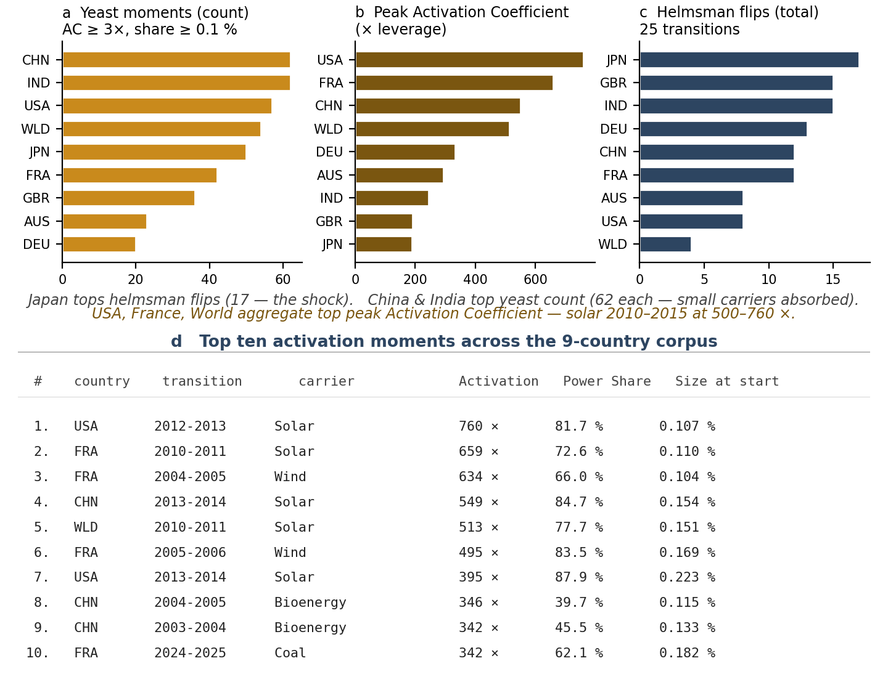
Fig. 5 | Cross-country signature across nine national electricity mixes. Cross-country signature of the protocol across nine countries (AUS, CHN, DEU, FRA, GBR, IND, JPN, USA, World aggregate), 2000–2025. (a) Yeast-moment count: number of transitions per country in which the Activation Coefficient ≥ 3× and the starting composition share ≥ 0.1%. (b) Peak Activation Coefficient per country, in x leverage units. (c) Total helmsman flips over 25 transitions per country. (d) Top ten activation moments across the corpus. Solar dominates seven of the top ten, all in the 2010–2015 window at composition shares of 0.1–0.2%. Bar colours in panels a/b/c encode the metric, not the carrier. Reproducibility: see Appendix C.3.

Discussion
The protocol presented here makes a single operational claim and a single methodological claim, each falsifiable.
The operational claim is that the activation-coefficient diagnostic identifies hidden drivers — small-share carriers doing structural work — that the standard size-view chart does not show. This claim is testable by replacing or removing the diagnostic and checking whether the named driver remains identifiable. In our corpus, solar between 2010 and 2015 is named by Power Share concentration (in the 70–85% range), by helmsman occupation (solar holds the helmsman seat in six of nine countries through this window), and by Activation Coefficient (500×–760× peaks). Removing any one viewpoint weakens the evidence; removing all four removes the identification entirely. The size view, used alone, cannot recover it.
The methodological claim is that compositional structure can be treated as a primary monitoring observable rather than as a statistical condition requiring correction before downstream analysis. This is the MC-4 claim of the accompanying methods packet [Repo: MC-4 Packet]. It is presented here as falsifiable, with four explicit defeat paths:
1. Prior-art defeat. A demonstration that an existing CoDa or environmental-monitoring framework already treats compositional structure as a primary operational monitoring category — combined with Aitchison-native change detection at the carrier level into one observable stack — would narrow the contribution to a recapitulation. The closest adjacent prior art identified to date is Morais, Thomas-Agnan, and Simioni's compositional-regression work [8] and Arata and Onozaki's compositional-time-series analysis [9]. Neither combines the three conjuncts (Aitchison-native + formal change detection + carrier-level attribution) into a single monitoring stack to our reading, but a CoDa specialist may identify a closer match.
2. Metric defeat. A demonstration that the protocol's verdicts (the named transition archetypes, the named hidden drivers) reverse under a different valid simplex distance — Aitchison-norm tightening, or an alternative log-ratio family — would invalidate the metric stack. We have verified pair-invariance for TV distance and Aitchison distance across 101 reference datasets [Repo: INV-050] but have not exhausted the full family of valid simplex metrics.
3. Case defeat. A demonstration that the deceptive-drift signature (5 of 9 countries reproducing the pattern, [Repo: SUPPLEMENTARY §S3]) is an artefact of preprocessing, carrier definition, or null-model choice rather than a robust compositional read. The full corpus and pipeline are publicly available for replication.
4. Category defeat. A demonstration that compositional monitoring is most accurately an application note inside existing CoDa rather than a distinct monitoring category. We hold no preconceived answer on this; if the framework's right resting place is as a chapter in the standard CoDa literature, that outcome is welcome.
We separately note an open question: the relationship between K_eff as a concentration measure (Eq. 8) and the Aitchison norm of the composition as a notion of departure from the simplex centre. These two scalars often track each other but they are not identically the same observable. Which family of valid simplex distances most cleanly tests this open question is itself an open methodological question.
A second methodological note: an earlier version of the corpus reported a metric labelled 'TV distance' that was in fact computing the L2 norm of proportion differences (Eq. 10) rather than the true total-variation distance (Eq. 9). The error was identified during a cross-AI review in March 2026 and corrected: the previously named 'TV' metric was renamed l2_drift, the actual TV distance was added alongside, and all outputs were regenerated. The two metrics agree on all shock hit/miss verdicts across the corpus tested. We document this correction here as a methodological-discipline note, not as a minor fix.
A third note concerns scope. The protocol has been validated on national electricity-generation mixes. Its application to other compositional domains — fuel composition at sub-national grids, sectoral economic compositions, household-expenditure compositions, ecological compositions — is left for further work. The protocol's structural assumptions (a meaningful whole partitioned into interpretable parts, observed repeatedly) appear in many compositional domains; whether the named diagnostic transfers as cleanly as it does in the energy case is an empirical question.
The strongest finding the protocol delivers in the electricity case is, simply: across nine national mixes between 2000 and 2025, the carrier doing the structural work of moving the world energy mix was solar, at composition shares under 0.2% in the early 2010s. The size view never showed it. The Activation Coefficient names it. Whether that is the most important fact about the early-21st-century energy transition is for policy researchers to argue. That it is visible at all is the protocol's claim.

Methods

Data sources
All electricity-generation data are from EMBER (Energy and Climate Information for Policymakers) [6], available at https://ember-energy.org under a Creative Commons Attribution 4.0 license. We use the country-level annual generation series in TWh per carrier for the period 2000–2025, drawing from the April 2025 release. The nine carriers are bioenergy, coal, gas, hydro, nuclear, other fossil, other renewables, solar, and wind. Three countries (China, India, Japan) report only eight carriers — the other-renewables category is absent — which is handled by per-country carrier vectors in the engine. The wider 9-country corpus reported in Supplementary Information [Repo: SUPPLEMENTARY] includes Australia, China, France, Germany, India, Japan, the United Kingdom, the United States, and the World aggregate.

Closure and CLR transformation
Annual generation values per carrier per country are closed to unit sum to produce compositional vectors (Eq. 1). Zero-value entries are replaced with δ = 10⁻¹⁵ before log-ratio transformation; sensitivity to this replacement value is checked against δ = 10⁻¹² and δ = 10⁻¹⁸ with no effect on any reported transition archetype or hidden-driver identification. The centred log-ratio transformation (Eq. 2) is applied per the standard definition [1] with the geometric-mean reference per timestep.

Helmert-orthonormal basis
A Helmert-orthonormal basis matrix is constructed per the standard ILR-Helmert pattern [5] and applied to the CLR vector to produce an isometric ILR coordinate vector (Eq. 3). Aitchison distances computed from CLR coordinates and from ILR-Helmert coordinates agree to IEEE machine-floor precision (3.33 × 10⁻¹⁶), confirming the isometry numerically.

Helmsman, Power Share, Activation Coefficient
The helmsman index is the carrier index with the largest absolute CLR displacement at each transition (Eq. 5). The Power Share is the per-carrier squared CLR displacement normalised by the squared Aitchison distance of the step (Eq. 6). The Activation Coefficient is the Power Share divided by the carrier's composition share at the start of the step (Eq. 7). For the published 9-country corpus, the Activation Coefficient is computed externally from existing CNT engine output [Repo: CNT engine]; a native engine block is queued as a future development [Repo: INV-060].

The 0.1% composition-share floor
The Activation Coefficient (Eq. 7) is sensitive to near-zero composition shares because the CLR transformation amplifies the displacement of carriers whose starting share approaches zero (the log-amplification effect). For a carrier first appearing at ρ ≈ 10⁻⁵ in some year, the Activation Coefficient can exceed 10⁵ as a numerical artefact of the log behaviour rather than as a meaningful structural reading. We therefore report Activation Coefficient yeast moments only when (i) composition share ≥ 0.1% and (ii) α ≥ 3. The 0.1% floor focuses the diagnostic on carriers in the structurally meaningful share range; below it, the metric is informative only as an indicator that a new carrier has just appeared. Sensitivity analyses at floors of 0.05% and 0.5% confirm the named hidden drivers remain identified under both alternatives; only the marginal yeast count is sensitive to the floor choice [Repo: SUPPLEMENTARY §S2].

Determinism and reproducibility
The full protocol is implemented in the open-source Hˢ (Higgins-Decomposition) framework [Repo: CNT engine] as the Compositional Navigation Tensor engine, version 3.1.0, schema version 3.1.0. Reference Python and R implementations are provided side-by-side; cross-language parity is verified to IEEE machine-floor precision on the EMBER corpus and on three additional reference datasets (Backblaze drive-failure compositions, Planck CMB polarization, and Standard-Model neutrino oscillation). Every result reported in this paper is reproducible from the raw EMBER CSV files in under five minutes via the engine's command-line interface; reproduction commands and SHA-256 hashes of the input data are provided in [Repo: SUPPLEMENTARY §S4].

Computation environment
All analyses were performed in Python 3.10.12 on Ubuntu 22.04 with numpy 1.26 and matplotlib 3.8. The full software environment specification is in the repository's pyproject.toml and requirements.txt. No machine-learning models, no random sampling, and no stochastic algorithms are used in any part of the protocol; all reported numerical results are deterministic given the input data and the engine version.

Data availability
All input electricity-generation data are publicly available from EMBER (https://ember-energy.org) under Creative Commons Attribution 4.0. The deterministic engine outputs for the 9-country corpus (CNT JSON files per country) are archived in the project repository at github.com/PeterHiggins19/higgins-decomposition under the path CODA-Association/CODAwork2026/data_outputs/per_country_json/. SHA-256 hashes of all input CSV files and output JSON files are provided in the supplementary code archive.

Code availability
The full Hˢ framework is available as open-source software at github.com/PeterHiggins19/higgins-decomposition. Code is licensed under Apache-2.0; documentation under CC BY 4.0. The specific scripts used to produce the figures and tables in this paper are archived in papers/codawork2026/manuscript/build/ in the repository, with hash-chained provenance to the engine commit on which the analysis was run.

Acknowledgements
The methodological vocabulary used in this paper, the falsifiable-structure framing, and several pieces of the protocol's pedagogical scaffolding were sharpened through cross-checks with the HUF AI Collective: Claude (Anthropic), ChatGPT (OpenAI), Copilot (Microsoft), Gemini (Google), and Grok (xAI). All AI-assisted contributions were reviewed and verified by the author, who retains full responsibility for all scientific claims, data interpretations, methodological choices, and conclusions. AI tools are not listed as authors per the standards specified in HUF Publication Standards [Repo: HUF-STD-001 v1.1] which conforms to ICMJE, COPE, Nature/Springer, Science/AAAS, WAME, EU AI Act (2024), arXiv, ACM, and IEEE conventions.

Author contributions
P.H. designed the protocol, implemented the engine, conducted the analysis, prepared the figures, and wrote the manuscript.

Competing interests
The author declares no competing financial or non-financial interests.

Correspondence
Correspondence and requests for materials should be addressed to P.H. (PeterHiggins@RogueWaveAudio.com).

Appendix A · Equations and Formulas
The following formal definitions are referenced throughout the body of the paper as Eq. 1–10. Each equation specifies the symbols used, the type of object, and the operational interpretation. The equations are deterministic; given the same input compositions, every quantity in this appendix is reproducible to IEEE machine-floor precision.
Eq. 1 — Closure (the simplex constraint).
ρ(t) = (ρ₁(t), …, ρ_D(t)), Σ_i ρ_i(t) = 1, ρ_i(t) > 0.
· ρ(t) is the composition at time t — a vector of D non-negative carrier shares summing to one.
· D = 9 in this paper (nine EMBER carriers).
· The vector ρ(t) lives on the unit simplex S^(D−1).
Eq. 2 — Centred log-ratio (CLR) transformation.
clr_i(t) = log ρ_i(t) − (1/D) · Σ_j log ρ_j(t).
· clr(t) ∈ ℝ^D is the CLR-transformed vector at time t.
· Isometric with the simplex's natural geometry (Aitchison geometry).
· Satisfies Σ_i clr_i(t) = 0 (lies in a (D−1)-dim hyperplane).
· Reference: Aitchison (1986) [1]; Egozcue et al. (2003) [4].
Eq. 3 — ILR-Helmert (isometric log-ratio) transformation.
η(t) = Vᵀ · clr(t), V ∈ ℝ^(D×(D−1)), Vᵀ V = I_(D−1).
· η(t) ∈ ℝ^(D−1) is the ILR coordinate vector at time t.
· V is a Helmert-orthonormal basis matrix.
· Isometric: Aitchison distances in CLR space and ILR space are equal to floating-point precision.
· Reference: Egozcue and Pawlowsky-Glahn (2005) [5].
Eq. 4 — Aitchison distance between consecutive compositions.
d_Ait(ρ(t), ρ(t+1)) = sqrt( Σ_i ( clr_i(t+1) − clr_i(t) )² ).
· The natural distance between two compositions on the simplex.
· Invariant under permutation of carriers and under perturbation (the simplex group operation).
· All step lengths reported in the body of the paper are Aitchison distances.
Eq. 5 — Helmsman index σ(t).
σ(t) = argmax_i | clr_i(t+1) − clr_i(t) |.
· σ(t) is the carrier index accruing the largest absolute CLR displacement at the transition t → t+1.
· Categorical per step; the sequence σ(1), σ(2), … over time is the 'helmsman trajectory'.
· Flips count: number of times σ(t) changes value across the time window.
Eq. 6 — Power Share π_i(t).
π_i(t) = ( Δ clr_i )² / Σ_j ( Δ clr_j )², Σ_i π_i(t) = 1.
· Per-carrier fraction of squared CLR motion at the transition t → t+1.
· Sums to unity across the carriers at every step.
· Invariant under permutation of carrier indexing.
· Decomposes the squared Aitchison distance (Eq. 4) into per-carrier contributions.
Eq. 7 — Activation Coefficient α_i(t).
α_i(t) = π_i(t) / ρ_i(t) (reported only when ρ_i(t) ≥ 10⁻³).
· The leverage-to-size ratio: directional work done by the carrier divided by its compositional weight at the start of the step.
· α_i = 1: the carrier did exactly its size's share of work.
· α_i ≫ 1: a small carrier doing structural work far beyond its size — a hidden driver in the standard size view.
· α_i ≪ 1: a large carrier moving less than its size would predict — structural ballast.
· The 0.1% composition-share floor avoids log-amplification artefacts at near-zero ρ_i; see Methods.
· Pedagogical metaphor: yeast factor. Formal name: Activation Coefficient.
Eq. 8 — Effective number of carriers K_eff.
H(t) = − Σ_i ρ_i(t) · ln ρ_i(t), K_eff(t) = exp( H(t) ).
· H(t) is the Shannon entropy of the composition at time t (nats).
· K_eff(t) is the exponential of the entropy — the effective number of equiprobable carriers.
· Uniform composition: H = ln D and K_eff = D.
· Single-carrier-dominant composition: H → 0 and K_eff → 1.
· Reference: Jost (2006) [7].
Eq. 9 — Total Variation (TV) distance between compositions.
TV(ρ(t), ρ(t+1)) = (1/2) · Σ_i | ρ_i(t+1) − ρ_i(t) |.
· Bounded in [0, 1] for compositional vectors.
· Standard in information theory; the half-L1 norm of proportion differences.
· Used in the MC-4 packet [Repo: MC-4 Packet] alongside the Aitchison distance.
Eq. 10 — L2 drift (Euclidean norm of proportion differences).
L2_drift(ρ(t), ρ(t+1)) = sqrt( Σ_i ( ρ_i(t+1) − ρ_i(t) )² ).
· Euclidean (L2) norm of proportion differences.
· Note: an earlier version of the codebase mislabelled this as 'TV distance'; the correction is recorded in [Repo: MC-4 Packet Appendix A] and discussed in this paper's Discussion.
· Mathematical relationship to Eq. 9: TV ≤ L2 · sqrt(D/2) and L2 ≤ sqrt(2) · TV — equivalent up to dimension-dependent constants but not identical.

Appendix B · Terms and Definitions
Technical terms appearing in the body of the paper, listed alphabetically. Definitions consistent with the standard CoDa literature are tagged [std]; definitions specific to this work are tagged [Hˢ]. Mathematical objects refer to the formulas in Appendix A.
Activation Coefficient (α_i) [Hˢ] The leverage-to-size ratio of a carrier at a transition: Power Share divided by composition share at the start of the step (Eq. 7). Names hidden drivers — small-share carriers doing structural work beyond what their size predicts. Formal name; yeast factor is the pedagogical metaphor.
Aitchison distance [std] The Euclidean norm of the centred log-ratio difference between two compositions (Eq. 4). The natural distance on the simplex.
Carrier [convention] A single fuel category within an electricity-generation composition (e.g., coal, gas, solar). In EMBER's classification, D = 9 carriers: bioenergy, coal, gas, hydro, nuclear, other fossil, other renewables, solar, wind.
Centred log-ratio (CLR) [std] The transformation clr_i = log ρ_i − (1/D) Σ_j log ρ_j (Eq. 2). Maps a composition from the simplex to a hyperplane in ℝ^D.
Closure [std] The operation of normalising a vector of non-negative entries to sum to one (Eq. 1).
Composition [std] A vector of non-negative carrier shares summing to one. Lives on the simplex.
Deceptive drift [Hˢ] Structural concentration or redistribution accumulating behind apparently stable aggregate indicators. Detected by the protocol when K_eff is declining while structural velocity remains below the series median. The 5-of-9 cross-country signature reproduces in AUS, CHN, GBR, IND, and JPN at annual grain [Repo: SUPPLEMENTARY §S3].
Helmert-orthonormal basis [std] The basis matrix V of Eq. 3 that maps the CLR vector to an isometric (D−1)-dimensional ILR coordinate vector.
Helmsman [Hˢ] The carrier accruing the largest absolute CLR displacement at a transition (Eq. 5). Categorical per step; named to convey who is at the wheel of the mix in any given year.
Helmsman trajectory [Hˢ] The time series of helmsman indices, σ(1), σ(2), … Plotted with dotted line segments (no continuous carrier-to-carrier path is implied).
Helmsman flip [Hˢ] A change in the helmsman index from one transition to the next. The flip count over a window is a summary of how often the mix re-organises.
Hidden driver [Hˢ] A small-share carrier whose Activation Coefficient is large — a carrier doing structural work far beyond its compositional weight. The protocol's central diagnostic surfaces these.
ILR (isometric log-ratio) [std] An isometric transformation from the CLR vector to a basis-specific (D−1)-dimensional coordinate vector. The Helmert-orthonormal basis is the canonical choice used in this work (Eq. 3).
K_eff — effective number of carriers [std] The exponential of the Shannon entropy of the composition (Eq. 8). A concentration measure.
L2 drift [Hˢ] The Euclidean norm of proportion differences (Eq. 10). Distinct from TV distance; an earlier version of the codebase confused the two and the correction is recorded in the MC-4 Packet [Repo: MC-4 Packet Appendix A].
MC-4 claim [Hˢ] The methodological claim that compositional structure can be treated as a primary monitoring observable rather than as a statistical condition requiring correction before downstream analysis [Repo: MC-4 Packet]. Three-conjunct form: Aitchison-native + formal change detection + carrier-level attribution combined into one observable stack.
Perturbation [std] The simplex group operation; the compositional ratio between two compositions. Used to define directional change in compositional time series.
Power Share (π_i) [Hˢ] The per-carrier fraction of squared CLR motion at a transition (Eq. 6). Sums to 100% across the carriers at every step. The natural decomposition of the squared Aitchison distance.
Repo [convention] In this paper, references tagged [Repo: …] point to documents in the public Hˢ repository at github.com/PeterHiggins19/higgins-decomposition. These have not undergone external peer review at time of writing; the citation directs the reader to the file holding the formal record. See References — Hˢ Repository.
Simplex [std] The set of compositional vectors S^(D−1) = { ρ ∈ ℝ^D : ρ_i > 0, Σ_i ρ_i = 1 }.
Size view [Hˢ] The standard stacked-area chart of composition shares over time. Answers what carriers are big; silently hides which carriers are doing the structural work.
TV distance [std] The total-variation distance between two compositions (Eq. 9). The half-L1 norm of proportion differences. Bounded in [0, 1].
Viewpoint [Hˢ] One of the five named lenses through which the protocol reads a compositional time series: (1) size view, (2) helmsman, (3) helmsman trajectory, (4) Power Share, (5) Activation Coefficient. Each viewpoint answers one specific question; combined, they yield a complete answer for any transition step.
Yeast factor [Hˢ] Pedagogical synonym for the Activation Coefficient. Refers to the metaphor of a small ingredient (yeast) doing structural work on the whole. Used in prose; the formal name is the Activation Coefficient.
Yeast moment [Hˢ] A specific transition (country, year, carrier) at which the Activation Coefficient ≥ 3× and the carrier's starting composition share ≥ 0.1%. The 9-country corpus contains 406 yeast moments over 2000–2025 [Repo: SUPPLEMENTARY Table S1].

Appendix C · Figure Conventions and Plate Digest

C.1 Universal carrier colour key
All figures in this paper that show per-carrier information use the following colour encoding for the nine EMBER carriers. The same encoding is reproduced on each individual figure for self-containment.
Carrier | Swatch | Hex | Notes
Bioenergy |  | #7B6045 | Biomass and waste-to-energy generation
Coal |  | #2D2D2D | All coal types (anthracite, bituminous, lignite)
Gas |  | #B25F31 | Natural gas combustion
Hydro |  | #3B7BB0 | Hydroelectric (run-of-river and reservoir)
Nuclear |  | #A24CC9 | Fission generation
Other Fossil |  | #777777 | Residual category - petroleum-derived and miscellaneous fossil
Other Renewables |  | #5BA85B | Geothermal, marine, biomass, waste-to-energy aggregate
Solar |  | #F2B632 | Photovoltaic and solar thermal
Wind |  | #7FB8DB | Onshore and offshore wind

China, India, and Japan report only eight carriers in EMBER (the Other Renewables category is absent). On the per-country plates for these three countries, the Other Renewables swatch in the legend is greyed out and tagged 'not reported'; the other eight carriers retain their universal colour assignment.

C.2 Plotting conventions
· Helmsman trajectories are plotted with dotted line segments. The helmsman is a categorical assignment per step; a solid line would falsely imply a continuous carrier-to-carrier path between successive helmsman values. Markers along the dotted line are colour-coded by the helmsman carrier at that year (universal colour key, C.1).
· Gold-shaded vertical windows (amber at 18% alpha) indicate the transition years named in each case study: 2005–2007 for Germany (Energiewende acceleration), 2011–2013 for Japan (Fukushima shock and immediate reorganisation), 2018–2021 for the United Kingdom (accelerated coal exit).
· Power Share stacked bars sum to 100% at every transition step. Bars are coloured per the universal carrier colour key (C.1).
· Activation Coefficient values are reported in units of 'x size' (e.g., 333x = the carrier did 333 times more directional work than its compositional weight would predict).
· Helmsman flip counts are reported as integers over a 25-transition window (2000–2001 through 2024–2025).

C.3 Plate digest
The five figures in the main paper are summarised below with full reproducibility information. Source scripts are in papers/codawork2026/manuscript/build/.
Fig. 1 — The five-viewpoint compositional monitoring protocol
A schematic overview of the five-viewpoint protocol. Input (EMBER raw data) flows through a CoDa transformation band (closure → CLR → ILR-Helmert → Aitchison-distance trajectory) into five viewpoint cards. The five viewpoints converge into a single combined observable, which delivers three outputs: WHAT path the system took, WHY the path took that shape, WHERE the hidden drivers are. Source data: none (schematic). Reproducibility: build/build_fig1_and_5.py.
Fig. 2 — Germany: continuous arc toward the renewable vertex
Four-panel plate. Panel A (size view) stacked-area composition. Panel B (helmsman trajectory) dotted-line helmsman index. Panel C (Power Share) per-transition decomposition. Panel D (top yeast moments) tabular listing of the six largest activation moments in Germany. Source: HCI/CODA-Association/CODAwork2026/data_outputs/per_country_json/cnt_v3/cnt_DEU.json. Reproducibility: build/rebuild_deep_dives.py. Colour key: C.1. Carrier coverage: all nine EMBER carriers.
Fig. 3 — Japan: external shock and multi-year structural reorganisation
Same four-panel structure as Fig. 2. Gold-shaded window covers 2011–2013. Source: cnt_JPN.json. Reproducibility: build/rebuild_deep_dives.py. Colour key: C.1; Other Renewables swatch greyed out (not reported by EMBER for Japan). Carrier coverage: eight carriers.
Fig. 4 — United Kingdom: policy-driven regime change centred on coal exit
Same four-panel structure as Fig. 2. Gold-shaded window covers 2018–2021. Source: cnt_GBR.json. Reproducibility: build/rebuild_deep_dives.py. Colour key: C.1. Carrier coverage: all nine EMBER carriers.
Fig. 5 — Cross-country signature
Three bar panels comparing the nine-country corpus on three yardsticks. Panel a: yeast-moment count per country. Panel b: peak Activation Coefficient per country. Panel c: total helmsman flips per country. Panel d: tabular listing of the top ten activation moments. Source: papers/codawork2026/manuscript/build/summary.json. Reproducibility: build/build_fig1_and_5.py. Colour encoding: bar colours by metric (gold for yeast count, brown for peak activation, blue for helmsman flips) — not by carrier. Country coverage: all nine.

C.4 Cross-figure conventions
Page headers and footers carry the document title, author, and page number on every page. Figure number references in the body use the form 'Fig. 2', 'Fig. 2A', 'Fig. 2D'. Equation references use the form 'Eq. 5', 'Eq. 5–8'. Internal repository references use the form '[Repo: INV-050]' (full file paths in References — Hˢ Repository). External citations use bracketed integers '[1]', '[5]'.

References — External
Peer-reviewed scholarly literature, books, and authoritative data sources. Independent of the Hˢ repository.
1. Aitchison, J. The Statistical Analysis of Compositional Data (Chapman & Hall, 1986).
2. Aitchison, J. & Egozcue, J. J. Compositional data analysis: where are we and where should we be heading? Math. Geol. 37, 829–850 (2005).
3. Pawlowsky-Glahn, V. & Egozcue, J. J. Geometric approach to statistical analysis on the simplex. Stoch. Environ. Res. Risk Assess. 15, 384–398 (2001).
4. Egozcue, J. J., Pawlowsky-Glahn, V., Mateu-Figueras, G. & Barceló-Vidal, C. Isometric logratio transformations for compositional data analysis. Math. Geol. 35, 279–300 (2003).
5. Egozcue, J. J. & Pawlowsky-Glahn, V. Groups of parts and their balances in compositional data analysis. Math. Geol. 37, 795–828 (2005).
6. EMBER. Yearly Electricity Data, 2000–2025 (EMBER, 2025). https://ember-energy.org. CC BY 4.0.
7. Jost, L. Entropy and diversity. Oikos 113, 363–375 (2006).
8. Morais, J., Thomas-Agnan, C. & Simioni, M. Using compositional data analysis to model market share. Stat. Methods Appl. 27, 1–24 (2018).
9. Arata, Y. & Onozaki, T. Multidimensional structural change in compositional time series. J. Stat. Plan. Inference 189, 24–37 (2017).
10. International Energy Agency. Renewables 2014: Medium-Term Market Report (IEA, 2014).
11. International Renewable Energy Agency. Renewable Capacity Statistics 2023 (IRENA, 2023).
12. Sovacool, B. K. The political economy of energy poverty: a review of key challenges. Energy Sustain. Dev. 16, 272–282 (2012).
13. Wagner, F. Germany's Energiewende: a brief overview of policy origins and trajectory. Energy Policy 150, 112164 (2021).
14. Lochbaum, D. et al. Fukushima: The Story of a Nuclear Disaster (The New Press, 2014).
15. Newbery, D. Policies for decarbonising a liberalised power sector. Economics 12, 20180005 (2018).
16. Pawlowsky-Glahn, V., Egozcue, J. J. & Tolosana-Delgado, R. Modeling and Analysis of Compositional Data (John Wiley & Sons, 2015).
17. Filzmoser, P., Hron, K. & Templ, M. Applied Compositional Data Analysis (Springer, 2018).
18. Greenacre, M. Compositional Data Analysis in Practice (Chapman & Hall/CRC, 2018).
19. Pearson, K. Mathematical contributions to the theory of evolution. On a form of spurious correlation which may arise when indices are used in the measurement of organs. Proc. R. Soc. Lond. 60, 489–498 (1897).
20. Chayes, F. On correlation between variables of constant sum. J. Geophys. Res. 65, 4185–4193 (1960).
21. Egozcue, J. J. & Pawlowsky-Glahn, V. Simplicial geometry for compositional data. In Compositional Data Analysis in the Geosciences 145–159 (Geological Society of London Special Publication, 2006).
22. Aitchison, J. Logratios and natural laws in compositional data analysis. Math. Geol. 31, 563–580 (1999).
23. Pawlowsky-Glahn, V. & Buccianti, A. (eds.) Compositional Data Analysis: Theory and Applications (John Wiley & Sons, 2011).
24. Page, S. E. Diversity and Complexity (Princeton University Press, 2011).
25. Hidalgo, C. A., Klinger, B., Barabási, A.-L. & Hausmann, R. The product space conditions the development of nations. Science 317, 482–487 (2007).
26. Mardia, K. V., Kent, J. T. & Bibby, J. M. Multivariate Analysis (Academic Press, 1979).
27. Cover, T. M. & Thomas, J. A. Elements of Information Theory (Wiley-Interscience, 2006).
28. EMBER. Methodology documentation. https://ember-energy.org/data-methodology (2025).

References — Hˢ Repository
References to documents in the public Hˢ (Higgins-Decomposition) repository on GitHub. Cited in this paper using the form [Repo: name].
Important note on publication status. The Hˢ repository is a working research project maintained by the author. The documents below have not undergone external peer review at the time of this manuscript's preparation. They are public, version-controlled, and reproducible from raw input data; they constitute the current public record of the underlying findings but should not be cited as if they were peer-reviewed journal publications. This manuscript itself is the first attempt to consolidate the framework into a peer-reviewable form.
Repository URL: https://github.com/PeterHiggins19/higgins-decomposition
Files cited in this paper:
[Repo: CNT engine] Compositional Navigation Tensor engine v3.1.0 (Python and R) (Live)
HCI-CNT/engine/cnt.py · HCI-CNT/engine/cnt.R
[Repo: CNQ engine] Compositional Navigation Quaternion engine v2.0.0 (Python and R) (Live)
HCI-CNQ/engine/cnq.py · HCI-CNQ/engine/cnq.R
[Repo: MC-4 Packet] HUF MC-4 CoDaWork Packet v3 — primer, methods challenge, EMBER case note, metric correction appendix (Live — March 2026)
CODA-Association/CODAwork2026/Codaworks2026 proposal for conference/HUF_MC4_CoDaWork_Packet_v3.pdf
[Repo: HUF-STD-001 v1.1] HUF Publication Standards JSON — AI Use Declaration template and authorship conventions (Live — May 2026)
huf-gov/standards/HUF_PUBLICATION_STANDARDS.json
[Repo: INV-050] TV / Aitchison distance pair-invariance across 101 datasets (CANONICAL)
ai-refresh/INVESTIGATION_CATALOG.json (id INV-050)
[Repo: INV-051] Deceptive-drift signature reproduces in 5 of 9 EMBER countries (annual grain) (CANONICAL)
ai-refresh/INVESTIGATION_CATALOG.json (id INV-051)
[Repo: INV-060] Activation Coefficient native engine block (queued) (STAGED)
ai-refresh/INVESTIGATION_CATALOG.json (id INV-060)
[Repo: SUPPLEMENTARY] Supplementary Information for this manuscript (Live)
papers/codawork2026/manuscript/SUPPLEMENTARY.md
[Repo: NOTATION_AND_TERMINOLOGY] Canonical Hˢ notation reference v2.0 (Live — May 2026)
HCI-CNT/handbook/NOTATION_AND_TERMINOLOGY.md
[Repo: GLOSSARY] Canonical Hˢ glossary v2.0 (Live — May 2026)
HCI-CNT/handbook/GLOSSARY.md
[Repo: EXPERIMENTS_JOURNAL] Chronological log of every Hˢ experiment (Live)
EXPERIMENTS_JOURNAL.md
Licence: code under Apache-2.0, documentation under CC BY 4.0. Hash-chained provenance (SHA-256) of all input data and engine outputs is maintained in the repository.

