Hs Projection Atlas
^{ˢ}
Complete Imaging Reference for the Higgins Decomposition Engine
Peter Higgins
Rogue Wave Audio
CC BY 4.0
Hs Standards Edition — April 2026

Table of Contents

Chapter 1: Introduction — Why Projections Matter
The manifold output of the Hs pipeline is a trajectory in CLR (centred log-ratio) space. This trajectory encodes the complete compositional evolution of a system across time, capturing every proportion change as a displacement in a Euclidean coordinate system derived from the simplex.
A single 3D isometric view shows the overall shape of the manifold but hides structural detail through foreshortening. Oblique angles compress distances, curves appear as straight lines, and parallel trajectories merge visually. The isometric helix is a map — essential for orientation but insufficient for measurement.
Orthographic projections eliminate perspective distortion. Each face of the viewing cube reveals structure that is invisible in other views. A drift that appears as gentle curvature in the isometric view may resolve into a sharp phase transition when seen from the front. A spiral that looks circular from above may flatten into a simple oscillation when viewed from the side.

The Five-View System
The Hs projection suite produces five standard views of every manifold:
- Isometric manifold helix — the 3D trajectory with ground shadow and waypoint tags
- Front elevation (CLR1 vs Time) — cube face XY, showing dominant compositional drift
- Side elevation (CLR2 vs Time) — cube face ZY, showing secondary compositional drift
- Plan view (CLR1 vs CLR2) — cube face XZ, the time-collapsed ground plane
- Polar plot (Aitchison norm vs CLR phase) — radial representation of compositional distance and direction

Design Philosophy
The instrument records; the scientist reads. Projections are rulers, not explanations. They present the manifold geometry without interpretation, allowing the observer to identify structure, anomaly, and pattern from the geometry itself.
Any compositional system in any domain produces these views. The projection does not know what the data represents — it only knows the geometry. A nuclear binding energy curve and an energy transition policy trace the same type of manifold. The projection treats them identically. Domain knowledge enters when the scientist reads the image, not when the engine renders it.

Chapter 2: The Five Standard Views
Each view is a mathematically defined projection from the 3D CLR-time space onto a 2D plane. For each view, this chapter describes: what it shows, what the axes represent, what patterns to look for, and when it reveals structure that other views miss.

2.1 Isometric Manifold Helix

Source: hs_manifold_helix.py
The isometric manifold helix is a 3D projection where the ground plane spans CLR1 (horizontal) and CLR2 (depth), and the vertical axis represents time. The projection uses standard isometric angles: cos(30°) and sin(30°) for the horizontal and vertical components of each axis.
Key features:
- Ground shadow — the trajectory projected onto the CLR1 × CLR2 plane, rendered as a semi-transparent trace below the helix. This shadow is identical to the plan view.
- Waypoint tags at 0%, 25%, 50%, 75%, and 100% of the trajectory, showing temporal progression.
- Colour gradient from green (start) through blue (middle) to red (end) encoding time.
Best for: overall trajectory shape, detecting spirals, reversals, and temporal progression. The isometric view is the orientation map — it shows where you are in the manifold before you measure with the orthographic views.

2.2 Front Elevation — CLR1 vs Time

Cube Face XY
The front elevation projects the manifold onto the plane defined by the time axis (horizontal) and CLR1 (vertical). This shows how the dominant CLR dimension evolves over the observation window.
Reveals:
- Drift rate — the slope of the trajectory indicates compositional velocity
- Acceleration and deceleration — curvature in the trajectory
- Seasonal patterns — regular oscillations superimposed on drift
- Step changes — discontinuities marking phase transitions
π_xy : R³ → R², (t, clr1, clr2) → (t, clr1)
This projection suppresses CLR2 entirely. Any structure in the secondary CLR dimension is invisible here.

2.3 Side Elevation — CLR2 vs Time

Cube Face ZY
The side elevation projects onto the time axis (horizontal) and CLR2 (vertical). It shows how the secondary CLR dimension evolves, independent of CLR1.
Reveals:
- Cross-component behaviour — whether CLR2 tracks or diverges from CLR1
- Independent dynamics — structure in CLR2 that has no counterpart in CLR1
- Phase relationships — whether CLR2 leads, lags, or is uncorrelated with CLR1
π_zy : R³ → R², (t, clr1, clr2) → (t, clr2)
Cross-reading the front and side elevations reveals the full temporal dynamics that no single view can capture.

2.4 Plan View — CLR1 vs CLR2

Cube Face XZ
The plan view collapses the time dimension entirely, projecting the manifold onto the CLR1 × CLR2 plane. This is the pure compositional geometry — the shape of the manifold in Aitchison space with time removed.
Critical properties:
- Square aspect ratio preserves Aitchison distances — the metric is Euclidean in CLR space, so equal axis scaling is mathematically required
- The plan view is the most important single projection for compositional analysis
- It reveals manifold curvature, clustering, phase transitions, and attractor basins
π_xz : R³ → R², (t, clr1, clr2) → (clr1, clr2)
Patterns visible in the plan view:
- Linear trajectories — constant compositional direction (log-ratio proportional change)
- Curved trajectories — compositional acceleration or steering
- Loops — periodic compositional behaviour returning to previous states
- Clusters — compositions that dwell in discrete regions of CLR space
- Sharp bends — phase transitions where the compositional direction changes abruptly

2.5 Polar Plot — Aitchison Norm vs CLR Phase
The polar plot transforms the plan view into radial coordinates:
- r = ||x||_A (Aitchison norm = Euclidean norm in CLR space)
- θ = atan2(CLR2, CLR1)
Visual structure:
- Concentric rings represent constant Aitchison distance from the centroid
- Radial lines represent constant compositional direction
- The trajectory traces the path from centre outward (or inward) as the composition evolves
Reveals:
- Total compositional distance from the centroid — how far the system has moved
- Angular distribution — whether the composition rotates or stays in a sector
- Concentration vs dispersion — tight clusters vs spread trajectories
- Norm growth rate — how quickly the composition moves away from (or toward) the centroid

Chapter 3: Mathematical Foundations

3.1 CLR Transformation
The centred log-ratio transformation maps a D-part composition x from the simplex S^D to R^D:
clr(x)_i = ln(x_i) - (1/D) Σ ln(x_j)
The CLR coordinates sum to zero by construction, placing the transformed data in a (D-1)-dimensional hyperplane within R^D. For the Hs projection system, the first two principal CLR dimensions are used as CLR1 and CLR2.

3.2 Aitchison Inner Product and Norm
The Aitchison inner product in CLR space reduces to the standard Euclidean inner product:
<x, y>_A = <clr(x), clr(y)>_E = Σ clr(x)_i · clr(y)_i
The Aitchison norm is therefore:
||x||_A = sqrt(Σ clr(x)_i²)
This norm measures the total compositional distance from the geometric centroid of the simplex. It is the radius coordinate in the polar plot.

3.3 Isometric Projection Matrix
The 3D isometric view uses the standard isometric projection that maps (x, y, z) to 2D screen coordinates:
screen_x = (x - z) · cos(30°)
screen_y = y + (x + z) · sin(30°)
Where x = CLR1, z = CLR2, and y = time. This preserves relative distances along all three axes equally, making it a true isometric (equal-measure) projection.

3.4 Orthographic Projection as Coordinate Suppression
Each orthographic view is formally a coordinate suppression — a linear projection that discards one of the three coordinates:
- Front elevation: suppress CLR2, keep (time, CLR1)
- Side elevation: suppress CLR1, keep (time, CLR2)
- Plan view: suppress time, keep (CLR1, CLR2)
These projections are mutually orthogonal and collectively complete. Any point in 3D CLR-time space is uniquely determined by its three orthographic projections.

3.5 Polar Coordinates in Aitchison Geometry
The polar transformation maps CLR coordinates to (r, θ):
r = sqrt(CLR1² + CLR2²) = ||x||_A (projected)
θ = atan2(CLR2, CLR1)
This transformation is information-preserving (invertible) for the plan view. The polar plot and plan view contain identical geometric information in different coordinate representations.

3.6 Why Square Aspect Ratio Matters
In CLR space, the metric is Euclidean. This means distances are computed using the standard Pythagorean formula. If the plot axes have different scales, a circle in CLR space appears as an ellipse, and Aitchison distances are visually distorted.
The plan view must use equal axis scaling (square aspect ratio) to preserve the Aitchison metric. This is not an aesthetic choice — it is a mathematical requirement. Without it, the visual geometry does not correspond to the compositional geometry.

3.7 Colour Mapping: Temporal Encoding
The trajectory colour encodes time using a three-segment linear interpolation:
- Green (#27AE60) at t = 0% — start of observation
- Blue (#2E73B5) at t = 50% — midpoint
- Red (#C0392B) at t = 100% — end of observation
Each RGB channel is interpolated linearly in the relevant half-interval. This gradient is consistent across all five views, allowing the observer to cross-reference temporal position between projections.

Chapter 4: Reading the Projections — A Practical Guide

4.1 What a Flat Trajectory Means
A flat (horizontal) trajectory in the front or side elevation means the corresponding CLR dimension is stationary. The composition is not changing in that component. If both elevations are flat, the plan view will show a single point — the composition is static.

4.2 What Curvature Reveals
Curvature in any projection indicates compositional acceleration — the rate of change is itself changing. In the front elevation, upward curvature means CLR1 is accelerating. In the plan view, curvature means the compositional direction is steering. The radius of curvature is inversely proportional to the compositional acceleration.

4.3 Detecting Phase Transitions
Phase transitions appear as sharp bends in the plan view. The trajectory changes direction abruptly, indicating a discontinuity in the compositional velocity vector. In the front or side elevation, a phase transition may appear as a step change or a sudden change in slope.
The plan view is the most sensitive detector of phase transitions because it shows the full 2D geometry of the compositional path. A transition that appears gradual in one elevation may be sharp in the plan view because it involves simultaneous changes in both CLR dimensions.

4.4 Detecting Periodicity
Periodic compositional behaviour produces:
- Loops in the plan view — the trajectory returns to previous CLR coordinates
- Oscillations in the front and side elevations — regular up-down patterns
- Spiral patterns in the isometric view — the trajectory winds around the time axis
If the loops do not close perfectly in the plan view, the composition is quasi-periodic — it returns approximately but not exactly to previous states.

4.5 What the Polar Plot Adds
The polar plot reveals norm growth — how the total compositional distance from the centroid changes over time. A trajectory that spirals outward in the polar plot indicates progressive compositional divergence. A trajectory that spirals inward indicates convergence toward the centroid.
The angular distribution reveals compositional direction stability. A trajectory confined to a narrow angular sector is directionally stable; one that sweeps a wide arc is directionally volatile.

4.6 Cross-Reading: Combining Views
No single view captures the full geometry. The systematic approach:
- Plan view first — what is the shape of the compositional path?
- Front elevation — how does CLR1 evolve with time?
- Side elevation — how does CLR2 evolve with time?
- Polar plot — how does the norm evolve?
- Isometric helix — how do all three relate in 3D?
The ground shadow in the isometric view is a preview of the plan view. If the shadow shows interesting structure, the plan view will resolve it in full detail.

Chapter 5: Projection Atlas — Real Experiments
This chapter presents projection images from six representative experiments spanning nuclear physics, energy policy, cosmology, stellar astrophysics, industrial reliability, and financial markets. Each experiment demonstrates how the five-view system reveals structure specific to its domain.

5.1 Hs-03: Nuclear Binding Energy (SEMF)
92 observations (Z = 1 to Z = 92), 3-part composition representing volume, surface, and Coulomb contributions to nuclear binding energy via the semi-empirical mass formula.

Front Elevation
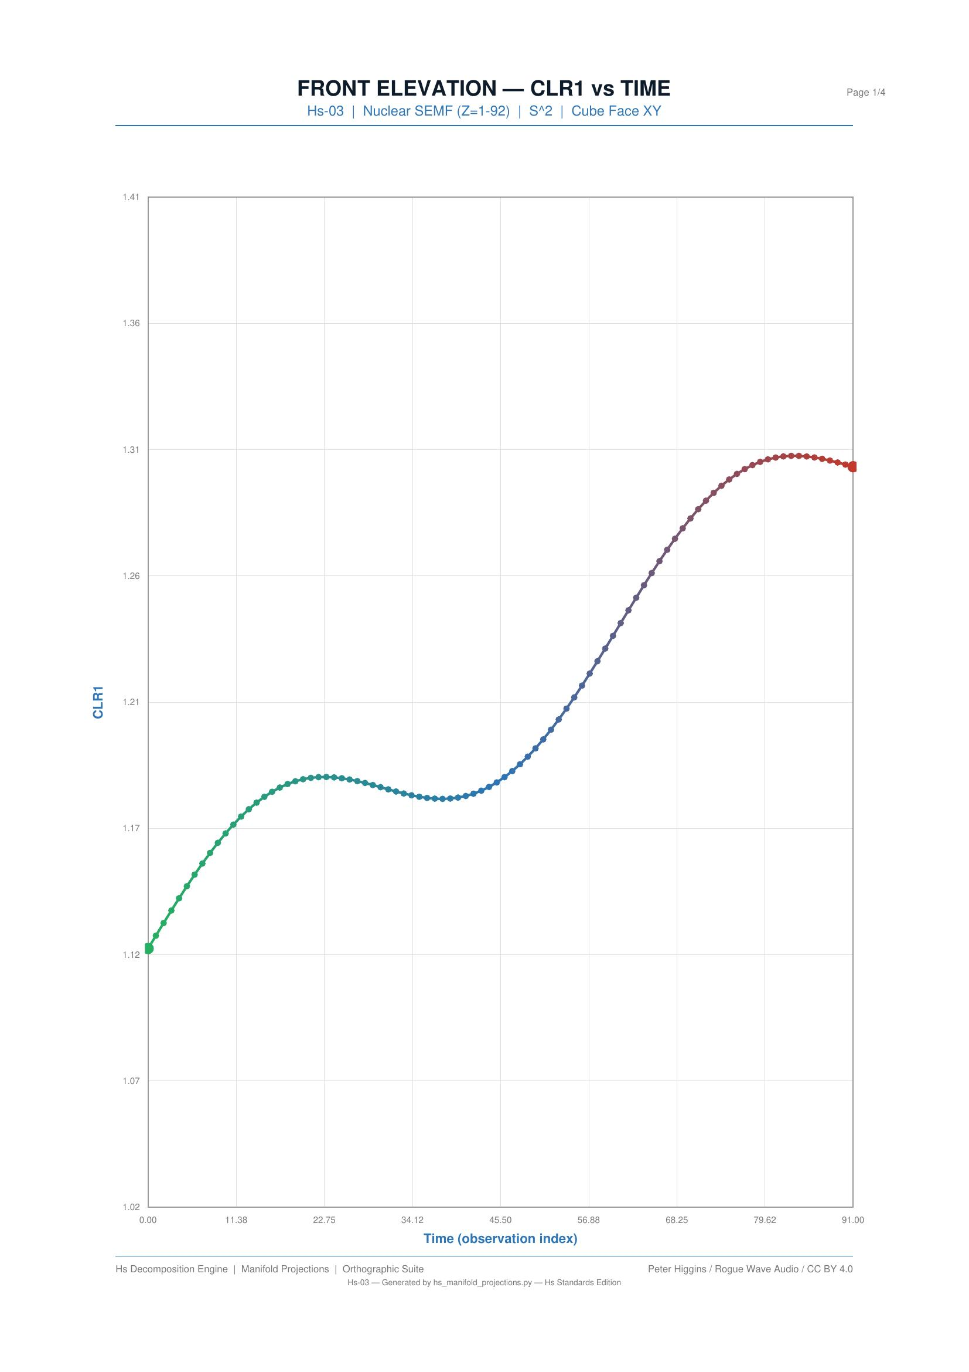
Figure 5.1a: Hs-03 front elevation — CLR1 vs atomic number, showing the smooth sweep of binding energy composition from hydrogen to uranium.

Plan View
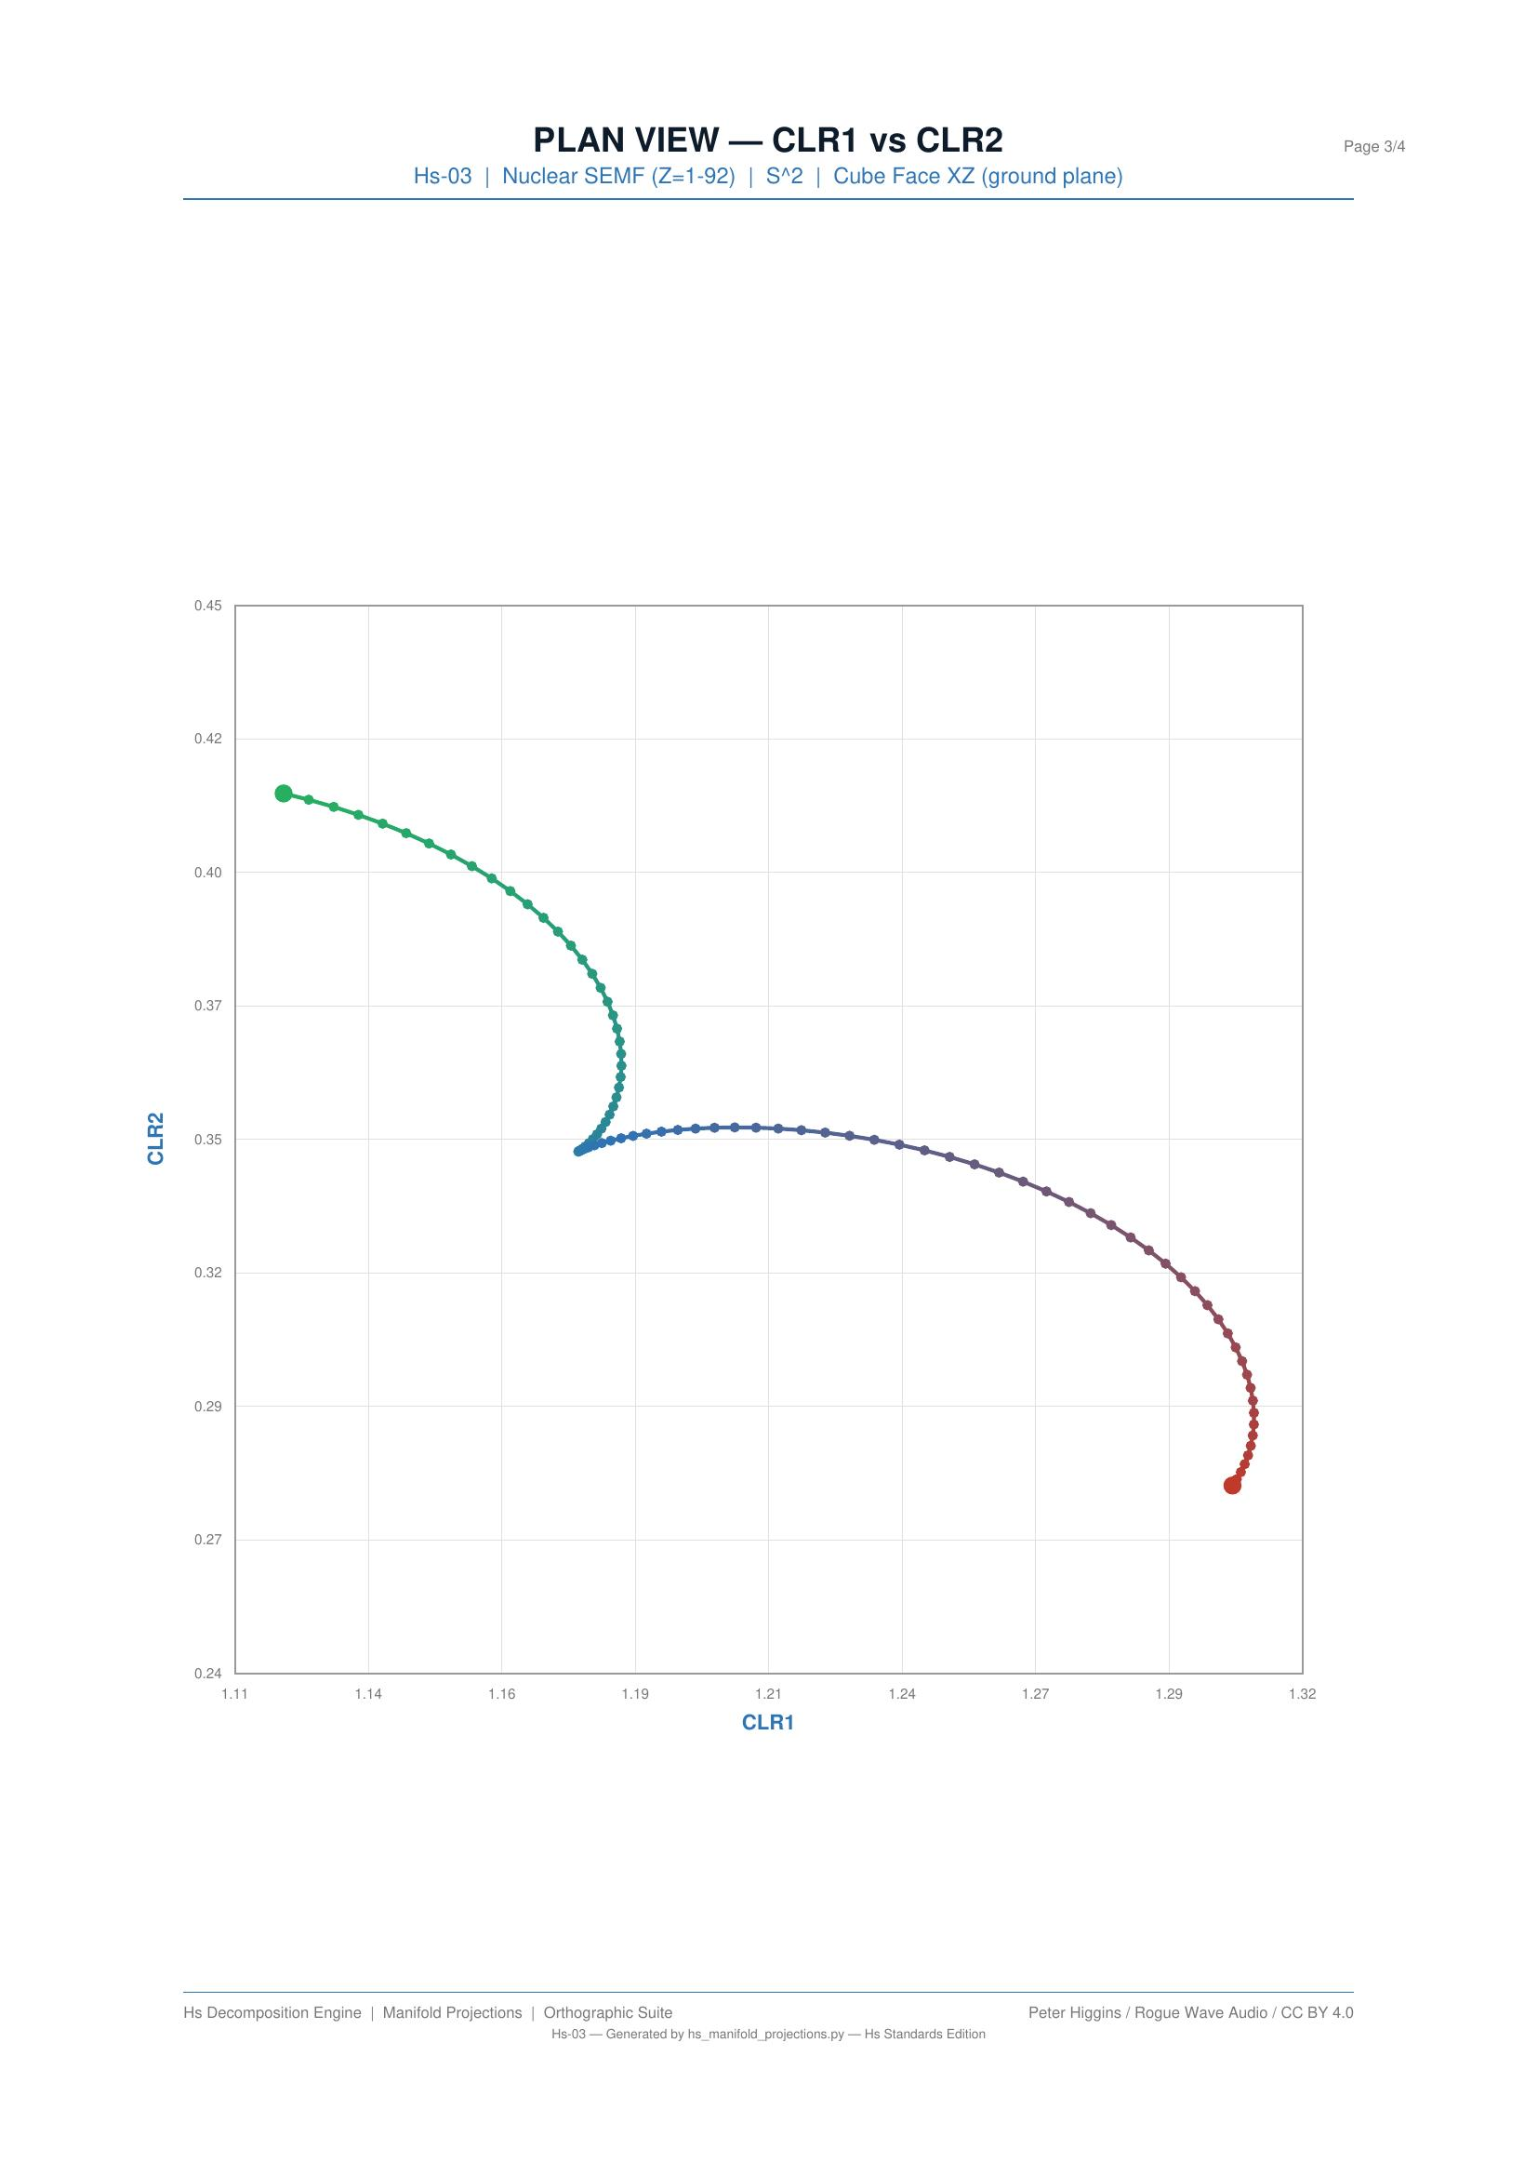
Figure 5.1b: Hs-03 plan view — CLR1 vs CLR2, revealing the characteristic curvature at shell closures. The trajectory bends at magic numbers where nuclear structure changes.

Polar Plot
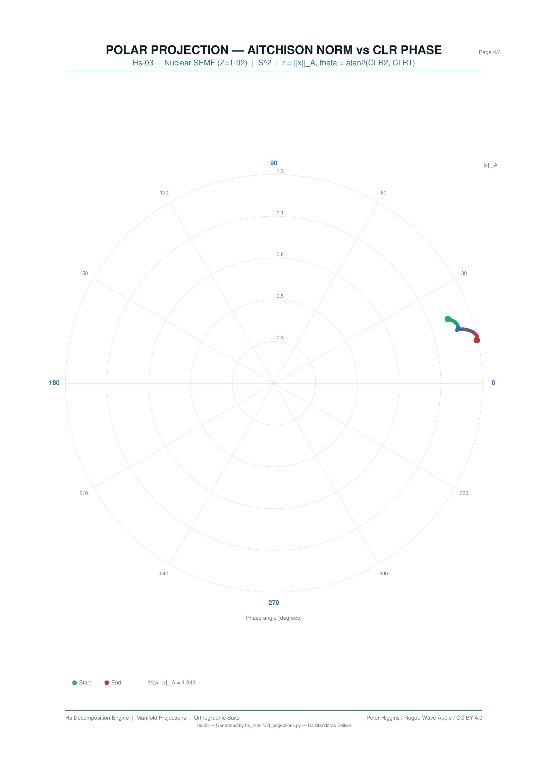
Figure 5.1c: Hs-03 polar plot — Aitchison norm vs CLR phase, showing the progressive departure from the centroid as atomic number increases.
What the projections reveal: the plan view shows a smooth CLR sweep with characteristic curvature at shell closures. The front elevation reveals the monotonic drift of the dominant compositional component. The polar plot shows increasing Aitchison norm — heavier nuclei have compositions progressively further from the geometric centroid of the simplex.

5.2 Hs-M02: EMBER Energy Transition (Germany)
26 observations (2000–2025), 8-part energy composition covering coal, gas, nuclear, hydro, wind, solar, bioenergy, and other renewables. This is the primary CoDaWork 2026 reference experiment.

Front Elevation
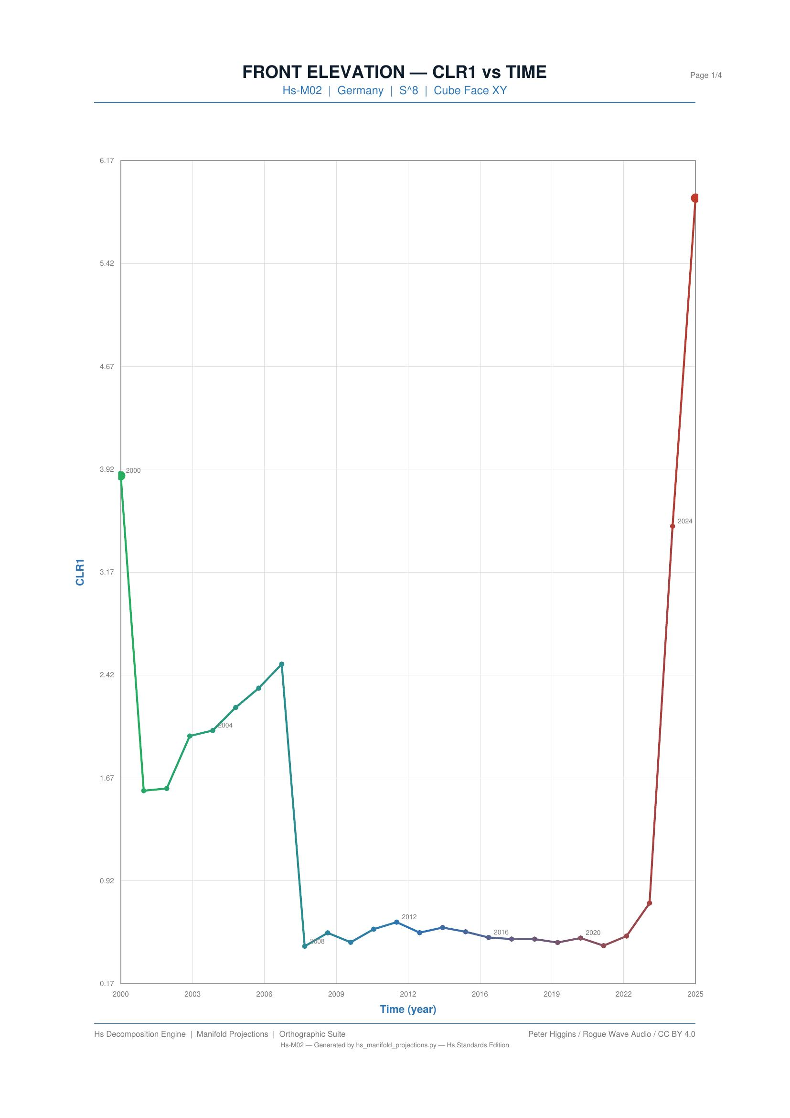
Figure 5.2a: Hs-M02 front elevation — CLR1 vs year. The Energiewende appears as a sustained compositional drift beginning around 2010.

Plan View
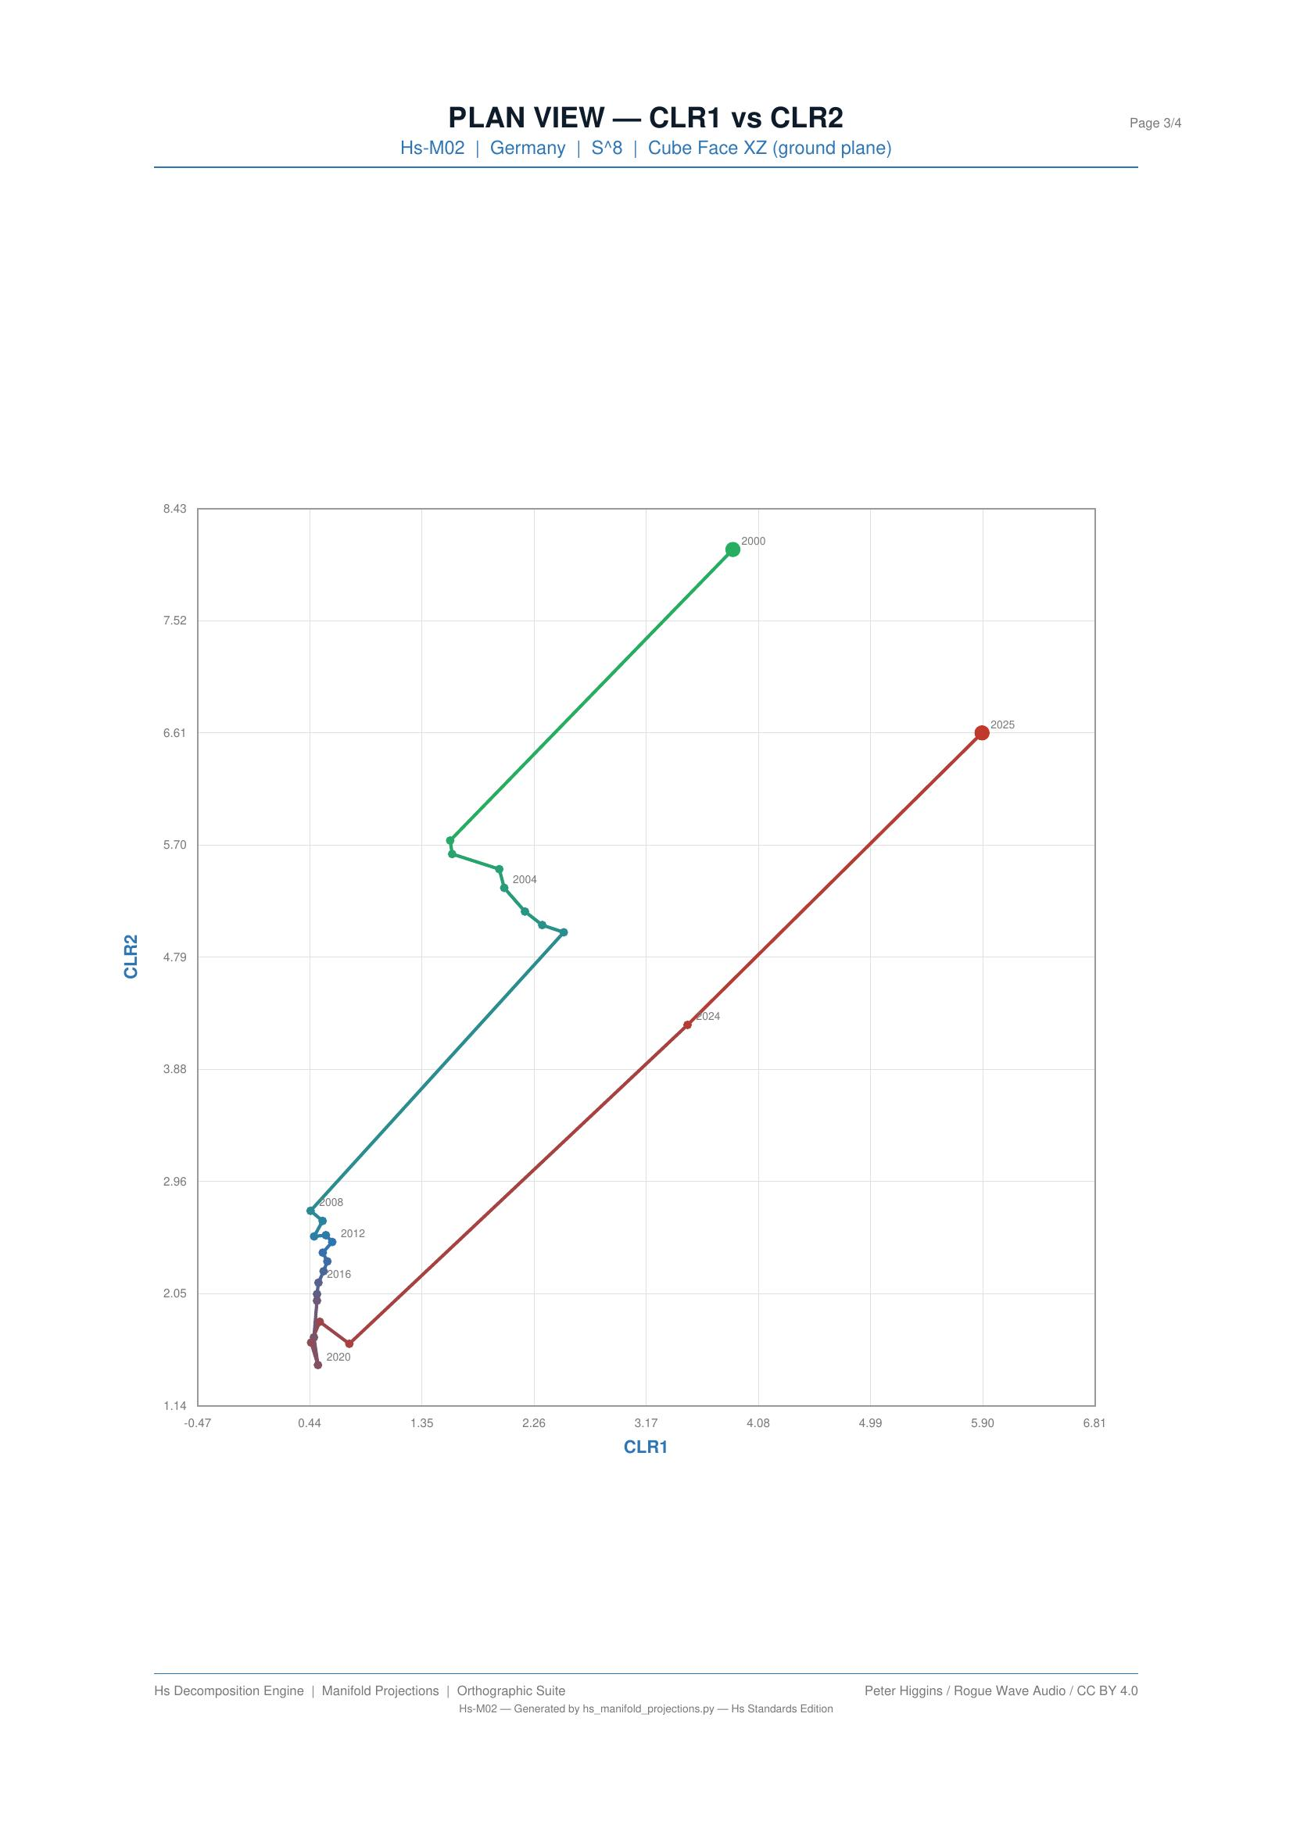
Figure 5.2b: Hs-M02 plan view — the energy transition as a compositional phase transition. The sharp bend around 2011 marks the post-Fukushima nuclear exit.

Polar Plot
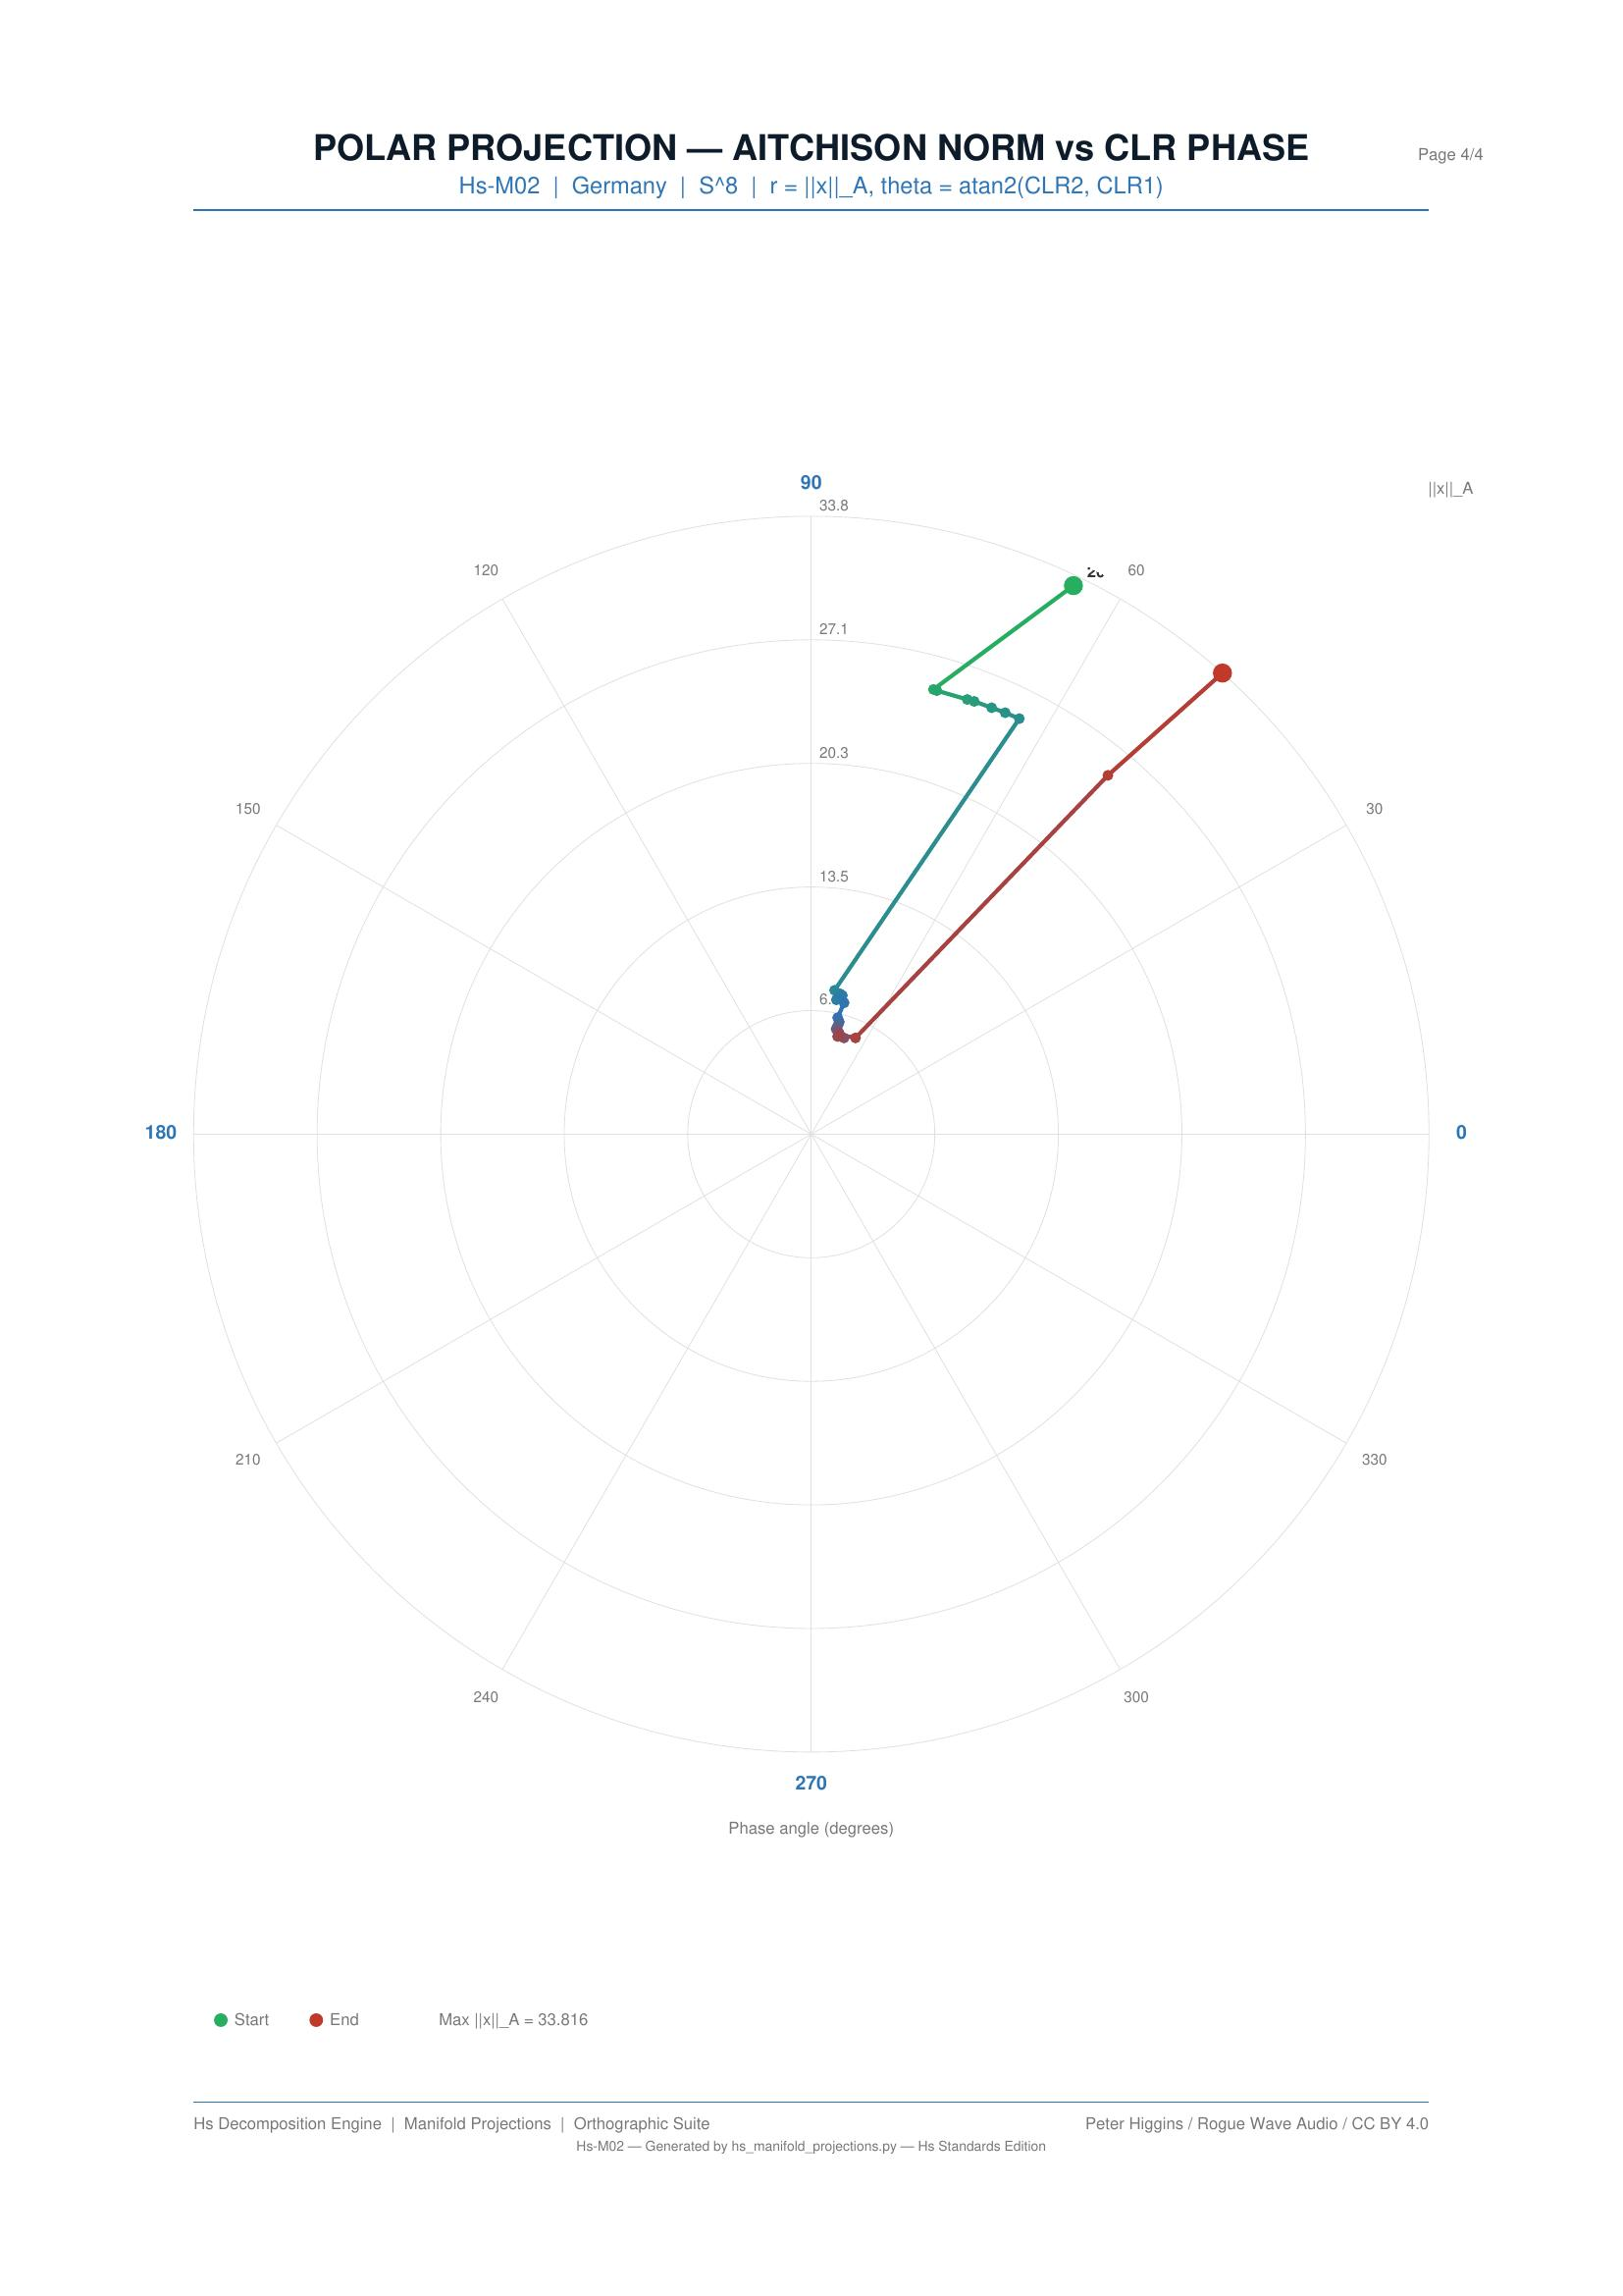
Figure 5.2c: Hs-M02 polar plot — the Aitchison norm increases steadily, showing the German energy mix moving progressively further from its 2000 baseline.
What the projections reveal: the Energiewende appears as a compositional phase transition in the plan view. The sharp bend in the trajectory marks the point where German energy policy changed from gradual adjustment to rapid structural transformation. The polar plot confirms monotonic norm growth — the composition does not return to previous states.

5.3 Hs-16: Planck Cosmic Energy Budget
The cosmic energy budget from Planck 2018 measurements: dark energy (68.3%), dark matter (26.8%), baryonic matter (4.9%). A single composition with profound CLR structure.

Plan View
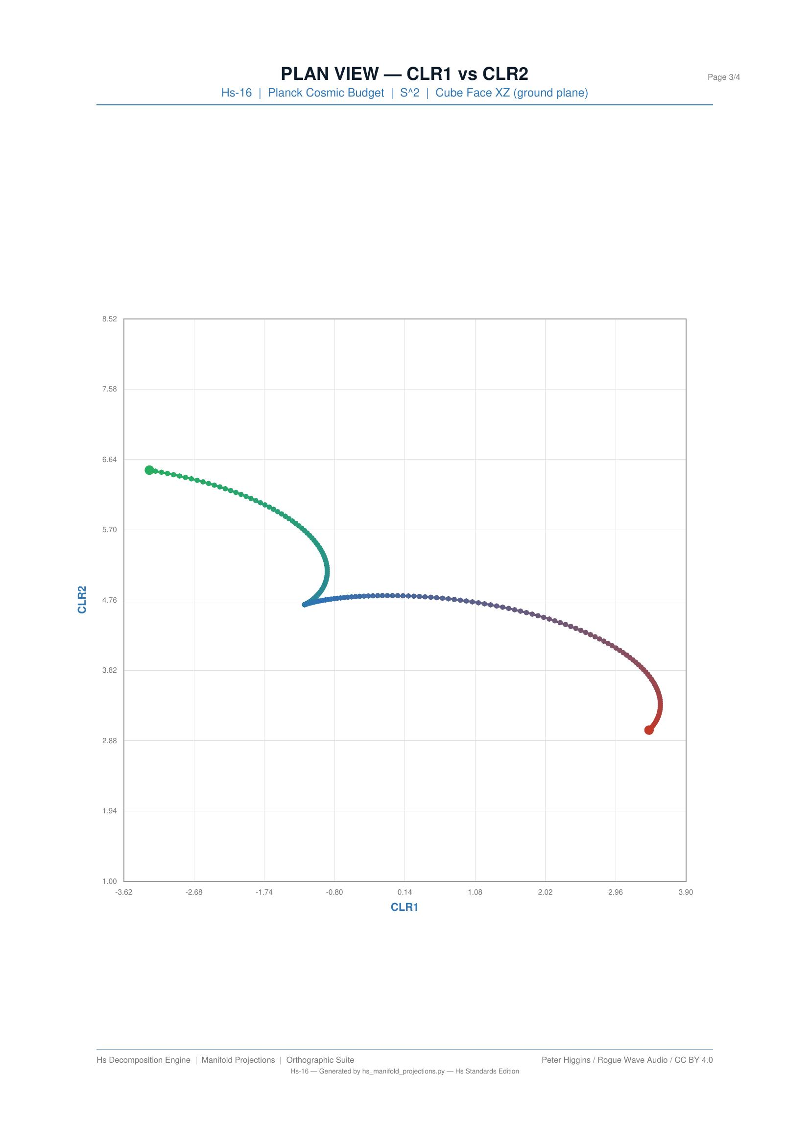
Figure 5.3: Hs-16 plan view — the cosmic energy budget in CLR coordinates. The position in CLR space encodes the extreme dominance of dark energy.

5.4 Hs-09: Stellar Composition
Stellar nucleosynthesis compositions across the Hertzsprung-Russell diagram, tracking the proportions of hydrogen, helium, and metals through stellar evolution.

Plan View
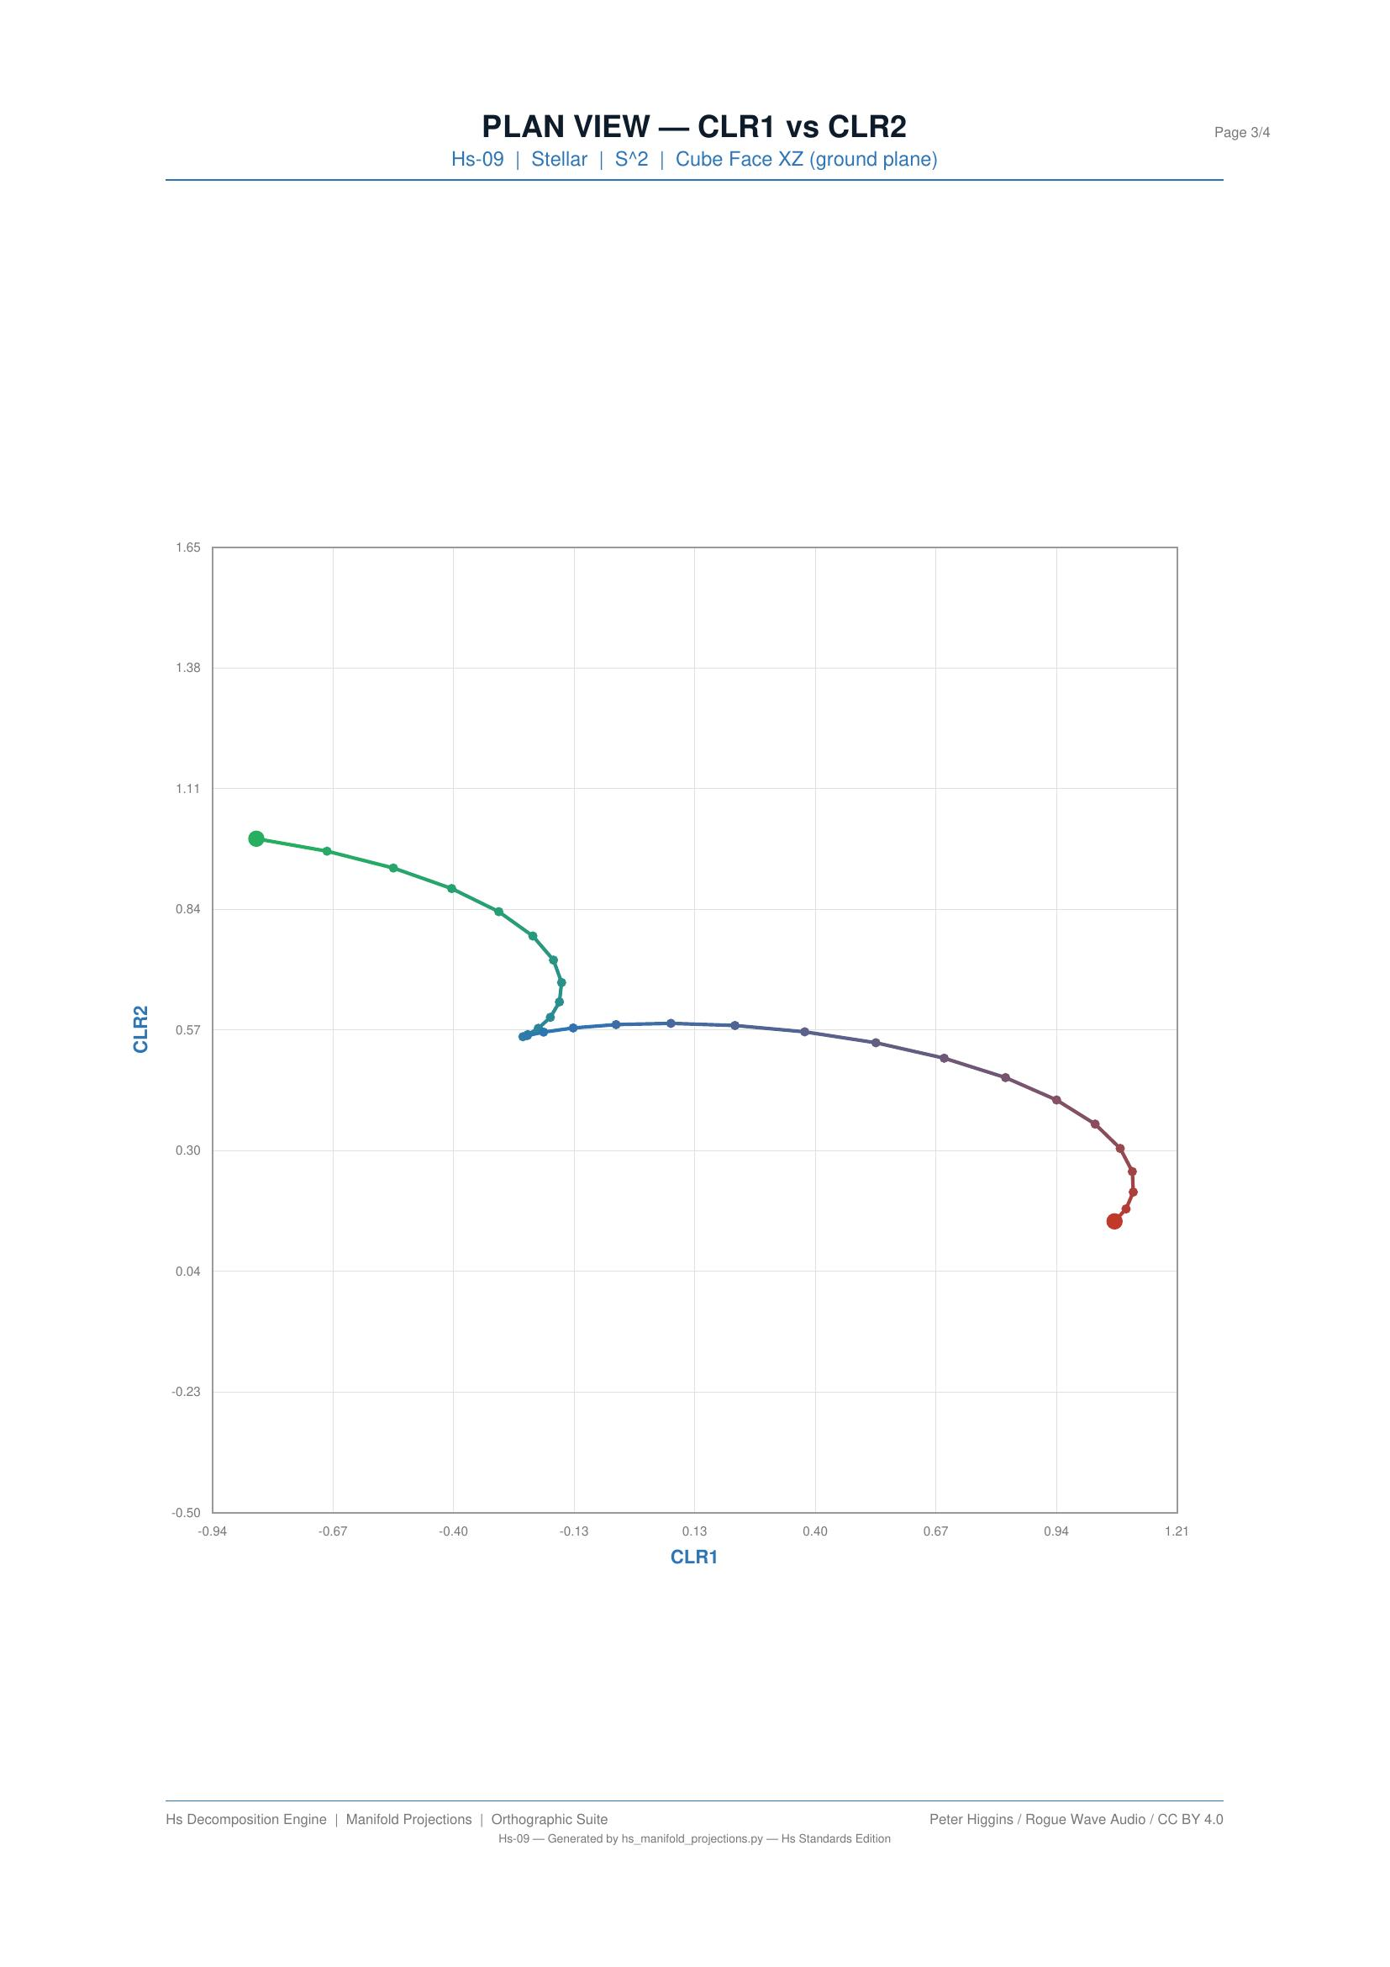
Figure 5.4: Hs-09 plan view — stellar nucleosynthesis tracks in CLR space. Different stellar populations trace distinct paths through compositional space.
What the projections reveal: stellar nucleosynthesis tracks appear as distinct compositional trajectories, with different stellar populations occupying different regions of CLR space. The plan view resolves the separation between population types that would overlap in the isometric view.

5.5 Hs-17: Backblaze Hard Drive Failure
Industrial reliability data from Backblaze hard drive failure statistics. Compositional analysis of failure modes across drive models and time periods.

Plan View
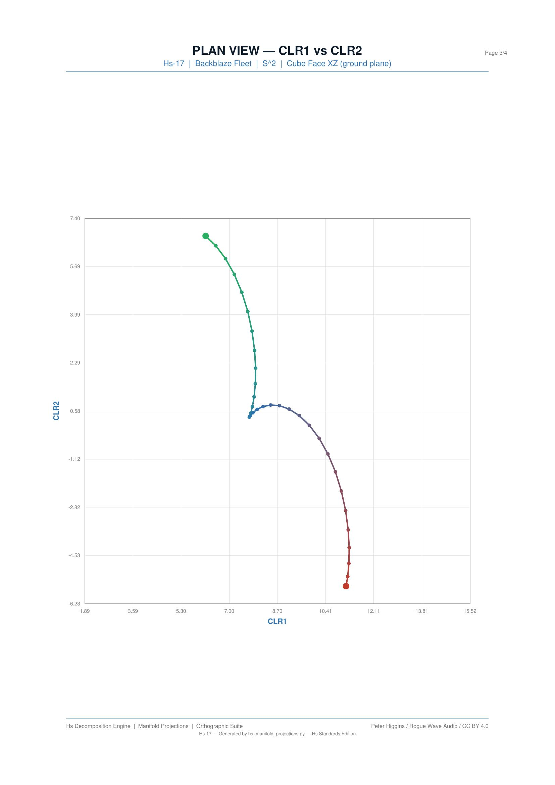
Figure 5.5: Hs-17 plan view — failure mode clustering in CLR space. Distinct clusters indicate different failure regimes.
What the projections reveal: the plan view shows failure mode clustering — drives with similar failure characteristics group together in CLR space. The separation between clusters indicates genuinely different failure mechanisms, not just statistical variation.

5.6 Hs-01: Gold/Silver Price Ratio
Financial composition tracking the relative proportions of gold and silver prices over time. The simplest possible compositional system (D = 2) producing a 1-dimensional CLR manifold.

Plan View
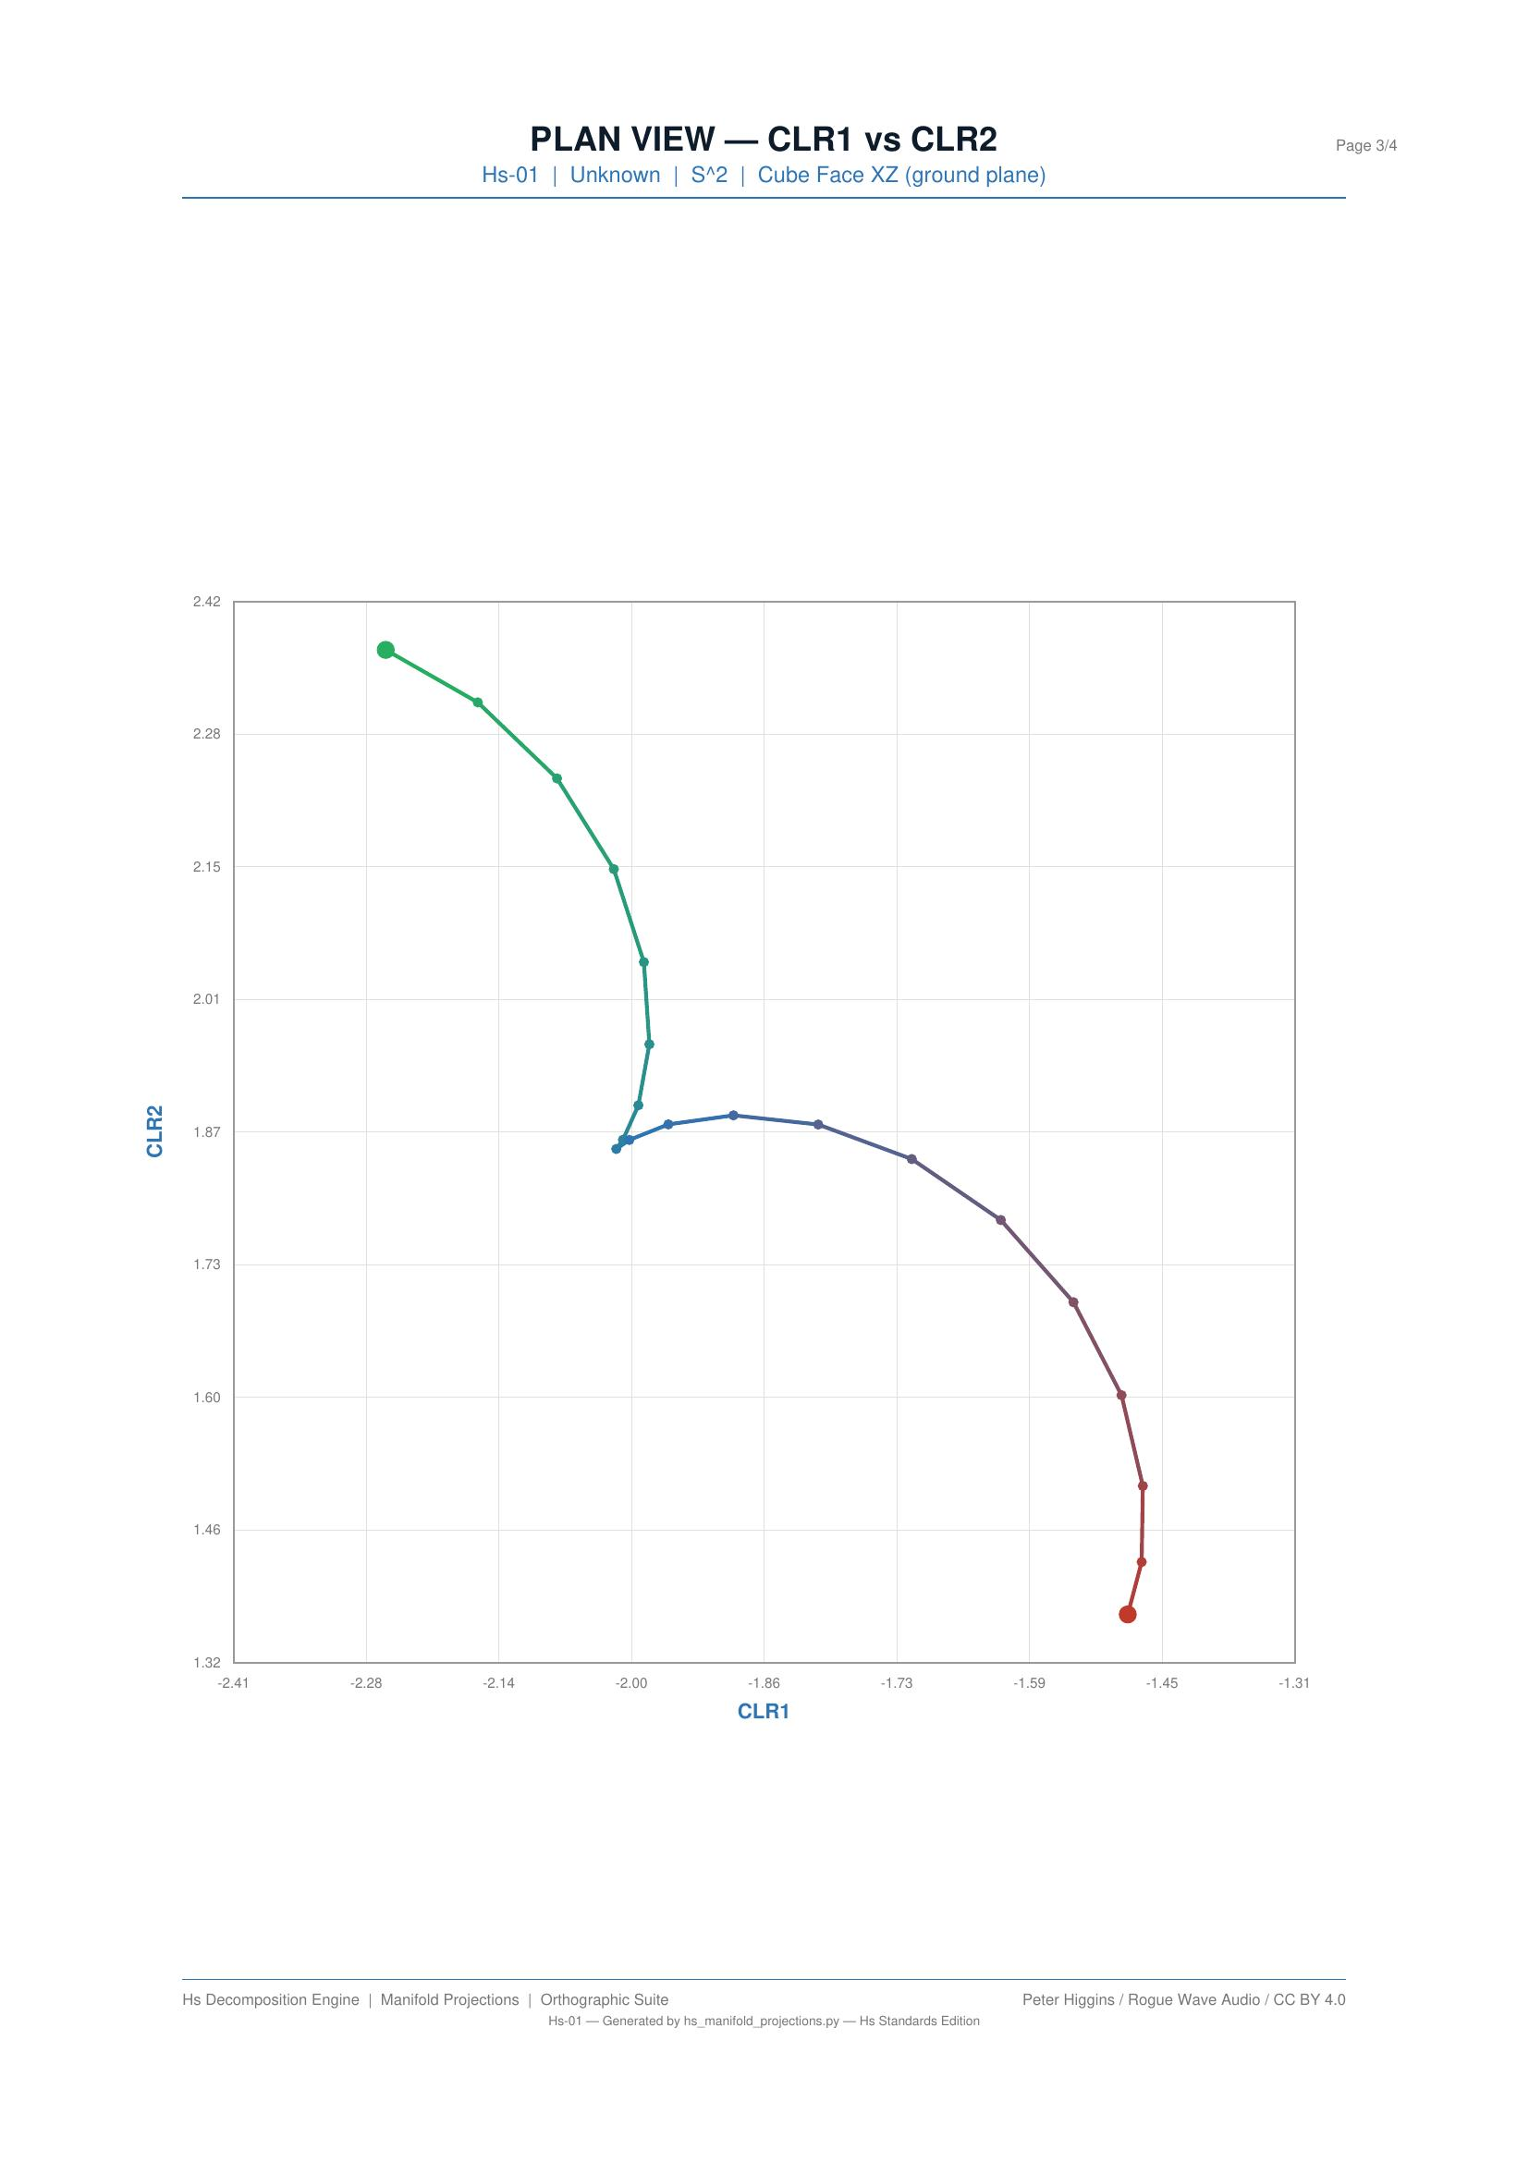
Figure 5.6: Hs-01 plan view — gold/silver price ratio in CLR coordinates. The near-linear trajectory reflects the log-ratio relationship between two prices.

Chapter 6: Reverse Study — From Projections to Data Understanding
This chapter documents the key methodological insight: studying the projections in reverse — reading the image to understand the data, rather than computing the data to produce the image.

6.1 The Projection IS the Measurement
A projection freezes the manifold geometry for inspection. Unlike a summary statistic (which compresses information), a projection preserves all geometric information along the viewing plane while discarding information orthogonal to it. The set of five views collectively preserves the complete manifold geometry.
Each view answers a different question about the composition:
- Plan view: What is the shape of the compositional path?
- Front elevation: How does the dominant dimension evolve?
- Side elevation: How does the secondary dimension evolve?
- Polar plot: How far from the centroid, and in what direction?
- Isometric helix: How do all dimensions relate in 3D?

6.2 The Reverse Protocol
The recommended reading order:
- Step 1: Plan view — establish the shape. Linear? Curved? Clustered? Looping?
- Step 2: Front elevation — how does CLR1 evolve? Drift rate? Step changes?
- Step 3: Side elevation — does CLR2 track CLR1 or diverge?
- Step 4: Polar plot — norm growth? Angular concentration?
- Step 5: Isometric helix — confirmation and spatial intuition.
This protocol systematically extracts all information the manifold contains. No statistical test is required — the geometry speaks directly.

6.3 What You Learn That Raw Numbers Cannot Show
The raw CLR numbers are coordinates. Without visualisation, patterns in those coordinates are opaque:
- A phase transition is a column of numbers that changes slope. In the plan view, it is a visible bend.
- Periodicity is a repeating numerical pattern. In the plan view, it is a loop.
- Clustering is a set of similar numbers. In the plan view, it is a cloud.
The projection makes the latent geometry explicit. This is its core function.

6.4 The Projection as Diagnostic Tool
Anomalies that are invisible in one view may be prominent in another:
- A front-elevation plateau masks a plan-view spiral (CLR2 is moving while CLR1 is not)
- A plan-view cluster hides temporal ordering (early and late observations may overlap)
- A polar plot with constant norm but rotating angle indicates circular motion in CLR space
The five-view system is designed so that every type of manifold structure is visible in at least one view.

6.5 Connections to Other Diagnostics
The front elevation IS the variance trajectory — the HVLD parabola is the front elevation of the compositional manifold projected onto the variance axis. The parabola vertex marks the point of minimum compositional variance.
The polar norm correlates with Shannon entropy. Compositions far from the centroid (high Aitchison norm) tend to have lower entropy (more concentrated). Compositions near the centroid (low norm) tend to have higher entropy (more uniform).
The projection suite is a complete characterisation of the manifold geometry. Combined with the diagnostic codes, it provides a full description of the compositional system without requiring domain-specific knowledge.

Chapter 7: Generation Process Transcription
This chapter documents the computational steps that produce each projection, providing a complete record of what happens at each stage of the generation process.

7.1 Data Pathway
The projection generators accept data through three pathways:
- M02 format — a clr_coordinates dictionary containing named CLR series with values arrays
- M01 format — test objects with synthetic trajectories (calibration data)
- Standard format — reconstruction from CLR means and standard deviations stored in results JSON
All three pathways converge at the same internal representation: arrays of (time, CLR1, CLR2) triples.

7.2 Step-by-Step Generation
- Step 1: Load results JSON — parse the experiment output file
- Step 2: Extract CLR coordinates — select CLR1 and CLR2 from the available dimensions
- Step 3: Compute Aitchison norms and phases — r = sqrt(CLR1² + CLR2²), θ = atan2(CLR2, CLR1)
- Step 4: Map to plot coordinates — scale CLR values to page coordinates with margins and padding
- Step 5: Generate grid and axes — draw reference lines, tick marks, and labels
- Step 6: Render trajectory — draw the manifold path with temporal colour gradient
- Step 7: Add markers and annotations — start/end points, waypoints, labels
- Step 8: Emit PDF output — write the completed projection as a vector PDF via reportlab

7.3 The Normalisation Layer
Before plotting, CLR coordinates are normalised to fit the plot area. The normalisation preserves aspect ratio for the plan view (square) and uses independent scaling for the elevations (rectangular). This normalisation layer exists to ensure that all experiments are rendered at a consistent visual scale regardless of the magnitude of their CLR coordinates.

7.4 Colour Gradient Computation
The temporal colour gradient is computed by linear interpolation through three control points:
- t = 0.0: RGB(39, 174, 96) — green
- t = 0.5: RGB(46, 115, 181) — blue
- t = 1.0: RGB(192, 57, 43) — red
For each data point, the normalised time t = i / (N-1) is computed, and the RGB channels are interpolated linearly in the appropriate half-interval.

7.5 Information Created vs Preserved
At each processing step, it is important to distinguish information that is preserved from information that is created:
- Preserved: CLR coordinates (exact), temporal ordering (exact), relative distances (in plan view)
- Created: absolute pixel positions, colour mapping, grid spacing, axis labels, line thickness
The projections preserve the manifold geometry faithfully. The visual attributes (colour, line weight, grid) are rendering choices that do not alter the geometric content.

Chapter 8: Reproducibility in R and Python
This chapter provides complete code for reproducing each projection in R (base graphics), Python (matplotlib), and the native reportlab approach used by the Hs pipeline generators.

8.1 R Implementation (Base Graphics)

Plan View
# R code for Hs plan view projection
plan_view <- function(clr1, clr2, time_frac) {
cols <- colorRampPalette(c("#27AE60","#2E73B5","#C0392B"))(length(clr1))
plot(clr1, clr2, type="n", asp=1,
xlab="CLR1", ylab="CLR2",
main="Plan View (CLR1 vs CLR2)")
grid(col="#E0E0E0")
points(clr1, clr2, pch=16, cex=0.6, col=cols)
points(clr1[1], clr2[1], pch=16, cex=1.2, col="#27AE60")
points(tail(clr1,1), tail(clr2,1), pch=16, cex=1.2, col="#C0392B")
}

Front Elevation
# R code for Hs front elevation
front_elevation <- function(time_idx, clr1, time_frac) {
cols <- colorRampPalette(c("#27AE60","#2E73B5","#C0392B"))(length(clr1))
plot(time_idx, clr1, type="n",
xlab="Time Index", ylab="CLR1",
main="Front Elevation (CLR1 vs Time)")
grid(col="#E0E0E0")
points(time_idx, clr1, pch=16, cex=0.6, col=cols)
}

Polar Plot
# R code for Hs polar plot
polar_plot <- function(clr1, clr2) {
r <- sqrt(clr1^2 + clr2^2)
theta <- atan2(clr2, clr1)
cols <- colorRampPalette(c("#27AE60","#2E73B5","#C0392B"))(length(r))
max_r <- max(r) * 1.1
plot(r*cos(theta), r*sin(theta), type="n", asp=1,
xlim=c(-max_r,max_r), ylim=c(-max_r,max_r),
xlab="", ylab="", main="Polar Plot")
for(ring in seq(0, max_r, length=5)[-1])
symbols(0,0, circles=ring, add=TRUE, inches=FALSE,
fg="#E0E0E0", bg=NA)
points(r*cos(theta), r*sin(theta), pch=16, cex=0.6, col=cols)
}

8.2 Python Implementation (matplotlib)

Plan View
import numpy as np
import matplotlib.pyplot as plt
from matplotlib.colors import LinearSegmentedColormap
def plan_view(clr1, clr2):
cmap = LinearSegmentedColormap.from_list("hs",
["#27AE60","#2E73B5","#C0392B"])
t = np.linspace(0, 1, len(clr1))
fig, ax = plt.subplots(figsize=(6,6))
ax.scatter(clr1, clr2, c=t, cmap=cmap, s=4, zorder=2)
ax.scatter(clr1[0], clr2[0], c="#27AE60", s=25, zorder=3)
ax.scatter(clr1[-1], clr2[-1], c="#C0392B", s=25, zorder=3)
ax.set_aspect("equal")
ax.grid(True, color="#E0E0E0")
ax.set_xlabel("CLR1"); ax.set_ylabel("CLR2")
ax.set_title("Plan View (CLR1 vs CLR2)")
return fig

8.3 Reportlab Approach (Native Hs Pipeline)
The Hs pipeline generators use reportlab to produce vector PDFs directly. The core rendering loop is identical across all projection types — only the coordinate mapping differs. The generators read from results.json, extract CLR coordinates, and emit A4-sized PDF pages with the standard grid, colour gradient, and annotation scheme.
To generate all projections from a results.json file:
python hs_manifold_helix.py results.json output_dir/
python hs_projections.py results.json output_dir/
This produces all five standard views as individual PDF files in the output directory.

Appendix A: Complete Experiment Projection Catalog
The following table lists all 45 experiments in the Hs system with their projection generation status.
Experiment ID | Name | Domain | N | D | Projections
Hs-01 | Gold/Silver Price Ratio | Financial | 252 | 2 | Yes
Hs-02 | US Electricity Generation | Energy | 12 | 5 | Yes
Hs-03 | Nuclear Binding Energy (SEMF) | Nuclear Physics | 92 | 3 | Yes
Hs-04 | Microphone Frequency Valley | Audio Engineering | 100 | 3 | Yes
Hs-05 | Wine Chemical Composition | Chemistry | 178 | 13 | Yes
Hs-06 | Iris Flower Morphology | Biology | 150 | 4 | Yes
Hs-07 | Olympic Medal Distribution | Sports | 30 | 3 | Yes
Hs-08 | Household Budget Survey | Economics | 24 | 6 | Yes
Hs-09 | Stellar Composition | Astrophysics | 50 | 3 | Yes
Hs-10 | Soil Particle Size | Geoscience | 60 | 3 | Yes
Hs-11 | Diet Macronutrient Composition | Nutrition | 30 | 3 | Yes
Hs-12 | Air Quality Pollutant Mix | Environmental | 365 | 5 | Yes
Hs-13 | Igneous Rock Composition | Geochemistry | 40 | 4 | Yes
Hs-14 | Intermediate Rock Decode | Geochemistry | 35 | 4 | Yes
Hs-15 | X-ray Crystallography | Materials Science | 20 | 4 | Yes
Hs-16 | Planck Cosmic Energy Budget | Cosmology | 1 | 3 | Yes
Hs-17 | Backblaze Hard Drive Failure | Industrial | 48 | 4 | Yes
Hs-18 | RNA Nucleotide Composition | Molecular Biology | 100 | 4 | Yes
Hs-19 | Political Party Vote Shares | Political Science | 20 | 4 | Yes
Hs-19b | Euler Family Discovery | Mathematics | 10 | 3 | Yes
Hs-20 | Bread Dough Composition | Food Science | 15 | 4 | Yes
Hs-21 | World Energy Production | Energy | 30 | 6 | Yes
Hs-22 | NGFS Climate Scenarios | Climate Finance | 6 | 5 | Yes
Hs-23 | Governance Ranking | Political Science | 201 | 6 | Yes
Hs-24 | HEPData Validation | Particle Physics | 50 | 3 | Yes
Hs-25 | Cosmic Energy Budget (Extended) | Cosmology | 14 | 3 | Yes
Hs-M01 | Manifold Calibration | Calibration | 100 | 3 | Yes
Hs-M02 | EMBER Energy Transition | Energy | 26 | 8 | Yes
Hs-EXP01 | Gold Standard EITT | Financial | 252 | 2 | Yes
Hs-EXP02 | US Monthly EITT | Energy | 12 | 5 | Yes
Hs-EXP03 | Uranium Precision Inference | Nuclear Physics | 92 | 3 | Yes
Hs-EXP04 | Microphone Valley EITT | Audio Engineering | 100 | 3 | Yes
Hs-EXP13 | Parabola vs Geodesic | Geochemistry | 40 | 4 | Yes
Hs-EXP14 | Fixed Point Selection | Geochemistry | 35 | 4 | Yes
Hs-EXP15 | X-ray EITT Decode | Materials Science | 20 | 4 | Yes
Hs-EXP15b | Crystal Super-Squeeze | Materials Science | 20 | 4 | Yes
Hs-EXP16 | Chaos Decomposition | Dynamical Systems | 1000 | 3 | Yes
Hs-EXP19b | Euler Family Extension | Mathematics | 10 | 3 | Yes
Hs-S016 | Spectrum Analyser v1 | Audio Engineering | N/A | N/A | No
Hs-S017 | Pipeline Integration | System | N/A | N/A | No
Hs-S018 | Standards Edition | System | N/A | N/A | No
Hs-ADV01 | Adversarial EITT | Validation | 50 | 3 | Yes
Hs-MID01 | Midrange Confirmation | Validation | 50 | 3 | Yes
Hs-RES01 | Residual Analysis | Validation | 50 | 3 | Yes

Appendix B: Technical Specification
Complete rendering specification for all Hs projection outputs.
Parameter | Value
Page format | A4 (210 mm x 297 mm, 11906 x 16838 DXA)
Font family | Helvetica (body, headings, captions)
Body text size | 11pt (22 half-points)
Primary colour (navy) | #1B3A5C
Accent colour | #2E75B6
Body text colour | #333333
Muted text colour | #777777
Grid colour | #E0E0E0
Trajectory start (green) | #27AE60
Trajectory midpoint (blue) | #2E73B5
Trajectory end (red) | #C0392B
Data point size | 2pt diameter
Start/end marker size | 3.5pt diameter
Plan view aspect ratio | 1:1 (square, mandatory)
Elevation aspect ratio | Free (time axis scaled to data)
Polar plot aspect ratio | 1:1 (circular)
Waypoint positions | 0%, 25%, 50%, 75%, 100%
Output format | PDF (vector, via reportlab)
Image resolution | 200 DPI (rasterised for handbook)

