AudioPlayer

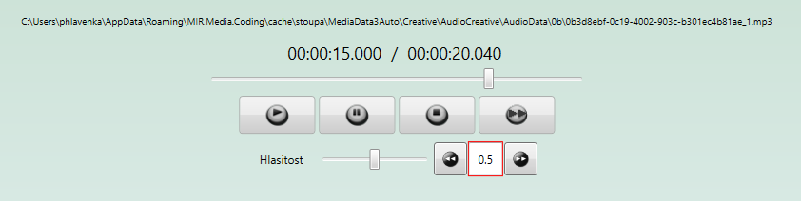

Framework.Multimedia:

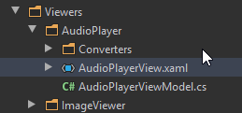

Parsovani na double problem s carkou a teckou v textBoxu – uprava krokovani

Krokovani v AudioPlayeru. V zavislosti na cultureInfo, byl problem dostat do textboxu bindovaneho na double carku nebo tecku. Cs-CZ kultura ma jako decimal oddelovac carku, kdezto anglictina ma tecku. Resil jsem to tak, ze textbox prozenu commatodotconverterem

Text="{Binding Step, Mode=TwoWay, UpdateSourceTrigger=LostFocus, StringFormat=N1, Converter={StaticResource commaToDotConverter}}"

Rikam: pokud je v teto kulture oddelovac carka, replacni mi tecku za carku a naopak

namespace Mediaresearch.Framework.Multimedia.Viewers.AudioPlayer.Converters  
{  
 public class CommaToDotConverter : IValueConverter  
 {  
 public object Convert(object value, Type targetType, object parameter, CultureInfo culture)  
 {  
 return culture.NumberFormat.CurrencyDecimalSeparator == "," ? value?.ToString().Replace('.', ',') : value?.ToString().Replace(',', '.');  
 }  
  
 public object ConvertBack(object value, Type targetType, object parameter, CultureInfo culture)  
 {  
 return culture.NumberFormat.CurrencyDecimalSeparator == "," ? value?.ToString().Replace('.', ',') : value?.ToString().Replace(',', '.');  
 }  
 }  
}