**GridView**

Pouziva se uvnitr ListView

**Je mozne pridat radek pro detaily ktery se zobrazi po kliknuti na radek: (Staci definovat kdekoli uvnitr gridView)**

<DataGrid.RowDetailsTemplate>

<DataTemplate>

<TextBlock>Details</TextBlock>

</DataTemplate>

</DataGrid.RowDetailsTemplate>

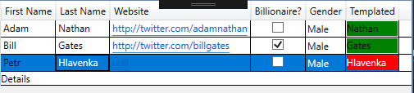

**Pozadi vybranych policek ve sloupci muzeme zmenit pomoci Converteru** Funguje to jen u CellTemplate

<DataGrid.Columns>Ra

<DataGridTextColumn Header="First Name" Binding="{Binding FirstName}"

<DataGridTextColumn Header="Last Name" Binding="{Binding LastName}"/>

<DataGridHyperlinkColumn Header="Website" Binding="{Binding Website}"/>

<DataGridCheckBoxColumn Header="Billionaire?" Binding="{Binding IsBillionaire}"/>

<DataGridComboBoxColumn Header="Gender" SelectedItemBinding="{Binding Gender}" ItemsSource="{Binding Source={StaticResource genderEnum}}"/>

<DataGridTemplateColumn Header="Templated">

<DataGridTemplateColumn.CellTemplate>

<DataTemplate>

<TextBlock Text="{Binding LastName}" Background="{Binding LastName, Converter={StaticResource Conv}}"/>

</DataTemplate>

</DataGridTemplateColumn.CellTemplate>

</DataGridTemplateColumn>

</DataGrid.Columns>

**Data se dokonce daji definovat v Xamlu:**

<local:Record FirstName="Adam" LastName="Nathan" Website="http://twitter.com/adamnathan" Gender="Male"/>

<local:Record FirstName="Bill" LastName="Gates" Website="http://twitter.com/billgates" IsBillionaire="True" Gender="Male"/>

<local:Record FirstName="Petr" LastName="Hlavenka" Website="null" IsBillionaire="False" Gender="Male"></local:Record>