LINQPad

Aktivacni kod licence Nielsen WZJSN-HGTTY (aktivuje i napovedu)

<https://www.youtube.com/watch?v=reRfw22XG18>

**result.Dump() -** Vypis na konzoli

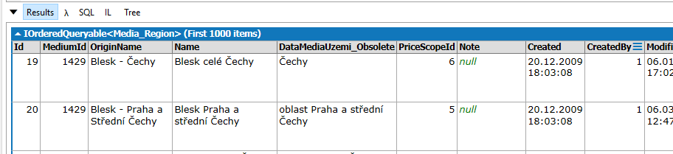

# Vypis promenne na konzoli C# Statement(s)

var test = (from n in Media_Regions

select n).Take(1000);

test.Dump();

**nebo staci jen :**

(from n in Media_Regions select n).Take(1000);

Na konci nazvu kazde tabulky musi byt ‘s’

