LightVideoPlayer

**Debugovat se da jen ve stejne instanci VisualStudia debile**

Je v baliku Multimedia. Pokud ho chci upravit, musim si pridat projekt Multimedia a nareferencovat ho. Postup zde:

C:\Users\phlavenka\OneDrive\Nielsen prace\Moje poznamky Nielsen\MediaResearchFramework cesta.docx

Otevreme sln Frameworku. Xaml je v **LightVideoPlayerControl** a ovlada ho codeBehind kde je spousta DependencyProperty

LightVideoPlayerViewModel. (ve view je prd) Samotny prehravac je MediaKitPlayer.

Chci napr pridat zavorku a v ni novy cas ke slideru

* Otevru LightVideoPlayerControl

<TextBlock

Name="PositionInfo"

Margin="2,0,5,0"

VerticalAlignment="Center"

FontSize="12" />

Catching ma instanci LightVideoPlayerViewModelu dale VM.

VM ma instanci LightvideoPlayerControlu.

**Catching**

LightVidePlayerViewModel

private MediaKit.LightVideoPlayerControl m_player;

* Z Catchingu muzu zmenit propertu VM. VideoPlayerViewModel.Position = PositionSeconds * 1000;

**Jak nareferencovat neco z baliku naprimo**

<https://d.docs.live.net/b22fb0fb09218bf0/Nielsen%20%20prace/Moje%20poznamky%20Nielsen/MediaResearchFramework%20cesta%20jak%20referencovat%20FW%20natvrdo.docx>

Vydani baliku

* Commit do Frameworku
* Push
* TFS – Build and Release
* Navod zde : <https://d.docs.live.net/b22fb0fb09218bf0/Nielsen%20%20prace/Moje%20poznamky%20Nielsen/Vydani%20balicku%20%20NugetPackage.docx>

# Keep zoom checkbox

[Task 51978](https://tfs.mediaresearch.cz/AdIntel/AdIntel/_workitems/edit/51978): Kódovadlo - Keep zoom

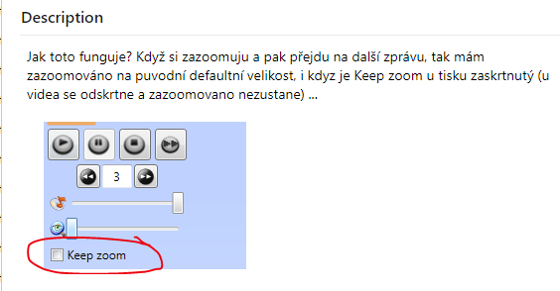

**Analyza :**

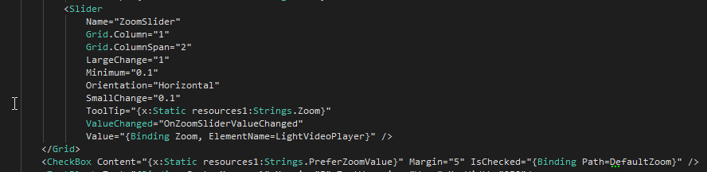

Jenze boolean DefaultZoom je jen na starem VideoPlayerViewModelu, ne na Light verzi. Tady se nazoomuje default jen pokud neni zaskrtnuto:

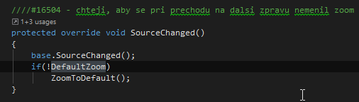

V light verzi se zoom nastavuje na nulu jen v metode ResetLayout() :

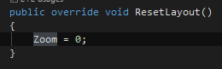

LightVideoPlayerControl ma codeBehind kde se hybe sliderem v metode OnMediaOpened(): Kdyz tyhle dva radky zakomentuju, zoom pri prechodu na jiny source zustane..

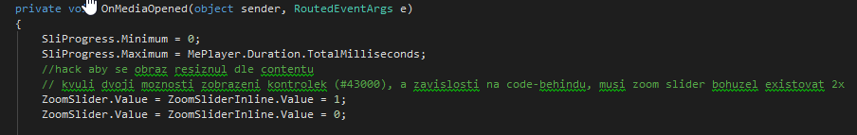

**Postup:**

* Vytvorim bool dependencyPropertu v codeBehindu LightVideoPlayerControl.xaml
* Bude se jmenovat KeepZoom, to se mi libi vic

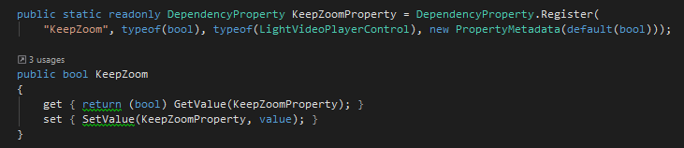

* Nabinduju na to checkbox, pozor je to na dvou mistech v tom xamlu (dve templaty):



* V OnMediaOpened reknu, ze pokud neni zaskrtnuto KeepZoom, at se slider prenastavi na 0 :

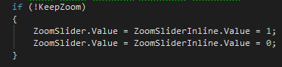

**Works.. Ovsem jen v pripade, ze se meni jen source a ne cela instance prehravace**

# ShiftedPosition – treti cas pod sliderem prehravace

Staci jen setnout playeru Shift:



V lightVideoPlayeru uz je vse poresene a zobrazi se toto (jenze se nehybe :C):

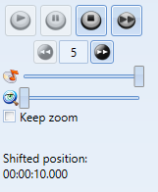

Ted to predelam tak, aby ten cas byl pod sliderem prehravace: shiftnuty / normalni / celkovy cas

* V Normovadle, nebo jinem softu, predam playeru RealVideoDateTime, nebo hodnotu shiftu, pripadne cas From na MM:



* V LightVideoPlayerViewModelu pridam do metody volani metody na LightVideoPlayerControlu:

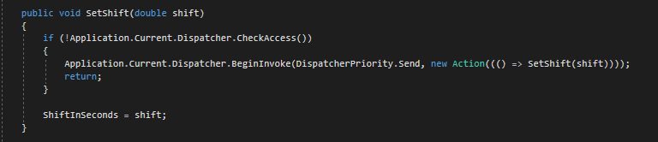

* V metode OnViewLoaded, po vytvoreni playeru, predam controlu tuto hodnotu:

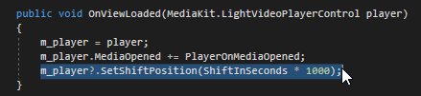

* Metodu si vytvorim v LightVideoPlayerControlu:

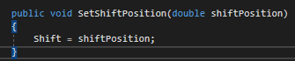

* A k tomu propertu:



* V metode, kam se dostaneme pokazde kdyz se zmeni depProperty position prevedu double na string a vrazim ho do view:

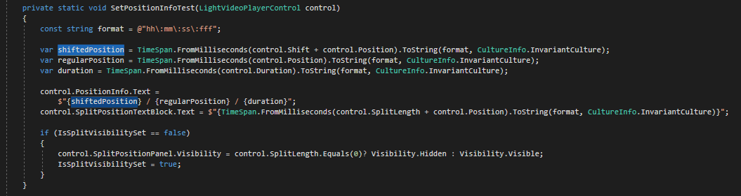

* Vysledek:

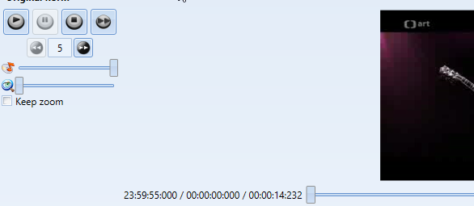

Na LightVideoPlayeru zavolam metodu SetShift a predam double. Promenna ShiftInSeconds se mi inicializuje touto hodnotou. View je bindovane na string propertu ShiftedPosition, v getteru vezme double ShiftInSeconds a prevede to na string.

V LightVideoPlayeru mam metodu SetSplitTime, ktera zavola metodu na controlu a preda ji double ktere ma v properte SplitPosition. MediaElementNormPlayer.SplitPosition = 10;

# Zrychlene prehravani pomoci dependencyProperty v LightVideoPlayerControl:

7.6.2019

DependencyProperty slouzi jako NofifyChanged. Musí byt samozrejme v behindu. Upravoval jsem LightVideoPlayerControl. Potreboval jsem propertu SpeedIncreased typu bool abych mohl z behindu informovat view o zmene rychlosti prehravani.

**Uzivatel stlaci tlacitko, které je napojene na builtIn command IncreaseTreble:**

<Button Width="32" Height="32" Margin="2" Command="MediaCommands.IncreaseTreble"

ToolTip="{x:Static localisation:Localisation.FastForward}">

<Image>

<FrameworkElement.Style>

<Style TargetType="{x:Type Image}">

<Setter Property="Image.Source" Value="../../../Resources/Images/mp_fast.png"/>

<Setter Property="FrameworkElement.Margin" Value="-1"/>

<Style.Triggers>

<DataTrigger Binding="{Binding SpeedIncreased, ElementName=LightVideoPlayer}" Value="True">

<Setter Property="Image.Source" Value="../../../Resources/Images/next.png"/>

</DataTrigger>

</Style.Triggers>

</Style>

</FrameworkElement.Style>

</Image>

</Button>

**Definice commandu:**

<CommandBinding CanExecute="FastForwardCanExecute" Executed="FastForwardExecuted"

Command="MediaCommands.IncreaseTreble"/>

**Tim se dostaneme sem**:

public void FastForward()

{

this.SpeedIncreased = this.MePlayer.FastForward();

}

**MePlayer je samotny prehravac vlozeny do controlu a je typu MediaPlayer. Jeho metoda nastavi rychlost a vraci bool podle toho jestli je prehravani zrychlene:**

public bool FastForward()

{

this.MePlayer.SpeedRatio = this.MePlayer.SpeedRatio > 1.0 ? 1.0 : 2.0;

return this.MePlayer.SpeedRatio > 1.0;

}

**Control se teda dozvi, ze nastala změna a zmeni se bool SpeedIncreased. Na to aby se mi změna z behindu dostala do view, potrebuju DependencyProperty: Ta se postara o notifikaci:**

public static readonly DependencyProperty **SpeedIncreasedProperty** = DependencyProperty.Register(nameof (SpeedIncreased), typeof (bool), typeof (LightVideoPlayerControl), new PropertyMetadata());

public bool **SpeedIncreased**

{

get

{

return (bool) this.GetValue(LightVideoPlayerControl.SpeedIncreasedProperty);

}

set

{

this.SetValue(LightVideoPlayerControl.SpeedIncreasedProperty, (object) value);

}

}