SimLogViewer

## Тест Мастер (Test Master)

It is another part in SimLogViewer app:

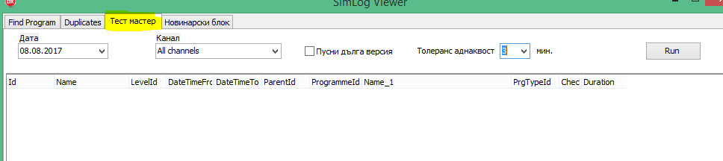

It is used for checking if all atomic parts of a broadcast are merged in a composite broadcast. One example how it is seen in SimLog app:

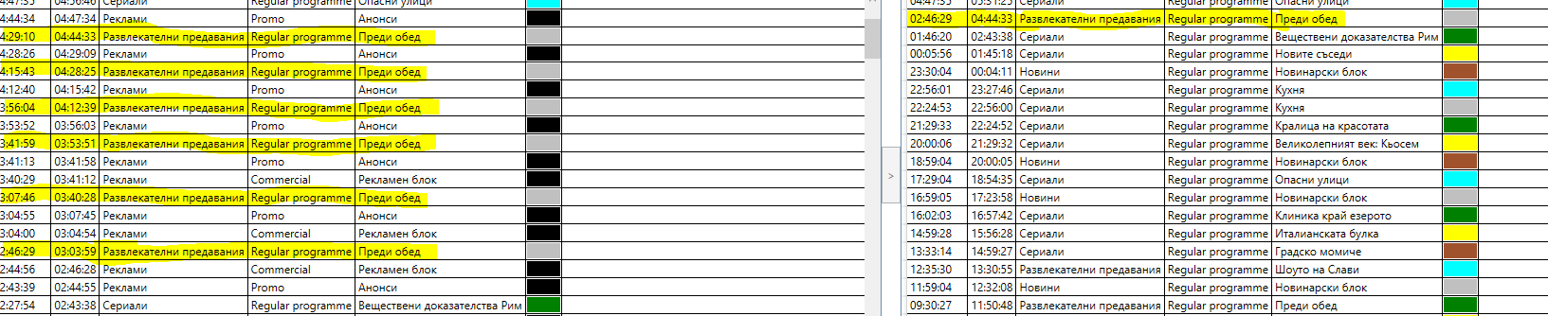

Functions:

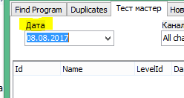

*Дата* – it is **TV** date - from 06:00 on one calendar date to 06:00 on the next calendar date. It is **important** to stay this way.

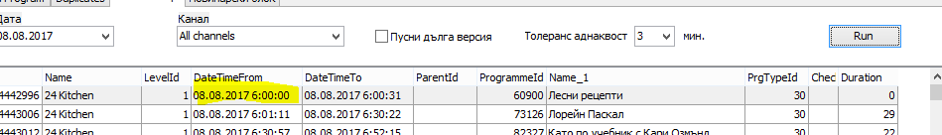

It is always set for the previous date – today is 09.08.2017.

Anyway you can change the date:

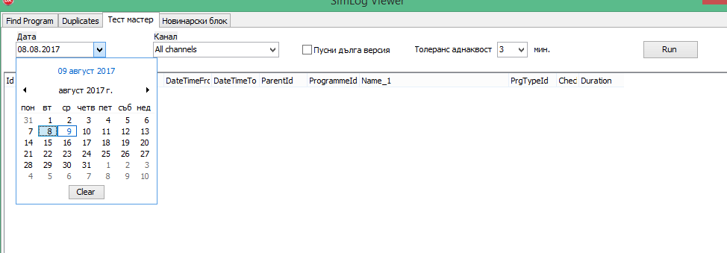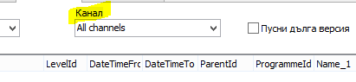

*Канал* – it is Channel. You can observe all channels by default or you can choose only one channel from the list:

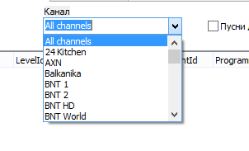

You have just to step on the selected channel:

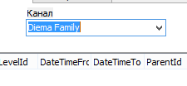

You see only stand alone and composite titles:

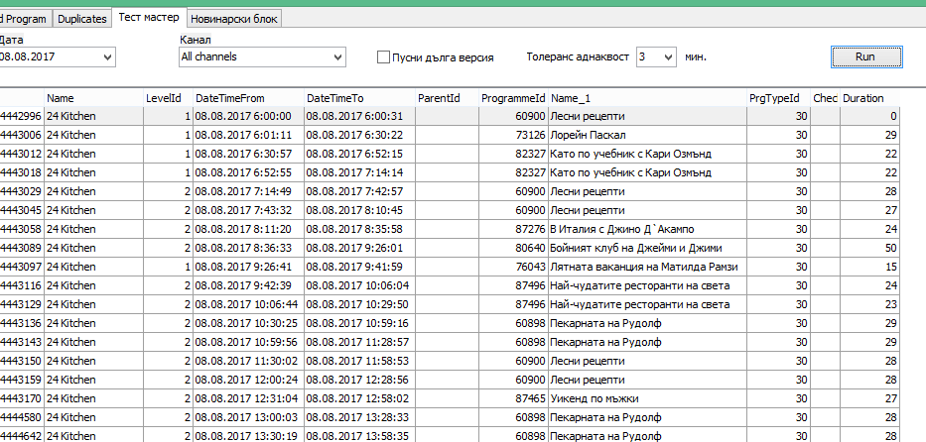

**N.B.** These two titles: **33/Анонси/Promo/Promo/Реклами**

**4934/Рекламен блок/Advertising break/Commercial/Реклами**

**are not visible** in the list. **It should stay this way.**

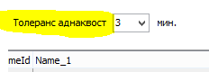

*Толеранс еднаквост* – it means a tolerance for duration difference between the same one after the other composite or stand alone titles.

The aim of this app is when we have composite and stand alone titles one after the other and their durations are different we to have a sign for this difference. The suspicious rows (duration difference more than 3 min) become red.

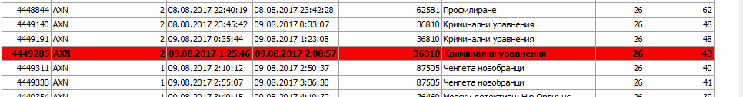

You can change the duration difference tolerance:

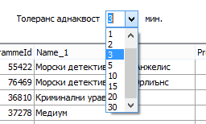

But 3 minutes is the optimal and it is set by default.

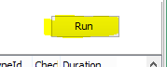

*Run* – with this button you run the application.

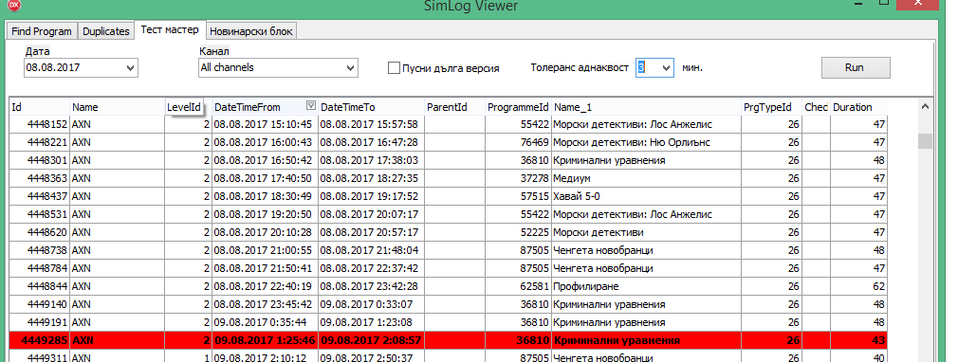

You can see the columns names that open after *Run* is set and the information in them (some are empty). The columns (information) we need are: *Name* (Channel), *DateTimeFrom, DateTimeTo, ProgrammeId, Duration.*

And of course we need the red rows – it is all because of them.

## Новинарски блок (News Block)

## It is the last part of SimLog Viewer. The aim of this check is similar to Тест Мастер (Test Master) but for the news blocks. We check if all parts of News block are merged in a composite broadcast. The rule is that if there are broadcasted News and after that Weather Forecast and/or Sport news, all the broadcasts have to have as a master News block.

The problem is that in different channels News have different names. So I asked our IT guy to create this application which shows if the following titles: **1135/Спортни новини/Sport news/Regular programme/Новини**

and **4031/Прогноза за времето/Weather forecast/Regular programme/ Новини**

are **NOT** merged in the master: **23143/Новинарски блок/News block/Regular programme/ Новини**

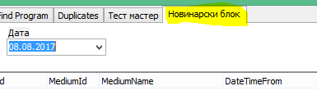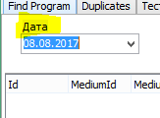

*Дата* – it is **TV** date - from 06:00 on one calendar date to 06:00 on the next calendar date. It is **important** to stay this way.

It is always set for the previous date – today is 09.08.2017. But it is possible to change the date:

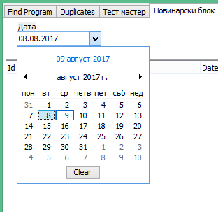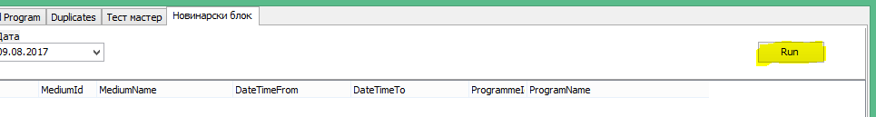

*Run* – a button to run the application with one left click of the mouse.

This is the result:

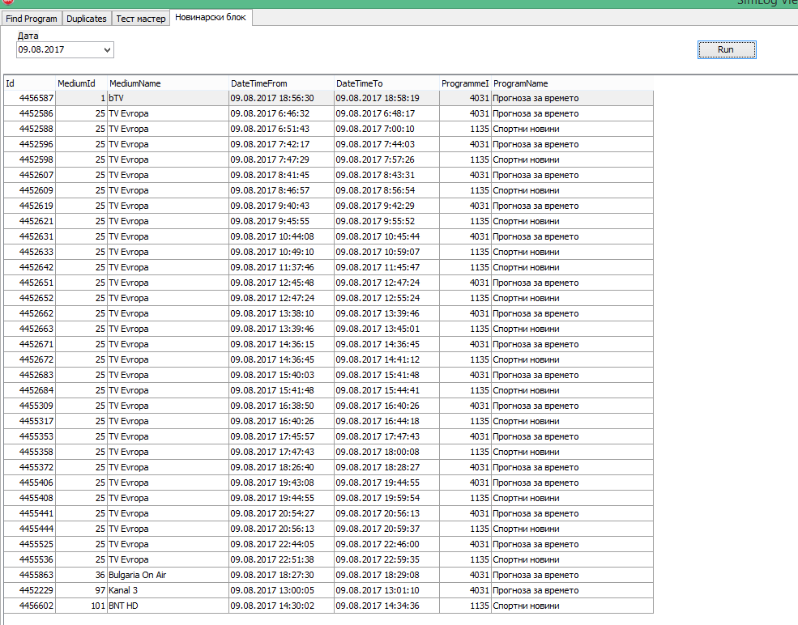

The important information we need is in the columns: *MediumName* (Channel), *DateTimeFrom, DateTimeTo*, *ProgramName* (title of the broadcast in BG).

SimLog Viewer parts and versions

Probably you notice that SimLog Viewer currently has one more part - *Duplicates*:

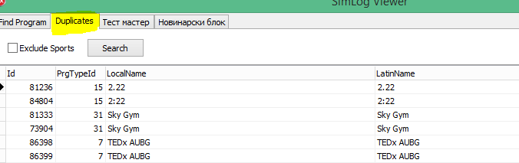

It was a try for finding duplicate titles but because of the spelling differences we use for the search not exact matches but key words. An example for duplicate title:

Голямото, голямо, голямо предаване на Cartoon Network!

Голямото,голямо,голямо предаване на Cartoon Network

So this part doesn’t do. Please ignore it.

**Neignorujeme, uděláme jim to pomocí sql funkce na “podobnost stringů”**