ParamsDao

# Pouziti IParamsDao a DatabaseParamsSource

Kodovadlo (parametrizace Kodovadla)

Viz take

Chceme pouzivat parametry ktere jsou v dbo.Params. Abychom nemuseli resolvovat ParamsDao vsude tam, kde potrebujeme nejakou propertu a pak ji ziskavat pomoci metody na paramsDao, mame k dispozici tridu DataBaseParamsSource : IparamsSource

* **Nejprve tridu zaregistrujeme v Castlu:**

container.Register(Component.For<IParamsSource>().ImplementedBy<DatabaseParamsSource>());

* **Trida DataBaseParamsSource ma dependency na IParamsDao, ktere mi Castle z nejakeho duvodu nechtel resolvnout. Obesel jsem to pridanim konstruktoru se zavislosti na IDaoSource.**

public DatabaseParamsSource(IDaoSource daoSource, ITimeProvider timeProvider)

{

m_paramsDao = daoSource.GetDaoByEntityType<IParamsDao, MediaData.Dbo.Params, byte>();

m_timeProvider = timeProvider;

m_refreshTimer = new Timer(_ => m_cache.Clear(), null, TimeSpan.FromMinutes(10), TimeSpan.FromMinutes(10));

}

* **V kazdem miste, kde potrebuju nejakou propertu z params, (typicky v installerech ) si bud pridam zavislost na IParams nebo reknu:**

var **paramSource** = container.Resolve<IParamsSource>();

Component.For<IMediaMessageSpecificComponent>().ImplementedBy<SheetViewModel>().Named("sheetComponent")

.DependsOn(

Property.ForKey("supportedMediumIds").Eq(new[] {**paramSource**.MladaFrontaMediumId})

),

**Tohle je blbe, protoze v kodovadle je spatne registrovana EntityDaoFactory a IDaoSource . Viz dale**

[**ConfigBase Sections AppConfig.docx**](ConfigBase%20Sections%20AppConfig.docx) - DatabaseConfiguration podle SimBiosu

[**IDaoSource a EntityDaoFactory.docx**](IDaoSource%20a%20EntityDaoFactory.docx)

**Zachytavadlo – VM do params:**

**Musim mit zaregistrovaneho ITimeProvidera a IParamsSource:**

container.Register(Component.For<ITimeProvider>().UsingFactoryMethod(() => new TimeZoneTimeProvider(container.Resolve<ConnectionStringsHolder>().ServerTimeZoneId)));

container.Register(Component.For<IParamsSource>().ImplementedBy<DatabaseParamsSource>());

**Do configu pridame:**

Pro CZ: <serverTimeZone>Central Europe Standard Time</serverTimeZone> Pro BG: <serverTimeZone>E. Europe Standard Time</serverTimeZone>

<serverTimeZone>#{serverTimeZone}</serverTimeZone>

**Do properties pridame propertu:**

public string ServerTimeZone { get; set; }

**V installeru zaregistrujeme:**

Component.For<ITimeProvider>().UsingFactoryMethod(() => new TimeZoneTimeProvider(container.Resolve<Properties>().ServerTimeZone)),

Component.For<IParamsSource>().ImplementedBy<DatabaseParamsSource>());

**Do databaze pridam do params co potrebuju:**

INSERT INTO [MediaData3Auto].[dbo].[Params] (Name, dbo.Params.[Value], dbo.Params.ActiveFrom, dbo.Params.ActiveTo, dbo.Params.Description)

VALUES ('VideoMatchingUserIds', '3, 107, 108, 110, 111, 112, 117, 118, 142, 242, 243', '2000-01-01 00:00:00.000', '2100-01-01 00:00:00.000', 'Zachytavadlo, vycet VideoMatching useru - podbarvovani MM v gridu (byte[])')

**Musim upravit tridu DatabazeParamsSource – pridat novou propertu:**

public const string VideoMatchingUserIdsKey = "VideoMatchingUserIds";

doplnim m_workableValues: {VideoMatchingUserIdsKey, ConvertIntEnumeration}

public byte[] VideoMatchingUserIds => GetConfiguration<byte[]>(VideoMatchingUserIdsKey);

**Na rozhrani IparamsSource pridam:**

byte[] VideoMatchingUserIds { get; }

**V miste, kde potrebuju propertu z params (tady je to InstallerCz a InstallerBG), reknu jen:**

MessageLogWrapper.VideoMatchingUserIds = container.Resolve<IParamsSource>().VideoMatchingUserIds;

**Problem:**

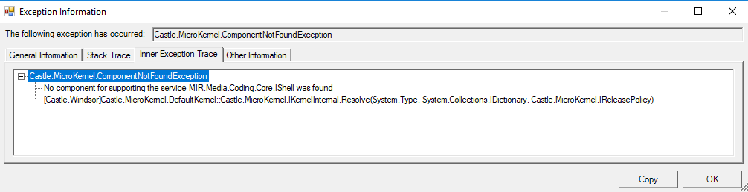

**Reseni:** V prvni rade musi byt hodnota radne v databazi. Pridat jen do workable values a do stringu, nedavat na rozhrani a pak jen zavolat

var source = container.Resolve<IParamsSource>();

var advTypes = source.GetParamValue<byte[]>("AdvertisePageOrderComputerAdvTypes", DateTime.Now);

**Reseni2:**  rozdelit resolve IParamsSource a vlozeni hodnoty do property. Nevim co pomohlo najednou to jde ..

# Zjisteni lokace (CZ\BG):

Ve tride TvMessageLoader : MessageLoaderBase zjistim lokaci na zaklade tabulky dbo.Params :

public TvMessageLoader(IDaoSource daoSource, IPricedItemMediaMessageConverter<TvPricedItemWrapper, IPricingTvMediaMessage> converter, IEnumerable<IComputer<TvPricedItemWrapper>> sorters)

:base(daoSource)

{

m_converter = converter;

m_sorters = sorters;

IsCzLocation = GetLocation(daoSource);

if (IsCzLocation)

{

DateRestrictionIsChecked = true;

AdvertisedTo = DateTime.Today.Subtract(TimeSpan.FromDays(2));

AdvertisedFrom = DateTime.Today.Subtract(TimeSpan.FromDays(3));

}

else

{

AdvertisedFrom = DateTime.Today.AddDays(-1);

AdvertisedTo = AdvertisedFrom.AddDays(1);

}

m_tvMediaMessageDao = daoSource.GetDaoByEntityType<ITvMediaMessageDao, ITvMediaMessage, int>();

}

## Metoda na zjisteni lokace:

Vytvori objekt typu paramsDao a na dao tride si zavola metodu GetAll..

private bool GetLocation(IDaoSource daoSource)

{

var paramsDao = daoSource.GetDaoByEntityType<IParamsDao, Params, byte>();

var result = paramsDao.GetAllParamsByKey("Location");

return result.FirstOrDefault()?.Value == "CZ";

}

# V Normovadle se paramsDao tvori takto:

m_paramsDao = (ParamsDao)entityDaoFactory.CreateDaoByEntityType<Params, byte>();