# U

# Poznamky:

* Budete-li tedy mit nejaky zmeny, udelejte commit a pak pomoci menu Actions/Create patch vytvorte soubor (pripona diff) a hodte ho asi sem. Pojmenujte ho stejne jako ten commit, at tu nemame samy odkazy na path.diff.
* to jsou DNS...dej tam od Borka 10.255.1.36
* 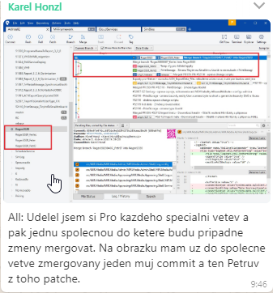

# Nssm:

Zmenseni console : [HKEY_CURRENT_USER\Console]

**The default console layout settings live here in the registry:**

[HKEY_CURRENT_USER\Console]

You can modify these settings and they will apply to ALL command windows that launch, regardless of the path. Unfortunately, the raw values are not human friendly.

To set them the way you want them, open a regular cmd window, then edit the settings to your liking. Look in the registry at the above path and you should see a sub key under "Console" for cmd.exe. Export that key to a file, change the path to the above and import, or just manually copy the values from one to the other. You can then delete the cmd.exe specific entry. Now, all command windows that open will use the modified defaults.

I've found it handy to create a couple of registry entry files with my standard defaults so that I can easily pop them onto a new server when I RDP in for the first time. I made presets for the two sizes I typically use.

For 1024 x 768 (I use this for servers normally accessed via a multi session RDP tool):

Windows Registry Editor Version 5.00

[HKEY_CURRENT_USER\Console]

"ScreenBufferSize"=dword:012c0050

"WindowSize"=dword:00190050

"WindowPosition"=dword:000a000a

"FontSize"=dword:000c0007

"FontFamily"=dword:00000030

"FontWeight"=dword:00000190

"FaceName"="Terminal"

"QuickEdit"=dword:00000001

For 1280 x 1024:

Windows Registry Editor Version 5.00

[HKEY_CURRENT_USER\Console]

"ScreenBufferSize"=dword:0bb800af

"WindowSize"=dword:004b00af

"WindowPosition"=dword:000a000a

"FontSize"=dword:000c0007

"FontFamily"=dword:00000030

"FontWeight"=dword:00000190

"FaceName"="Terminal"

"QuickEdit"=dword:00000001

**Nasel jsem na stackOwerflow (presne muj pripad):**

I'm trying to run my wpf service with nssm service manager. The problem is that using nssm I can install service, but then when I try to start it I get the following response in terminal:

MyService: Unexpected status SERVICE_PAUSED in response to START control.

Then in EventViewer I get the following error:

Service cannot be started. The service process could not connect to the service controller

I found an answer! I was too dumb to realize that nssm is a service manager, and I tried to run with it a windows service...

**V logu nssm jsem mel chyby:**

Cannot start service from the command line or a debugger. A Windows Service must first be installed (using installutil.exe) and then started with the ServerExplorer, Windows Services Administrative tool or the NET START command.

# Vystrihovadlo pad:

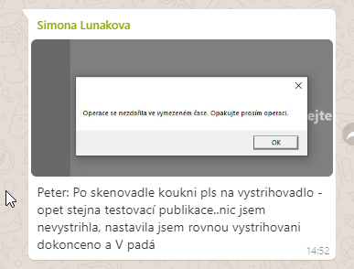

# Skenovadlo bug

# Normovadlo nejde naciast stream

132803690 MM

PAda

var streamInfo = GetStreamInfo(videoProcess);

# Zachytavadlo instrukce:

Prihlasis se na svuj komp pod admin userem a musis zkusit zda funguje bez domenoveho uctu.

Do useru insertnout pro me a pro simu adminusera, musi se zalozit podle nazevpocitace\admin

Jeden komp uz mame, v konverzaci jh neco ten tam taky insertnes pro simu

Membership zkusit bud zakomentovat nebo zakladat usery v membership tabulce

Jestli zakomentujes a vsechno bude videt tak ok. 19:45 odhad

# Cenikovadlo

Pricing - CommunicationObjectFaultedException - sluzba bezi, zkusil jsem ji vyrobit outbound rule a nastavil jsem TCP port podle reprocessing service.

Sluzba ma tento port:

net.tcp://localhost:13892/PricingService"

Cenikovadlo ma:

<PricingServiceClientEndpointAddressUri>net.tcp://10.255.1.105:13892/PricingService

# Importovadlo

**Adsapp1 : 10.255.1.105**

**MD3, PrintStorage, Pricing - 10.255.1.100\A**

**MDExport3 - 10.255.1.100**

**[9:45, 5. 4. 2020] Miroslav Špaček: Petr právě instaluje JH VM stroj....takže ten... IP 10.253.1.6 na INprocessing**

**[9:47, 5. 4. 2020] Miroslav Špaček: PRE processing zatím match01 .107**



# Vystrihovadlo

protected override DoneResponse DoActionInternalInTransaction(UpdateDataBaseAfterPageRotatedRequest request)  
{  
 m_pageDao.DeletePageMessages(request.PrintStoragePageId, m_auditableIdentityProvider.UserIdentity.UserId,  
 false);

**Vola storovku:**

[SprocName("dbo.proc_Page_DeleteRelatedMediaMessage")]

# Normovadlo

Pro ostatní:

v app.cfg importní win služby je podle mě <system.diagnostics> , příklad konfigurace pro zapnutí výjimek z WCFka, až nám zase nepůjde nějaké spojení

134397104 MMId

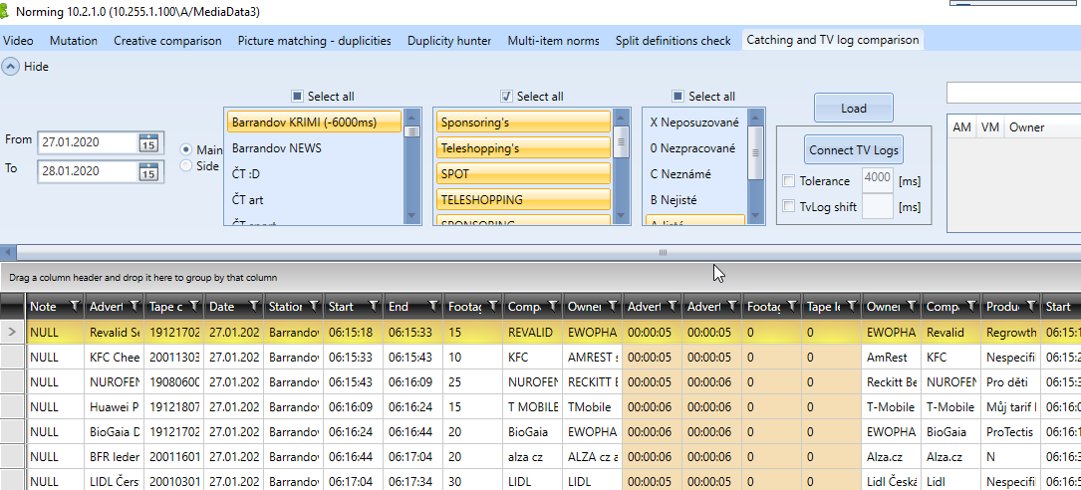

# Vystrihovadlo

<https://drive.google.com/open?id=1iNhISVDAHnrt9Yd91xssZTIC7eQMyIEQ>

<https://drive.google.com/open?id=1MVhoL30PueGYukl6gTf5CNHP--jXu_UF>

Vymena conn stringu

* Nasmerovat na spravny reprocessing service v app.configu

Id kreativ itemu pro ktere mi selhal reprocessing : 13876260, 13876269

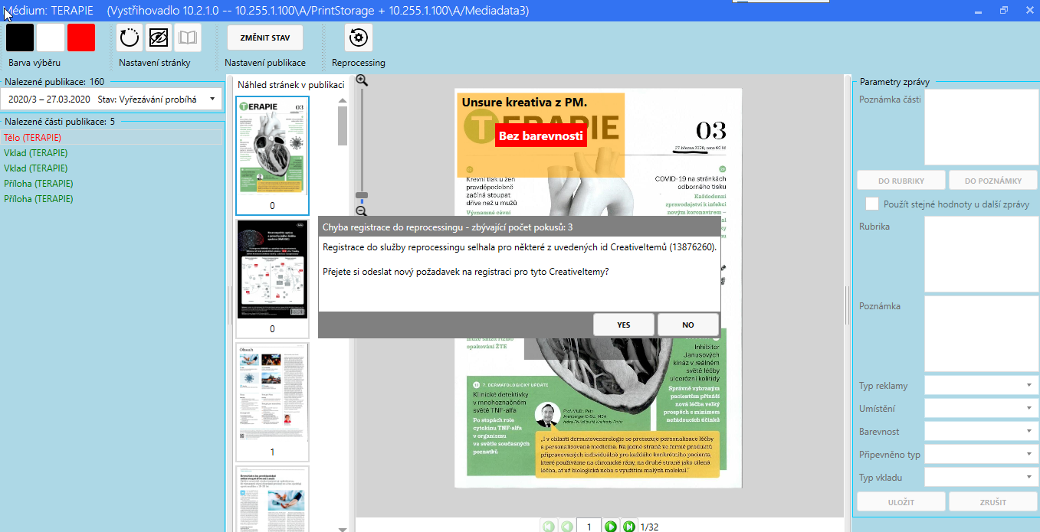

Povolovani portu:

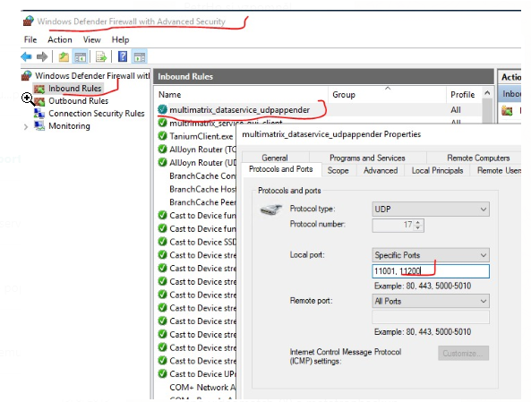

**=== ===**

# Zachytavadlo

**Potreboval jsem:**

Pouzil jsem produkcni configy

Zmenil jsem constringy na databaze (i v log4netu),

Chybel mi login pro MediaDataCatchingUser na tvStorage

poresit v_targetGroupView – vyjimka : Nemuze najit ALFRED in sys.servers.

zmenil jsem v configu location – zakomentoval jsem hradeckou a nechal jen Prahu

insert permission na tvStorage2 kvuli insertu outputRequestu - SaveDataForHqVideo()

filesystem se dal poresit jednoduse – pokud neprojde autentifikace, tak nic ukladat nechce.

Videomatching –

Nejde mi remote desktop

Branch – release z 27

Oteviram Nova 29.3.2020 6:00

Striham MM

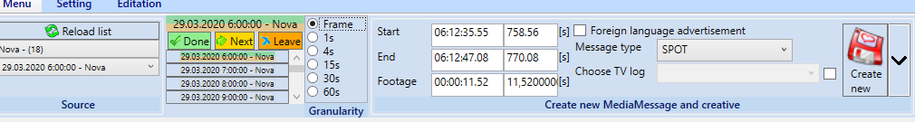



=== ===

**V_TargetGroup (exc)**

já si myslím, že ta [v_TargetGroup] je obsolete....kdyby byl za pár dní nějaký problém někde v cenění, tak si na to vzpomeňte...já to jdu odstranit...resp. jdu z toho view vracet "nic"...

===========

**FileSystem.Container.Config**

dvě využití:

NormVideoDialogViewModel - pokud norma jeste neni na filesystemu tak se ji tam pokusi insertnout

MediaMessageCreationMenuGroupViewModel - protoze neprojde autentifikace, nastavi se bool autentificated na false; diky tomu se nepokousi ukladat na filesystem.

===========

OK, MD3 nastavena/připravena - OPATRNĚ - OSTRÁ

určitě Vám ještě nějaký app sql login nebude fungovat...hned se obracejte na mě, zařídím...

MD3, PrintStorage, Pricing - 10.255.1.100\A

MDExport3 - 10.255.1.100

hesla v emailu, používat jen ManagementStudio pro sql, ne RD

user: sa pro oba - opatrně sysadmin

connstring tedy bude mít jen jiný název srv, jinak se nic nemění, např:

"Data Source=10.255.1.100\A;Initial Catalog=MediaData3;User ID=MediaDataCoding2User;Password=..."

GoodLuck...o všem mě informujte, ať vím, co už můžeme zkusit, co už jede, ať si to tu mohu odškrtávat

**Prihlaseni na servery user .\administrator a odvoditelne heslo se slimakem**

**Prihlaseni na kompy .\admin a heslo Zirafa.pha0123,2020**

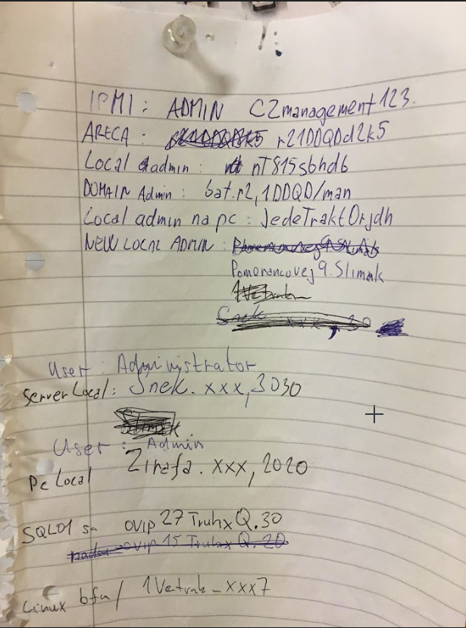

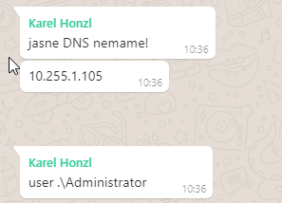

**Roger – Zachytavadlo**

# Nacteni videoprocessSkeletonu do sources comba.

* Initialize() a LoadSources() .. vola se kdyz se zmeni stream, nebo jeho status
* SourceMenuGroupViewModel.**LoadSourcesInternal**()
* GetCatchingVideoProcessData()

[SqlQuery(@"SELECT a.Id, VideoDateTime, DATEADD(ms, Shift, VideoDateTime) AS RealVideoDateTime, TvStorageOutputRequestId,  
 a.ChannelId, TvStorageLocationId, a.MediumId, a.MediumName, a.Shift, a.VideoLength, a.VideoProcessStatusId  
 FROM   
 (SELECT vp.Id, VideoDateTime, TvStorageOutputRequestId, vp.TvStorageChannelId AS ChannelId, vp.VideoLength/1000 as VideoLength,  
 TvStorageLocationId, m.Id AS MediumId, mdv.Name AS MediumName, vp.Shift, vp.TvStorageChannelId, scv.MediumId AS SlicedMedium,  
 vp.VideoProcessStatusId   
 FROM Creative.VideoProcess vp  
 JOIN media.TvMedium tm ON tm.TvStorageChannelId = vp.TvStorageChannelId  
 JOIN media.Medium m ON tm.Id = m.Id  
 JOIN media.MediumVersion mdv ON m.Id = mdv.MediumId AND mdv.ActiveFrom <= vp.VideoDateTime AND mdv.ActiveTo > vp.VideoDateTime  
 LEFT JOIN media.SlicedChannelVersion scv ON m.Id = scv.MediumId  
 AND (vp.VideoDateTime <= scv.ValidFrom AND scv.ValidFrom < DATEADD(hh, 1, vp.VideoDateTime)  
 OR scv.ValidFrom <= vp.VideoDateTime AND vp.VideoDateTime < scv.ValidTo)  
 WHERE vp.VideoProcessStatusId = 2) a  
 WHERE   
 ((SELECT COUNT(Id) FROM Media.TvMedium WHERE TvStorageChannelId = a.TvStorageChannelId) > 1 AND a.SlicedMedium IS NOT NULL)   
 OR   
 ((SELECT COUNT(Id) FROM Media.TvMedium WHERE TvStorageChannelId = a.TvStorageChannelId) = 1)   
 ORDER BY a.VideoDateTime, a.MediumName")]  
public abstract List<CatchingVideoProcessSkeleteon> GetCatchingGetVideoProcessData();

**LoadSourcesInternal:**

var sources = m_videoProcessDao.GetCatchingVideoProcessData();  
var outputRequests = m_outputRequestDao.GetOutputRequestByIds(sources.Select(s => s.TvStorageOutputRequestId.Value).ToArray());

# Cteni souboru po bytech a ukladani do appData - FileStreamStorage

Zjistime zdroj na zaklade TvStorageOutputRequestId z VideoProcesu. TvStorageStreamFileSourceProvider potrebuje z configu jen storageIds (jh = 18, praha = 2)

FileInfo sourceFileInfo = m_streamFileSourceProvider.GetSourceFileInfo(request);

Na Mediaresearch.TvStorage2.FileAccess.Servicies –

**GetSourceFileInfo()**

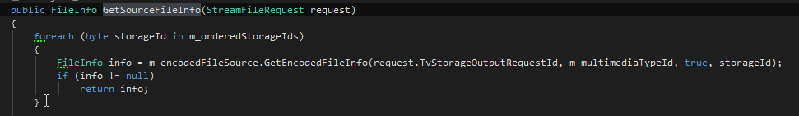

**GetEncodedFileInfo()**

public FileInfo GetEncodedFileInfo(int outputRequestId, short? multimediaTypeId = null, bool readonlyCredentials = false, byte? preferedStorageId = null)  
{  
 if (!m_outputRequestDao.OutputRequestIsDone(outputRequestId))  
 throw new InvalidOperationException($"Output request id '{outputRequestId}' not in done status.");  
  
 OutputRequest outputRequest = m_outputRequestDao.GetOutputRequestByIds(new[] {outputRequestId}).First();  
  
 OutputRequestSkeleton skeleton = new OutputRequestSkeleton(outputRequest.Id, outputRequest.StorageServerId, outputRequest.ChannelId,  
 TimeSpan.FromMilliseconds(outputRequest.Length), TimeSpan.Zero, outputRequest.MultimediaTypeMask, outputRequest.DateTime,   
 outputRequest.EncodePriority, (OutputRequestStatusValues) outputRequest.OutputRequestStatusId,  
 outputRequest.EncodingLocationId, outputRequest.AudioStreamCode, outputRequest.OutputRequestConfigId, null, outputRequest.AdditionalCopies.Select(d => d.StorageServerId).Distinct().ToList(), outputRequest.ParentOutputRequestId);  
  
 var result = GetEncodedFiles(new[] {skeleton}, multimediaTypeId, readonlyCredentials, preferedStorageId);  
  
 if (result.Any())  
 return result.First().FileInfo;  
  
 return null;  
}

**GetEncodedFiles()**

public IEnumerable<EncodedOutputRequestSkeleton> GetEncodedFiles(IEnumerable<OutputRequestSkeleton> outputRequests, short? multimediaTypeId = null, bool readonlyCredentials = false, byte? preferedStorageId = null)  
{  
 List<EncodedOutputRequestSkeleton> resultFiles = new List<EncodedOutputRequestSkeleton>();  
  
 foreach (var outputRequest in outputRequests)  
 {  
 var storage = GetStorageManager(readonlyCredentials, outputRequest, preferedStorageId);  
  
 resultFiles.Add(GetEncodedFileInfo((o, expression) => storage.GetFileInfo(o, expression),   
 (skeleton, multimediaType, fileInfo) => new EncodedOutputRequestSkeleton(skeleton, multimediaType, fileInfo),   
 outputRequest, multimediaTypeId));  
 }  
  
 return resultFiles;  
}

**GetStorageManager()**

private IFileSystemAccessManager GetStorageManager(bool readonlyCredentials, OutputRequestSkeleton outputRequest, byte? preferedStorageId = null)  
{  
 byte storageId = preferedStorageId ?? outputRequest.StorageServerId;  
  
 StorageServerSkeleton storageServerSkeleton = m_storagesCache.GetOrAdd(storageId, b => m_storageServerDao.GetStorageServerById(storageId, readonlyCredentials));  
  
 IFileSystemAccessManager storage = m_storageResolver.GetRemoteStorage(storageServerSkeleton);  
 return storage;  
}

Jakmile mame FileInfo, vyrobime si cestu kam se budou streamy ukladat:

string destinationTmpFilePath = $"{Path.Combine(m_cacheResolver.CacheInfo.Path, $"{m_prefix}{videoProcessId}{Path.GetExtension(sourceFileInfo.FullName)}.tmp")}";  
string destinationFileName = Path.Combine(Path.GetDirectoryName(destinationTmpFilePath), Path.GetFileNameWithoutExtension(destinationTmpFilePath));

a pomoci input a output streamu cteme a zapisujeme po bytech.

Mediaresearch.TvStorage2.FileAccess.Servicies

using Mediaresearch.TvStorage2.Entities.Skeletons;

using Mediaresearch.Framework.DataAccess.BLToolkit.Dao;  
using Mediaresearch.TvStorage2.Entities.Dbo;  
using Mediaresearch.TvStorage2.Entities.Skeletons;

namespace Mediaresearch.TvStorage2.Entities.Dao

using Mediaresearch.Framework.DataAccess.BLToolkit.Dao;  
using Mediaresearch.Framework.FileSystem.Extensions;  
using Mediaresearch.Framework.Utilities;  
using Mediaresearch.TvStorage2.Entities.Dao;  
using Mediaresearch.TvStorage2.Entities.Dao.Impl;  
using Mediaresearch.TvStorage2.Entities.Dbo;  
using Mediaresearch.TvStorage2.Entities.Skeletons;  
using Mediaresearch.TvStorage2.FileAccess.Servicies;

namespace Mediaresearch.TvStorage2.FileAccess