Schedule

Jde o sluzbu. Projekt je v MIR.Schedule. Co se spusti je definovano v Installers.configu. Nad jakou db je definovano v container.configu. Nikdy neodkomentovat v installers.configu NielsenExport !!

# Poznamky

Container.Current.Install(new MediaDataDaoSourceInstaller());

var test3 = Container.Current.Resolve<IMediaDataDaoSource>();

Container.Current.Install(new TvStorageDaoSourceInstaller());

var test1 = Container.Current.Resolve<ITvStorageDaoSource>();

Container.Current.Install(new PoolingDaoSourceInstaller());

var test = Container.Current.Resolve<IPoolingDaoSource>();

Container.Current.Install(new MediaDataExportDaoSourceInstaller());

var test2 = Container.Current.Resolve<IDaoSource>(MediaDataExportDaoSourceInstaller.DaoSourceKey);

var dao = test2.GetDaoByEntityType<IMediaMessageForExportDao, IMediaMessageForExport, int>();

Container.Current.Register(

Component.For<IAggregator>().ImplementedBy<Aggregator>().Named("neilsenAggregator")

);

Container.Current.Register(Component.For<PrepareMediaMessagesStep>().Named("prepareMediaMessagesStep")

.DependsOn(

Property.ForKey("daoSourceMDE3").Is(MediaDataExportDaoSourceInstaller.DaoSourceKey),

Property.ForKey("aggregator").Is("neilsenAggregator")

));

var neco = Container.Current.Resolve<PrepareMediaMessagesStep>();

Container.Current.Install(Castle.Windsor.Installer.Configuration.FromXmlFile("MIR.Schedule.Service.Container.Installers.config"));

Container.Current.Install(new ConnectionInstaller());

Container.Current.Install(new HDDCacheAuthenticatorInstaller());

ISchedulerJob[] schedulerJobs = Container.Current.ResolveAll<ISchedulerJob>();

//if (m_log.IsInfoEnabled)

// m_log.Info($@"Installed jobs:{Environment.NewLine}{string.Join(Environment.NewLine, schedulerJobs.Select(j => j.JobName))}");

// Container.Current.ResolveAll<IDaoSource>();

lazy loading PoolingDaoSourceInstaller

//if (!container.Kernel.HasComponent(DaoSourceKey))

//{

// var stringHolder = container.Resolve<ConnectionStringHolder>();

// container.Register(Component.For<EntityDaoFactory>().UsingFactoryMethod(() =>

// new EntityDaoFactory(stringHolder.PoolingDbAlias, stringHolder.PoolingConnectionString, new TransactionManager())

// {

// DaoAssemblies = new[] { "Mediaresearch.Spots.Entities" },

// EnumTableAssemblies = new[] { "Mediaresearch.Spots.Entities" },

// ServerTimeZoneId = container.Resolve<ConnectionStringHolder>().ServerTimeZoneId,

// Interceptors = container.ResolveAll<IDbOperationInterceptor>()

// }

// ).LifestyleSingleton().Named(ConnectionStrings.PoolingEntityDaoFactoryKey));

// container.Register(Component.For<IDaoSource>().Forward<IPoolingDaoSource>().ImplementedBy<DependencyDaoSource>().Named(DaoSourceKey)

// .DependsOn(

// Dependency.OnComponent(typeof(EntityDaoFactory), ConnectionStrings.PoolingEntityDaoFactoryKey)));

//}

# Jak vyrobit data pro duplicity killera

pro killera vlož jakékoliv 2 CrItemy do tabulky NormDuplicity

měl by to pak oszačit za vyřešené

C:\Users\phlavenka\OneDrive\Nielsen prace\Moje poznamky Nielsen\My Scripts\Schedule\Vytvoreni dat pro otestovani DuplicityKillera.sql

# Jak vyrobit data k ceneni pro sluzbu

-- Pricing.Queue je fronta k ceneni v cenici sluzbe. Abych nasel novejsi zorderuju si to descending

SELECT TOP 100 *

FROM pricing.Queue q ORDER BY q.Created DESC

-- Vyberu si z resultu nejakou polozku k ceneni a zmenim ji QueueStatus na 1 -new

UPDATE pricing.Queue

SET

Pricing.Queue.QueueStatusId = 1

WHERE pricing.Queue.Id = 72178703

# Spusteni u me na konzoli:

**Bud z TotalCommanderu napisu nazev exe + console**



**Nebo z VS**.

[‎21.‎01.‎2019 21:23]  Karel Honzl:

to by asi nefungovalo

V solution exploreru nastav jako StartUp project "MIR.Schedule.Service"

[‎21.‎01.‎2019 21:25]  Karel Honzl:

A pak v properties "MIR.Schedule.Service" v menu "Debug" napis do Command line arguments: console

[‎21.‎01.‎2019 21:25] Karel Honzl:

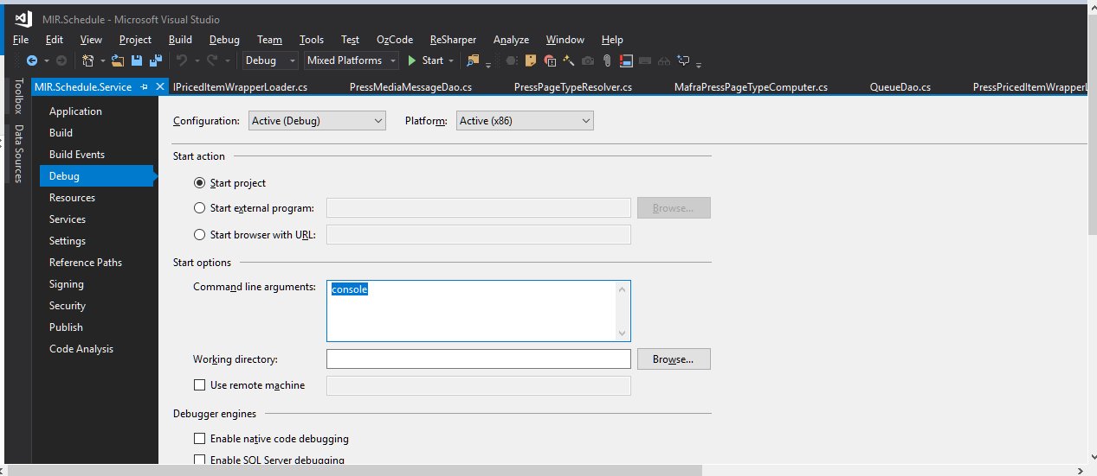

 [‎21.‎01.‎2019 21:26]  Karel Honzl:

A pak to muzes normalne poustet jako konzolovou aplikaci :)

# Proc se nic nevypisuje na konzoli

Je to zavisle na tom, jake appendery jsou zapnute v log4netu:

<root>

<level value="ALL" />

<appender-ref ref="DebugRollingFileAppender" />

<appender-ref ref="InfoRollingFileAppender" />

<appender-ref ref="UdpAppender" />

<appender-ref ref="ConsoleAppender" />

</root>

# Kam loguje Schedule spustena na konzoli

