TransactionManager

* Najdeme ho na na daoSource . Ve scanovadle : IPrintStorageDaoSource daoSource

public UpdateMediumAction(IAuditableIdentityProvider auditableIdentityProvider, IMediumDao mediumDao, IMediumPublicationPeriodicity

mediumPublicationPeriodicity, **IPrintStorageDaoSource daoSource**)

: base(auditableIdentityProvider)

{

m_mediumDao = mediumDao;

m_mediumPublicationPeriodicity = mediumPublicationPeriodicity;

**m_transactionManager = daoSource.TransactionManager;**

}

protected override DoneResponse DoAction(UpdateMediumRequest request)

{

void Action()

{

m_mediumDao.UpdateMedium(request.Medium);

m_mediumPublicationPeriodicity.UpdateMediumPeriodicity(request.Medium);

}

**m_transactionManager.CallInsideTransaction(Action, m_mediumDao.CreateCommonDbContext());**

return DoneResponse.Successfull();

}

Na dao tride mame transakci takto:

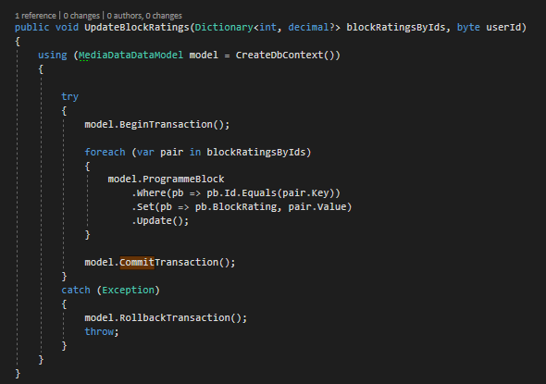

**Nebo si ho muzeme resolvnout v konstruktoru:**

ITransactionManager transactionManager

**a pak vyrobit:**

m_transactionManager = transactionManager;

**K tomu ale potrebujeme registraci:**

container.Register(Component.For<ITransactionManager>().ImplementedBy<TransactionManager>());

**Pokud ale mam zaregistrovane dve entityDaoFactory, chci pouzit toho spravneho managera a v takovemto pripade je mozna lepsi si ho vzit z daoSource:**

