1. Zmenovadlo – zeptat se Dobese proc se to menilo

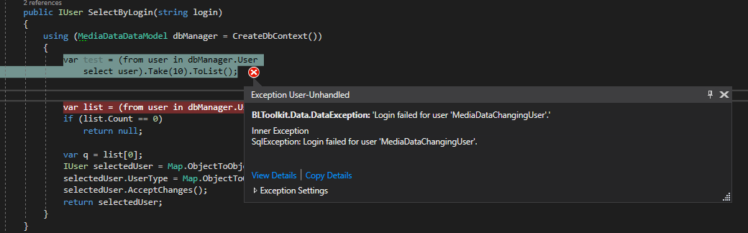

**Reseni: Chybel MediaDataChangingUser na BG v databazi :**

[‎6/‎20/‎2018 10:22 AM] Peter Hlavenka:

zkusim ,  jakto, ze tam nebyl changingUser vzdyt zmenovadlo jsem poustel i na BG  a taky Iva to testovala .. to je divne

[‎6/‎20/‎2018 10:24 AM] Petr Dobeš:

Jenže v těch testovacíh cfg se tam přihlašujes pod svým loginem, kdyžto produkční tam pak lehe pod speciálním uživatelem

1. Zachytavadlo (Catching) nereaguje na deploymentService
2. Zmenovadlo - Ikona na plose pro BGClickOnce ma koncovku -1
3. Opravit reference na TvLogGeneratoru
4. Pricing export do xlsx
5. void DeleteDuplicityPackages(List<int> value, DateTime modified, byte modifiedBy);

/// <summary>

/// Prohleda vazby, necha nejstarsi balik a o statni smaze.

/// </summary>

/// <param name="items"> seznam CreativeItemId ktere patri do teto kreativy </param>

/// <param name="modified"></param>

/// <param name="modifiedBy"></param>

/// <returns> z baliků vybere ten, ktery patri nejstarsi kreative a vrati jeji Id, pokud nenajde duplicitni balik vrati nulu </returns>

public void DeleteDuplicityPackages(List<int> items, DateTime modified, byte modifiedBy)

{

using (var model = CreateDbContext())

{

var samePackages = from ctci in model.CreativeToCreativeItem

group ctci by ctci.CreativeId

into gr

where gr.Count() == items.Count && gr.All(d => items.Contains(d.CreativeItemId))

select gr.Key;

if (!(samePackages.Count() > 1))

{

return;

}

// var sameTest = samePackages.ToList();

var oldest = (from cre in model.Creative

join mes in model.MediaMessage on cre.Id equals mes.CreativeId

where samePackages.Contains(cre.Id)

orderby cre.Created, cre.Id

select new {mes.NormCreativeId, mes.CreativeId}).First();

//var presmerovaneTest = (from m in model.MediaMessage

// where samePackages.Contains(m.CreativeId) && m.CreativeId != oldest.CreativeId

// select m).ToList();

model.MediaMessage.Where(m => samePackages.Contains(m.CreativeId) && m.CreativeId != oldest.CreativeId)

.Set(d => d.CreativeId, oldest.CreativeId)

.Set(d => d.NormCreativeId, oldest.NormCreativeId)

.Set(d => d.Modified, modified)

.Set(d => d.ModifiedBy, modifiedBy)

.Update();

// var deleteTest = model.CreativeToCreativeItem.Where(d => samePackages.Contains(d.CreativeId) && d.CreativeId != oldest.CreativeId).ToList();

// smazu vazby mladsim balikum

model.CreativeToCreativeItem.Where(d => samePackages.Contains(d.CreativeId) && d.CreativeId != oldest.CreativeId).Delete();

}

}

1. List<List<int>> GetCreativeItemsByCreativeId(IEnumerable<int> creativeIdList);

public List<List<int>> GetCreativeItemsByCreativeId(IEnumerable<int> creativeIdList)

{

using (var model = CreateDbContext())

{

var query = from m in model.CreativeToCreativeItem

group m by m.CreativeId

into gr

where creativeIdList.Contains(gr.Key)

select gr.Select(d => d.CreativeItemId);

return query.Select(d => d.ToList()).ToList();

}

}

3)

IEnumerable<int> GetCreativeIdsByCreativeItemId(int id);

public IEnumerable<int> GetCreativeIdsByCreativeItemId(int id)

{

using (var model = CreateDbContext())

{

return model.CreativeToCreativeItem.Where(d => d.CreativeItemId == id).Select(d => d.CreativeId).ToList();

}

}

**Hotova Action :**

private void ResolveDuplicityPackages()

{

void Action()

{

var itemId = 3472295;

// var itemId = 10587409;

// var itemId = ((ICreativeItem)ActualCreativeItem).Id);

var relations = m_creativeToCreativeItemDao.GetRelations(itemId);

// odmazu item

m_creativeToCreativeItemDao.DeleteByCreativeItemId(itemId);

// va vazbach mam cca 40 000 polozek , zgroupnu podle creativeId

var grouped = from n in relations

group n by n.CreativeId

into gr

select new { gr.Key, Group = gr.Select(d => d) };

// zgroupnuta dict podle CreativeId

var dict = grouped.Select(t => new { t.Key, t.Group }).ToDictionary(t => t.Key, t => t.Group.ToList());

// otocena dict, zgropnuta podle value (ve value jsou ted CreativeIds)

var klicemJeString = dict.GroupBy(x => string.Join(",", x.Value.Select(d => d.CreativeItemId))).ToDictionary(x => x.Key, x => x.Select(i => i).ToList());

// vyberu duplicitni CreativeIds

var duplicit = from k in klicemJeString // vsechny v jednom listu je nejaka duplicita => tj nejmene dve ruzne CreativeId, ktere maji stejny balik

where k.Value.Count > 1

select new

{

CtciCollection = k.Value.SelectMany(a => a.Value.Select(i => i))

};

var deletedCreativeIds = new List<int>();

foreach (var item in duplicit)

{

var oldest = item.CtciCollection.OrderBy(d => d.Created).ThenBy(n => n.CreativeId).First().CreativeId;

var others = item.CtciCollection.Where(d => d.CreativeId != oldest).Select(d => d.CreativeId).Distinct().ToList();

deletedCreativeIds.AddRange(others);

m_mediaMessageDao.UpdateDuplicityCreativePackageMessages(oldest, others, m_auditableIdentityProvider.ModifiedStamp.DateTime, m_auditableIdentityProvider.UserIdentity.UserId);

}

m_creativeToCreativeItemDao.DeleteRelations(deletedCreativeIds);

}

m_transactionManager.CallInsideTransaction(Action, m_mediaMessageDao.CreateCommonDbContext());

}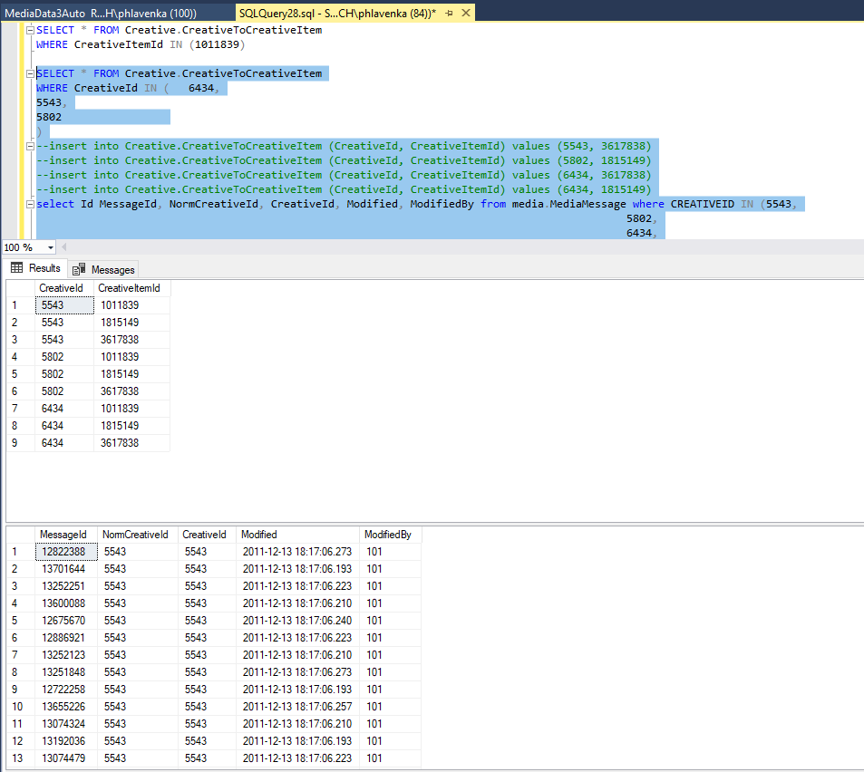

Message ktere jsou vyselektovane budou ukazovat na nejstarsi z duplicit tj 19.10.2011 6334 duplicity jsou 3 kdyz odecteme nejstarsi kreativu tak dve.

**Tuesday, July 10, 2018**

* V kodovadle misto mazani vazeb zavolat storovku :

[‎7/‎10/‎2018 1:54 PM] Miroslav Špaček:

m_creativeDao.DeleteNorm()

* OrderBy doplnit do porovnavani string.Join
* Odstranit z daa vse co pouzival Admin na zalozce, ze ktere se odebiraly buttony. Ctrl + Alt + F7 nad repozitarem
* Debug v Management Studiu

Monday, August 13, 2018

* Master sln s testy neprojde
* Vpn videa
* TeamFoundationServer
* Git

Monday, August 20, 2018

**~~Kodovadlo~~** ~~– rozbite reference na jakemkoli defaultu (smazal jsem !NugetPackages)~~

**~~Spravovadlo~~**  ~~-~~

1. ~~ukladani do Excelu – odstranil jsem reference a nainstaloval jsem knihovny z nugetu Telerik.Windows.RadGrid, Controls, Data -> v outputu bezi~~

~~System.Windows.Data Error: 40 : BindingExpression path error: 'TvStorageChannelId' property not found on 'object' ''TvMediumSkeleton' (HashCode=34109290)'. BindingExpression:Path=TvStorageChannelId; DataItem='TvMediumSkeleton' (HashCode=34109290); target element is 'ValueSetter' (Name=''); target property is 'Value' (type 'Object')~~

~~Nebo:~~

~~System.Windows.Data Error: 40 : BindingExpression path error: 'TvLogShift' property not found on 'object' ''MediumVersion' (HashCode=61277095)'. BindingExpression:Path=TvLogShift; DataItem='MediumVersion' (HashCode=61277095); target element is 'ValueSetter' (Name=''); target property is 'Value' (type 'Object')~~

1. Ve spravovadle je conductor se zalozkama. Na zalozce Sprava Medii muze byt horni grid podle vyberu v comboBoxu bud Press nebo TvMediumGridView

Jaky typ to bude urcuje MediumGridTemplateSelector

Tim, ze se pri prepnuti zalozky, nebo zmene comba vybere nova DataTemplata, resetnou se radGridView filtry. Da se to nejak resit ? Chtel jsem si na Loaded event dostat do GridViewModelu RadGridView z UI a pak na override metodu OnDeactivated si ulozit RadGridView.Descriptors a na OnActivated si tyto descriptors zase nacist. Jenze ukladam a nacitam zrejme z jinych instanci protoze Descriptors jsou vzdy pri zmene zalozky prazdne.

1. Da se jako parametr commandu vlozit UIElement ktery je na UserControlu (ktery je na stejnem xamlu) ?

<Buttom command -> nejakyCommand CommandParameter = MediumVersionGridView .RadGridView

<MediumVersions:MediumVersionGridView Grid.Row="1" DataContext="{Binding MediumVersionGridViewModel}" />

Potrebuju do VM dostat radGrid ktery je na tomto UserControlu. Delat to pres Loaded event se mi zda divne

Wednesday, August 29, 2018

[#41842](http://tp.mediaresearch.cz/RestUI/Board.aspx?acid=6C17D8319C81AC3D36AFAD64CAE08A28#page=userstory/41842&appConfig=eyJhY2lkIjoiNDRGMDk4QUQ1MDIzMThCMDQzODI4QTQ0OTU3OUI2RjkifQ==)

**Spravovadlo - drobné úpravy Správa médií**

d0efc311fd49ef9fbf10287dc4c3c1210e641ca8 Po nacteni TV se apka sekne -> revertnout 7 filu z commitu, vymenit export za xls a vse funguje.