# CoordsysChanger

This small application for MapInfo Pro can help you transform tables to a different coordinate system, either using the built-in coordinate transformation in MapInfo Pro or by switching the coordinate system of the table but keeping the existing coordinate values.

## Using the application

First, you need to run the application in MapInfo Pro. If you use it often, it is advised to set the application to be auto-loaded from the *Tools* window.

You can activate the application in a number of ways:

* Right-click on the tool in the Tools window
* Activate the tool via the “*Change Coordsys*“ control on the Table tab.

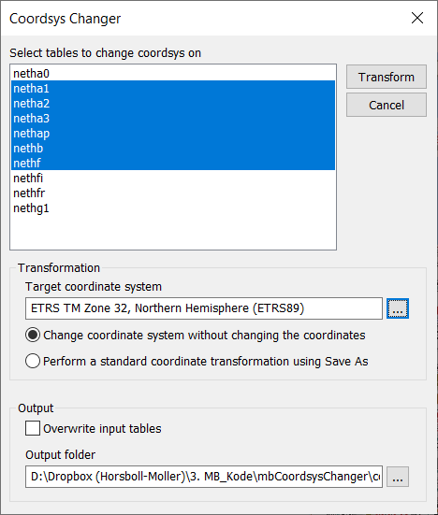You will now see the “*Coordsys Changer”* dialog on your screen.

Select the tables that you want to transform via the field “*Select tables to change coordsys on*”.

In the “*Transformation*” section, you select the target coordinate system using the button.

You also need to specify the transformation type:

* “*Change coordinate system without changing the coordinates*”: This is useful if you have imported some data but you can see they are positioned at a wrong place. Sometimes this happens if you select the wrong coordinate system during import.
* “*Perform a standard coordinate transformation using Save As*”: This creates a batch job using the standard Save As functionality and can be used to change the coordinate system of a dataset that is correctly place.

In the “*Output*” section, you can control the output. If you check the “*Overwrite input tables*”, the application will overwrite the existing tables with the new tables with the new coordinate system. It is recommend to create a back-up of your table before using this option.

In the “*Output folder*” field, you can browse where you want to save the newly created tables. If you do not use “*Overwrite input tables*”.

Click Transform to start the transformation.